Y Trajectory With Drag: Spreadsheet Directions and “answers”

You can figure this out all on your own, or you can follow my directions, below. Either way, you should check your progress as you go by looking at the attached answer key (make sure your yellow inputs are the same as mine). It's easier to pinpoint problems if you check as you go, rather than trying to do your debugging at the end.

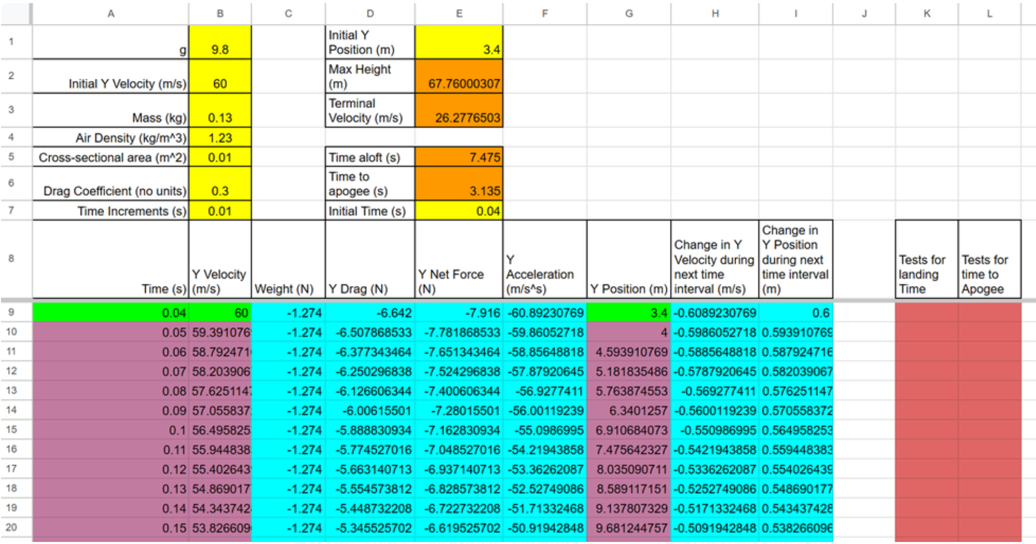

First, the easy, green cells
- For the starting time, in cell A9, enter the formula "=E7" to grab the initial time from up above.
- For the starting y velocity, in cell B9, enter the formula "=B2" to grab the y velocity from up above.
- Same for the starting y position (G9). Enter a formula to take the initial y position from above.
Now the turquoise cells...
- First, if you don't know what dollar signs (absolute cell reference) do in spreadsheet formulas, you should look it up or watch my video. For this spreadsheet, the simple rule is that you should just put them before every row number above row 8 on the spreadsheet -- and not before any row number below row 8. For example, you might want to enter the formula "=E9/B$3" because 9 is below row 8 and 3 is above it.
- Weight = mg, but let's use "=-B$3*B$1" because weight is a downward (negative force).
- Drag is a tricky, so let's do it partway now, and fix it in a couple of minutes. Drag = 0.5*A*Cd*Density*v^2, so the basic formula in D9 should be "=-0.5*B$5*B$6*B$4*B9^2" Notice that only velocity does not get a dollar sign, because it's below row 8. Also, note that drag is negative because it is initially downward.
- Net force is simple, since this spreadsheet only applies to the coasting phase -- no drag. So the net force is the sum of drag and weight. Since both forces have the sign built in, we can just add them... "=C9+D9"
- Y acceleration comes from Fnet=ma. You can do this one. Solve for a and make sure that the mass gets a dollar sign, because it's above row 8.

- Skip Y position for now, and move on to "change in y velocity during the next time interval." Since acceleration = (change in velocity) / (change in time), change in y velocity = acceleration * change in time. "Change in time" is provided in the time increments cell, which you should enter as B$7. In your formula, use the acceleration you calculated in cell F9.
- Finding change in position is like finding change in velocity, except that you use the velocity formula ( v = change in position / change in time ).
- Now let's fix drag. The problem with our formula is that it's always going to give us negative drag, but when the rocket's velocity is negative (moving downward), drag should be positive (upward.) We need to use a conditional formula, like this "= if(logical test,value if true, value if false)". The test will be the current velocity (B9). If it's positive, drag should be negative. If it's not positive, drag should be positive. You can copy and paste what you already have to save time. Here's what it should look like... "=if(B9>0, -0.5*B$5*B$6*B$4*B9^2, 0.5*B$5*B$6*B$4*B9^2)"
- Now that the turquoise cells are done, we need to copy them down to the next row. The easiest way to do this is to select several of them at once and then grab the little "handle" in the bottom right of the selected cells and drag it down one row.
Now the "light magenta" (pinkish/purplish) cells...
- The time needs to move forward by one increment every row, so the formula in A10 is "=A9+B$7"
- The new Y velocity is the old Y velocity (from Cell B9) plus the amount that velocity has changed during the time interval (H9).
- Similarly the new Y position is the old Y position plus the previous change in y position.
- Area and Drag are easy. Just set them equal to the cells above (e.g. "=N9" for cell N10).
- Now you can select all of the magenta and turquoise cells in row 10, grab their "handle," and copy them all the way down to row 1000. It will take a while.
Now the easy orange cells...
- Max height can be found with the "max" function. In Cell E2, enter the formula "=max(G9:G1000)"
- To calculate terminal velocity, you will need to solve for v. At terminal velocity, weight = drag, so set mg=.5*A*Cd*density*v^2, and solve for v. Then enter your formula, starting with an equal sign.
Finally, the cells that work together -- the remaining orange cells, and the red cells...
- To determine time aloft, we're going to use a formula in column K to look for rows late in the flight when the rocket is very close to the ground, and we're going to average those times together. First, in cell E5, enter the formula "=average(K9:K1000)"
- Now, in cell K9, enter "=if(abs(G9)<0.5,A9,""). This is checking the absolute value of the rocket's y position. If the rocket is closer than 0.5m to the ground, the current time (from A9) appears in this cells. If it is not greater than one, the two quotation marks with nothing between them ("") causes the cell to be blank.
- We will be copying the red K9 formula down to row 1,000, but first let's take care of finding time to apogee. Then you can copy the two red cells down together. In cell E6, enter a formula like the one in cell E5, except that the values to average will be in column L instead of column K.
- In cell L9, create a formula like the one in K9, but this one is a test for the rocket reaching its highest point. Ask yourself what value would tell us whether the rocket is reaching its highest point? Use that value as your test. You will again need to use the absolute value function, abs().
- Now select the two red cells ( K9 and L9) and copy them down to row 1000. If you scroll past rows 292 and 703, you should see the times appear.

