Unit 1 Practice Test Version 2 – Motion and Forces Name: ____________________________
Physics 200 (25-26)

Multiple Choice, Matching, and Short Answer

1. Circle all of the quantities that are vectors.
Velocity Speed Displacement Acceleration Force Distance

2. This tells us how the velocity of an object changes over time.
Position Displacement Velocity Speed Acceleration Distance

3. This tells us how fast something is moving and the direction of its movement.
Position Displacement Velocity Speed Acceleration Distance

4. This tells us how far something moves, but it does not tell us the direction of movement.
Position Displacement Velocity Speed Acceleration Distance

#5-9 Answer Choices: A. Weight B. Tension C. Normal Force D. Drag E. Friction

5. A B C D E Resistance acting on an object moving through a fluid

6. A B C D E The pulling force in a rope, cable, or chain

7. A B C D E A force exerted perpendicularly outward by a surface

8. A B C D E Resistance between two surfaces sliding across one another

9. A B C D E The force of a planet’s gravity acting on a smaller object.

10. Initial Velocity: $v_{0}$ $v$ $\overline{v}$ $x$ $∆y$ $a$ $∆t$ $∆v$

11. Change in Velocity: $v_{0}$ $v$ $\overline{v}$ $x$ $∆y$ $a$ $∆t$ $∆v$

12. Final Velocity: $v_{0}$ $v$ $\overline{v}$ $x$ $∆y$ $a$ $∆t$ $∆v$

13. Displacement: $v_{0}$ $v$ $\overline{v}$ $x$ $∆y$ $a$ $∆t$ $∆v$

Fill in the blanks…

14. 1kg = _________________ pounds 15. 1 foot = _________________ meters

16. 1N = ________________ pounds 17. 1 m/s = _________________ mph

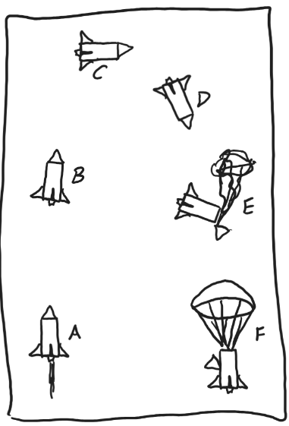
18-20. Draw sets of position, velocity, and acceleration graphs for the situations described below. To keep things simple, you may assume that accelerations are constant.
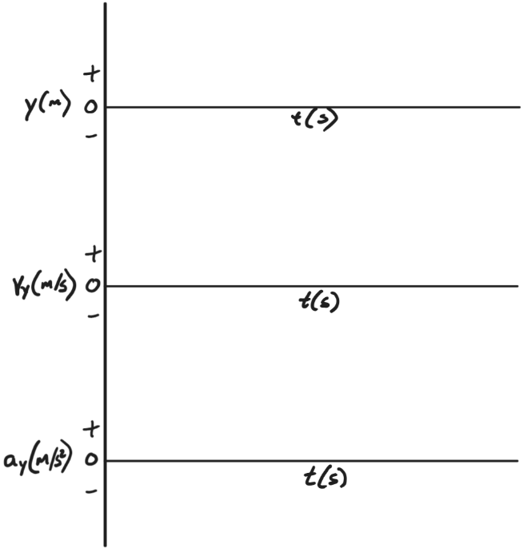
18. During stage A, the middle of the thrust phase

19. During stage F, when the rocket is falling at terminal velocity

20. During stage B, after thrust has ended, when the rocket is on its way to apogee

21. a. Describe a situation in which people feel weightless, even though they are not weightless.

b. Explain why this isn’t really weightlessness.

22-28. For all of the moments in a water rocket’s flight, choose the correct signs (positive, negative, or zero) for both velocity and acceleration.
# | Description | Velocity | Acceleration
 |  | (+, -, or 0) | (+, -, or 0)
22 | Thrust has just begun. The rocket has just left the launcher. Water is still spewing from the rocket.
23 | Part of the rocket has just touched the ground, but its center of mass has not stopped falling.
24 | The parachute has fully deployed, and the rocket is falling at terminal velocity.
25 | The rocket was at its apogee 0.1 seconds ago. The parachute has not started to deploy.
26 | The parachute is almost fully deployed, and the rocket’s fall is slowing down.
27 | The rocket is at its apogee.
28 | Thrust ended 0.01 seconds ago. The rocket is coasting upward.

29. `Consider a water rocket that is in its water thrust phase. The rocket is accelerating upward, and water is shooting out behind the rocket, and there are three types of forces acting on the rocket. For each type of force, there exists a “3rd law pair.” For each third law pair, describe objects exerting force, the objects the forces are exerted on, and the directions of the forces.

Problems: ****Include correct units with all answers. Also include correct signs or directions for all answers that are vectors. For possible partial credit, clearly show useful starting formulas and intermediate answers.****
1. A rocket flies directly upward and then falls directly downward. At t = 3.5s, the rocket’s height is 60m. At t=3.6s, the rocket reaches its highest point, at 62m. At t=4.1s, the rocket’s height is 54m.
a. What was the rocket’s average velocity from t=3.5s to t=4.1s?

b. What was the rocket’s average speed for that same time interval?

2. Suppose a lunar lander travels 15.2m rightward in a time of 3s, accelerating at a constant rate for the entire time. At the end of this 3 seconds, the lander collides with the Moon at a velocity of 0.55m/s. Find “everything” about the lander’s motion during these three seconds.

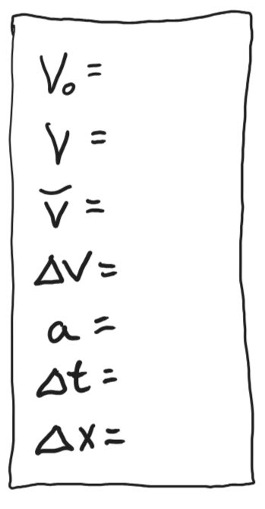

3. In the absence of air resistance, a rocket is launched directly upward from a height of 0m. It returns to Earth (height = 0m) 14 seconds later. Find “everything” about the rocket’s motion during these 14 seconds.

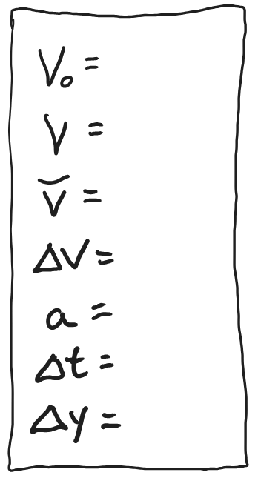

4. A rocket is falling from the sky at a velocity of -15m/s and it is accelerating upward at a rate of 1.5m/s². It is experiencing a drag force of 2N.

Draw a diagram of the rocket meeting all of these requirements:
- Diagram shows: 1) the rocket, 2) all of the individual forces, and 3) the net force acting on the rocket.
- Use arrows to show the directions of each of the forces.
- Label each force with a correct name.
- Label each force with its magnitude and units.

5. The data below describe a water rocket in flight. Create a diagram meeting the same requirements described in problem #4.
- Rocket Cross-sectional = 0.01m²
- Density of surrounding air = 1.26kg/m³
- Rocket Drag coefficient = 0.3.
- Rocket Velocity = 55m/s upward
- Mass = 0.25kg
- Rocket acceleration = 20m/s² upward

