Physics 200 Name: __________________
Unit 8 Handout (current and Circuits)

What makes circuits go?
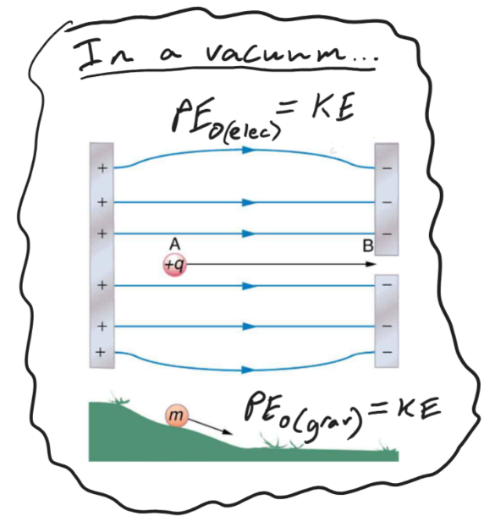
The diagram on the right presents an analogy comparing electric potential energy to gravitational potential energy. In both cases, potential energy is stored when an object is moved in the opposite direction that it “wants to go.” Gravity causes objects to experience a downhill force, and charged objects experience attractive or repulsive forces (depending on what other objects are nearby). In both cases, when the objects are released, that potential energy gets turned into kinetic energy – IFF this is happening in a vacuum (where no energy is lost to non-conservative work).

When charges flow through the wires of an electric circuit, none of this energy gets conserved. Every bit of it is converted to some sort of work. Always. In the diagram below, charges leave the positive battery terminal with a lot of potential energy, and charges enter the negative terminal with no energy at all. If you remove the hair dryer, the light bulb, and the simple resistor, the wire itself will take all of the energy, and it will probably melt and start a fire. The charges at the end of the circuit are always totally depleted of energy. [**Note that the charges are moving the wrong way. It is electrons that move through circuits, and they flow from negative to positive, but we pretend current goes the other way because that is what Ben Franklin thought it did. All of the early textbooks followed his lead.]
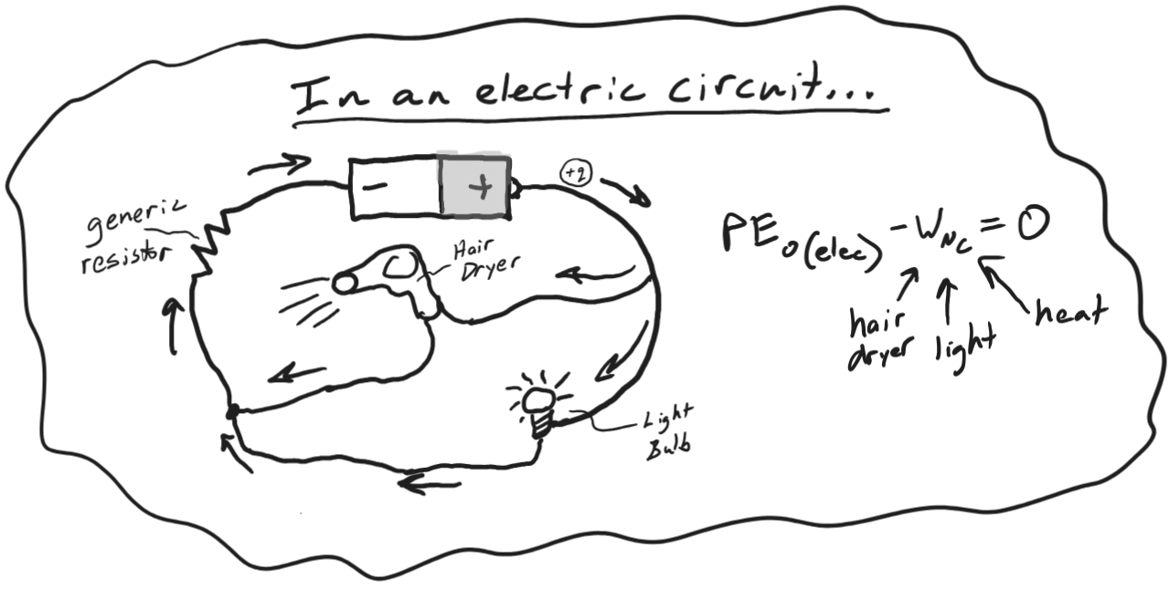

One Analogy For Thinking About Circuits: There is another analogy that will will look at later. They both have problems, but they are both useful.

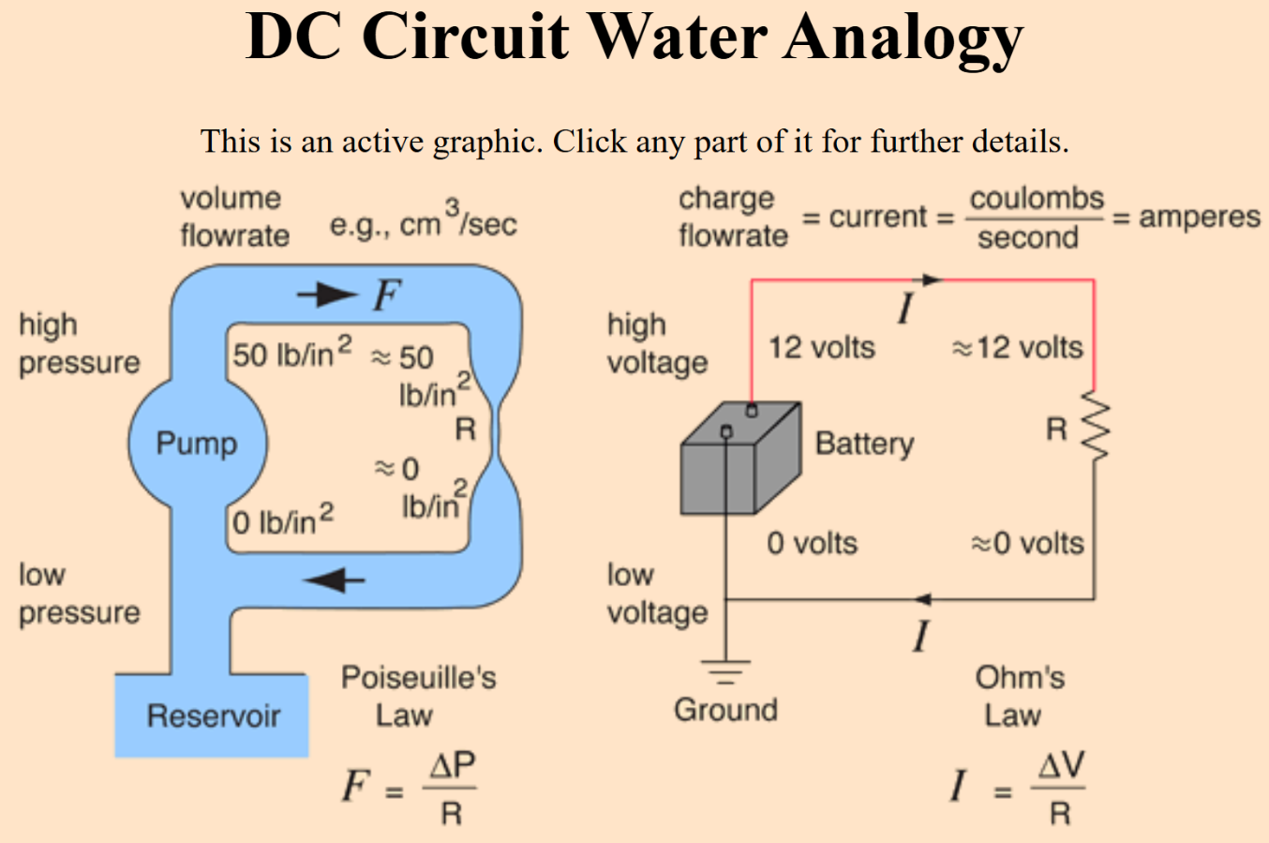

Based on the graphic above, provide units and a basic description for…

Voltage:

Units for Voltage:

Electric Current:

Units for Current:

Resistance:

Units for Resistance

Working Definitions (for now): But the terms need to be filled in…

- _________________ is a change in potential energy. That’s sort of what it is, and it’s a good enough definition for now.

- ___________________ and ___________________ are pumps that take in low potential energy charges on their negative ends and push out high potential energy charges on their positive ends; they pump up the voltage of the charges that pass through them.

- ___________________ is the flow rate of charge through a circuit. If a circuit were a river, this would be measured in gallons per minute, but instead it is measured in Coulombs per second (a.k.a. Amps).

- ______________________ is something that resists the flow of charge, and in the process it takes energy from the charges, reducing their potential energy (voltage).

Ohm’s Law (a very important law):

- What happens to the flow of charge through a circuit if we increase voltage and keep resistance the same?

- What happens to the flow of charge through a circuit if we increase resistance and keep voltage the same?

- If 3A of current is flowing through a 5Ω resistor, how much voltage does it use up?

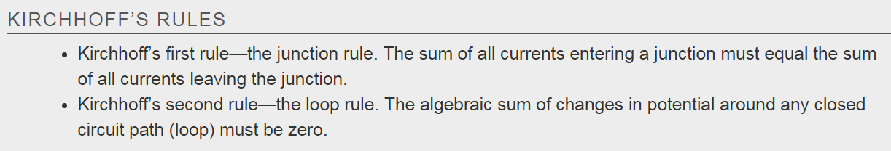

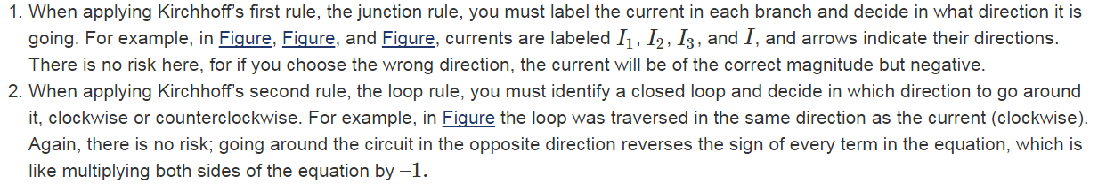
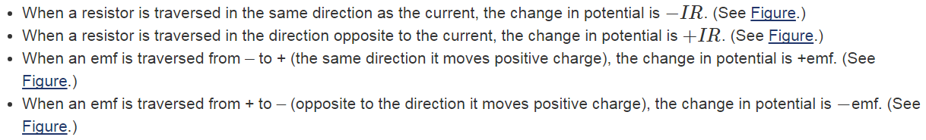
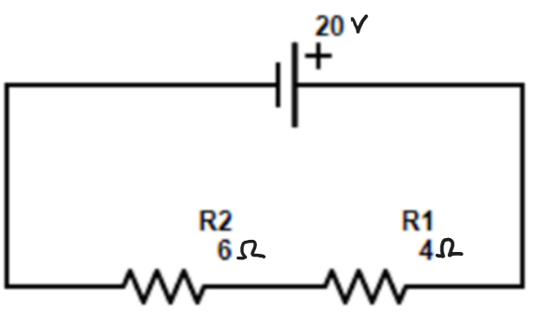

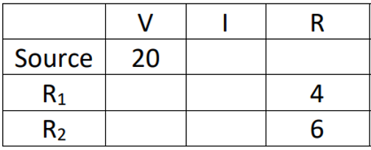

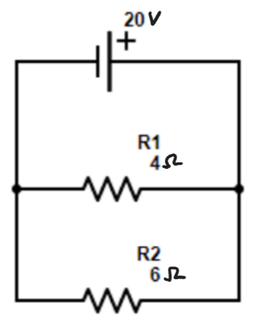

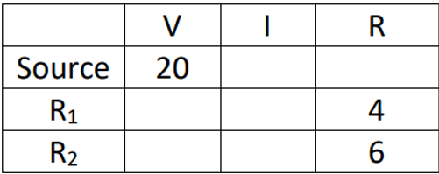

Circuits With 1 Battery: Fill in the tables
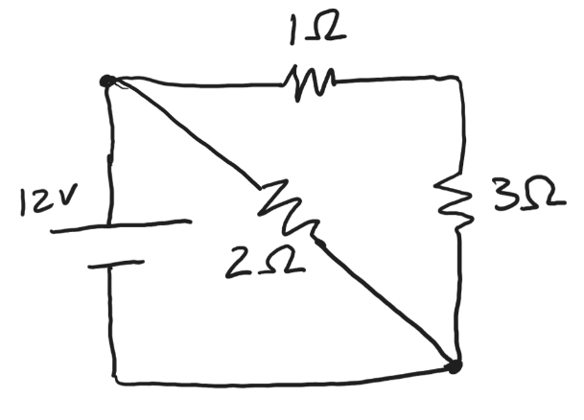
 | V | I | R
Source | 12
 |  |  | 1
 |  |  | 2
 |  |  | 3

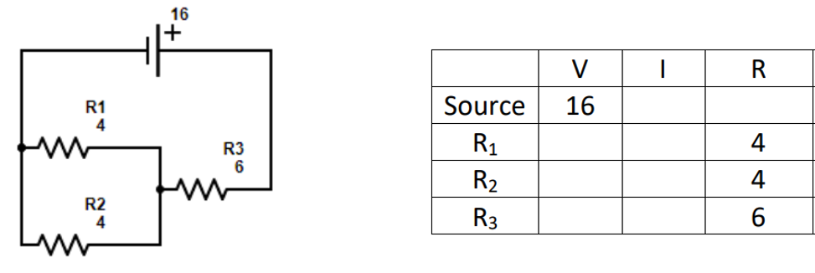

Circuits With 2 Batteries: Name and Calculate the Currents, and Indicate Their Directions
