Physics 200 (Stapleton) Name: __________________________________
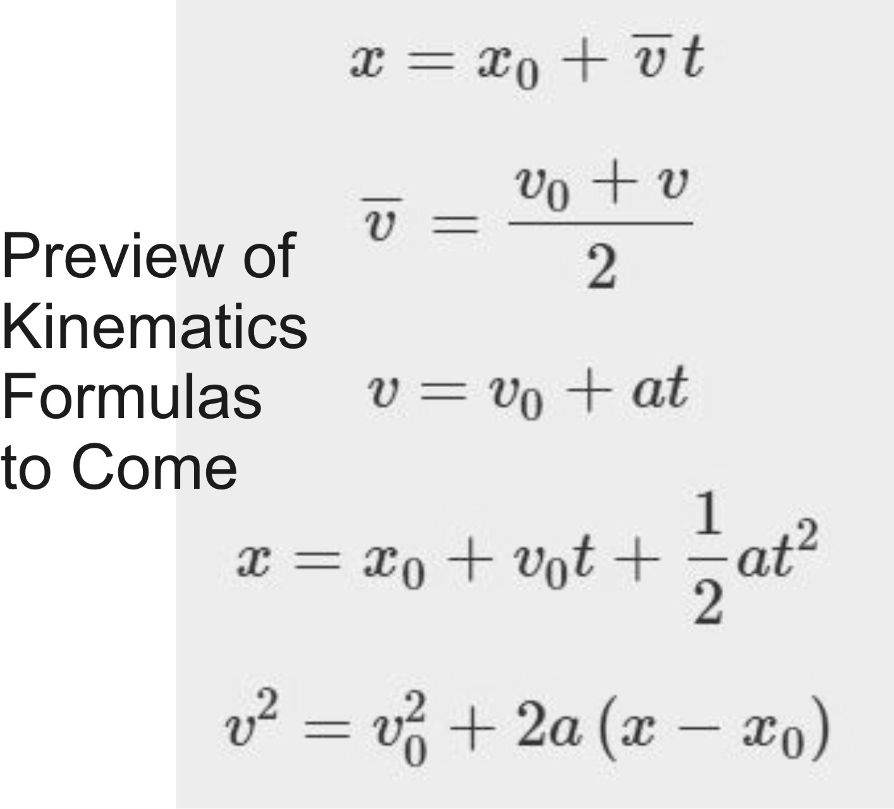
1-D Kinematics Notes, Part 1

Kinematics: The study of motion without considering its causes.

Scalar: A quantity with magnitude but no direction.

Vector: A quantity with magnitude and direction. Numerically, may be positive or negative, depending on the chosen reference frame. Usually, signs follow the same conventions as an x/y grid… upward = positive, downward = negative, rightward = positive, leftward = negative.

Δ = Delta = Final - initial = “change in”. If x changes from 3m to 1m, then Δx = 1m - 3m = -2m.

 | Symbol | Meaning (what it’s supposed to mean) | Vector or Scalar? | Common Units | How to estimate or convert
Position | x (or y, depending on axis of motion) | An indicator of distance and direction from some chosen point of origin. |  | Meters (m) | 1 long step  0.305m ≈ 1foot
Displacement (often called “distance.”) | Δx (or Δy)  Sometimes = d | Final position minus original position(e.g. x-x₀); “Change in position” |  | Meters (m) | 1 long step  0.305m ≈ 1foot
Distance | d | How far something has traveled from its original position, disregarding direction. Distance is not negative. |  | Meters (m) | 1 long step  0.305m ≈ 1foot
Distance traveled | d | Sum of all of the distances traveled on a trip. Distance traveled is what is recorded by a car’s odometer -- generally. |  | Meters (m) | 1 long step  0.305m ≈ 1foot
Time | t | ? |  | Seconds (s) | 1s = “one mississippi”
Speed | v (even though v is technically velocity) | How fast something is moving. A ratio of distance traveled to travel time elapsed. |  | Meters per second (m/s) | 1m/s ≈ 2.24mph ≈ 1 long step per second
Velocity | v | Speed in a particular direction. A ratio of displacement to travel time elapsed. |  | Meters per second (m/s) | 1m/s ≈ 2.24 mph  4.5m/s = 6min/mile pace

Average Velocity (symbol = ): when we measure velocity, average velocity is what we will actually measure. This is the average speed of an object as it travels through a given distance. The object may speed up or slow down over that distance, but the average velocity that we calculate will not show this.

Instantaneous Velocity: the velocity of an object at a single point in time

“Initial velocity” symbol =

Final velocity symbol =

If I have a velocity of 3 m/s, what does that mean?

Explain how to walk with a velocity of 1m/s.

Average Velocity Formula (Hint: the units provide the formula)

Two Ways to Graph The Same Event

Position vs. time graph (below, left) [also called “distance vs. time”]:
- For the first 2 seconds, Chuck walked steadily away from a motion sensor. During that time, he traveled 4m “forward.”
- For the next 4 seconds (from t=2 to t=6), Chuck stood still at the 4m distance mark.
- During the last 4 seconds (t=6 through t=10), Chuck walked steadily back toward the sensor. During those two seconds, Chuck traveled 2m “backward.”

Velocity vs. time graph:
- During the first segment, Chuck traveled 4m forward (+4m) over a time of 2s. His average velocity for that interval is therefore 4m/2s = 2m/s. The velocity vs. time graph shows a constant velocity of 2m/s for the first two seconds.
- During the second segment of data (2s to 6s), Chuck stood still (0m distance) over a time of 4s. His average velocity for that interval was therefore 0m/4s = 0m/s. The velocity vs. time graph shows a constant velocity of 0m/s for the second segment of data.
- During the 3rd segment (6s to 10s), Chuck moves 4m backward (-4m). His average velocity for that interval is therefore -4m/4s = -1m/s. The velocity vs. time graph shows a constant velocity of -1m/s for the second segment of data (6s through 10s).

The small graphs, below, are actually more realistic than the large graphs. Why?

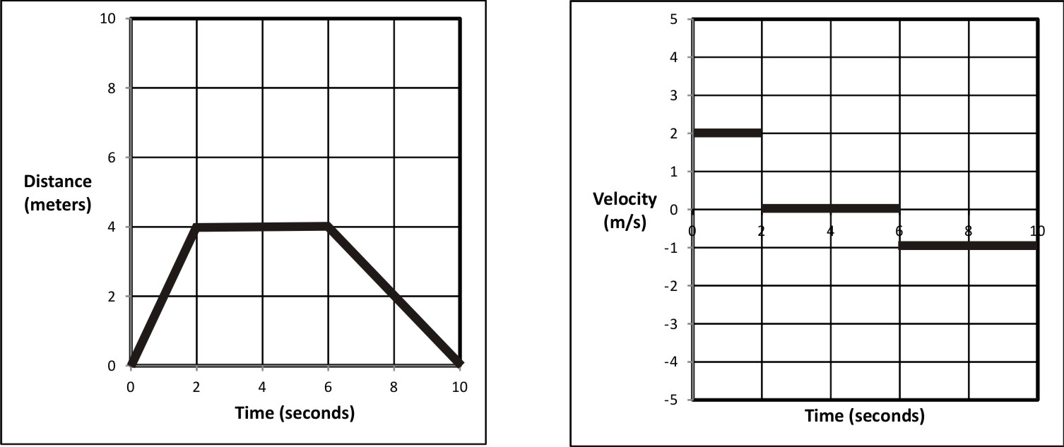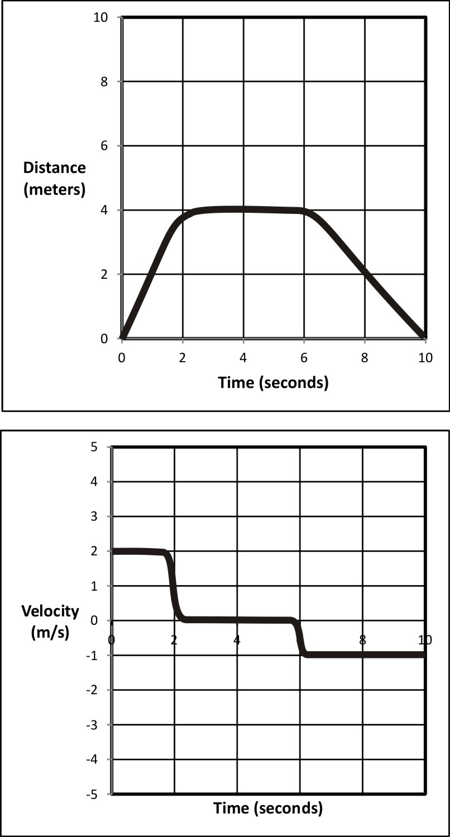

Velocity Practice: The graph on the right shows the movement of an object in front of a motion sensor. Determine the velocity of the moving object for lettered each segment, and use your calculations to fill out a velocity vs. time graph for the object (bottom of page).

1. Fill in the correct information for segment A, in the graph on the right.
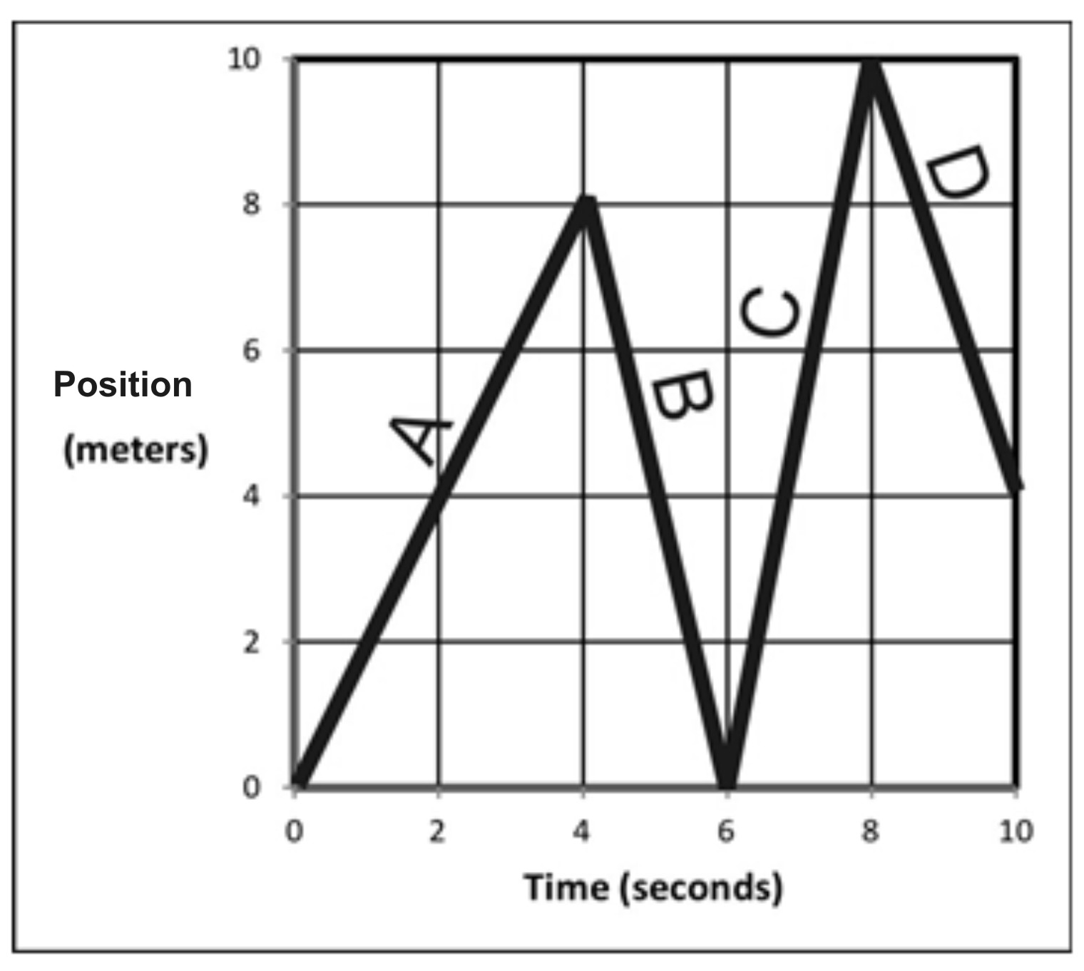
Displacement = _________

Δt = _________

v_{average} = _________

Distance traveled = ___________

Position at end of segment = ____________

2. Fill in the correct information for segment B.

Displacement = _________

Δt = _________

v_{average} = _________

Distance traveled = ___________

Position at end of segment = ____________

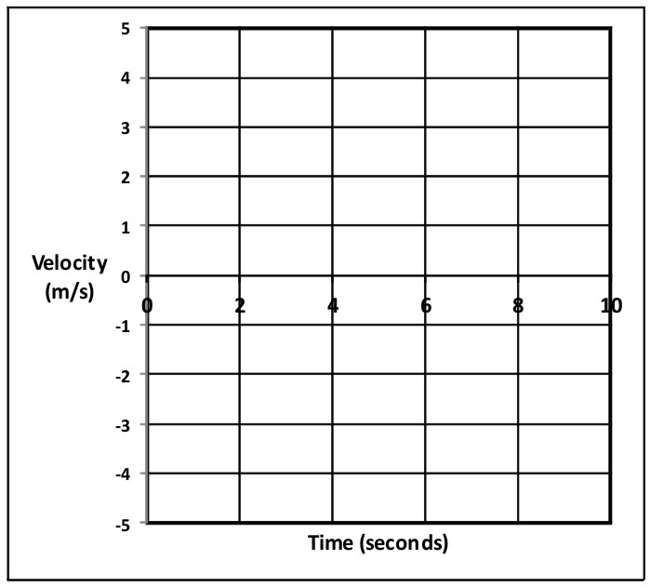
3. Fill in the correct information for the entire trip (segments A-D).

Displacement = _________

Δt = _________

v_{average} = _________

Distance traveled = ___________

Position at end of segment = ____________

4. Use the distance vs. time graph above to fill in the velocity vs. time graph on the right.

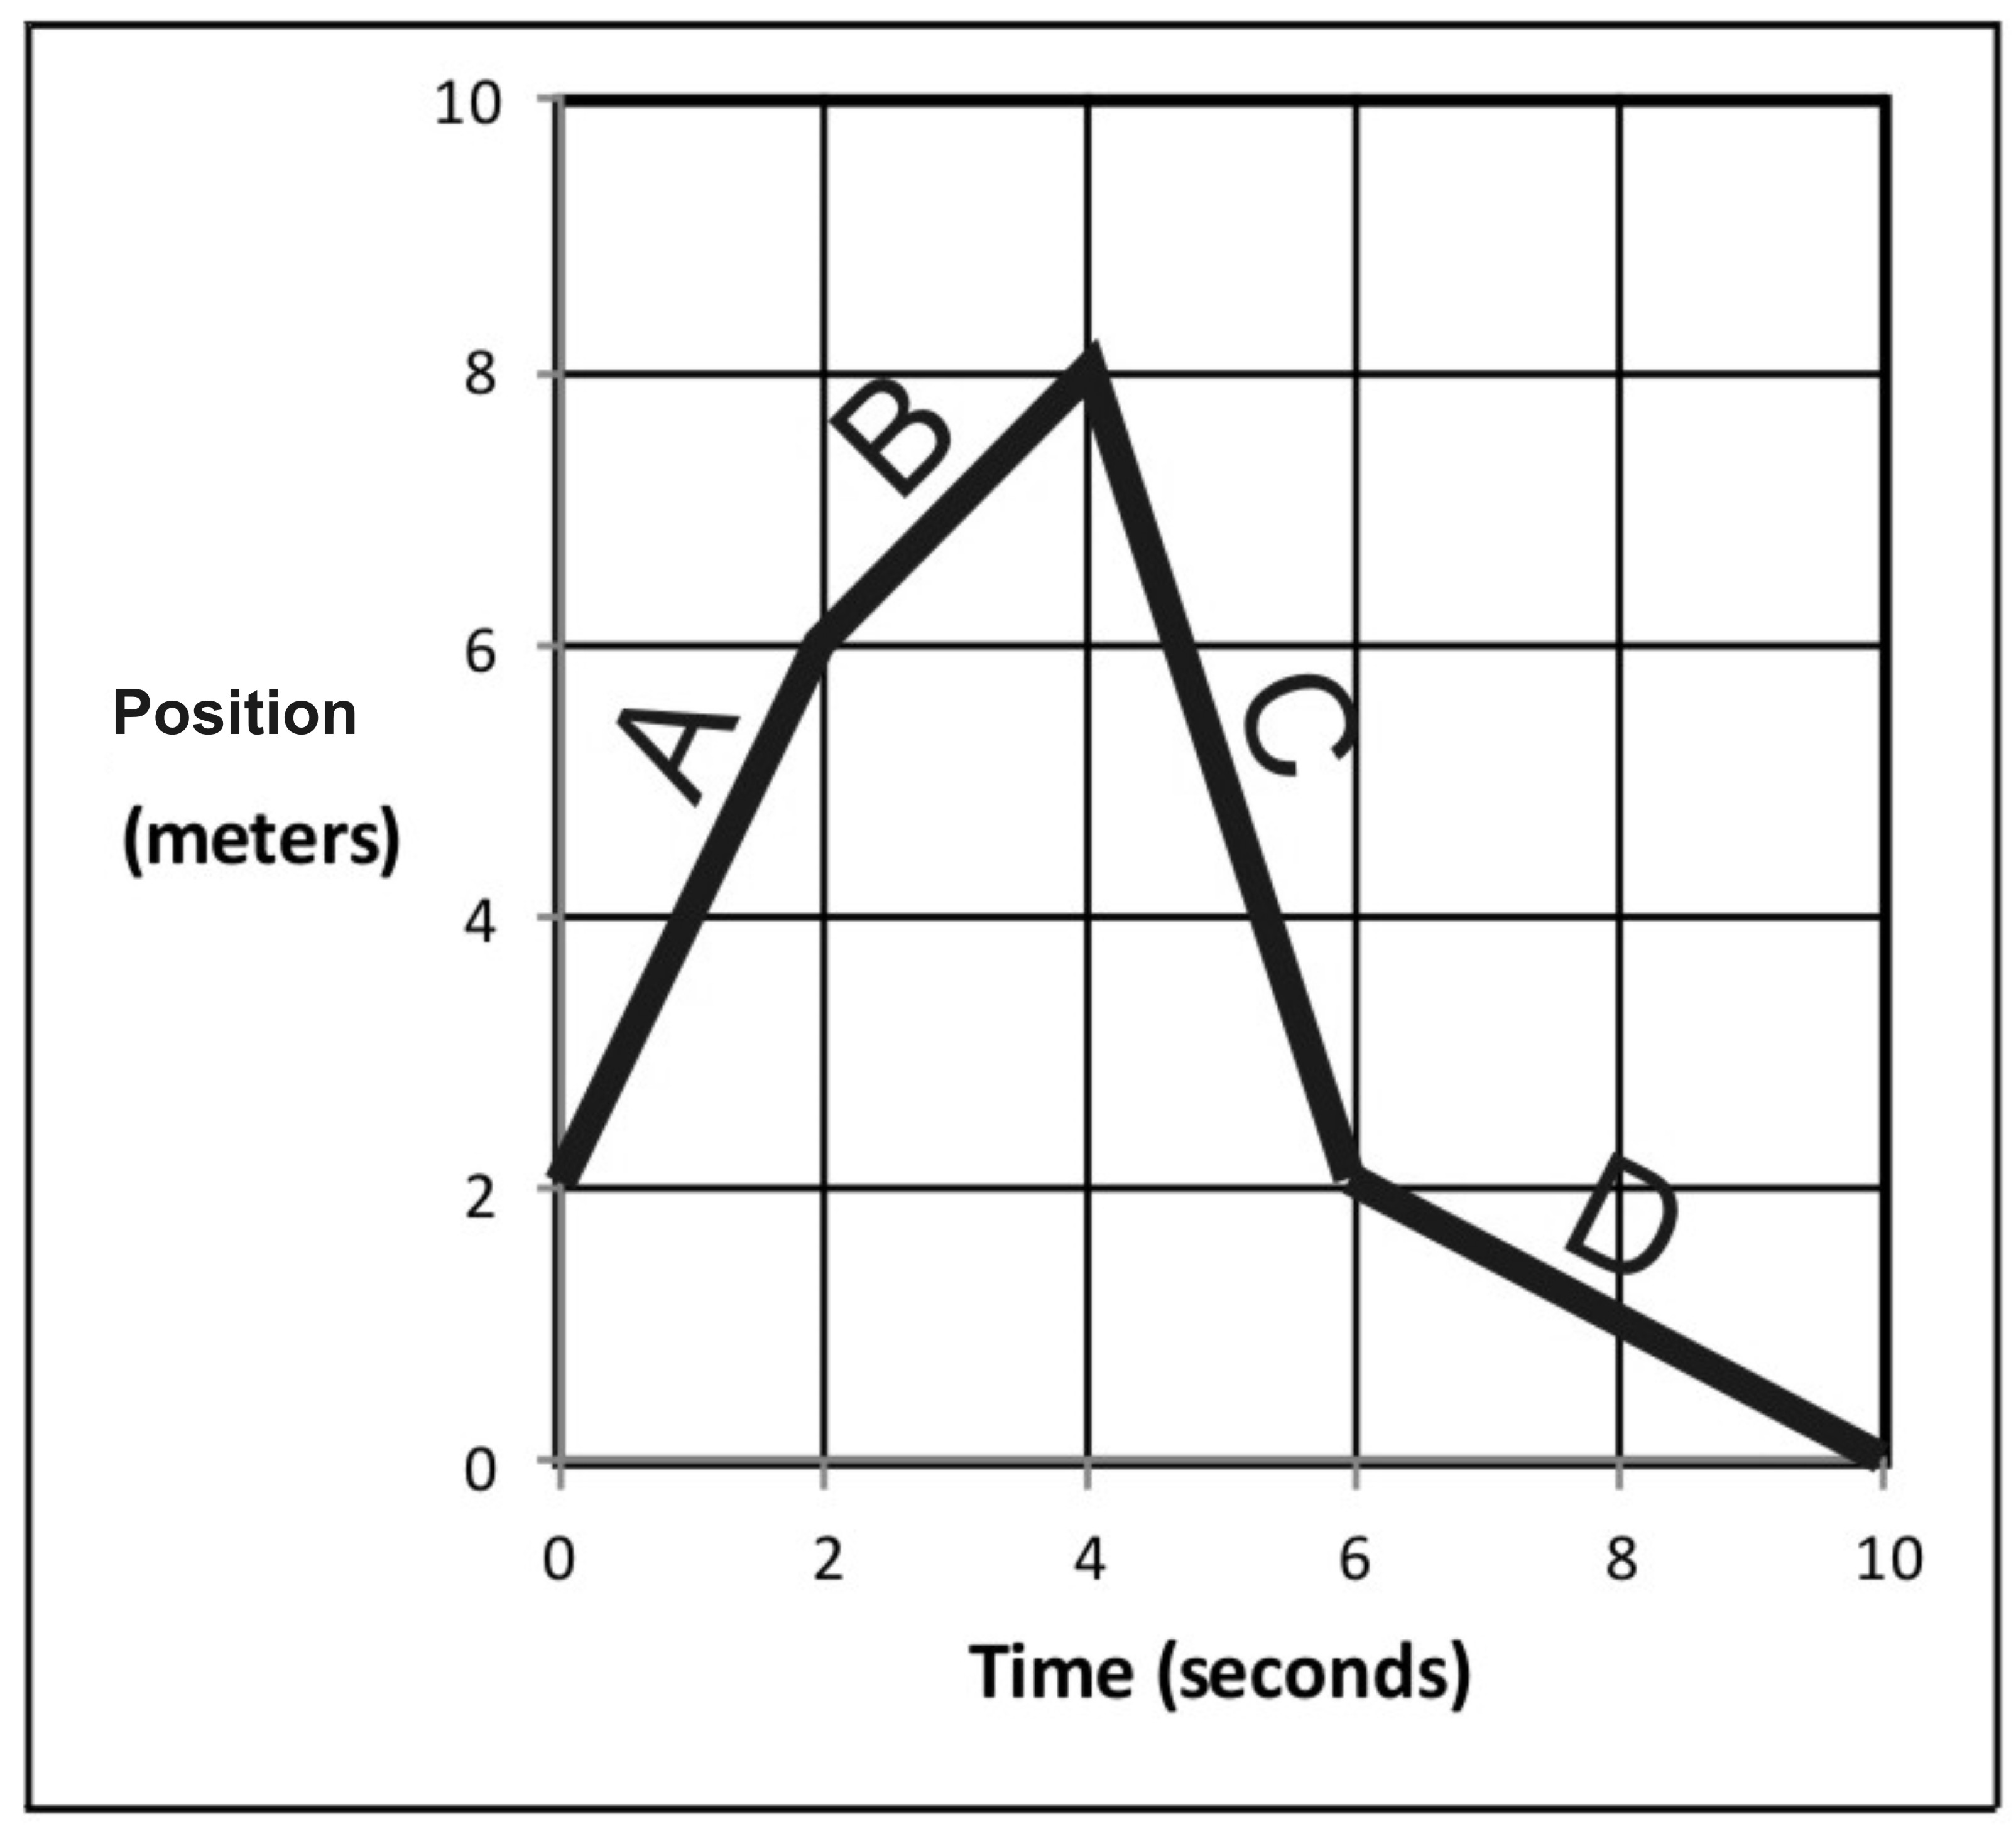
5. Fill in the correct information for segment A, in the graph on the right.

Displacement = _________

Δt = _________

v_{average} = _________

Distance traveled = ___________

Position at end of segment = ____________

6. Fill in the correct information for segment D.

Displacement = _________

Δt = _________

v_{average} = _________

Distance traveled = ___________

Position at end of segment = ____________

7. Fill in the correct information for the entire trip (segments A-D).

Displacement = _________

Δt = _________

v_{average} = _________

Distance traveled = ___________

Position at end of segment = ____________

8. Use previous answers and the distance vs. time graph above to fill in the velocity vs. time graph on the right.
Position vs. Time Motion Matching Activity Questions:

On a motion sensor graph of position vs. time…

1. What does a positive (upward) slope tell you about the object’s motion?

2. What does a negative slope indicate?

3. What does the steepness of a slope tell you about the object’s motion?

4. What does a constant (straight line) slope indicate?

5. What might a smoothly curving line indicate?

6. Sketch a negative slope that is becoming less steep. What does this curve indicate about the motion of an object?

7. Sketch a negative slope that is getting steeper. What does this curve indicate about the motion of an object?

8. Sketch a positive slope that is becoming less steep. What does this curve indicate about the motion of an object?

9. Sketch a positive slope that is getting steeper. What does this curve indicate about the motion of an object?

