Physics 200 (Stapleton) Name: _____________________ School
Work and Energy – Spring Energy and Review Problems

Formulas and Info:

W=Fd $P=\frac{W}{t}$ W_{net} = ΔKE $KE=\frac{1}{2 }mv^{2}$ ΔPE = mgh

KE_{initial} +PE_{initial} = KE_{final} + PE_{final} KE_{initial} +PE_{initial} + W_{nc} = KE_{final} + PE_{final}

1horsepower = 746W 1 Calorie = 4,184 Joules. 1kcal = 1 food calorie = 4.184 Joules

F_{spring} =-kx ${PE}_{spring} =\frac{1}{2}kx^{2}$ $\% Efficiency= \left(\frac{Energy Output}{Energy Input}\right)\left(100\%\right)$

Part 1: Springs

1. Consider an ideal compression spring with k=300N/m. How much force is required to compress the spring a distance of 5cm?

2. How much energy is stored in the spring above when it is compressed 5cm.

3. An ideal extension spring of negligible mass is hanging from a ceiling. One end of the spring is attached to the ceiling, and the other end is pointing downward. A 50g object is added to the bottom of the spring and is then released. The object stretches the spring downward, bobs around for a while, and comes to rest with the spring stretched 20cm beyond its original length.
a. How much energy is stored in the spring after the object comes to rest?
b. What is the spring’s k?
c. Now the 50g object is attached to the end of the spring, raised upward nearer the ceiling, and then released. The object falls to a low point and then bounces back up. When the object is at its low point, the spring is stretched 80cm beyond its original length. How far did the object fall before bouncing back upward?

4. A water rocket’s water thrust phase lasts for 0.05 seconds. During this time, the rocket travels upward 0.85m with an average thrust of 400N.
a. How much work is done by the rocket during the water thrust phase?
b. What is the average power output of the rocket during this phase, in Watts? In horsepower?

5. Neglecting air resistance, describe an object that would generate exactly 1horsepower simply by falling.

6. Mt. Everest is 8,848m above sea level, and an average waffle offers about 82,000 calories. Considering only the vertical travel that must take place, how many waffles must a 150 pound human eat in order to climb from sea level to the top of Mt. Everest? Assume that the human’s conversion of waffle energy to mechanical energy is 30%.

7. A 300hp sports car has a mass of 1,600kg. The car accelerates using all 300hp for 6 seconds. Then the driver releases the accelerator and hits the brakes, skidding to a stop. The car’s µ_{s} = 0.5 and it’s µ_{k} = 0.8.
a. What is the car’s speed after 6 seconds?
b. How far does the car skid?

8. Is a car’s stopping distance directly proportional to its velocity or is it directly proportional to its kinetic energy? Why?

9. A frictionless roller coaster (500 kg) is pulled up to point 1 where it and its screaming passengers are released from rest. Assuming that total energy is conserved, complete the empty elements in the chart below.
Good Stuff

1 km = 1000 m
1 hour = 3600 s
1 mile = 1609 m
W = Fdcosθ
KE = ½ mv²
PE_{g} = mgh
PE_{s} = ½ kx²
P = W/t
F = - kx

Position | Height (m) | Total Energy (J) | Potential Energy (J) | Kinetic Energy (J) | Velocity (m/s)
1 | 35.0 |  |  |  | 0
2 | 0.0
3 | 28.0
4 | 15.0
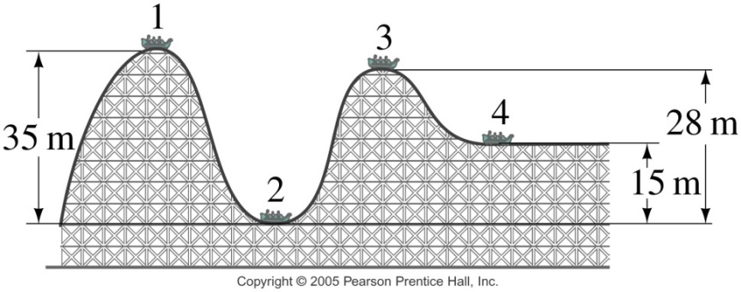

10. A child creates a homemade bow with the force curve shown on the right. The graph shows how the force applied to the bow string changes as the child pulls it back to the full draw distance of 0.5m.

a. How much work is done in drawing the bow?

b. If the bow is 60% efficient, how much energy will the arrow have when it leaves bow?

c. If the child wants to shoot an arrow with a velocity of 30m/s, what arrow mass should be used?

