Physics 200 Name: ______________________________

Notes: Momentum and Impulse

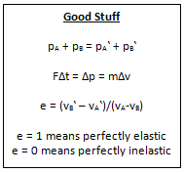

Definition of Momentum:

Symbol: Why?

Formula:

Units:

Is momentum a vector quantity or a scalar quantity?

What is “impulse?”

Derive the relationship between impulse and momentum:

What does “conserved” mean, with regard to physical laws?

Law of Conservation of Momentum:

When does the Law of Conservation of Momentum apply?

Whether or not the Law of Conservation of Momentum applies depends on how one chooses the “system.”

Example 1: System = 2 cars collide head to head with 2,000N of force. The collision lasts 0.1second. Car A is traveling leftward. Car B is traveling rightward.

Net force on the System =

Is the cars’ total momentum conserved?

Use impulse to explain why, or why not.

Example 2: System = Only Car A, from above

Net force on the System =

Is the car’s momentum conserved?

Use impulse to explain why, or why not.

Elastic Collision:

Inelastic Collision:

Practice Using the Law of Conservation of Momentum:

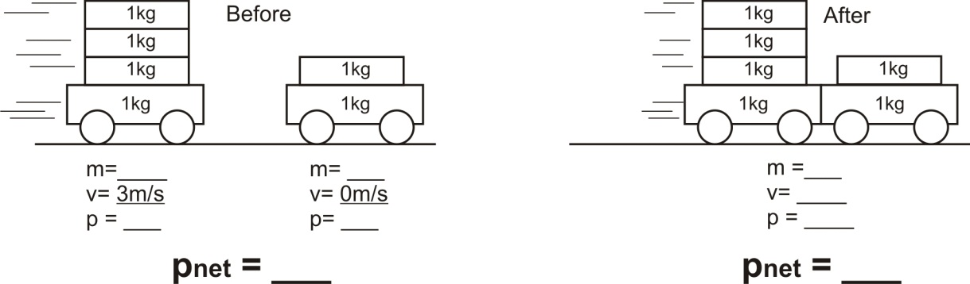1.

2.

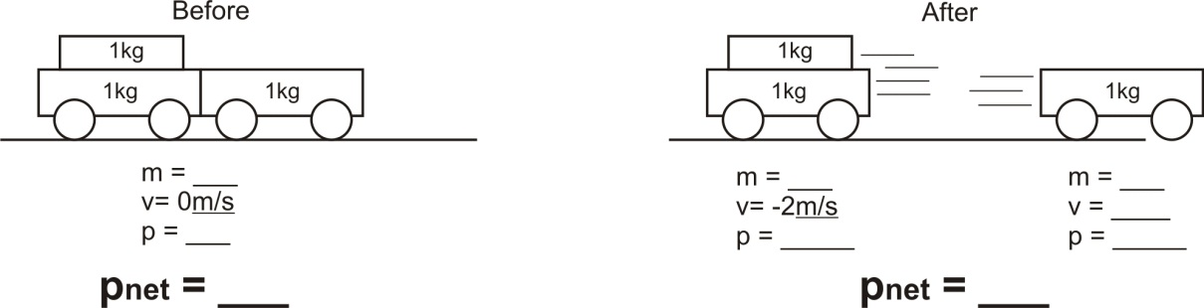

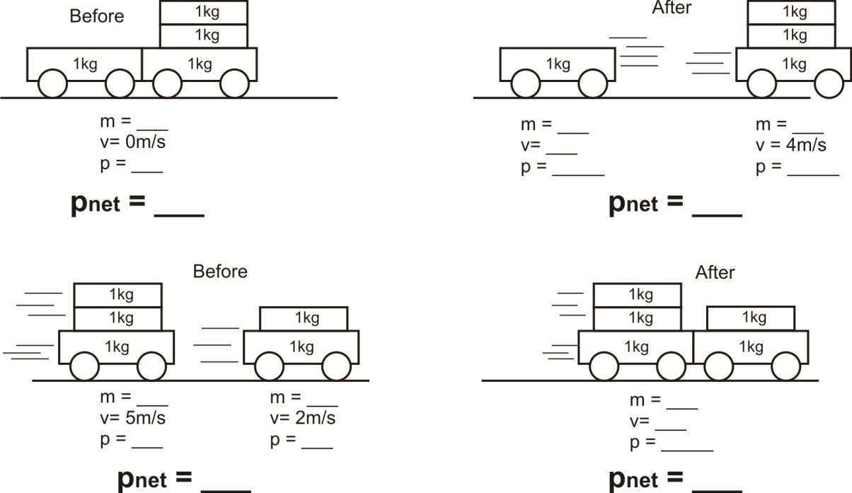3.

**Practice with Conservation of Momentum**

**Conceptual Questions**

1. Why is momentum conserved for ALL collisions, regardless of whether they are elastic or not?

2. A Superball is dropped from a height h onto a hard steel plate (fixed to the Earth), from which it rebounds at very nearly its original speed. (a) Is the momentum of the ball conserved during any part of this process? (b) If we consider the ball and Earth as our system, during what parts of the process is momentum conserved?

3. At a hydroelectric power plant, water is directed at high speed against turbine blades on an axle that turns an electric generator. For maximum power generation, should the turbine blades be designed so that the water is brought to a dead stop, or so that the water rebounds? Explain why.

**Problems**

1. A child in a boat throws a 6.40 kg package out horizontally with a speed of 10.0 m/s. Calculate the velocity of the boat immediately after, assuming that it was initially at rest. The mass of the child is 26.0 kg, and that of the boat is 45.0 kg. Ignore water resistance.

2. A 12,600-kg railroad car travels alone on a level frictionless track with a constant speed of 18.0m/s. A 5350-kg load, initially at rest, is dropped onto the car. What will be the car’s new speed?

3. A 3800 kg open railroad car coasts along level tracks with a constant speed of 8.60 m/s. Snow begins to fall vertically and fills the car at a rate of 3.50 kg/min. Ignoring friction with tracks, what is the speed of the car after 90 min?

4. A softball of mass 0.220 kg that is moving with a speed of  collides head-on and elastically with another ball initially at rest. Afterward the incoming softball bounces backward with a speed of  Calculate (*a*) the velocity of the target ball after the collision, and (*b*) the mass of the target ball.

5. Two bumper cars in an amusement park ride collide elastically as one approaches the other directly from the rear (Fig. 7–34). Car A has a mass of 450 kg and car B 550 kg, owing to differences in passenger mass. If car A approaches at  and car B is moving at  calculate (*a*) their velocities after the collision, and (*b*) the change in momentum of each.

6. A 0.280-kg croquet ball makes an elastic head-on collision with a second ball initially at rest. The second ball moves off with half the original speed of the first ball. (*a*) What is the mass of the second ball? (*b*) What fraction of the original kinetic energy  gets transferred to the second ball?