Physics 200 Name: _______________________
Freefall

Freefall (physics definition): Any motion of a body where gravity is the only force acting on that body.

On Earth, the acceleration due to gravity ≈ _______________

Why is this acceleration an approximation?

We will often use a rough approximation for acceleration due to gravity → ____________

If something freefalls from a height, for every second that it falls…

… and if something is traveling upward in freefall (sounds odd), for every second that it travels…

Projectile launched directly upward in freefall:

Suppose an object is thrown upward from the Earth’s surface with some initial velocity. It freefalls (no air resistance) for 6 seconds before returning to the ground. Fill in the diagram below with correct values. Assume that the launch is vertical, even though the diagram shows an arc so that we can discuss the ascent and descent separately.

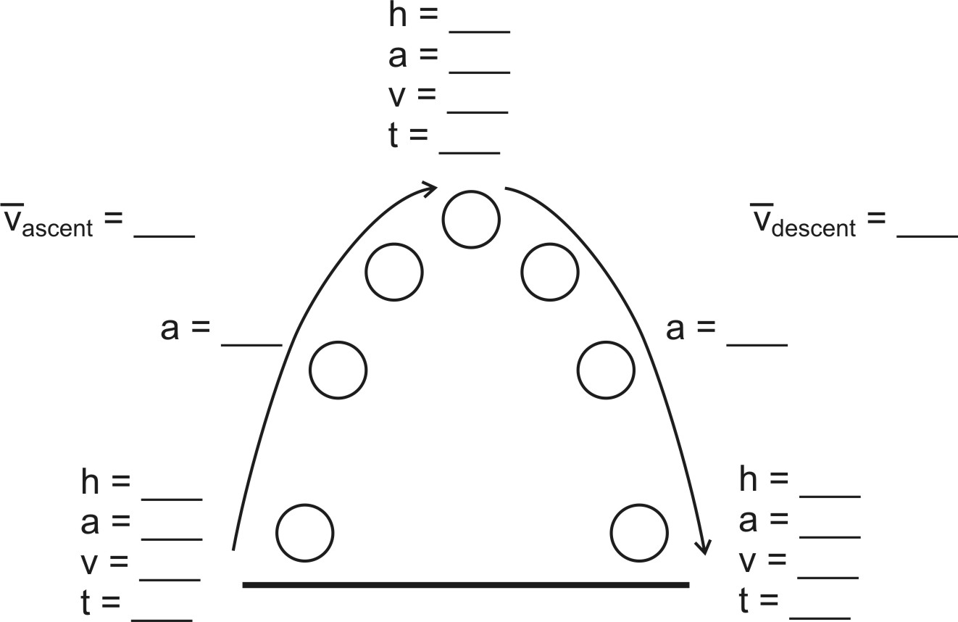

Fill in the diagram below for a freefalling object that is launched directly upward from ground level and returns to ground level after 10 seconds.

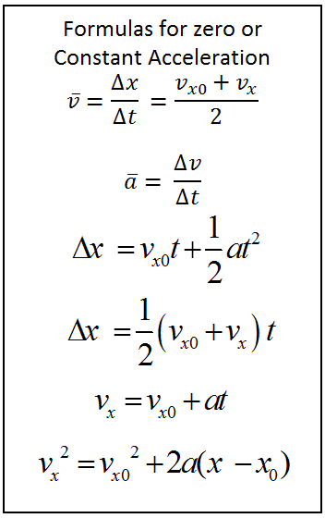
Symbols Review: 10 letter symbols are used in the formulas on the right. Explain the meaning of each symbol.

