Physics 200 Name: _________________________
Notes and Practice – Currents and Projectiles

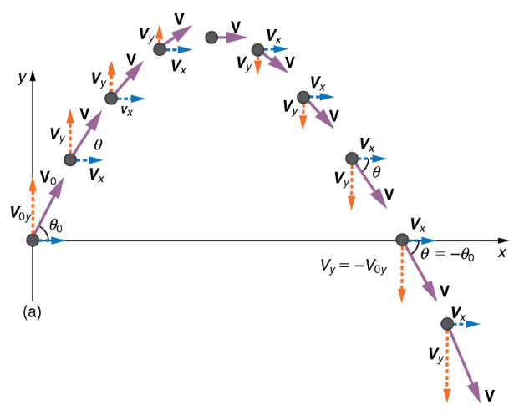
Projectiles:

1. The velocity of a launched projectile can be resolved into vertical (y) and horizontal (x) components. What happens to each of these components during the flight of the projectile? Why? Assume that there is no air resistance.

2. A projectile is launched horizontally and to the left from the top of a tall building in the absence of air resistance. Sketch the path of the projectile as it falls to the ground. Use arrows to represent the object’s speed, Vx, and Vy at the topmost point and at some other points during the fall.

3. Suppose a boat travels across a river, maintaining a heading that is due north. The boat’s speed, relative to the water, is a steady 4m/s. The river’s current has a westward velocity of 2m/s. What happens to the x and y components of the boat’s velocity as it crosses the river? Sketch a diagram showing the boat’s path. For at least three points, sketch vectors representing the boat’s speed and velocity components (Vx and Vy).

4. What’s the main difference between “river problems” and projectile problems?
A projectile is launched from ground level with an initial speed of V at an angle of θ above horizontal to the right. The projectile flies in the absence of air resistance until it returns to ground level. Remember Mr. Pennington’s Huge Idea.

5. Create a sketch showing the initial conditions in this problem. Show the initial velocity vector. Also resolve the initial velocity vector into X and Y components and sketch those components.

6. Use trig identities to express the values of Vox and Voy.

Vox =

Voy =

7. Which component vector determines the time that the projectile remains in flight? Derive an equation for time aloft.

8. Derive an equation for the maximum height reached by the projectile.

Some Equations Provided On the Quiz

Resolving into x & y components:

Range formula:

Horizontal motion:

Vertical Motion:

Memorize: 1mph = 2.24m/s

9. Derive an equation for the x displacement of a projectile with the same starting and ending height. This is known as the range formula.

Projectile Practice Problems: Assume for all problems that there is no air resistance.

1. A car traveling at 60mph drives horizontally off of a cliff and falls to the ground 100m below.

a. Convert 60mph to m/s.

b. How long does it take the car to reach the ground?

c. How far, horizontally, does the car fly through the air?

2. You throw a ball at a 70° angle with an initial speed of 30mph. The ball flies in an arc and lands on a shelf at the same height from which you released it.

a. Convert 30mph to m/s.

b. Find the ball’s v_{0x} and v_{0y} .

c. How long will the ball remain aloft before hitting the shelf?

d. What is the distance between the point of release and the point of impact on the shelf?

e. What maximum height was reached by the ball?

3. You are trying to throw a ball through an open window that is 20m above the point at which you will release the ball and 5m in front of that release point. To minimize possible damage, you want the ball to enter the window at its apogee (max height). At what angle and with what initial speed should you release the ball?

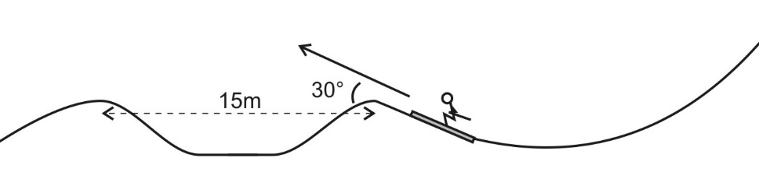
4. A skier builds a jump and a landing area as shown on the diagram to the right. The takeoff point and the landing point are 15m apart and at equal elevations. The jump is inclined to horizontal at a 30 degree angle.

a. What speed does the skier need to attain in order to travel exactly 15 meters?

b. Given the initial speed from part a, what is the skier’s maximum height, relative to the takeoff point?

c. Given the same initial speed, what is the skier’s time aloft?

