Physics 100 Name: ____________________________
Quiz Review: Physics, Music, and Instruments

1. How many notes does a musician play in a one-octave scale?
2. Define frequency, as it relates to a vibrating string.

3. Define pitch, as it relates to a vibrating string.

4. If you play two notes that are separated by one octave, how do the frequencies of those notes compare?

5. By what factor is frequency multiplied when you go up three octaves on an instrument?

6. Most modern music divides an octave into pieces called half steps. How many half steps are there in one octave? [This question is not asking about the pattern of whole and half steps for major and minor scales]

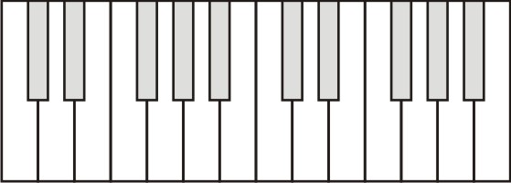
7. What major key scale can be played on a keyboard without using any black keys?
8. What is the pattern of whole and half steps that must be followed when one plays a major key scale?

9. What minor key scale can be played on a keyboard without using any black keys?
10. What is the pattern of whole and half steps that must be followed when one plays a minor key scale?

11. On the top keyboard to the right, label the names of all of the keys that you would play in a one-octave A major scale. You can call the black keys either sharps or flats.
12. On the keyboard to the right, label the names of all of the keys that you would play in a one-octave D minor scale.

13. Label the nut and bridge on the instrument to the right.
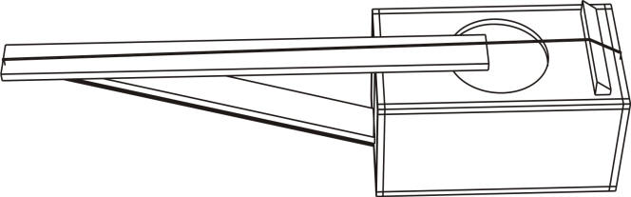
14. On the string instrument fingerboard below, darken the strings that you would play in a 1 octave major scale.

15. On the string instrument fingerboard below, darken the strings that you would play in a 1 octave minor scale.

16. How many half steps above C flat is the next G sharp?

17. Suppose an instrument string is 0.45m long, and when the open string is plucked, the frequency we hear is 350hz.

- Draw and label a diagram showing the fundamental vibration of this string. Label any nodes and antinodes.

- What is the full wavelength of the waves that are traveling down your string?

- What is the speed of those waves?

- The 5th fret mark on your finger board needs to correspond to a note that is five half-steps higher than the open string. What is the frequency of a note that is five half steps higher than the 350hz open string?

- In order to play that note, what wavelength must your string have? [hint: you know the string’s wave speed]

- How long must the vibrating portion of the string be in order to produce that wavelength?

- How far from the nut should the first fret be located? In other words, by what distance must you shorten your string in order to raise your instrument’s pitch by one half step?

