Physics 100 Name: _________________________
Test: Light, version 3

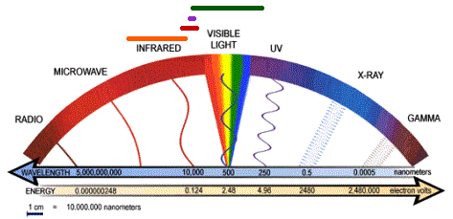

Short Answer

1. What is light?

2. Describe two particle-like characteristics of light.

3. List the colors of light from longest to shortest wavelength.

4. Give the name of a type of electromagnetic radiation with a wavelength that is too long for humans to see.

5. Describe two wave-like behaviors or properties of light.

6. Draw a diagram to show how a prism separates a beam of white light into individual colors. Label the colors as they exit the prism.

7. a. Which wavelengths of electromagnetic radiation are generally most dangerous?

b. Why?

8. What color are the hottest stars? ______________ What color are the coolest stars? ______________

9. The speed of light is constant. Why, then, does light travel more slowly when it enters a material such as glass?

10. If a material has a high index of refraction, what does that tell you about the speed of light in that material?

11. Light passes from a material with a low refractive index to a material with a high refractive index. The angle of incidence is 28 degrees. What do you know about the angle of refraction?

12. You’re wading in shallow water, trying to spear a fish. You see a fish under the water a few feet ahead of you. Where should you aim your spear?

Ray Diagrams

13-16. Continue the rays of light to show how they refract or reflect in the situations below. In the two diagrams on the left, the objects shown are glass lenses. In those diagrams, show how light refracts. The two objects on the right are mirrors. Show how light reflects off of those mirrors.

.

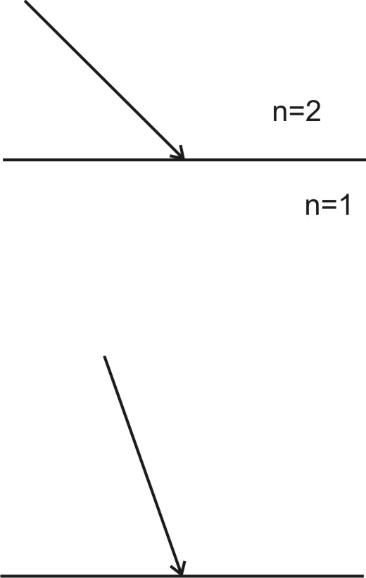
17. The diagram on the right shows a ray of light hitting the boundary between two materials with different indices of refraction.
- Draw the refracted ray.
- Draw and label a normal line segment.
- Label the angle of incidence.
- Label the angle of refraction.

18. The diagram on the right shows a ray of light hitting a mirror.
- Draw the reflected ray.
- Draw and label a normal line segment.
- Label the angle of incidence.
- Label the angle of reflection.

19-22. For each of the following diagrams, complete the diagram so that it shows…
- Standard pencil: The actual path of rays passing from both ends of an object to the eye of an observer
- Standard pencil: The actual observed object
- Colored Pencil: The perceived image (as perceived by the observer), correctly oriented and located
- Colored Pencil: The perceived path of rays on their way from the perceived image to the eyes of the observer. [This only applies to paths that do not coincide with the actual path of light rays.]

19. An object is viewed through the lens shown below. The object observed appears to be upside-down.

20. An object is viewed through the lens shown below.

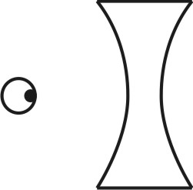

21. An observer views herself in a convex mirror. Her image is upright and reduced in size.
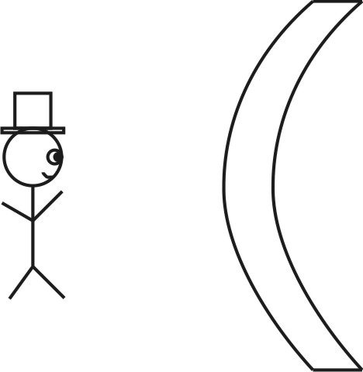

22. An observer views himself in a flat (ordinary) mirror.

