Physics 100 Name: _____________________________________
Test: Waves
More Formulas

d = v × t v = d ÷ t t = d ÷ v

v = f × λ f = v ÷ λ λ = v ÷ f

Speed of sound in air = 340 m/s

v
f
λ

Key Equations:

f = waves/seconds
T = seconds/waves
T = f = v = λf

Multiple Choice: DARKEN the correct answer.

  - Answer Choices. Use each answer once: A. Longitudinal wave B. transverse wave
C. electromagnetic wave D. mechanical wave

1. A B C D An oscillation that can travel through a vacuum (empty space)
2. A B C D An oscillation in matter
3. A B C D Oscillations are perpendicular to the direction of travel
4. A B C D Oscillations are parallel to the direction of travel

5. Which of the following is not a property of all waves
- They transfer energy
- They include oscillations
- They travel at the speed of sound
- They travel from one point to another

Match the abbreviations and units below to the correct quantities.

A. Frequency B. Wave Speed C. Period D. Wavelength

6. λ A B C D
7. T A B C D
8. s A B C D
9. hz A B C D
10. m/s A B C D
11. m A B C D
12. v A B C D

10. Darken the approximate period and frequency of the wave on the right.

Period = 1s 2s 3s 4s 5s 6s 7s 8s 9s 10s

Frequency = 1hz 1/2hz 1/3hz 1/4hz 1/5hz 1/6hz 1/7hz 1/8hz 1/9hz 1/10hz

11-15. Answer the following questions using the graph below.

11. Which wave has the shortest wavelength? A B C D
12. What is that wavelength, in meters? 0.1 0.2 0.3 0.4 0.5 0.6
13. Which wave has the largest amplitude? A B C D
14. What is that amplitude, in meters? 0.1 0.2 0.3 0.4 0.5 0.6
15. Which two waves, when added together, will give complete destructive interference? A&B A&C A&D B&C B&D C&D

16. When the two waves on the right interact, they will create beats. How many beats occur during the time span shown on the graph?

0 1 2 3 4 5 6 7 8 9

17. Which of the sets of waves below represents the quietest sound? A B C
18. Which of the sets of waves below has the highest amplitude? A B C
19. What is the period of the waves shown in answer choice B? 2 4 6 8 10 12 14 16 18 20

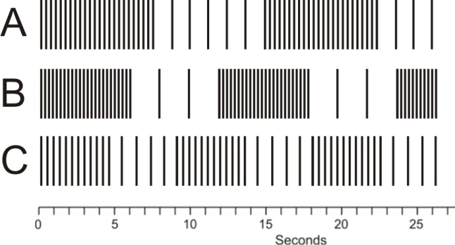

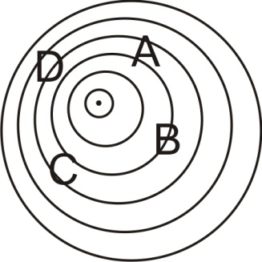
The diagram to the right shows an object moving and giving off sound waves:
20. Darken the arrow that shows the direction of travel of the object on the right.

21. At which location will an observer hear the highest frequency?
A B C D

22. At which location will an observer hear the lowest frequency?
A B C D

23. Bats use echolocation to find their prey. Bats can tell that a moth is flying away from them if they emit a screech and…
a. the frequency of the echo is higher than the original screech
b. the frequency of the echo is lower than the original screech

24. The average value of the air pressure around us is closest to
a. 1psi b. 5psi c. 10psi d. 15psi e. 20psi f. 30psi

25. A singer is singing a very clear note (A – 220hz). The singer’s sound wave consists of a series of rarefactions and compressions. When one of those rarefactions reaches your ear, what happens to the air pressure felt by your ear?
a. it increases b. it decreases c. no change

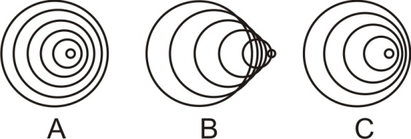
26. The pictures on the right show sound waves produced by moving objects. In which case is the object is moving the slowest?

- B. C.

27. What causes ordinary air pressure?

28. Given v = 40, use the graph on the right to find T, f, A, and λ.

T = _______

f = _______

A = _______

λ = _______

29. Sketch a standing wave in the space provided below that has 2 antinodes and 3 nodes. The dark line represents the wave’s equilibrium position.

30. How many wavelengths long is the diagram that you just drew, above? ___________

31. Suppose you hold your head close to a guitar and you hum. When you hum with a frequency of 220hz, one of the guitar strings suddenly begins to hum back at the same pitch. Why does that string begin to hum?

32. You saw lightning flash 14 seconds before you heard the thunder. How far away was the lightning strike?

33. A bat finds a moth by sending a sound pulse through the air and listening for the echo. If the moth is 15m away, how long after it makes the sound does the bat hear the sound’s echo?

34. You’re standing in the water at the beach, waiting for a good wave to body surf. You notice that 3 waves pass you every 18 seconds. Your friend is standing farther out in the deeper water, 16m away from you. You also notice that it takes waves 4 seconds to travel from where your friend is standing to where you are standing. Find:

- The frequency of the waves.

- The speed of the waves.

c. The wavelength of the waves

35. Fill in the table below with approximate values:

 | Approximate increase in air pressure due to sound waves (psi) | Sound Volume, in decibels
.30-06 rifle fired 1 meter away
Normal Conversation

