Physics 100 Name: _________________________________
Test: Newton’s Laws

Formulas: a = Δv / Δt F_{net} = m a m = F_{net}/a a = F_{net}/m Weight = m g g = 10 m/s²

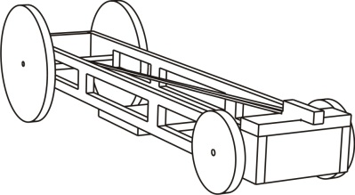
Part I: Car Stuff

The picture on the right shows a rubber band car. The graph shows how the car’s velocity changed after it was wound up and released.
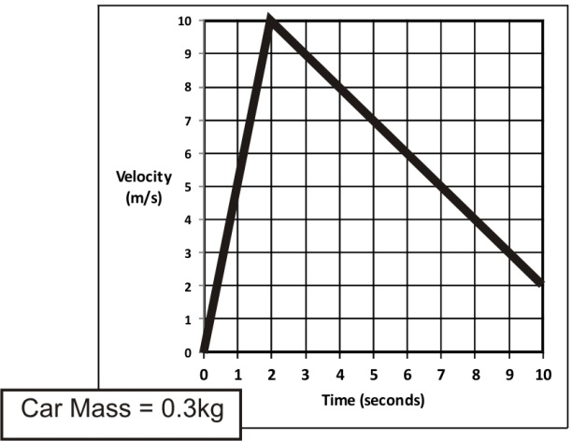
1. What was the car’s acceleration during the acceleration phase?

2. What was the car’s acceleration during the deceleration phase?

3. Complete the diagrams below by entering the correct component forces and net forces for the acceleration and deceleration phases. ***You can assume that the motor force is zero during the deceleration phase. ***You can also assume that the force of friction is the same during both phases.

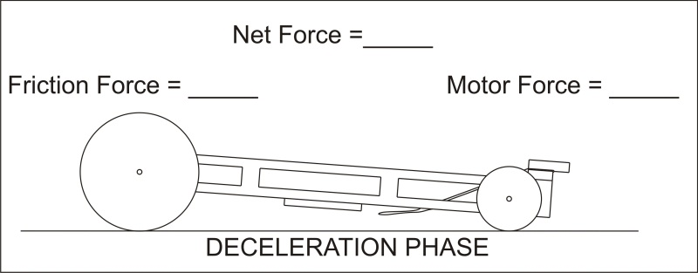
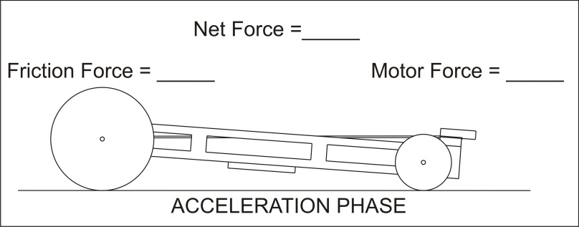

4. A different car was accelerated by a net force of 3N. The car’s acceleration was 6m/s². The car was then drilled full of holes, cutting its mass in half. What was the car’s new acceleration after its mass was reduced? You can assume that the net force remained the same.
Newton’s 3rd Laws states that, for every action, there is an equal and opposite reaction.

5. What are the action and reaction forces that are involved when a bicycle accelerates southward on a road?

6. What are the action and reaction forces that are involved when an apple falls to the ground?

7. Newton’s 1st Law states that objects _______________________________________________________

_____________________________________________________________________________________

unless ________________________________________________________________________________

8. The diagram below shows the path followed by a car. The car started at point A and traveled all the way to point F. The car only stopped once, at point C, were it parked for one hour. Circle the segments or letters at which the forces acting on the car were balanced (in other words, when there was no net force).

Answer choices: Between B and C At Point C Between C and D
Between D and E Between E and F

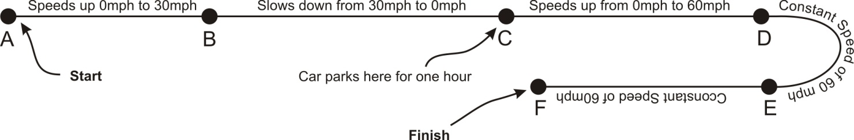

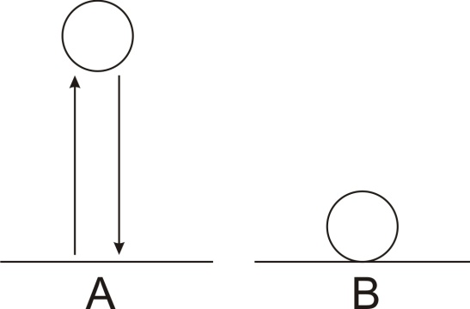
9. A tennis ball is thrown directly upward in the absence of air. It goes up; it comes down. Picture A shows the tennis ball at its highest point.

- What is the ball’s velocity at its highest point?

- What is its acceleration at its highest point?

- What net force is acting on the ball at its highest point?

10. Picture B shows the same tennis ball sitting motionless on the ground. What net force is acting on the ball when it is on the ground?

11. You’re standing in the middle of a perfectly frictionless frozen lake. The ice is unbreakable. You have a bowling ball.
- Use Newton’s 3rd Law to explain why you can’t simply walk to the shore.

- Explain how you could use the bowling ball to return to the shore.

12) Compared to its weight on earth, a 10-kg object on the moon will weigh __________.
A) the same amount. B) less. C) more.

13) Compared to its mass on earth, the mass of a 10-kg object on the moon is __________.
A) more. B) less. C) the same.

14) Suppose a 4N force is applied to an object. How does the acceleration the object relate to a change in the object’s mass?
A) Acceleration doesn't depend on mass at all.
B) Acceleration is directly proportional to mass.
C) Acceleration is inversely proportional to mass.

15) How does the acceleration of an object change in relation to the net force applied to the object?
A) Acceleration doesn't depend on net force at all.
B) Acceleration is directly proportional to net force.
C) Acceleration is inversely proportional to net force.

16) When an object reaches terminal velocity its acceleration is __________.
A) 0 m/s²
B) 4.9 m/s²
C) 9.8 m/s²

Matching: (Each answer is used exactly once.)
Answers: a. Force b. friction c. scalar d. vector e. terminal velocity
f. inertia g. acceleration h. weight

17. _____A push or a pull
18. _____Resistance to change in motion
19. _____A measure of how fast velocity is changing
20. _____When weight equals air resistance
21. _____Caused by microscopic bumps in the surfaces of objects
22. _____Having both a magnitude and a direction
23. _____The force of gravity
24. _____Having a magnitude but not a direction

25. The unit we use for force is ______.

26. The unit we use for mass is ______.
27. The unit we use for friction is ______.

28. The unit we use for weight is ______.

29-32. Fill in the dotted boxes below. Be sure to label with correct units!

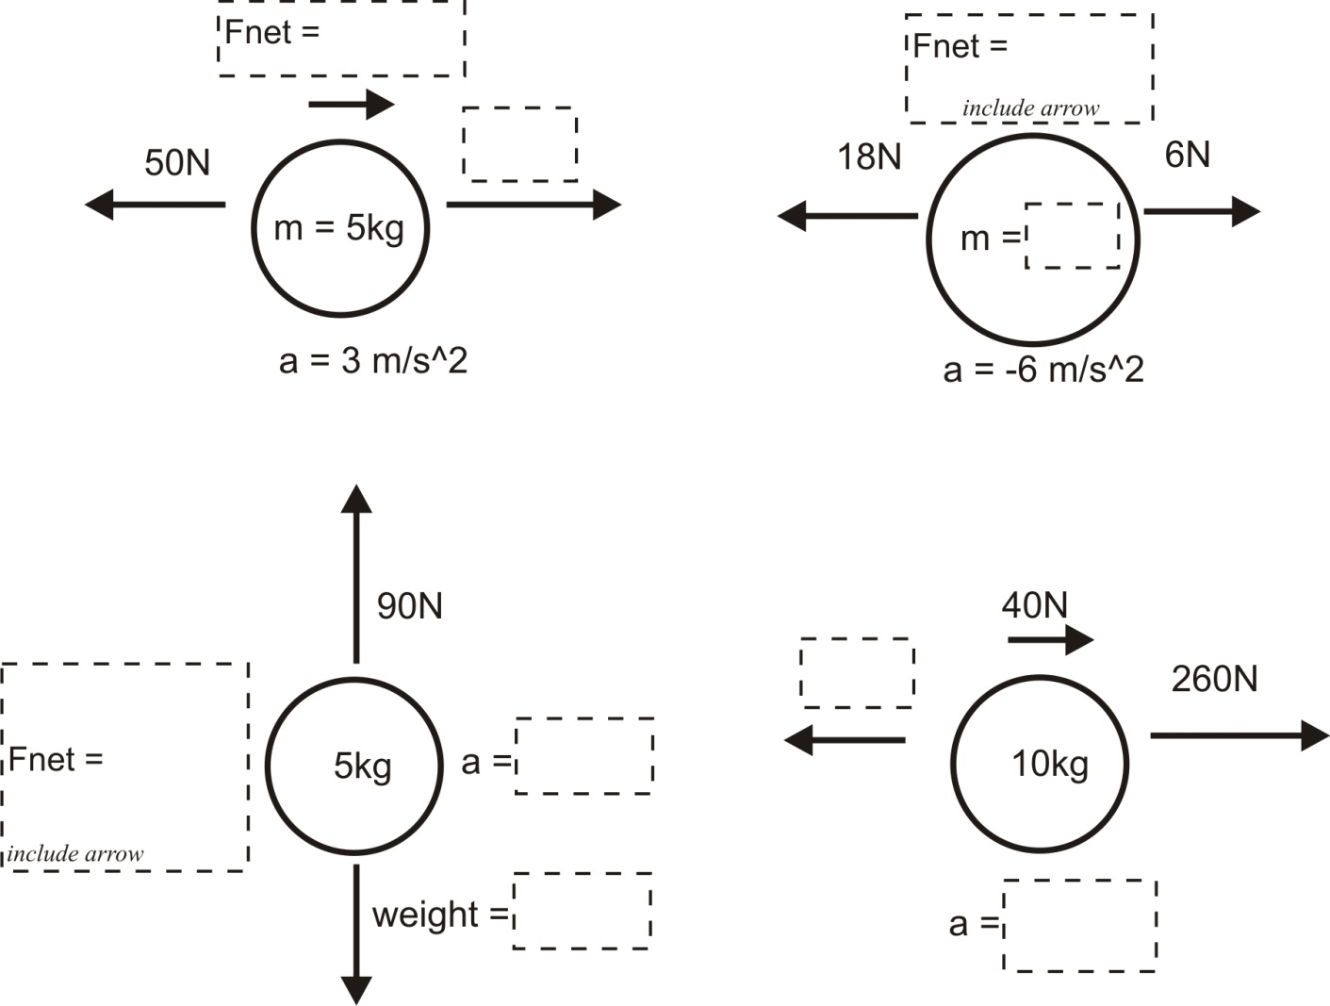

33. A ball is rolling down a hill at a constant velocity. Gravity is pushing the ball down the hill with a constant force of 3N.

a. What is the ball’s acceleration?

b. What is the net force acting on the ball?

- What is the total force of friction that is acting on the ball?

34. What is the mass of an object that has a weight of 20 N?

35. The first table, below, is a timeline detailing a parachuter’s descent from an airplane. The second table is an incomplete analysis of mass, forces, and acceleration relating to the parachuter’s fall. Use the timeline and your knowledge of physics to complete the second table. Pay close attention to the times in the second table. Most of them do not coincide with the times in the first table, but you can still use the first table to complete the analysis for those times. Before you go too far, it would be prudent to first identify the times in the second table at which the parachuter has reached terminal velocity.

Time | Event
0s | Parachuter steps out of plane
15s | Parachuter reaches a first terminal velocity of 50m/s
80s | Parachuter pulls chute cord. Chute deploys.
87s | Parachuter reaches a second terminal velocity of 5m/s
700s | Parachuter lands

Time | Parachuter Mass | Parachuter Weight | Air Resistance (plus direction) | F_{net}  (plus direction) | Acceleration  (direction) | Speed
0s | 70kg
5s |  |  | 500N Upward |  |  | 35m/s
50s
85s |  |  | 2800N Upward |  |  | 40m/s
500s

