Physics 100 Name: _____________________________________
Practice Test: Waves

Key Equations:
v
f
λ

f = waves/seconds T = seconds/waves
T = f = v = λf

1. Define “wave.”

2. Name one example of a mechanical wave.

3. Name one example of an electromagnetic wave.

4. Describe two ways in which mechanical waves different from electromagnetic waves?

5. What is the primary difference between a longitudinal wave and a transverse wave?

6. Identify each of the following as either a transverse or a longitudinal wave.
- A surfer is surfing on this wave.
- A sound wave.
- A cowboy sends a wave down the length of a whip.

7. Fill in the table below with the correct abbreviations and units

Quantity | Abbreviation/Symbol | SI Units
Wave Speed
Frequency
Wavelength

 | Period | Frequency
Wave A
Wave B
Wave C

8. Use the graph below to fill in the table on the right.

9-17. Answer the following questions using the graph below.

9. Which wave has the longest wavelength? ________
10. What is that wavelength? ___________
11. Which wave has the shortest wavelength? ________
12. What is that wavelength? ___________
13. Which wave has the largest amplitude? ________
14. What is that amplitude? ___________
15. Which wave has the smallest amplitude? ________
16. What is that amplitude? ___________
17. Which two waves, when added together, will give complete constructive interference?

18. When the two waves on the right interact, they will create beats.

- How many beats occur during the six seconds shown on the graph?

- Show the locations of the beats.

19. Given v = 60 m/s, use the graph on the right to find T, f, A, and λ.

T = _______

f = _______

A = _______

λ = _______

20. Suppose you are listening to some sound waves, and volume suddenly increases. This volume change is caused by a change in the waves’:
- Frequency b. period c. amplitude d. wavelength

21. By looking at sets of longitudinal waves, how can you tell which waves have the greatest amplitude?

22. What is the wavelength of the longitudinal wave, below?

23. Label a rarefaction and a compression on that wave.
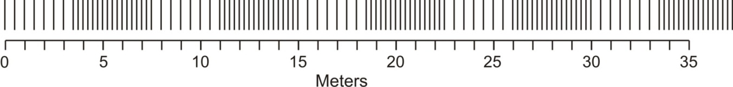

24. Find the period and frequency of the longitudinal wave, below.

Period = _________ Frequency = __________

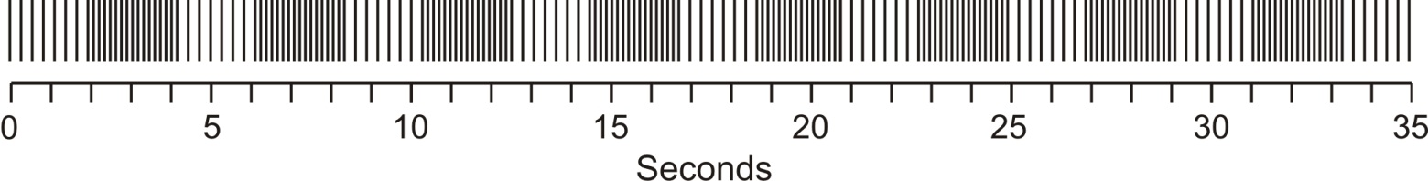

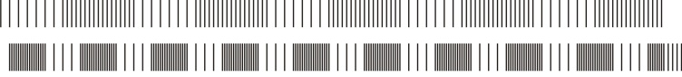
25. If you were listening to the two sound waves on the right, which one would have a higher pitch?

26. Sketch a standing wave in the space provided below that has 4 antinodes and 4 nodes. The dark line represents the wave’s equilibrium position How many wavelengths are present? (3 pts)

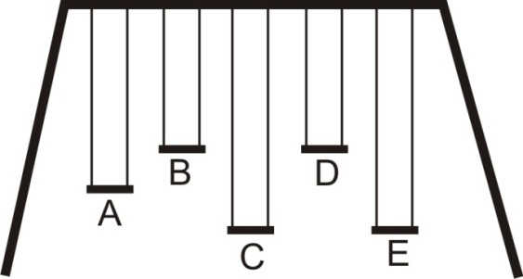
27. A school playground has an odd set of swings. None of the children can swing by themselves, and there is only one adult to push.
- If there are kids sitting on all of the swings, but only the kid on swing D is being pushed, which other child starts to swing?

- Explain why.

28. Explain how to break a wine glass using sound.

29. Explain why your method (from the previous question) works.

Good Stuff

d = v × t v = d ÷ t t = d ÷ v

v = f × λ f = v ÷ λ λ = v ÷ f

Speed of sound in air = 340 m/s

Speed of sound in water = 1500 m/s

30. You saw lightning flash 21 seconds before you heard the thunder. Exactly how far away was the lightning strike?

31. A dolphin finds food by sending a sound pulse through the water and listening for the echo. If the food is 200m away, how long does it take the dolphin to hear the echo?

32. A bored child is sitting on the dock, looking out at lake Champlain. She notices that 6 waves hit the dock in 12 seconds, and it takes each wave 3 seconds to travel the length of the 12 meter long dock. Find

- The frequency of the waves.

- The speed of the waves.

c. The wavelength of the waves

33. The diagram to the right shows an object moving and giving off sound waves:
- Use an arrow to show the object’s direction of movement.
- Write a “B” in an area where an observer would hear the highest frequency sound.
- Write a “C” in an area where an observer would hear the lowest frequency sound.

34. Bats use echolocation to find their prey. How does a bat know if a moth is flying toward the bat or away from the bat?

35. Two moths are flying toward a bat, but one is flying faster. How will the bat know which moth is flying faster?

36. How does a bat know how far away their prey is located?

37. On average the amount of pressure in the atmosphere around us is _________ psi.

38. What causes ordinary air pressure?

39. As sound travels from its source to our ears, the sound wave compressions represent __________

(increases/decreases) in air pressure, and the rarefactions represent __________ (increases/decreases) in air pressure.

40. Fill in the table below with approximate values:

 | Approximate increase in air pressure due to sound waves (psi) | Sound Volume, in decibels
.30-06 rifle fired 1 meter away
Normal Conversation

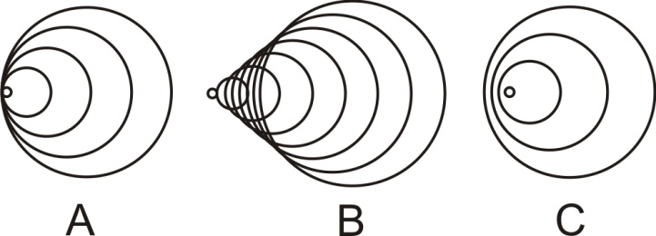
41. The objects on the right are moving and producing sounds. Rank them according to their speed.

