Physics 100 Name: ____________________________
Electricity Notes, Part IV: Odds, Ends, and Lenz’ Law

A.C. / D.C.

A.C. ( ________________________________):

D.C. ( ________________________________):

One reason that A.C. is used to deliver power over long distances is that __________________________________

________________________________________________________________ and _______________________

_____________________________________________________________________________________________

Power, Voltage, and Current

Power: Energy used per second. Units: ____________________

Formula:

Practice Problems

1. If a light bulb uses 1 amp of current at a household voltage of 120V, how much power does it use?

2. How much current will a 60W bulb draw at 120V of electric potential?

3. A table saw draws 15A of current at 120V. How much power does it use?

4. If the same table saw is rewired to use 240V, how much current will it draw?

5. Which of the table saws from the previous questions will “run cooler?”
Creating Electric Current:

Faraday’s Law: A change in the magnetic environment of a conducting coil induces voltage and current

Lenz’ Law: When a changing magnetic field induces current in a conducting coil, the induced current produces a second magnetic field opposing the change in the first magnetic field.

Generators are Motors in Reverse:
An electric current moving through a coil of wire can create a magnetic field. This magnetic field can be made to interact with a permanent magnet to create a ___________________. A magnetic field moving relative to a coil of wire can create ___________________________. This concept can be used to create a __________________.

6. Draw the magnetic field lines associated with the bar magnet on the right.

7. Show where the magnetic field is strongest, and explain how you can tell.

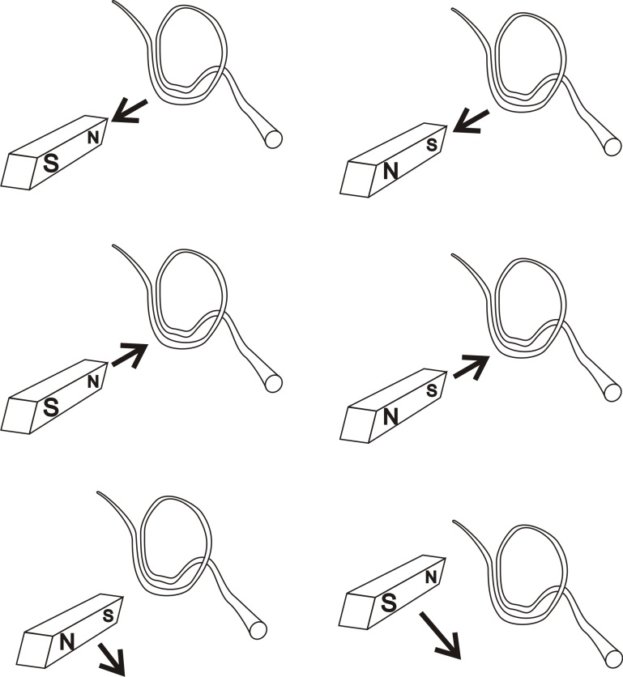
The diagrams on the right show a magnet moving relative to a conducting coil of wire. It is important to understand the strength of the magnetic field that is passing through the coil. How can you determine the strength of the magnetic field passing through the coil?

8. For each diagram…
- Use arrows to draw the magnetic field lines created by the bar magnet.
- Tell whether or not the magnetic field passing through the coil is strengthening or weakening
- Use one arrow and a “B” to show the new magnetic field that is created by the coil.
- Show the direction of the current that is induced in the coil.

Electricity and Magnetism Quiz Practice:

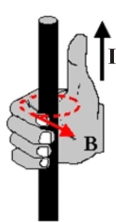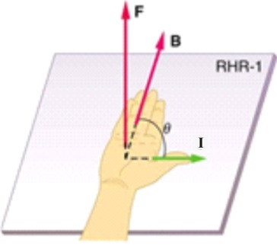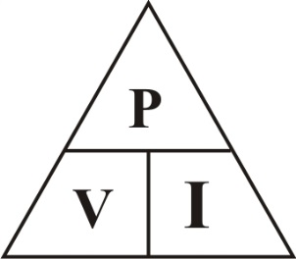
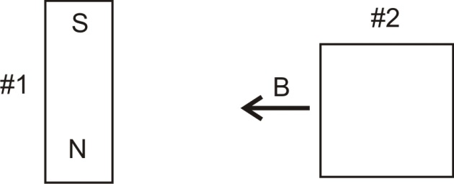
- Draw the magnetic field lines associated with bar magnet #1, on the right.
- The vector B indicates the magnetic field of bar magnet #2. Label the magnet’s poles.
- The North Pole of the earth is really a magnetic south pole. Explain how you can prove this.

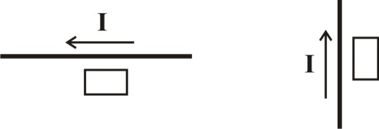
- The diagrams on the right show the direction of current traveling through a wire. In each diagram, there is a rectangle. At the location of the rectangle, tell whether the magnetic field created by the current is going into the paper or out of the paper.
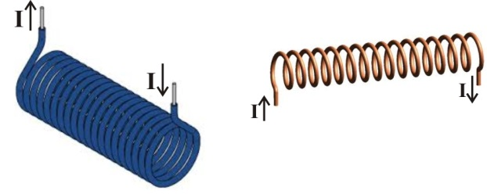
- Show the directions of the magnetic field created by the solenoids on the right.

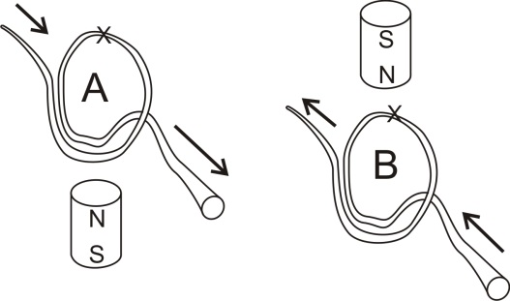
- In the diagrams on the right, current is flowing through a simple motor coil. Directly above or beneath the motor coil, there is a permanent magnet with labeled polarity. The top segment of the coil is labeled with an X. For each diagram, tell whether that coil segment (the X segment) will rotate to our left or to our right.

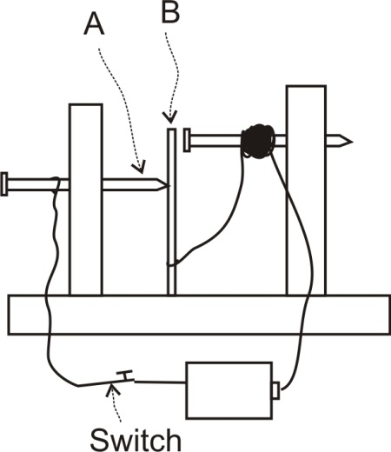
- The diagram on the lower right shows a simple solenoid buzzer like the one you made in class.
  - When the switch is closed, part B pulls away from part A. Explain why.

  - Soon after part B pulls away from part A, part B returns to its original position, touching part A once more. Explain why part B moves back to its original position.

- Explain what A.C. and D.C. mean. Briefly describe each one.

- If you have an electric mixer that draws 5A, at 120V, you know the mixer’s _________ and __________, and you can determine it’s __________________________, which turns out to be ______________________.

- If you have a 1500W hair dryer that operates at 120V, you know the mixer’s _________ and __________, and you can determine it’s __________________________, which turns out to be ______________________.

- You have an electric sweater shaver that needs 27W to operate. If the sweater shaver draws 3A of current, how much voltage will its battery need?

- In the early days of electric power, there was a debate over whether electric power should be distributed as A.C. or D.C. Describe one major advantage of A.C. power.

- Explain, in simple terms, how generators create electric current.

