Physics 200 (Stapleton) Name: _____________________________
Ballistic Pendulums

Formulas: $KE=\frac{1}{2}mv^{2}$ $p=mv$ $PE=mgh$

Consider the system below, which includes a ballistic pendulum (box) and a projectile (circle). Assuming that the string supports of the pendulum have negligible friction, and assuming that air resistance is also negligible…
…when is momentum conserved? Why?

…when is KE conserved? Why?

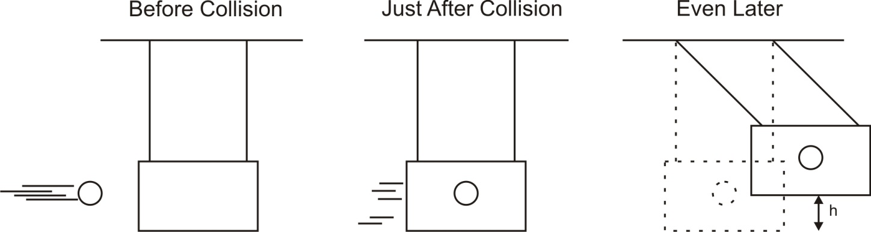

Calculate these projectiles’ initial velocities:

 | Launch 1 | Launch 2 | Your Launch
Projectile Mass (kg) | 4 | 0.5
Pendulum Mass (kg) | 0.5 | 0.02
Swing Height, “h” (m) | 6 | 0.4
Projectile Initial Velocity (m/s)

Using “Launch 1” Data:
1. What is the total potential energy of the ball and pendulum in the “even later” picture?

2. What was the total kinetic energy of the ball and pendulum in the “just after” picture?

3. What was the shared velocity of the ball and pendulum in the “just after” picture?

4. What was the net momentum of the ball and pendulum in the “just after” picture?

5. What was the momentum of the ball before the collision?

6. What was the velocity of the ball before the collision?

