Physics 100 Name: ________________________
Notes: Optics

The Electromagnetic Spectrum

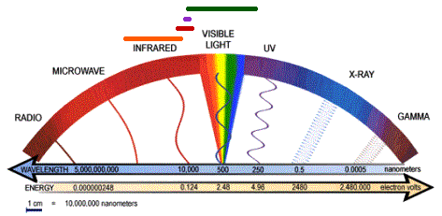

Mnemonic device for remembering light waves from longest to shortest wavelength:

Wave Behaviors:

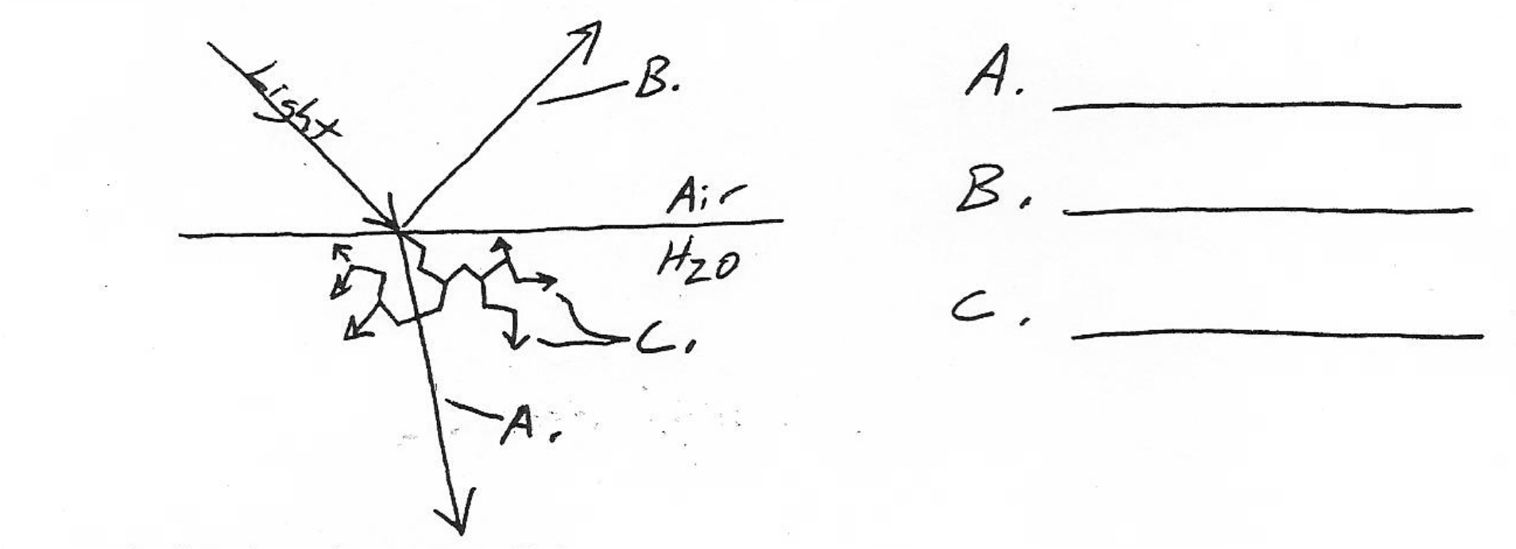
Refraction (Bending) of Waves

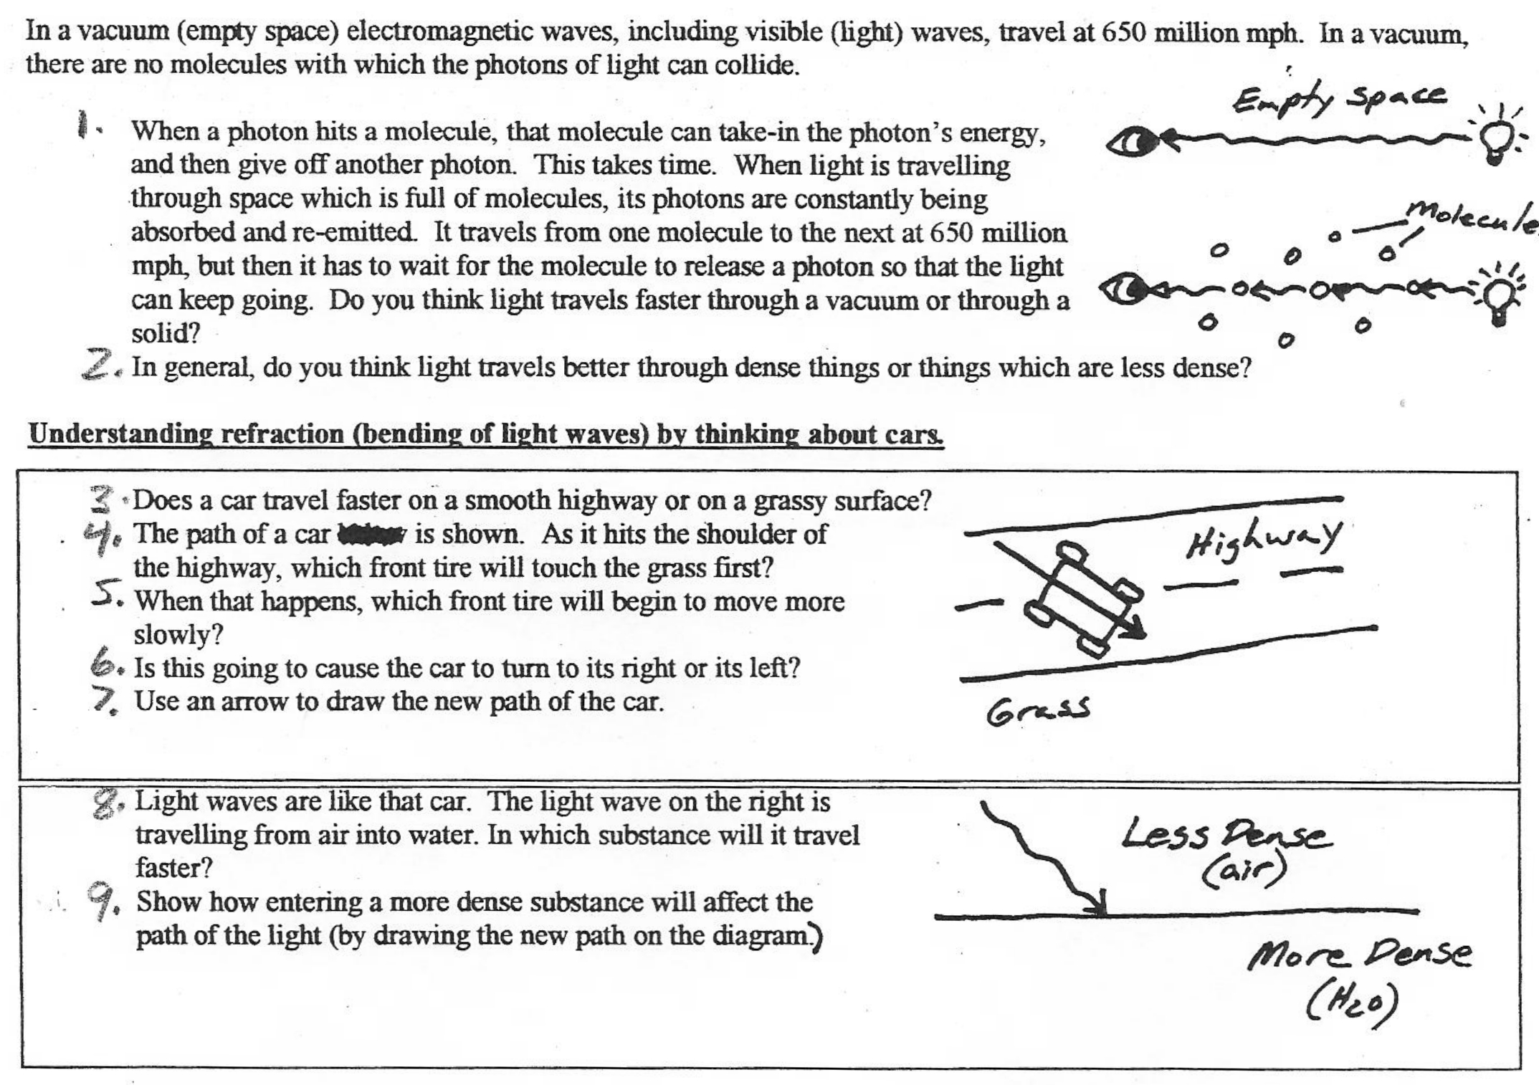

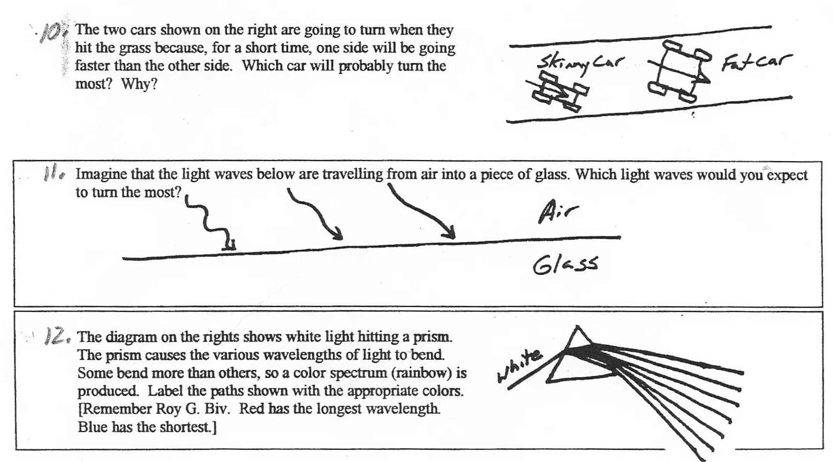

13. The eyeball is looking at the fish. It would like to shoot the fish right on the "x." The problem is that the eyeball "sees" the x in a place that really is not the true location of the fish. Draw the x where the eyeball sees it, and show the path of light traveling from the x to the eyeball.
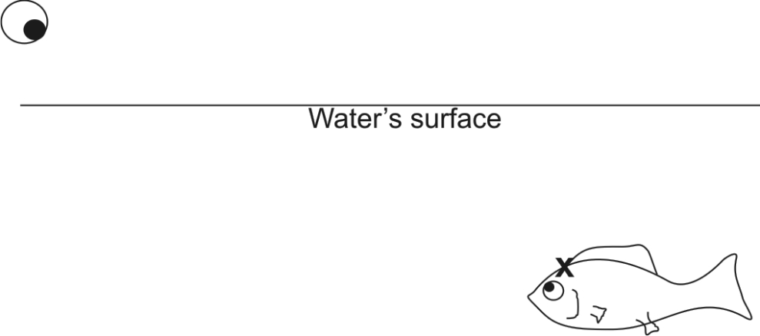
If you want to shoot a fish, where should you aim?

14. Show how rays of sunlight refract when they pass through the converging lens below.

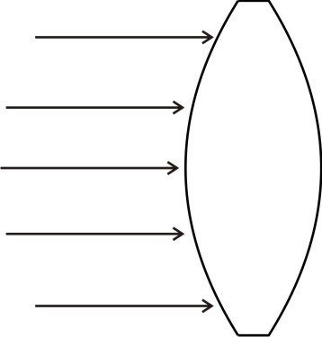
Reflection of waves:
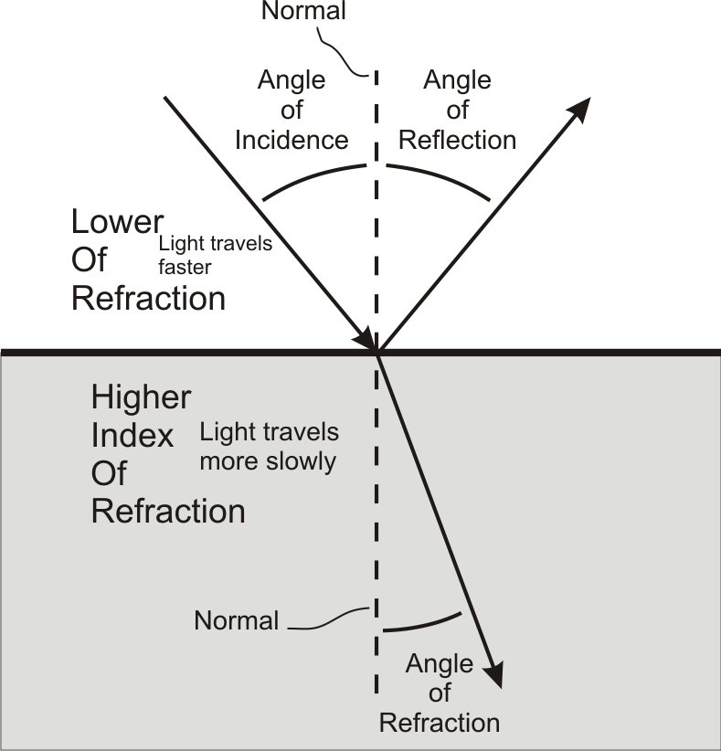
Angle of incidence = angle of reflection

Practice:
- Show how the rays are reflected when they hit the mirrors below.
- Draw the “normal.”
- Label the angle of incidence and the angle of reflection.

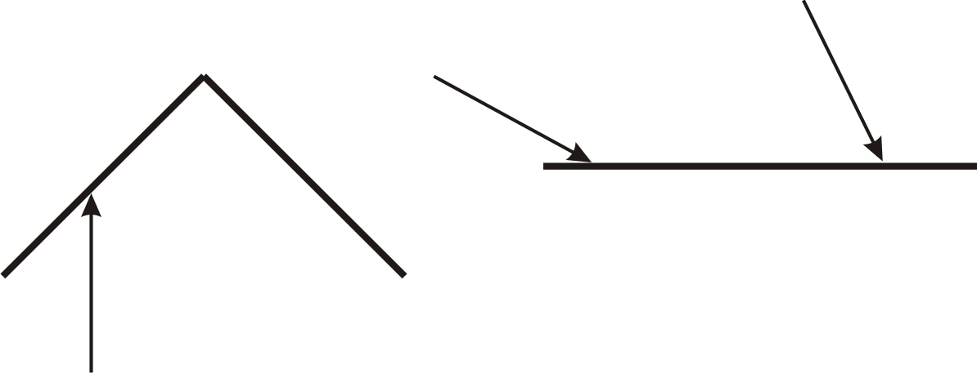

- Show how light reflects off of the parabolic mirror, below.



