Physics 100 Name: _______________________________
Rubber Band Car Topics
Torque, Work, Energy, Efficiency

Formulas: T=Fr F=ma W=Fd Efficiency = $\frac{Energy Output}{Energy Input}$

- Define torque?

- What is the formula for torque?

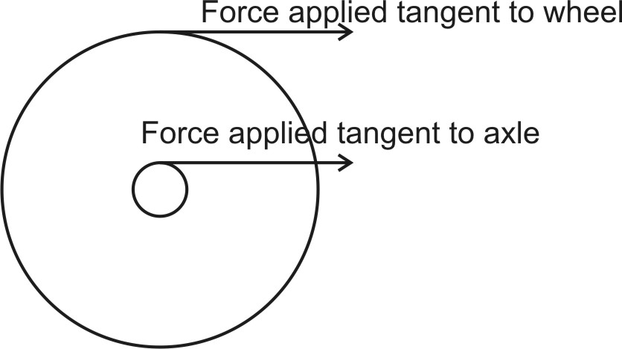
- You rotate a wheel by a force of 20N tangent to the edge of the wheel. If the wheel’s radius is 2m, what torque have you applied?

- If you apply the same force of 20N tangent to the wheel’s axle (axle radius = 0.1m), what torque have you applied?

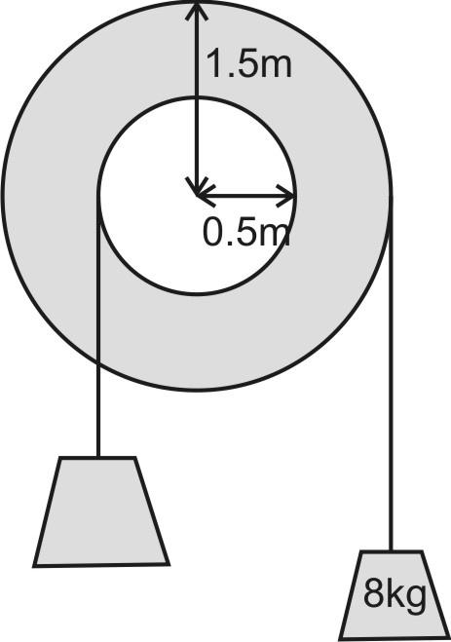
- The diagram on the right shows masses hanging from two pulleys. The pulleys are not turning (i.e., they are “balanced”).

  - What is the net torque acting on the system?

  - Calculate the weight of the object farthest to the right. Include correct units.

  - What torque is being exerted by the object on the right? (include direction)

  - What torque is being exerted by the object on the left? (include direction)

  - What is the weight of the object on the left?

  - What is the mass of the object on the left?

- In the diagram on the right…
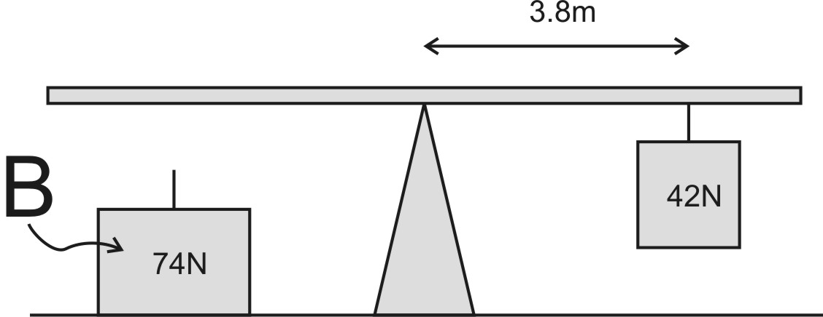
  - What is the triangle called in this sort of situation?

  - Where should object B be attached in order to balance the metal bar?

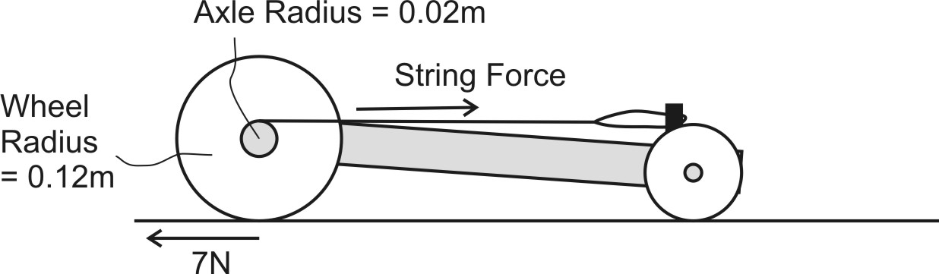
- The diagram on the right shows the force exerted by the car’s wheels against the road.

  - How much torque is generated by the car’s string and rubber bands?

  - How much force does the string apply to the car’s axle?

- Suppose the force of friction between your car’s drive wheels and the ground is 4N. If your rubber bands exert an initial force of 40N, and your axle radius is 0.003, what radius drive wheels should you have in order to prevent those wheels from spinning out?

- If you keep everything else the same, but you triple the diameters of your drive wheels…

  - What happens to your car’s wheel force?

  - What happens to your car’s acceleration?

  - What happens to your car’s top speed? Explain why.

- In reality, if the wheels aren’t slipping and all other variables except for wheels are kept equal, a car with smaller drive wheels will probably go faster than one with larger drive wheels. Why?

- How much work do you do if you push a box for 4 meters by applying a constant force of 30N?

- Suppose a 10kg rock is lifted a vertical distance of 10m.

  - What is the rock’s weight?

  - How much work is done?

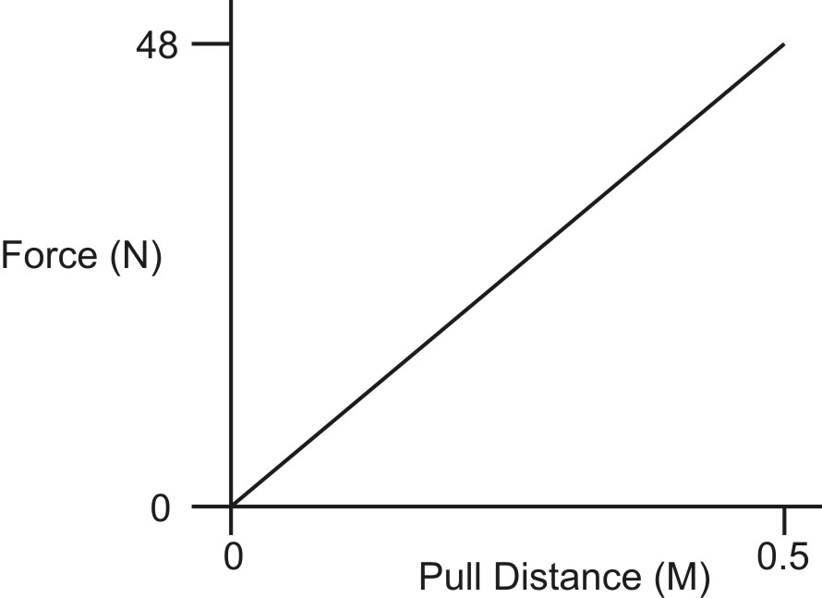
- The graph on the right shows the amount of force applied to a slingshot at different points during the process of stretching that slingshot.

  - What was the average force?

  - How much work was done on the rubber band?

  - How much energy did it take to do that work?

- Suppose the slingshot in the previous question propelled a rock. The rock’s mass was 0.03kg. When the rock left the slingshot, its motion was captured on slow motion video at a frame rate of 240fps. The rock traveled 0.5m in 7 video frames.

  - How much time did it take the rock to travel that distance?

  - What was the rock’s velocity?

  - What was the rock’s kinetic energy?

- Use information from the two previous questions to calculate the slingshot’s efficiency.

- Why isn’t the slingshot 100% efficient?

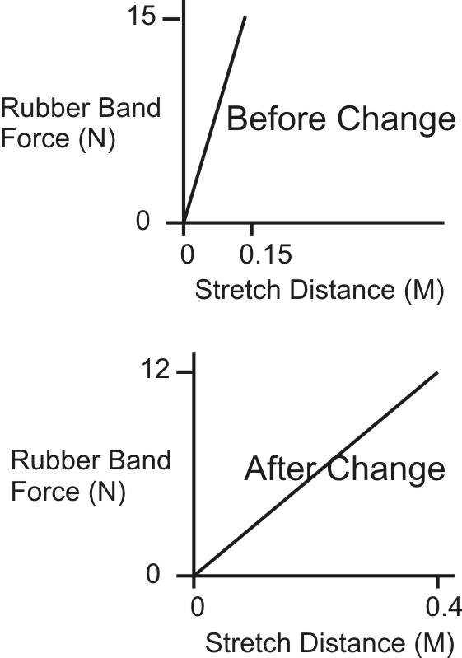
- Suppose you have a 150g (0.15kg) rubber band car. At first your rubber band anchor is fairly close to your drive axle, so your pull length is only 15cm (0.15m). Then you move your rubber band anchor farther forward, so your pull length is 40cm (0.4m). When you move your anchor forward, your rubber bands won’t stretch far enough, so you link them together. This makes them looser. The graphs show your rubber band force and pull distance for each situation.

  - Determine the average force for each graph.

Before (short pull length, higher force):

After (longer pull length, lower force):

  - Determine your car’s input energy for each situation.

Before (short pull length, higher force):

After (longer pull length, lower force):

  - Assuming that your car is 50% efficient, determine its maximum KE for each situation.

Before (short pull length, higher force):

After (longer pull length, lower force):

  - If you rearrange the KE formula (KE = 1/2mv²), you can solve for v. $v=\sqrt{\frac{2KE}{m}}$ . Use this formula to determine the car’s maximum KE for each situation.

Before (short pull length, higher force):

After (longer pull length, lower force):

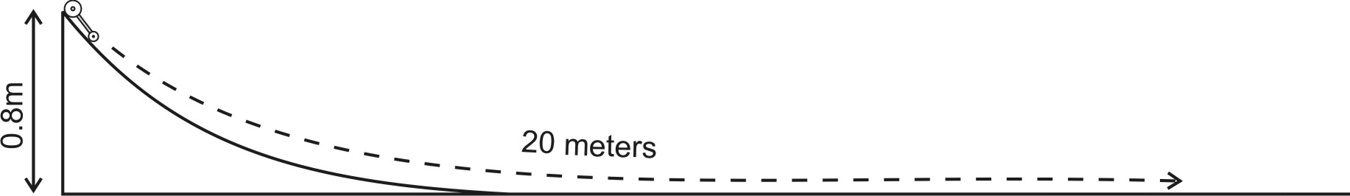
- A 130g car is placed at the top of a ramp that is 0.8m tall. The car is released and allowed to roll down the ramp and onto a level floor. The car eventually comes to a stop after rolling a total distance of 20m.

  - What is the car’s mass, in kg?

  - How much PE does the car have when it is at the top of the ramp?

  - How much KE does the car have when it is at the top of the ramp?

  - Label the diagram to show what happens to the car’s potential energy as it rolls down the ramp and across the floor.

  - Label the diagram to show what happens to the car’s kinetic energy as it rolls down the ramp and across the floor.

  - How much PE and KE does the car have when it comes to a stop?

  - The car stopped because friction did work against the car. What are the units of work?

  - How much work did friction do on the car?

  - What was the force of friction?

  - According to the law of conservation of energy, energy is neither created nor destroyed. After the car came to a stop, where was the energy? Where did it go?

