Physics 100 Name: _________________________
Rubber Band Cars
Torque -- mostly

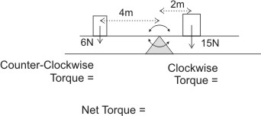
Torque = (force) x (radius)
T = fr
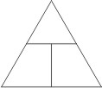

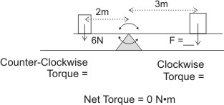

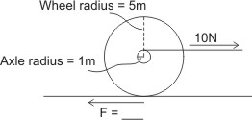

Problems:

A rubber band car is powered by a stretched rubber band that is attached to a string. The string is wrapped around the car’s axle. As the rubber band pulls the string, the string unwinds from the axle, causing the axle to turn.

1. Suppose the rubber band car has an axle thickness of 0.002m and a rubber band force of 10N. How much torque does the string apply to the axle and wheels?

2. The axles we are using in class have radii of 0.0016m. If you create a car that uses the maximum spring force of 50N, how much torque will the string apply to the axle and wheels?

3. Suppose your car’s “motor” gives the drive wheels and axle 0.02N•m of torque. If your wheel has a radius of 0.05m, how much force will your wheel exert at its edge?

4. The wheels designed by Mr. Stapleton have 0.032m radii. If they have 0.08 N•m torque, with how much force do those wheels push backward against the road?

Questions:

5. What is the relationship between axle thickness and the accelerating force that your car’s drive wheels apply to the road?

6. What is the relationship between axle thickness and the distance over which your car accelerates?

7. What is the relationship between wheel diameter and the accelerating force that your car’s drive wheels apply to the road?

8. What is the relationship between wheel diameter and the distance over which your car accelerates?

9. If your wheels are “spinning out,” would it be better to attach your rubber bands to your car’s axle: a) directly, b) using a thick string, or c) using a thin string? Explain.

10. Why can it be a problem if your car “pops a wheelie?”

