Physics 100 Name: ______________________________
Notes: Momentum

Definition of Momentum:

Symbol: Why?

Formula:

Three ways to arrange the momentum formula:

Units:

Practice Using the Momentum Formula:

1. A 3kg goliath frog has a velocity of 2m/s. What’s its momentum?

2. A 50kg pig has a momentum of 150kgm/s. What’s the pig’s velocity?

3. A farmer is chasing the pig. The farmer’s velocity is 4m/s, and her momentum is 200kgm/s. What is the farmer’s mass?

Momentum is a (vector or scalar) quantity:

Net Momentum:

Law of Conservation of Momentum:

Practice Using the Law of Conservation of Momentum:

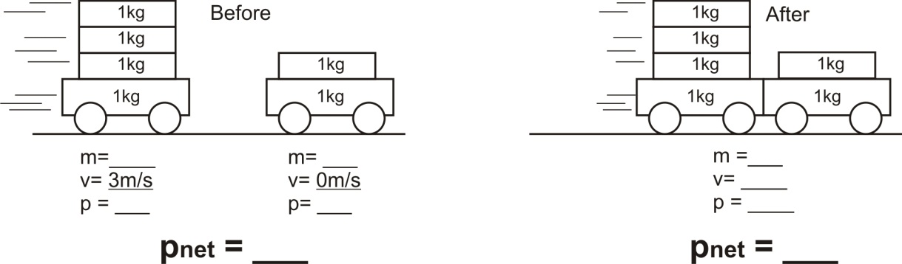
4.

5.
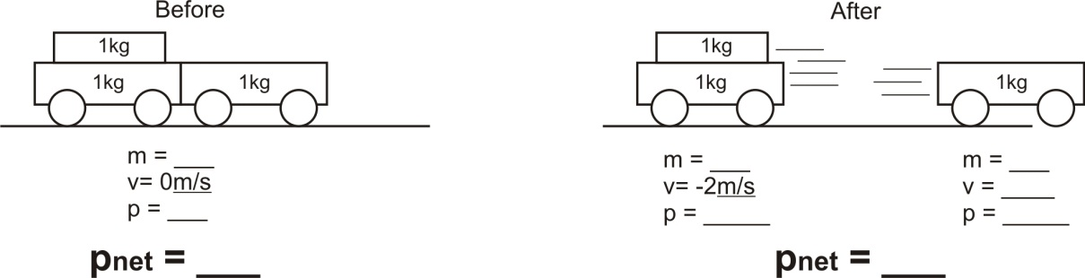

What is “impulse?”

Formula for impulse:

Units for impulse:

Three ways to rearrange the impulse formula:

Where does the formula come from?

6. A 2kg block of wood moving at a velocity of 5m/s slows to a stop over a time of 3 seconds. What net force brought the wood to a stop?

7. A 1,000kg car is rolling toward you at a velocity of 2m/s. In order to slow the car to a velocity of 1m/s by pushing against the car for 10 seconds, how hard will you have to push?

Impulse Practice Problems (attach extra paper if necessary)

1. A block of wood was sitting still. Then a 20N net force was applied to a block of wood for a time of 3 seconds.
- What is the wood’s change in momentum over those three seconds?
- What was the wood’s starting momentum?
- What was its momentum at the end of the three seconds?
- If the wood’s mass was 5kg, what was its velocity at the end of those three seconds?

2. A bicyclist and his bicycle have a total mass of 100kg. When the bicyclist first appears, he is pedaling at a constant velocity of 10m/s. He stops pedaling, and over the next two seconds the bicyclist’s velocity decreases to 8m/s.

- What is the bicyclist’s momentum when he first appears?
- What is his momentum after 2 seconds?
- What is his change in momentum?
- What net force was applied to the bicyclist while he decelerated from 10m/s to 8m/s?

Conservation of Momentum Practice Problems (attach extra paper if necessary)

