Physics 100 Name: _________________________
Mechanical Waves Notes

Wave:

Oscillation:

Types of Waves:

Mechanical Wave:

Examples of Mechanical Waves:

Electromagnetic Wave:

Examples of Electromagnetic waves:

Types and parts of waves:

Name the two different types of waves, below, and explain their primary difference.

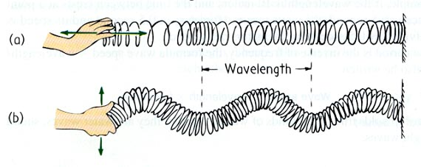

Parts of a transverse wave: crest, trough, wavelength, amplitude

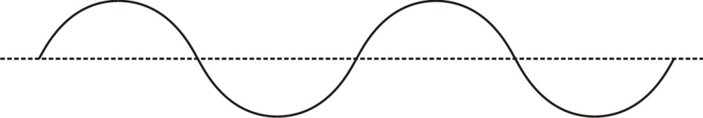

Parts of a longitudinal wave: compression, rarefaction, wavelength

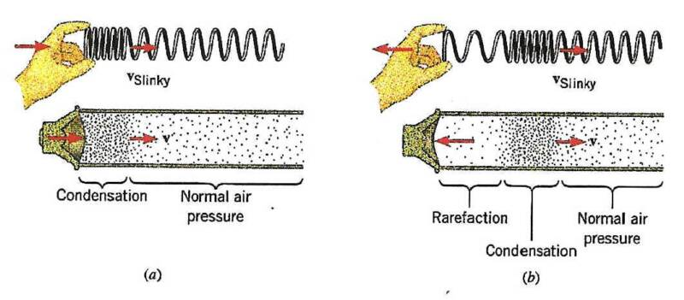
What determines the amplitude of a longitudinal wave?

Which of the series of waves on the right shows the greatest amplitude?

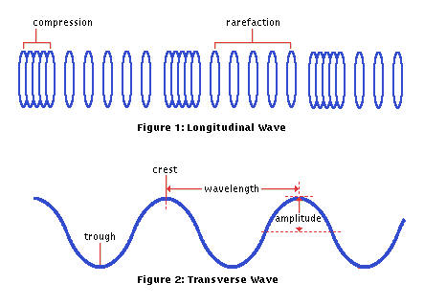
Sound waves are longitudinal, but they can be represented as transverse waves:

Period and Frequency

Period:

Frequency:

Symbol for frequency:

Units for frequency:

What is the period of the waves below? _________

Calculate the frequency of those waves. λ = ___

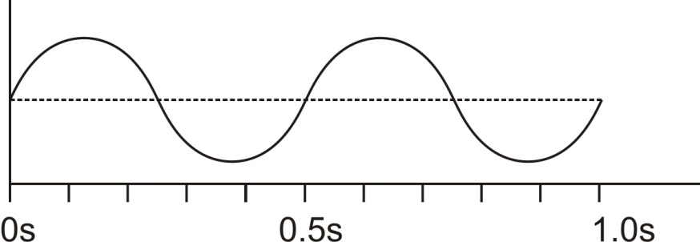

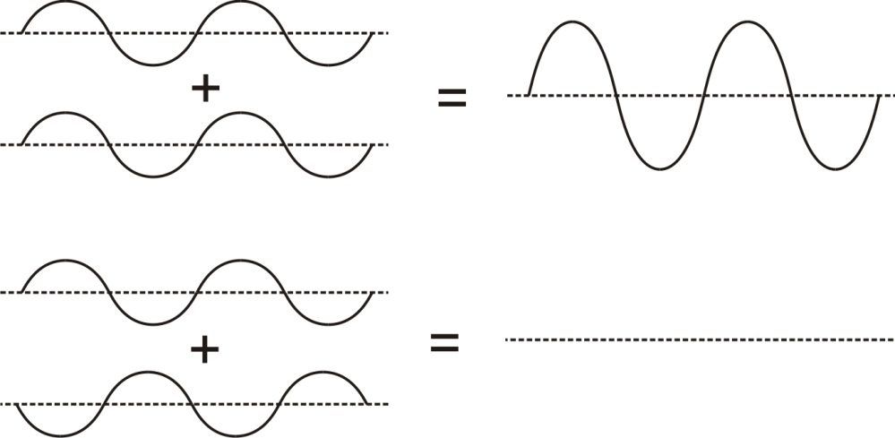
Wave Interference: When two waves overlap one another, their oscillations can add to one another, or they can diminish one another. Label the examples of interference on the right.

Wave Interference can cause “beats”. When two waves have slightly different frequencies, their interference alternates between constructive and destructive. The diagram below shows transverse representations of two sound waves (channels 1 and 2) and their resultant sound (channel 3).

- In the diagram, label the channel with the highest frequency (1 or 2).
- Then label regions of constructive and destructive interference. Channel 3 is the “sum” of channels 1 and 2.
- Label the “beats” that will be heard

