Physics 100 Name: _______________________________
Rubber Band Car Forces Practice

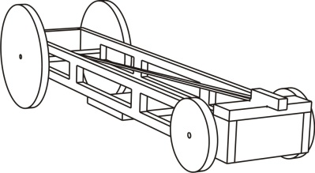

The picture on the right shows a rubber band car. The graph shows how the car’s velocity changed after it was wound up and released.

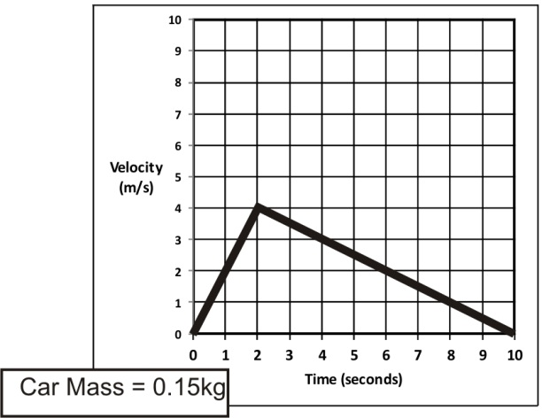
1. What was the car’s acceleration during the acceleration phase?

2. What was the car’s acceleration during the deceleration phase?

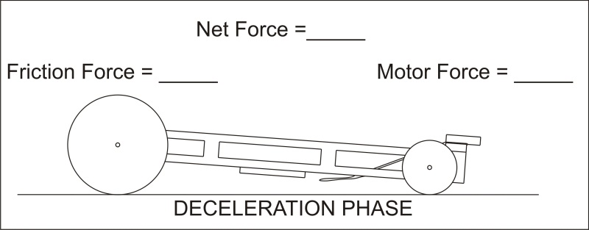
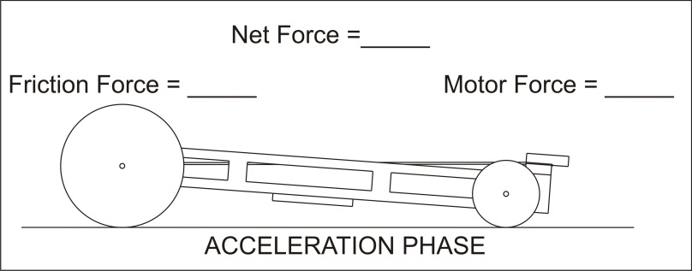
3. Complete the diagrams below by entering the correct component forces and net forces for the acceleration and deceleration phases. ***Assume that the force of friction remains constant throughout the car’s acceleration and deceleration phases.

Each graph shows the velocity of a rubber band car at various points in time. Use the graphs and the car masses to determine 1) the force of the car "motor" and 2) the force of friction.

Formulas: F = ma; a = change in velocity / change in time

