Physics 100 (Stapleton) Name: _________________________
Newton’s 1st and 2nd Laws

Newton’s 1st Law: Objects in motion __________________________________ _____________

________________________________________________________________________________, and

objects at rest stay at rest – unless _______________________________________________________

____________________________________________________________________________________.

If the forces acting on an object are balanced (no net force), what might that object be doing? What are the options?

What are the options for what an object might be doing if the forces on the object are not balanced (i.e. there is a net force)?

Newton's 1st Law is called the "Law of Inertia." Inertia is:

What objects of things have the most inertia? Give some examples.

Force Vector (in this class):

Net force:

The basic metric unit of force is the ______________. Its abbreviation is _________. It is

approximately equal to __________ or ____________________________________________________

1. Each of the pictures on the right shows one or more force vectors.

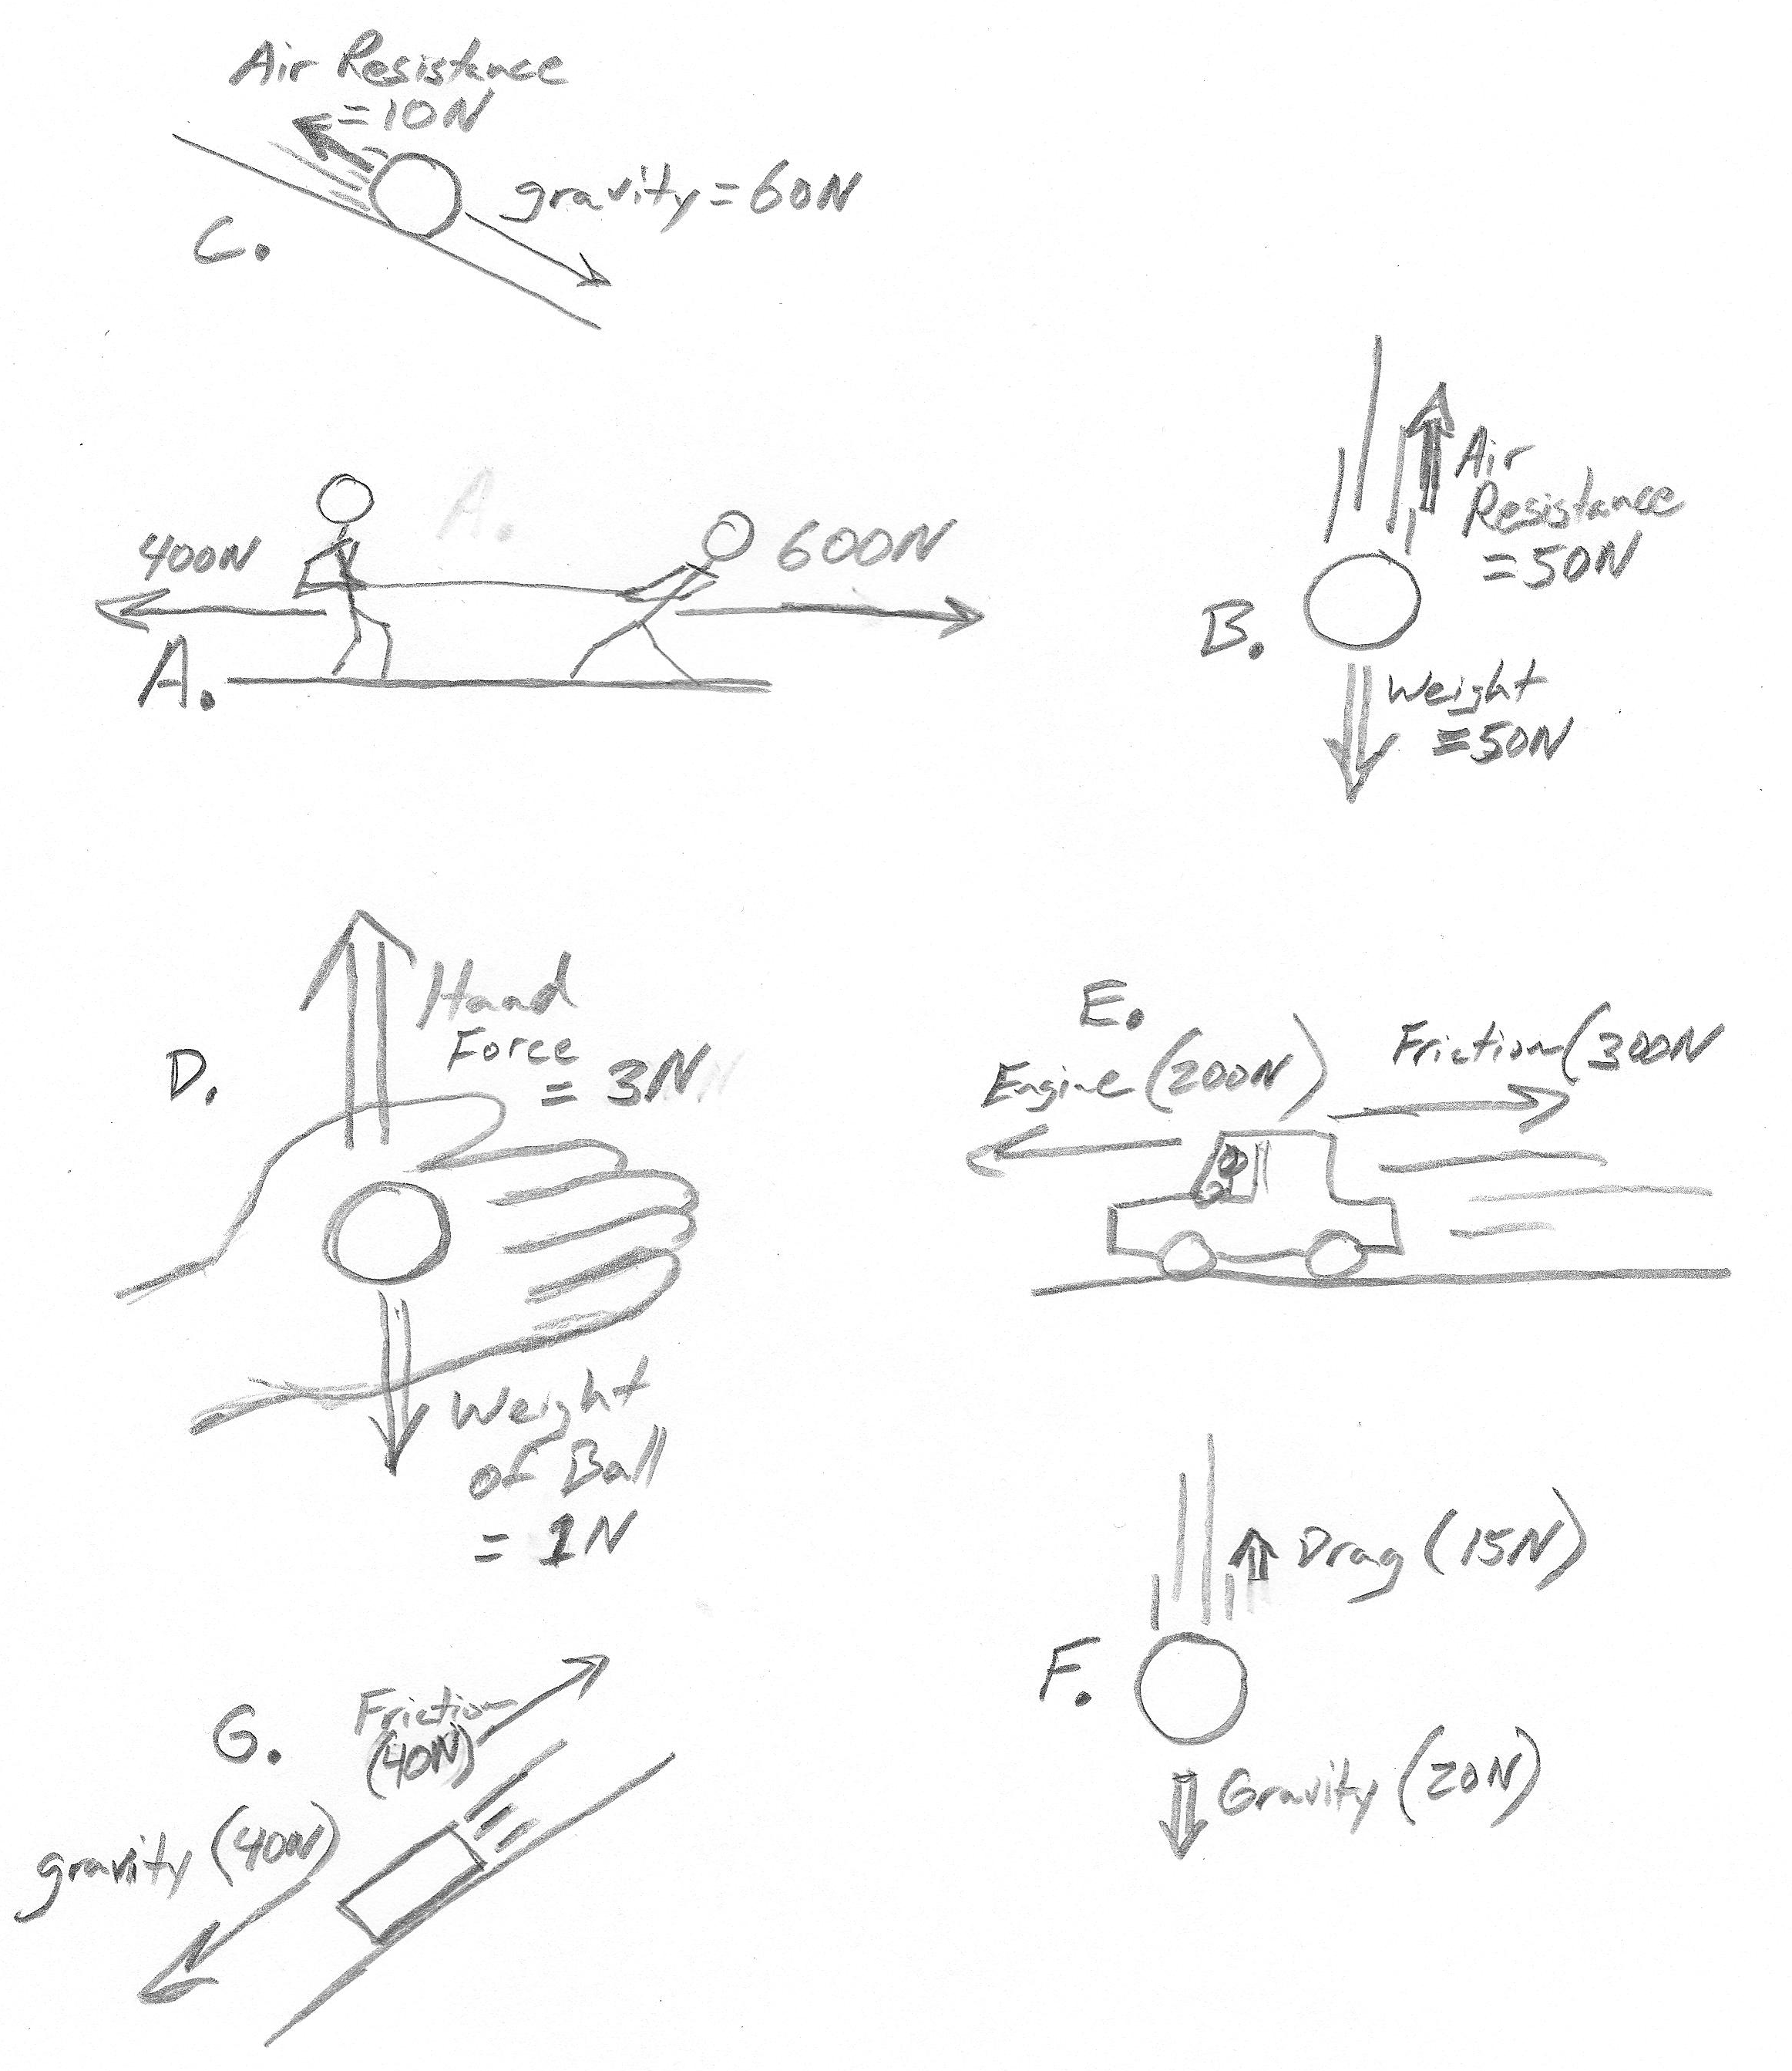
A) Look at the pictures and decide if the forces are balanced or unbalanced. Label them appropriately.

B) Look at each of the pictures and determine the net force. If the net force is not zero, draw and label a new vector representing the net force.

2. Forces are balanced whenever the net force on

an object is ____________.

3. The ball in picture C is rolling down a hill. What does the net force tell you about the ball's motion?

4. The ball in picture B is falling from the sky. What does the net force tell you about the ball's motion?

5. The ball and hand in picture D are just beginning to move. What does the net force tell you about their motion?

6. The car in picture E is driving to the left. What does the net force tell you about the car's motion?

7. The box in picture G is sliding down a hill. What does the net force tell you about the box's motion?

8. The ball in picture F is falling from the sky. What does the net force tell you about the ball's motion?
Newton's 2nd Law:

Mass:

Metric Base Unit for Mass = ________________________, which is abbreviated _________

A 1kg mass weighs about _______ Newtons or about ________ pounds.

Weight:

Calculating forces using Newton's 2nd law:

6. A 2kg mass accelerates at a rate of 3m/s/s. What net force caused this acceleration?

7. An unbalanced force was applied to a 7kg object. The object accelerated at a rate of 8m/s/s. What was the magnitude of the unbalanced force?

8. A 3kg bowling ball is dropped from an airplane. Gravity causes the bowling ball to accelerate at a rate of __________. What is the weight of the bowling ball? In other words, what force of gravity acts on the bowling ball?

Gravity causes a force even when an object is sitting still. If we know how fast gravity would accelerate the object if gravity were not balanced by any other force, then we can figure out the force of gravity acting on an object. This is the weight of the object.
Acceleration Due to Gravity Comparison
Body | Acceleration Due  to Gravity, "g" [m/s²]
Sun | 274.13
Mercury | 3.59
Venus | 8.87
Earth | 9.81
Moon | 1.62
Mars | 3.77
Jupiter | 25.95
Saturn | 11.08
Uranus | 10.67
Neptune | 14.07
Pluto | 0.42
9. What is the weight of a 30kg child who is standing on the Earth?

10. What is the weight of the same 30kg child, if that child is standing on Mars?

11. Fill in all of the missing forces in the two diagrams below.

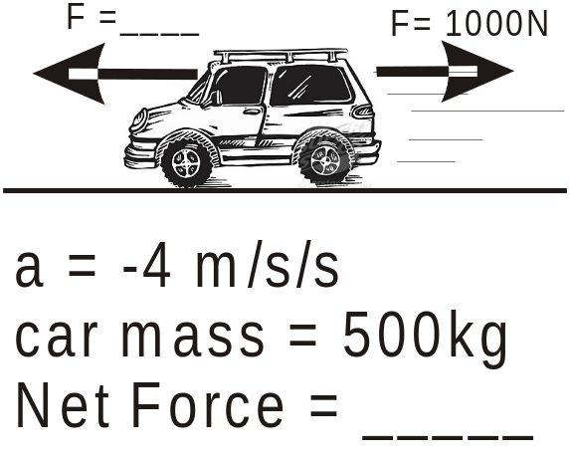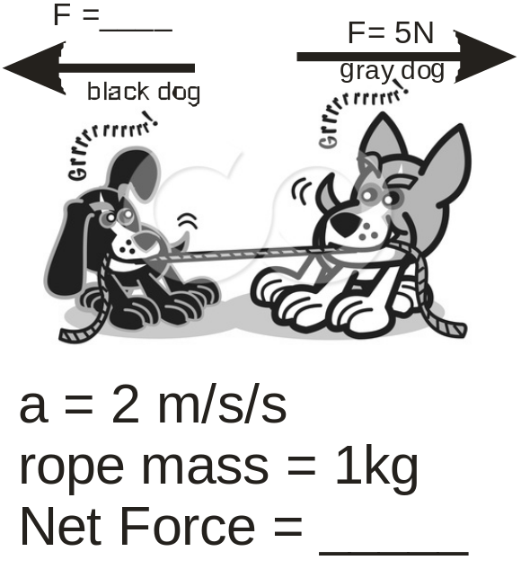
Physics Name: _____________________________
Newton’s 1st and 2nd Laws Practice

1. Define “weight”

2. A 1000kg car accelerates at a rate of 6m/s². What is the net force acting on the car?

3. On planet Y, falling objects accelerate at a rate of 0.8 m/s². In Newtons, how much does a 100kg man weigh on the planet Y?

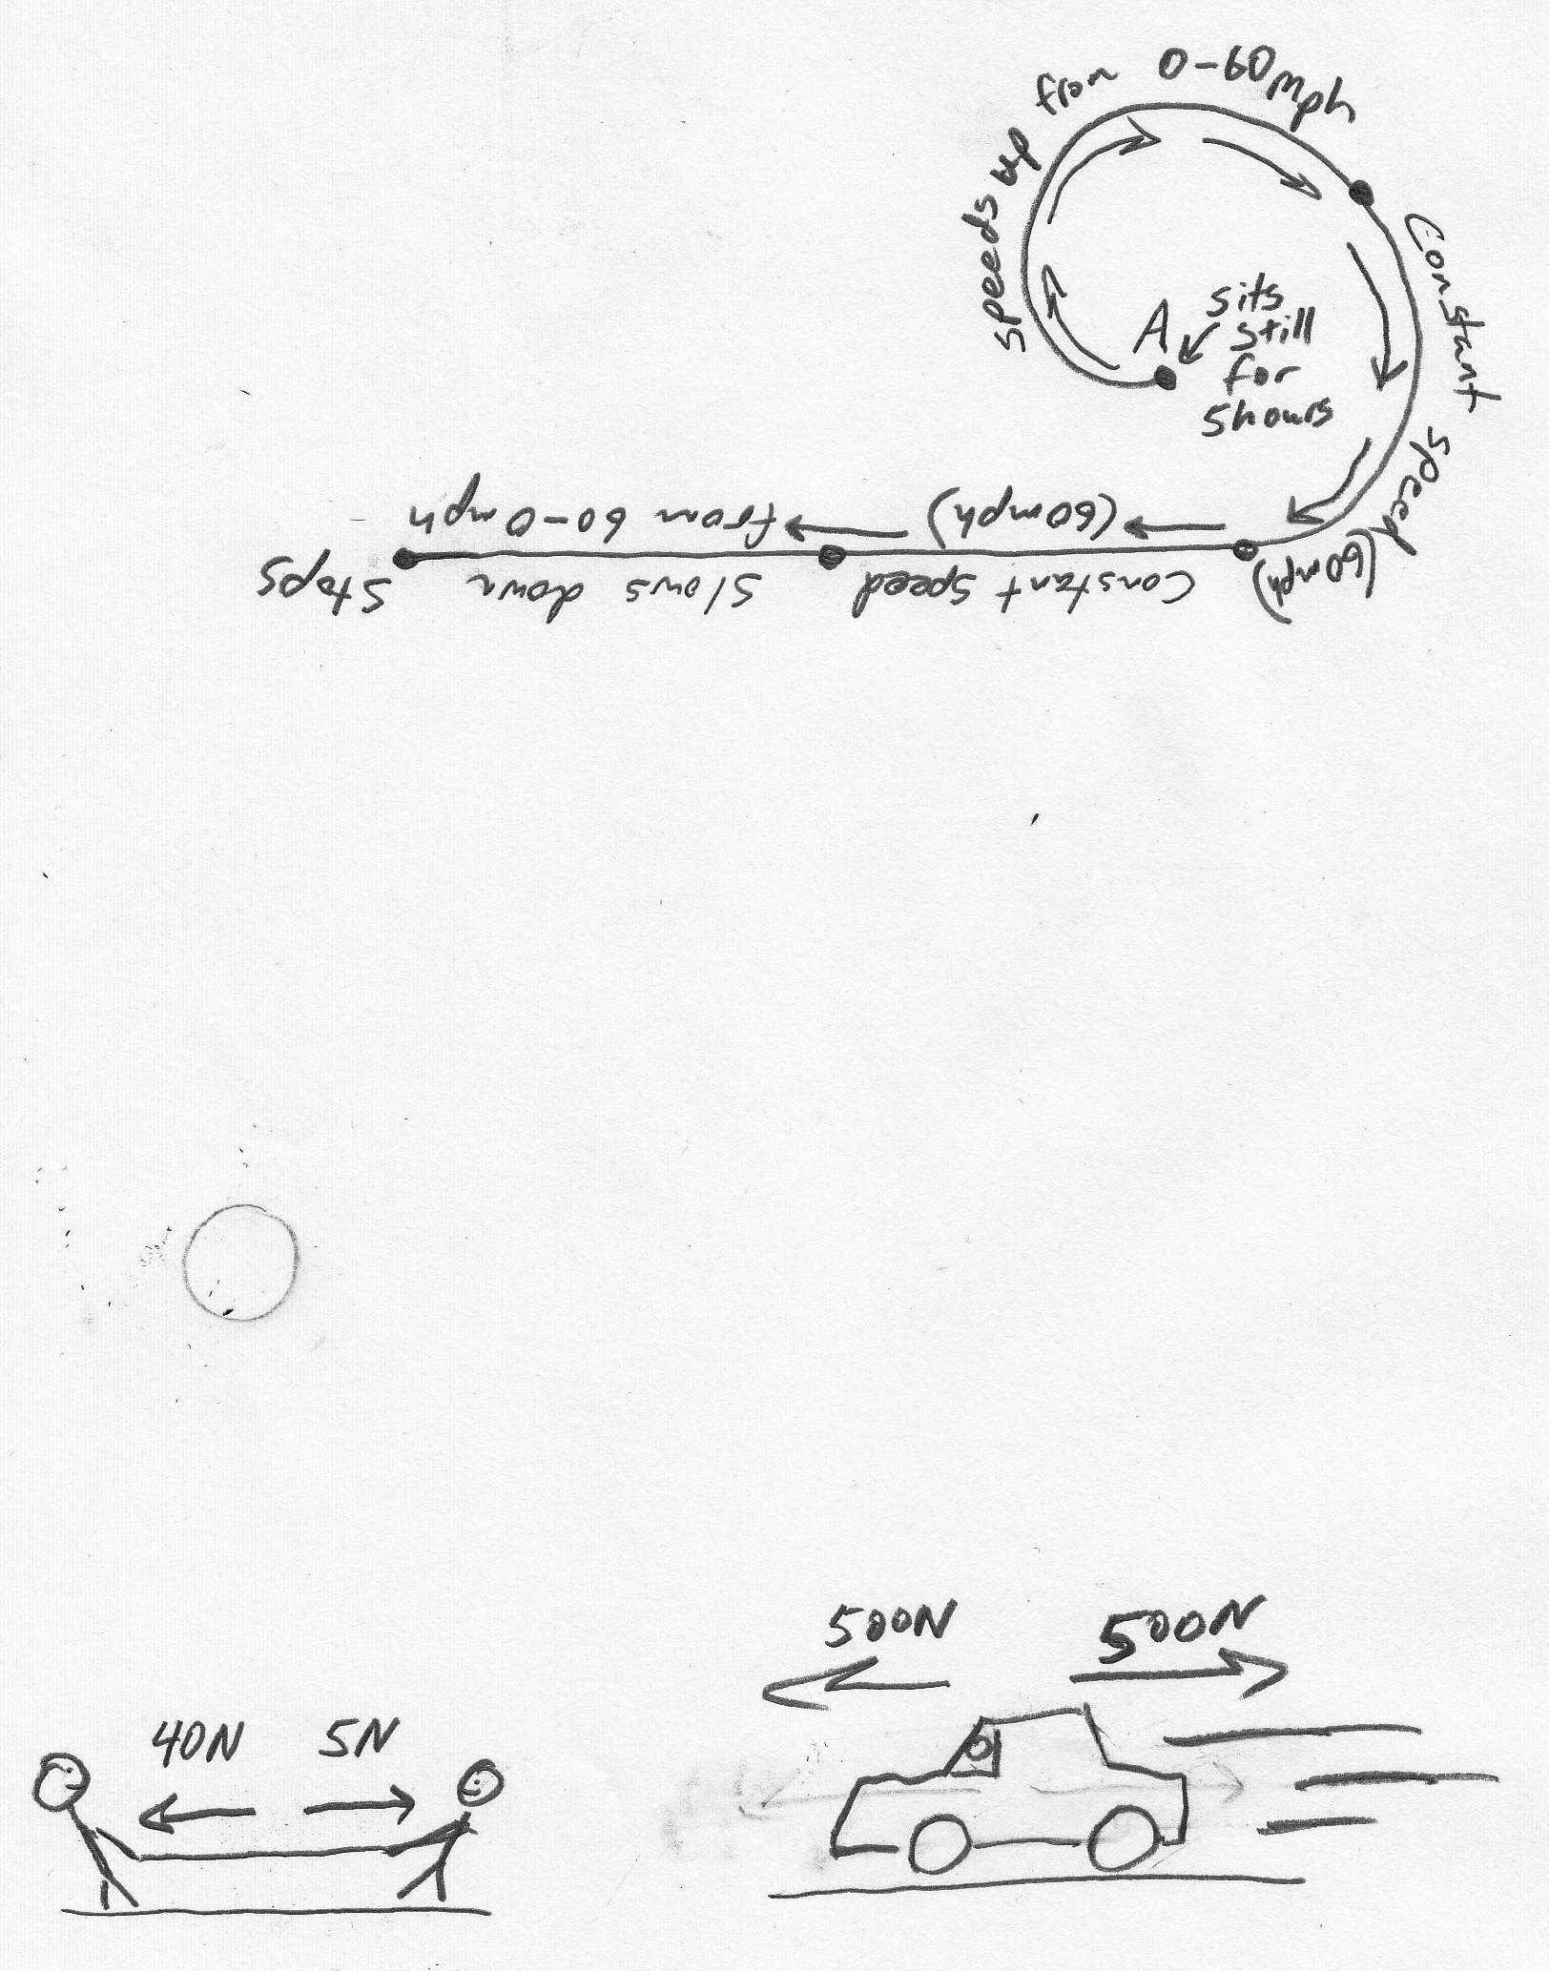
4. Use arrows to show the net forces in the drawings on the right. Label the arrows with the correct force, using the correct units. If there is no net force, you can leave off the arrow, but still give the net force.

5. Circle the answer that correctly completes the following sentence. When you jump out of a plane, before you reach terminal velocity…
a. your weight equals air resistance. b. your weight is greater than air resistance.
c. air resistance is greater than your weight. c. air resistance is equal to your mass.

The diagram below shows the path followed by a car. It also explains what is happening to the car’s speed as the car is traveling. For each of the segments of the car’s path, tell whether (by circling) the forces acting on the car are balanced (no net force) or unbalanced.
6. At point A : Balanced Unbalanced
B
7. Between A & B : Balanced Unbalanced
8. Between B & C : Balanced Unbalanced
9. Between C & D : Balanced Unbalanced
10. Between D & E : Balanced Unbalanced
D
11. A ball is sitting motionless on the ground. Earth’s gravitational pull accelerates objects at 9.8m/s². What do you know about the NET FORCE acting on the ball?

12-17. Fill in the missing forces in the diagrams below. First use Newton's 2nd laws to determine the net force. Then use the net force to find the other missing force.


