Physics 100 Name: _____________________________
Momentum and Impulse
Nerf Darts and Ballistic Pendulums

1. Impulse = change in momentum. Use this concept to explain why darts shoot faster from a compressed air cannon with a longer barrel.

2. Consider a Nerf dart with a mass of 0.0013kg. When the dart is shot from a 2m long barrel, its muzzle velocity (velocity as it leaves the barrel) is 120m/s.

a. What is the dart’s momentum when it leaves the barrel?

b. What is the dart’s Δp as it travels down the barrel?

c. What is the dart’s average velocity as it travels down the barrel?

d. How long does it take the dart to travel down the barrel?

e. What is the “impulse” that acts on the dart as it travels down the barrel?

f. What is the impulse time?

g. What average force propels the dart down the barrel?

3. Consider a Nerf dart with a mass of 0.001kg. When the dart is shot from a 2m long barrel, its muzzle velocity (velocity as it leaves the barrel) is 150m/s. What average force propels it down the barrel?

4. What was the mass of your fastest Nerf dart (approximate if you must)? _______ What was its muzzle

velocity? ________ What was the barrel length, in meters? ________ What average force propelled

your dart? ________

Measuring Velocity with a Ballistic Pendulum:

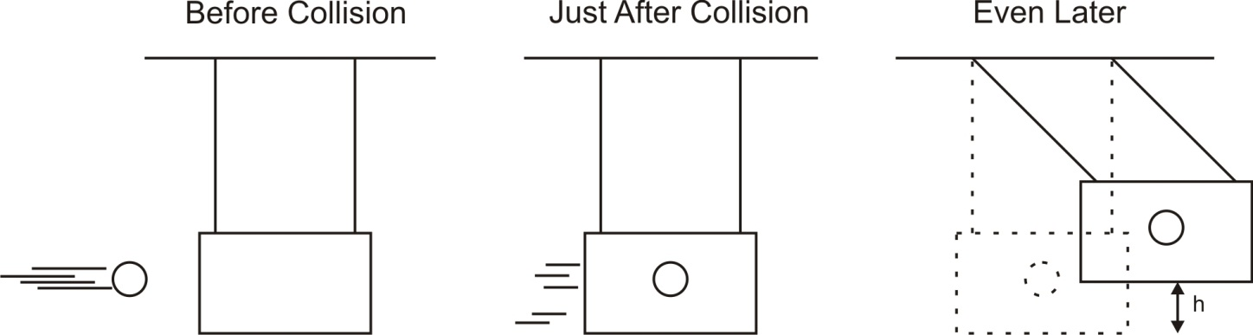

KE =

v_{(in term of KE)} =

PE_{gravitational} =

Elastic Collision:

Inelastic Collision:

A ballistic pendulum provides an example of an ___________________________ collision.

When the projectile collides with the pendulum, _________________ is not conserved but

_____________________ is conserved.

Calculate these projectiles’ initial velocities:

1. Projectile mass = 4kg. Pendulum (target) mass = 0.5kg. Swing height = 6m.

2. Projectile mass = 0.5kg. Pendulum (target) mass = 0.02kg. Swing height = 4m.

3. Projectile mass = ______ Pendulum (target) mass = ______ Swing height = _______

