Physics 100 Name: ________________________________
Mechanical Waves and Music

Note  Name | half steps  up from starting note | Frequency (hz) | Ratio: Current frequency / Previous frequency | Ratio of wavelength to starting note wavelength
A | 0 | 440 | NA | 1
A# (or B♭) | 1 | 466 | 1.059 | 0.944
B | 2 | 494 | 1.059 | 0.891
C | 3 | 523 | 1.059 | 0.841
C# (or D♭) | 4 | 554 | 1.059 | 0.794
D | 5 | 587 | 1.059 | 0.749
D# (or E♭) | 6 | 622 | 1.059 | 0.707
E | 7 | 659 | 1.059 | 0.667
F | 8 | 698 | 1.059 | 0.630
F# (or G♭) | 9 | 740 | 1.059 | 0.595
G | 10 | 784 | 1.059 | 0.561
G# (or A♭) | 11 | 831 | 1.059 | 0.530
A | 12 | 880 | 1.059 | 0.5
A# (or B♭) | 13 | 932 | 1.059 | 0.472
B | 14 | 988 | 1.059 | 0.445
C | 15 | 1047 | 1.059 | 0.420
C# (or D♭) | 16 | 1109 | 1.059 | 0.397
D | 17 | 1175 | 1.059 | 0.375
D# (or E♭) | 18 | 1245 | 1.059 | 0.354
E | 19 | 1319 | 1.059 | 0.334
F | 20 | 1397 | 1.059 | 0.315
F# (or G♭) | 21 | 1480 | 1.059 | 0.297
G | 22 | 1568 | 1.059 | 0.281
G# (or A♭) | 23 | 1661 | 1.059 | 0.265
A | 24 | 1760 | 1.059 | 0.25
1. When we hear two notes that are separated by

one ____________________, our ears perceive those notes as being the same notes, though one sounds higher and one sounds lower.

2. When two notes are separated by an octave, the higher note has a frequency that is

___________________ the frequency of the lower note.

For example, a musical note with a frequency of 110hz is an A. If we start singing at that pitch and move gradually upward, we will reach the next A when we get to ______hz. The next A after that will be heard at _______hz.

3. The music that most of us listen to uses notes

that divide each octave into ________ equal parts. Each of these equal parts is called a

_________________________

4. A one octave jump in pitch represents a ______________________________ of sound wave frequency.

5. A two octave increase in pitch represents a 2⁽ ⁾ increase in frequency.
6. A three octave increase in pitch represents a 2⁽ ⁾ increase in frequency.
7. A four octave increase in pitch represents a 2⁽ ⁾ increase in frequency.
8. A 1/12 octave increase in pitch (in other words, a half step) represents a 2⁽ ⁾ increase in frequency. In other words, to raise the pitch of a sound by a half step its frequency must be multiplied by 2^{(1/12)} ≈1.0595.

9. 2^{(1/12)} ≈1.0595

10. One whole step = ___________________

11. On a piano keyboard, the keys get higher in pitch as you travel to the ________________.

12. On a piano keyboard, the white keys are the notes (A, B, C, D,E, F, and G) and the black keys are called sharps (#) or flats(♭). The black key just above (to the right of) a white key is called a _______. The black key just below a white key is called a ________.

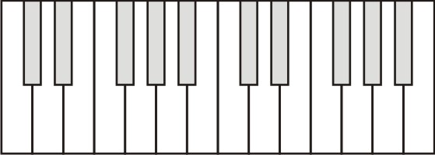
13. Label 13 consecutive piano keys with their note names. For the darkened keys, give either the sharp name or the flat name.

14. Starting from an A, how many half steps higher is the next E? _______
15. Starting from D♭, how many half steps higher is the next F#? ________

16. A major key has the following pattern of whole and half steps: __________________________

17. A minor key has the following pattern of whole and half steps: __________________________

18. Darken and label the keys of a 1-octave (8 note) A major scale.

19. Darken and label the keys of a 1-octave C major scale.

20. Darken the keys of a 1-octave A minor scale.

21. Darken the keys of a 1-octave C minor scale.

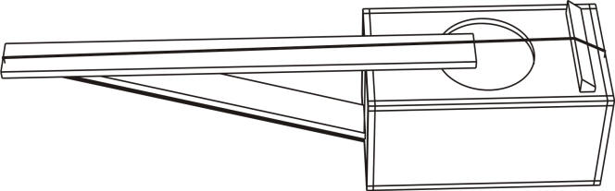

22. Label the nut and the bridge on the string instrument to the right.

23. The diagram below shows an idealized string instrument with fret marks. The string is shown in bold.
a. Label the locations of the nut and the bridge.
b. Darken the fret marks where you would place your fingers in order to play a 1-octave (8 note) major scale.

24. Show a different way to play a 1-octave (8 note) major scale by darkening the appropriate fret marks.

25. Darken the appropriate fret marks to show how to play a 1-octave (8 note) minor scale by darkening the appropriate fret marks.

26. Darken the appropriate fret marks to show another way to play a 1-octave (8 note) minor scale by darkening the appropriate fret marks.

Formulas:

- To raise frequency by 1 half step, multiply starting frequency by 2^{1/12} (or 1.0595)
- v = fλ

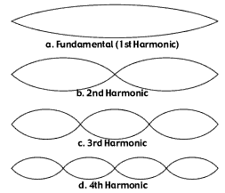
When a string is strummed (or plucked – or bowed), many types of waves travel along it, producing a variety of standing waves. The dominant (loudest) standing wave is called the fundamental. There are also other harmonics (a.k.a. overtones), which have higher pitch.

27. Suppose an instrument string is 50cm long, and when the open string is plucked, its frequency is 400hz.

- Draw a picture of the fundamental standing wave that is produced in the vibrating string. How many wavelengths does it represent?

- What is the full wavelength of the waves that are traveling down your string?

- What is the relationship between string length and the wavelength of the string’s fundamental standing wave?

- What is the speed of those waves?

- What is the frequency of a note one half step higher than the 400hz open string?

- In order to play that note, what wavelength must your string have? [hint: you know the string’s wave speed]

- How long must your string be in order to produce that wavelength?

- By what distance must you shorten your string in order to raise your instrument’s pitch by one half step?

- How far from the end must the second fret be located?

28. Create an Excel spreadsheet that will produce a list of fret mark positions

