Physics 100 Name: __________________________
Notes: Electricity and Magnetism, part 1

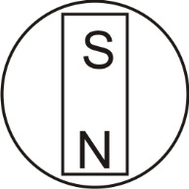
Magnetism: a phenomenon causing attractive and repulsive forces between objects and relating to motions of electric charge.

North Pole: this is the pole of a magnet that tends to point itself toward the Earth’s (current) North Pole. This is because, if you think of the Earth as a magnet, the North Pole is really its magnetic south pole. We call it the North Pole because magnets’ north poles point toward it.

South Pole: the pole of a magnet that points toward the Earth’s south pole.

Magnetic field lines: arrows flowing away from a magnet’s north pole and toward a magnet’s south pole.

1. Draw some magnetic field lines on the “Earth” to the right.

Letter Symbol for Magnetic Field = ________

2. As with electric charges, opposite magnetic poles ____________, and

like magnetic poles ____________.

3. Draw some bar magnets sticking together end-to-end.

4. Draw some of the same magnets sticking together side-by-side.

Another way to think of magnetic attraction and repulsion is to say that magnetic fields “like” to match up with one another, going the same way.

5. Draw the magnets that you just drew above, but this time show how their magnetic field lines align with one another.

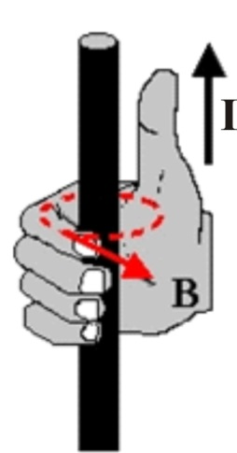
How Magnetic Fields Are Created:

Any moving charge creates a magnetic field. Enough charge, moving in the same direction, produces noticeable magnetism. Therefore, magnetism can be caused by electric current. The direction of a magnetic field caused by moving charge (electric current, I) can be understood by the “Right Hand Rule.”

Current (I) in a wire creates a magnetic field (B), according to the right hand rule.

Right hand rule: If you point your right thumb in the direction of current flow, and you curl your fingers on your right hand, your fingers point in the direction of the magnetic field lines. For a single current-carrying wire, the magnetic field around the wire is circular.

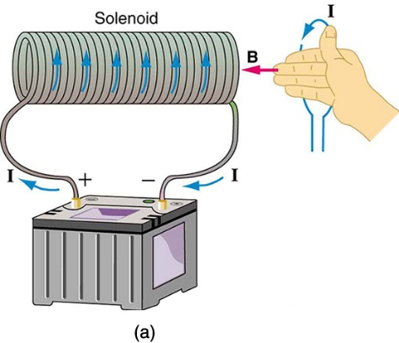

Solenoids (electromagnets): A solenoid is a coil of wire through which current is flowing. The right hand rule can be used to understand the direction of the magnetic field (B) created by a solenoid, if we know the direction of current (I).

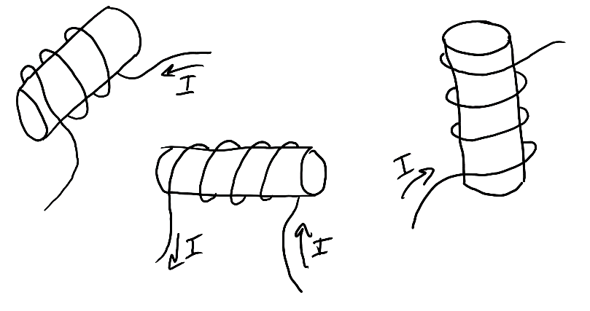
Each of the three solenoids on the right was created by wrapping wire around a cardboard tube. Draw the direction of the magnetic field (B) inside the tube, based on the direction of electric current (I) through the wire. Imagine grabbing the tube, with your fingers extending into the tube, and your right thumb pointing in the direction of the current flowing through the wire.

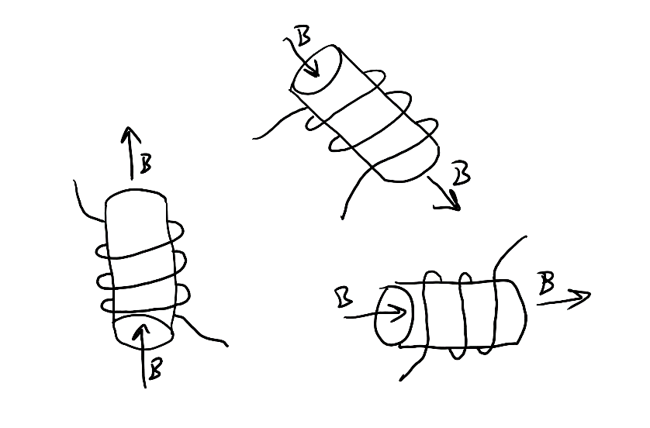
In the diagram on the right, the magnetic field direction (B) is shown for each solenoid. Label the wires to show the direction of current flow through each solenoid.

Electrons in atoms create magnetic fields:
- Most atoms have paired electrons. Electrons in pairs have opposite spin, so they cancel one another’s magnetic fields.
- Iron, however, has unpaired spinning electrons that create magnetic fields. In groups of iron atoms, called domains, the unpaired electrons align with one another’s magnetic fields. However, throughout the iron, the aligned domains are randomly oriented, so the iron has no overall magnetic field. When a strong magnet is brought near a piece of iron, the iron’s domains align with the magnet’s magnetic field. The iron becomes “magnetized,” and it sticks to the other magnet. When the magnet is taken away, the iron’s domains usually return to their normal orientations, so the iron does not become a permanent magnet.

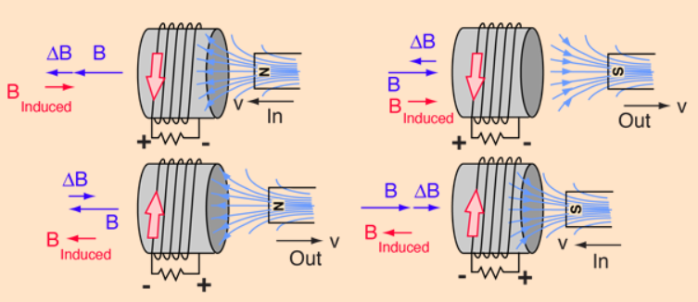
Lenz’ Law: A change in magnetic flux through a conductive coil induces a current in the coil, such that the induced current’s magnetic field opposes the first change in magnetic flux.

Magnetic Flux is a measure of the magnitude and direction of magnetic field passing through a given area.

