Physics 100 Name: ____________________
Electricity Part 1: Electric Charges and “static electricity”

Part 1: Charge Basics

1. What are the two types of charges?

2. Like charges __________________ and unlike charges _________________.

3. In atoms, ______________ carry negative charge and _______________ carry positive charge.

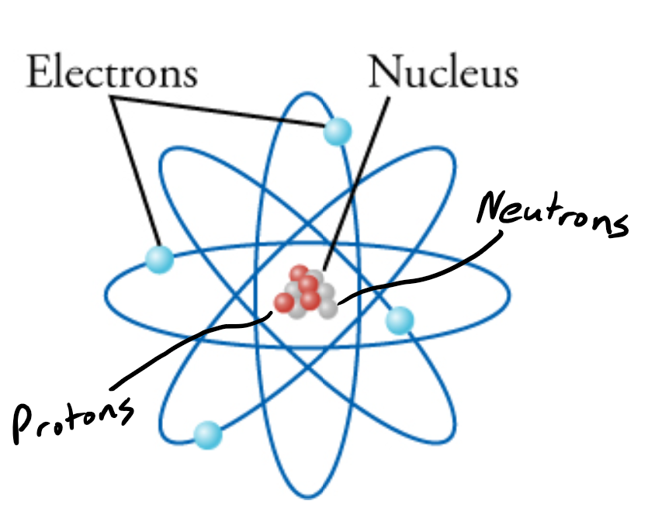

4. The strengths of a proton’s charge and an electron’s charge are

___________________ (though they are opposite)

5. “Net charge” is what you get when you add up all of the positive and negative charges inside something. What is the “net charge” of an object with only….

a. 3 protons b. 4 electrons

c. 2 protons and 1 electron d. 5 electrons and 3 protons

d. 7 protons and 7 electrons

6. When materials are rubbed together, charges can be separated, particularly if one material has a greater ________________________________________ than another.

7. Rabbit fur has a _______________ affinity for electrons, while PVC has a _____________ affinity for electrons.

8. Suppose we have a rabbit fur that has zero net charge, and we also have a PVC pipe that has zero net charge. What can we say about the number of protons and electrons in each object?

9. If we rub a PVC pipe with rabbit fur, what effects might we observe? Why?

10. During this experiment, what has happened to the total number of positive and negative charges (if we add up all the positive and negative charges on the two objects)? Has the total increased, decreased, or stayed the same. Explain.

11. Law of Conservation of Charge:

12. In the winter, people often talk about static electricity. What does the “static” part of “static electricity” mean? Why is it called “static electricity?”

Static Electricity – “Scotch” Tape Activity

**Important: At some points during this activity, your tape’s charge may leak away, so you may need to create new tapes A, B, C, and D.

1. Tape a ruler firmly to the edge of your table so that 20 - 25cm is protruding off of the table.

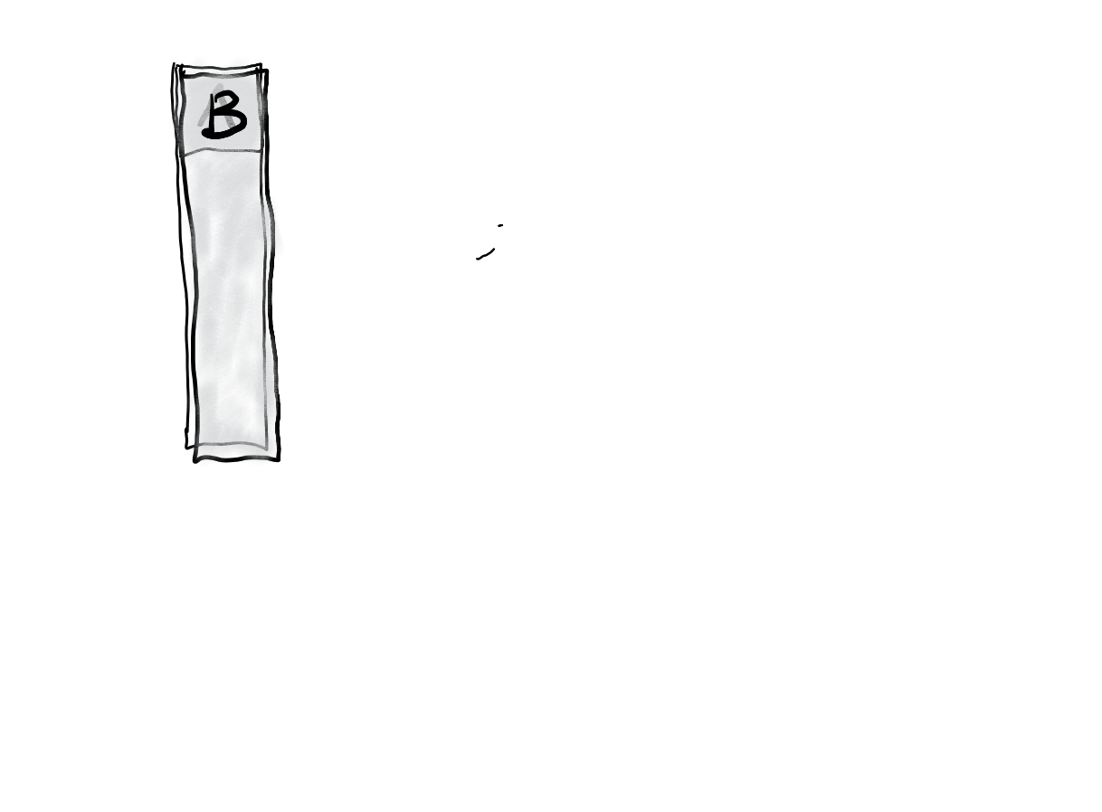
2. Get a piece of clear tape that is 8-10 cm long. Fold over the last 1-1.5 cm and stick it to itself. Stick this tape firmly and evenly to the surface of a desk. Label the folded part “A.”

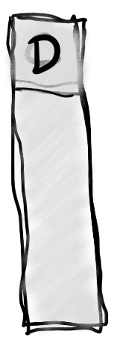
2. Repeat with another piece of tape, and stick this tape right on top of tape A. Label this tape “B.”

3. Do the same thing you did with tapes A and B, but this time label the tapes C and D. C goes on the bottom, and D goes on the top.

4. Grab the non-sticky end of your A/B pair of tapes and pull it off of the desk surface, all in one piece. Hold it near your free hand and observe the force experienced by the tape.

What happens when you hold the A/B pair close to your hand (circle one)? Attracts Repels
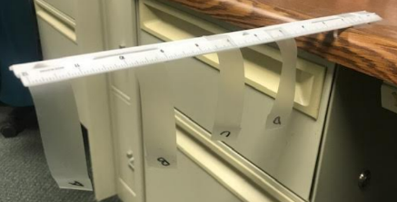
5. Separate pair A/B. Stick both tapes to your ruler, as shown in the picture below. Then stick the two pieces to your ruler, near the end, so that their lettered ends hang off the side of the ruler, as shown. Make sure that they’re separated by an inch or so.

6. Grab the non-sticky end of your C/D pair of tapes and pull it off of the desk surface, all in one piece. Hold it near your free hand. Then hold it next to tape A. After that, hold it next to tape B. Then separate the two tapes (C and D), and hold each one next to A and then next to B. Finally, stick them to the ruler in the same way that you attached A and B.

What happens when you hold C/D next to your free hand? Attracts Repels

What happens when you hold the C/D pair next to tape A? Attracts Repels

What happens when you hold the C/D pair next to tape B? Attracts Repels

What happens when you hold tape C next to A? Attracts Repels

What happens when you hold tape C next to B? Attracts Repels

What happens when you hold tape D next to A? Attracts Repels

What happens when you hold tape D next to B? Attracts Repels

7. Now use a Styrofoam (polystyrene) block and some fabric to determine the actual charges of the items in this activity. Conduct a short internet search to find a triboelectric series including polystyrene and the fabric that you used (or a similar fabric). Identify the charge that the items will take on when they are rubbed together:

Styrene Charge: _________ Fabric Charge: _________

8. Create a charge number line, with zero charge in the middle. Insert the following items on the number line, indicated their approximate net charges, relative to one another.

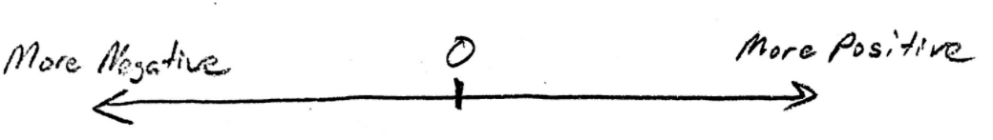
Tape A, Tape B, Tape C, Tape D, Tape pair A/B, Tape Pair C/D, Your Hand

9. You should have seen that all of the items above were attracted to your hand. Explain why.

10. Sense can be made of the number line above by creating a triboelectric series of the three surfaces that compete for electrons in this activity. The surfaces are 1) the tabletop, 2) the sticky side of the tape, and 3) the non-sticky side of the tape. Rank these three surfaces according to their affinity for electrons.

Part 2: Conductors and Insulators

1. _______________ allow electrons to easily move through them. List some examples.

2. _______________ do not allow electrons to move through them. List some examples.

3. Protons ________________ (can/cannot) flow through solid conductors. Why not?

4. Ground: a large, neutral source of charge (like the Earth). The ground can serve two purposes…

“The ground” can…

“The ground” can…

5. What happens to an object when the object is “grounded?”

6. What other objects, other than the Earth, could be used to ground something?

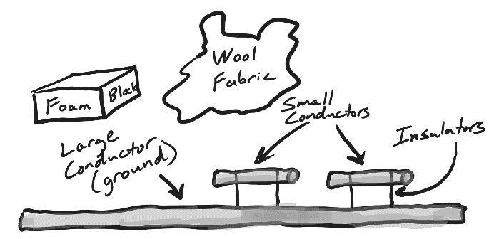
Charging By Induction:
Show two unique methods of charging the small conductors using the materials in the diagram, but without touching the styrofoam or wool to the conductors. This is called “charging by induction” to distinguish it from the other method of charging we have seen – charging by rubbing things together. Explain what is happening during your steps. Assume that everything has a neutral net charge in the beginning.

Method 1: Giving the small conductors opposite charges, without grounding.

Method 2: Charging one conductor at a time, using grounding.

Part 3: Electric Fields

1. What is an electric field?

2. Try the Electric Field Hockey (pHet Simulation) -- https://phet.colorado.edu/en/simulations/electric-hockey
1. Find and run the simulation.
2. Click the “Field” and “Trace” buttons.
3. Try to win levels 1 and 2.
4. What happens when you turn off “puck is positive,” so that the puck becomes negative?

3. What creates an electric field?

4. A map of an electric field has arrows. What does the direction of the arrows tell us?

5. Two drawings of charged “pucks” and a goals are shown below. For each diagram draw some positive charges that will make the puck go into the goal. Also draw at least one arrow representing the electric field.

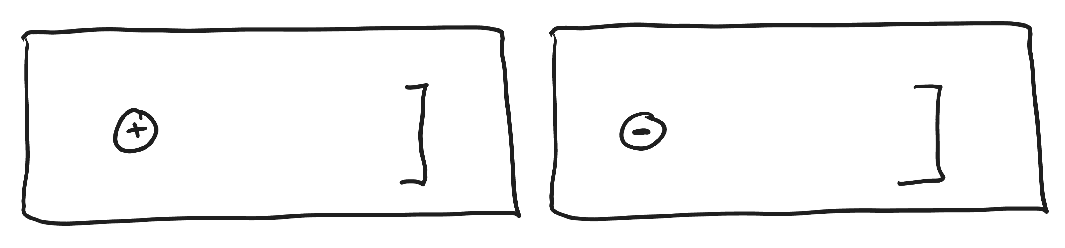

6. Do the same thing again, but this time use negative charges.

7. a. When a conductor (like the metal body of a car) is placed in an electric field, what do the charges in the conductor do?

b. This means that the electric field inside a conductor is _______________.

c. Why is this important?

8. Not all conductors of the same material can be charged equally. Guess what combination of shape and texture capable of building up the highest charge (before the charge escapes by shocking something). [Hint: we have a device that is designed to build up charge and shock things, and the shocking part of it has this shape and texture.]

Shape/Texture Best for Building Up Charge: _________________________

Invention with this shape/texture, and its purpose:

___________________________________________________________

9. Shape that is best for leaking charge (NOT building up charge):

_________________________

Invention with this shape, and its purpose:

__________________________________________________________

Physics 100 Name: ____________________
Unit 2: Electricity
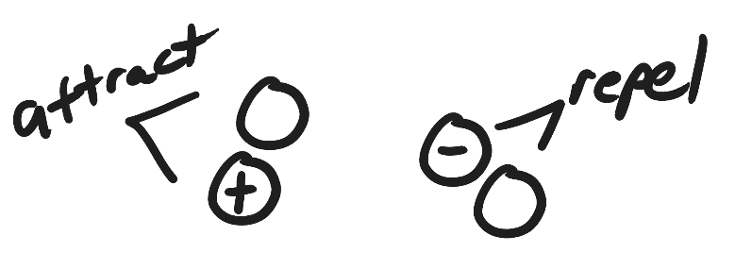
Test Review

Part 1:
1. For each of the pairs of charges on the right, add positive or negative signs to make the pairs attract and repel.

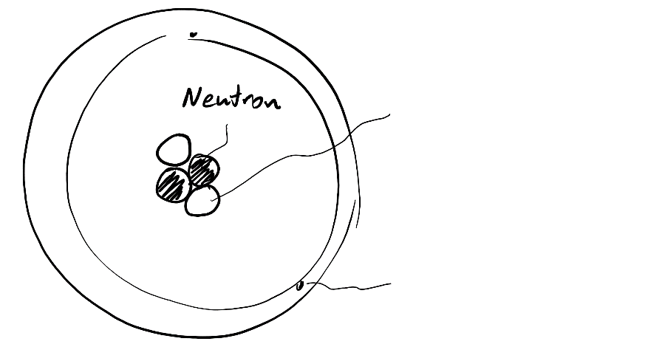
2. On the diagram to the right, write “proton” next to the line that points to a proton.

3. Write “electron” on the line that points to an electron.

4. Label the proton and the electron with appropriate charges (+ or -)

5. When two objects are rubbed together, and static electricity is created, which type of particle gets transferred?

6. Which has a stronger charge?
a. a proton b. an electron
c. neither, they’re equally strong

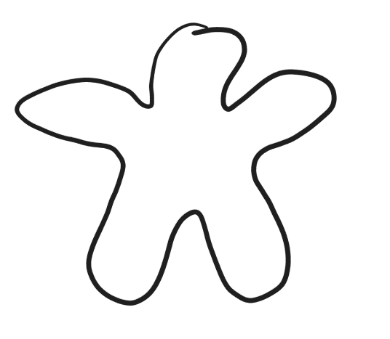
7. Draw charges in the object on the right so that there are 10 charges altogether and the net charge is +4?

8. What does the “static” part of the words “static electricity” mean?

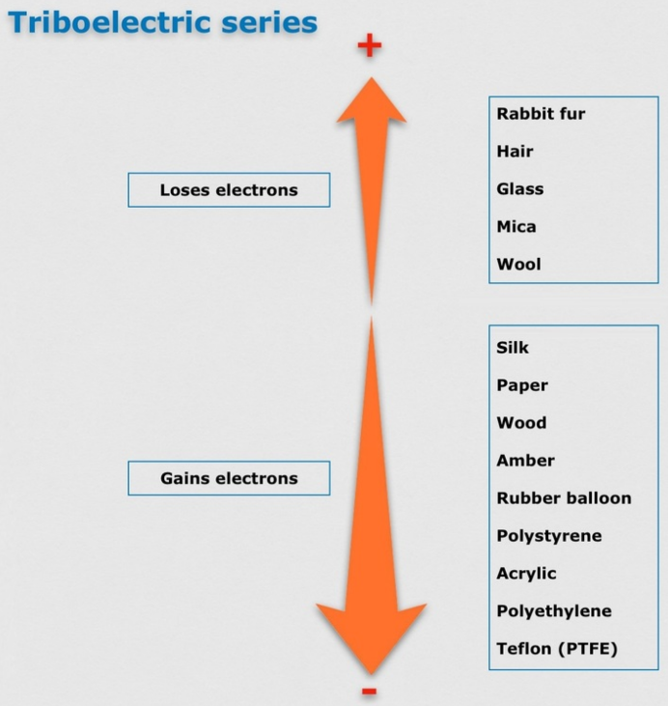
10. Sketch a simple picture of a neutral square of acrylic and a neutral wig of human hair. Draw some charges in each of them.

11. Refer to the diagram on the right, and then draw what the charges in the wool fabric and the stick of wood might look like after you rub them together.

12. What does the “Law of Conservation of Charge" tell us will happen when the wood and wool are rubbed together?

13. Draw a diagram showing how a balloon with a balloon with a strong negative net charge can stick to a wall that has zero net charge. Draw the balloon, the wall, and charges in both.

Part 2

1. Define “conductor” and give one example of a conductor.

2. Define “insulator” and give one example of an insulator.

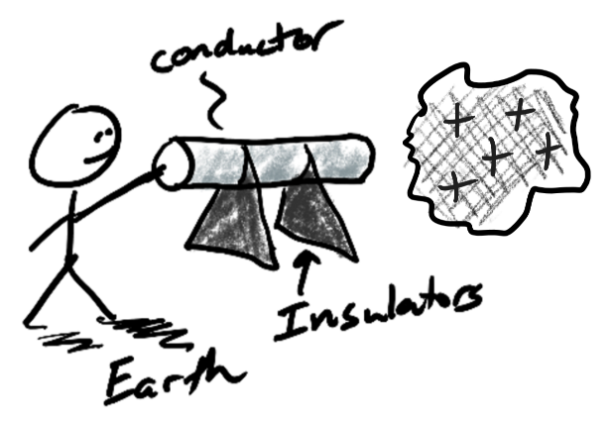
3. First you rub a foam block on some wool fabric. The foam block becomes negative and the wool becomes positive. Next you hold the wool next to a neutral conductor on an insulated stand. Then you touch the conductor and the Earth at the same time. Finally you let go of the conductor and remove the foam.

- What is the charge of the conductor after you let go? (+, -, or neutral)

- When you touch the small conductor with your finger, do charges move from the conductor to your finger or from your finger to the conductor?

- What type of charges move?

- Explain why these charges move in that direction.

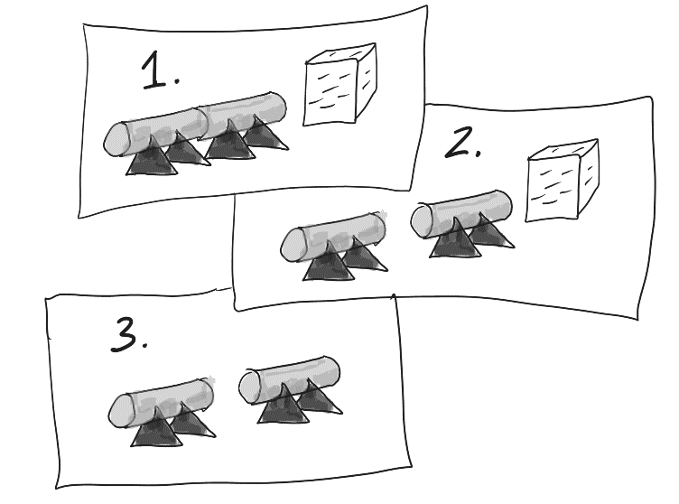
2. This time you place the two small neutral conductors so that they’re touching. Then you rub the foam block and the wool together. Next you hold the negatively charged foam block close to the conductor on one end, as shown in picture 1. Then you separate the conductors by touching only their insulator bases (like picture 2). Finally, you remove the foam block, as shown in picture 3.

- Label the charges of the conductors in picture 3 (+,-, or neutral)

- Describe what you could do to ground the positive conductor in picture 3.

- If you did ground the positive conductor, what type of charges would move at that time?

- What would those charges move from?

- What would those charges move to?

Part 3:

1. What is an electric field?

2. What creates an electric field?

3. A map of an electric field has arrows. What does the direction of the arrows tell us?

4. Two drawings of charged “pucks” and goals are shown below.
a. In the diagram draw some negative charges that will create an electric field that will cause the puck to go into the goal.
b. Draw an arrow representing the electric field created by your charges.

5. a. In the diagram below draw some negative charges that will make the puck go into the goal.
b. Draw an arrow representing the electric field created by your charges.

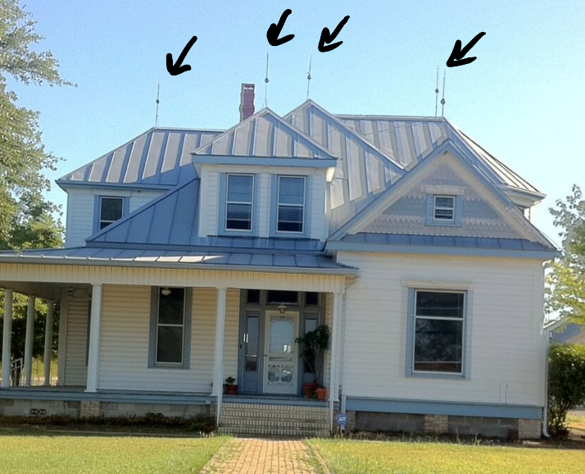
6. a. Why do people put lightning rods on buildings (like the house on the right)?

b. Explain what lightning rods do to charges.

7. If you’re inside a car, and lightning strikes the car, you will probably be okay. The reason that you’re safe has nothing to do with the tires. Why is a car a safe place to be during a lightning storm?

