Physics 100 Name: __________________________
Practice Quiz 1 (Electric Current and Circuits)

Ohm’s Law: [Hint: you may want to use a triangle] according to Ohm’s Law…

1. V = _______

2. I = _______

3. R = _______

4. According to Ohm’s law, what happens (or has happened) in a circuit when…

a. Voltage (V) is kept the same, but resistance (R) is increased?

b. Voltage (V) is kept the same, but current (I) increases?

c. Current (I) decreases, but resistance (R) is kept constant.

d. Resistance (R) increases, but current (I) is kept constant.

5. In this type of circuit, the individual voltage drops add up to the total circuit voltage.
a. series b. parallel c. both d. neither

6. In this type of circuit, the individual voltages are all equal to the total circuit voltage.
a. series b. parallel c. both d. neither

7. In this type of circuit, the individual currents add up to the total circuit voltage.
a. series b. parallel c. both d. neither

8. In this type of circuit, the individual currents are all equal to the total circuit voltage.
a. series b. parallel c. both d. neither

9. In this type of circuit, the individual power consumptions add up to the total circuit power consumption.
a. series b. parallel c. both d. neither

10. In this type of circuit, the individual power consumptions are all equal to the total circuit power consumption.
a. series b. parallel c. both d. neither

11. For each of the following circuits, identify whether the circuit is a series circuit or a parallel circuit. Then fill in the missing information for the overall circuit, and for each of the bulbs.

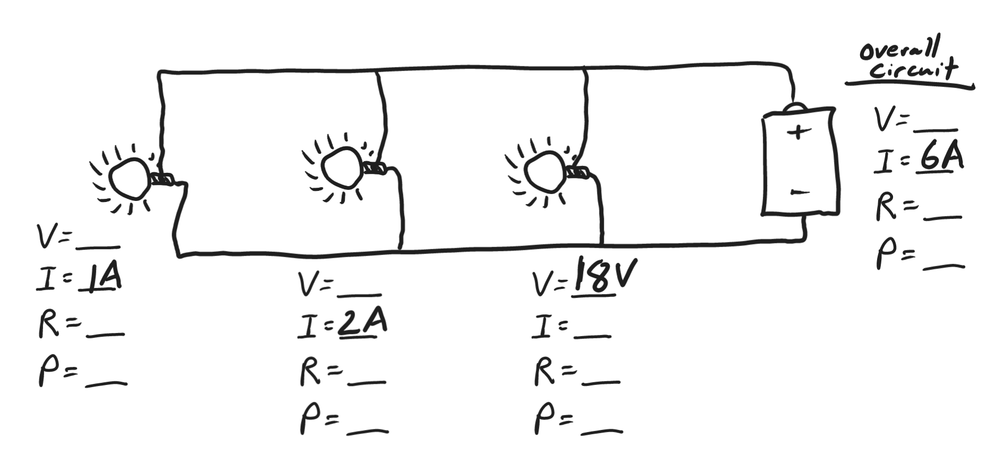
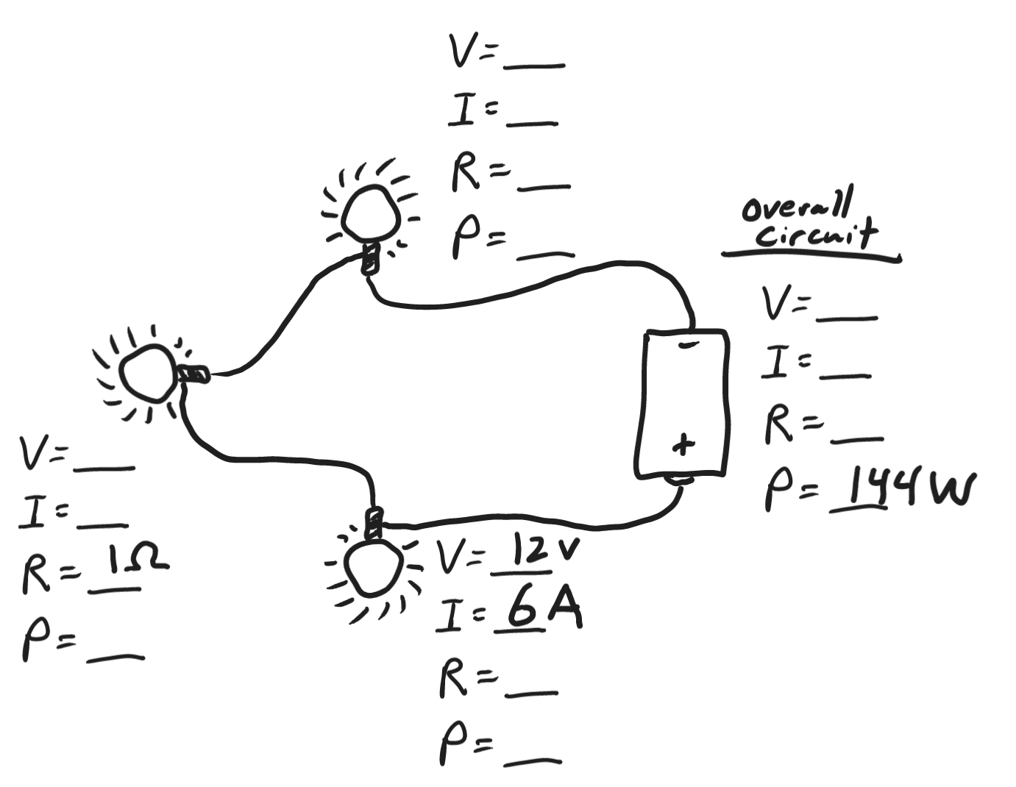
Physics 100 Name: __________________________
Practice Quiz 2 (Electric Current and Circuits)

Matching Section Answer Bank: Current, Voltage, Resistance, Circuit, power, DC, AC

1. ______________ A closed loop that electrons can travel in.
2. ______________ A measure of how fast electrical energy is used.
3. ______________ A type of circuit in which electrons only flow in one direction.
4. ______________ The “pressure” that pushes charge through a circuit
5. ______________ The amount of flow of electricity through a circuit
6. ______________ A type of circuit in which electron flow switches directions
7. ______________ Something that slows down the flow of electricity through a circuit

8. List three different sources of electricity that a Vermont homeowner could plug into in order to run an electrical device:
1) 2) 3)
9. How is coal used to create electricity?

10. How are dams used to create electricity?

11. How do solar panels create electricity?

12. Describe three ways that the electricity supply could be increased when demand increases.
1)

2)

3)

13. List at least one advantage and disadvantage for each of the following forms of electricity generation.
Source of Electricity | Advantages | Disadvantages
Coal and Gas
Nuclear
Hydroelectric
Wind
Solar

