Physics 100 Name: ____________________
Unit 2: Electricity
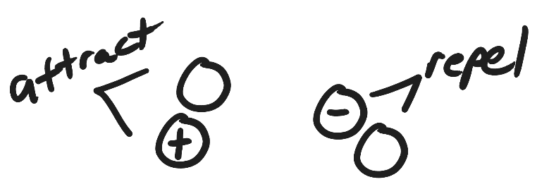
Test Review

Part 1:
1. For each of the pairs of charges on the right, add positive or negative signs to make the pairs attract and repel.

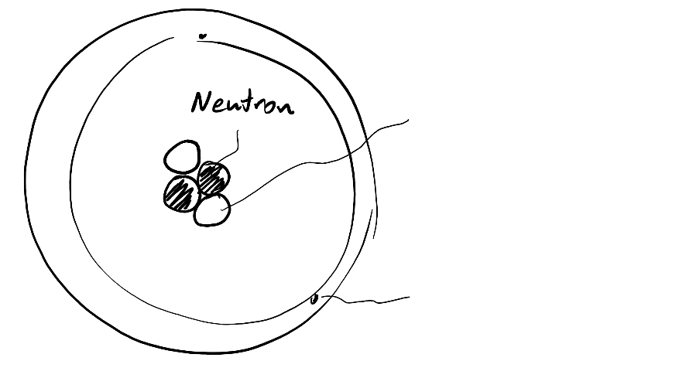
2. On the diagram to the right, write “proton” next to the line that points to a proton.

3. Write “electron” on the line that points to an electron.

4. Label the proton and the electron with appropriate charges (+ or -)

5. When two objects are rubbed together, and static electricity is created, which type of particle gets transferred?

6. Which has a stronger charge?
a. a proton b. an electron
c. neither, they’re equally strong

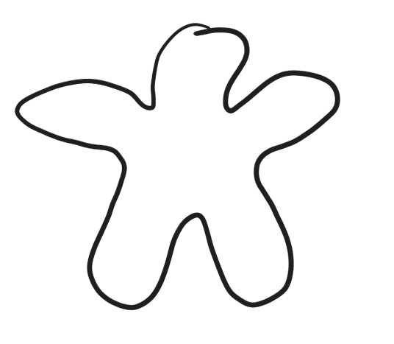
7. Draw charges in the object on the right so that there are 10 charges altogether and the net charge is +4?

8. What does the “static” part of the words “static electricity” mean?

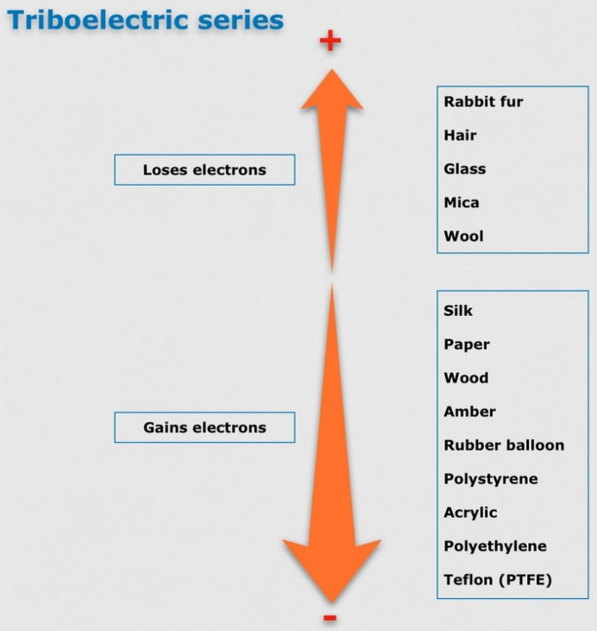
10. Sketch a simple picture of a neutral square of acrylic and a neutral wig of human hair. Draw some charges in each of them.

11. Refer to the diagram on the right, and then draw what the charges in the wool fabric and the stick of wood might look like after you rub them together.

12. What does the “Law of Conservation of Charge" tell us will happen when the wood and wool are rubbed together?

13. Draw a diagram showing how a balloon with a balloon with a strong negative net charge can stick to a wall that has zero net charge. Draw the balloon, the wall, and charges in both.

Part 2

1. Define “conductor” and give one example of a conductor.

2. Define “insulator” and give one example of an insulator.

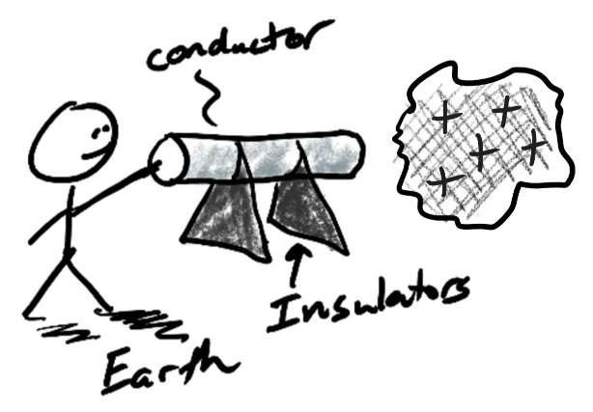
3. First you rub a foam block on some wool fabric. The foam block becomes negative and the wool becomes positive. Next you hold the wool next to a neutral conductor on an insulated stand. Then you touch the conductor and the Earth at the same time. Finally you let go of the conductor and remove the foam.

- What is the charge of the conductor after you let go? (+, -, or neutral)

- When you touch the small conductor with your finger, do charges move from the conductor to your finger or from your finger to the conductor?

- What type of charges move?

- Explain why these charges move in that direction.

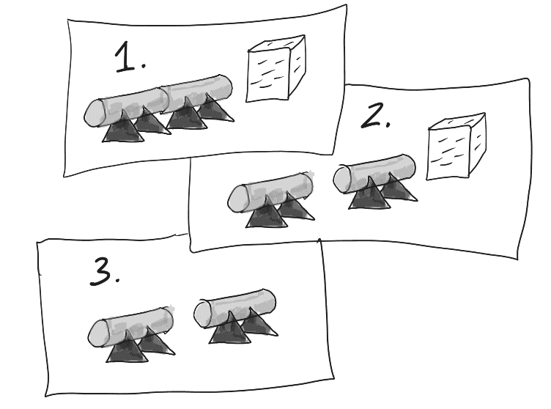
2. This time you place the two small neutral conductors so that they’re touching. Then you rub the foam block and the wool together. Next you hold the negatively charged foam block close to the conductor on one end, as shown in picture 1. Then you separate the conductors by touching only their insulator bases (like picture 2). Finally, you remove the foam block, as shown in picture 3.

- Label the charges of the conductors in picture 3 (+,-, or neutral)

- Describe what you could do to ground the positive conductor in picture 3.

- If you did ground the positive conductor, what type of charges would move at that time?

- What would those charges move from?

- What would those charges move to?

Part 3:

1. What is an electric field?

2. What creates an electric field?

3. A map of an electric field has arrows. What does the direction of the arrows tell us?

4. Two drawings of charged “pucks” and goals are shown below.
a. In the diagram draw some negative charges that will create an electric field that will cause the puck to go into the goal.
b. Draw an arrow representing the electric field created by your charges.

5. a. In the diagram below draw some negative charges that will make the puck go into the goal.
b. Draw an arrow representing the electric field created by your charges.

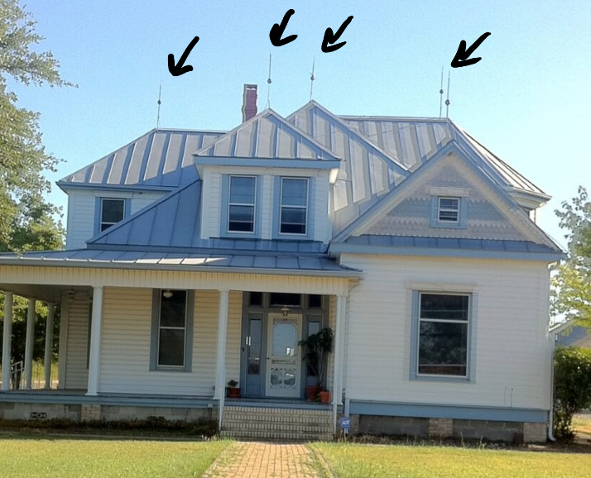
6. a. Why do people put lightning rods on buildings (like the house on the right)?

b. Explain what lightning rods do to charges.

7. If you’re inside a car, and lightning strikes the car, you will probably be okay. The reason that you’re safe has nothing to do with the tires. Why is a car a safe place to be during a lightning storm?

