Physics 100 Name: ____________________
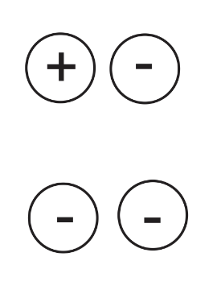
Unit 2: Electricity
Practice Quiz 1

1. For each of the pairs of charges on the right, tell whether the charges repel or attract one another.

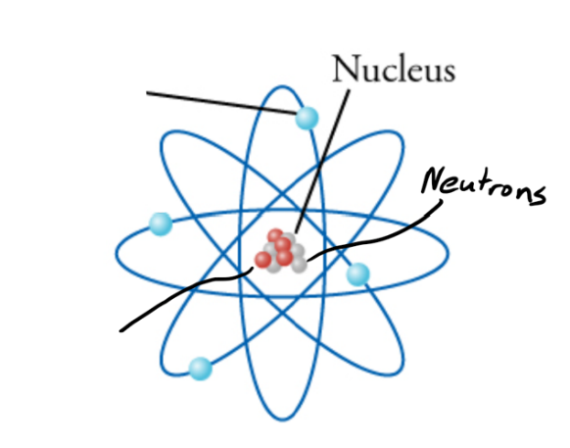

3. On the diagram to the right, write “proton” next to the line that points to a proton.

4. Write “electron” on the line that points to an electron.

5. Label the proton and the electron with appropriate charges (+ or -)

6. When two objects are rubbed together, and static electricity is created, which type of particle gets transferred?

7. Which has a stronger charge?
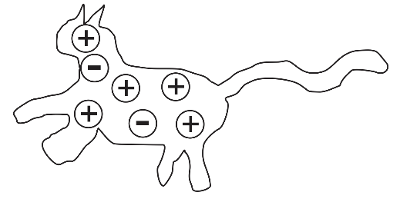
a. a proton b. an electron
c. neither, they’re equally strong

8. What is the net charge of the object on the right?

9. Why is static electricity called “static?”
a. It looks like static on a T.V.
b. When someone “gives you static,” it’s irritating, like a shock from static electricity.
c. The existence of static electricity was proven by using statistics.
d. Static charges don’t generally move. They don’t flow like electric current.

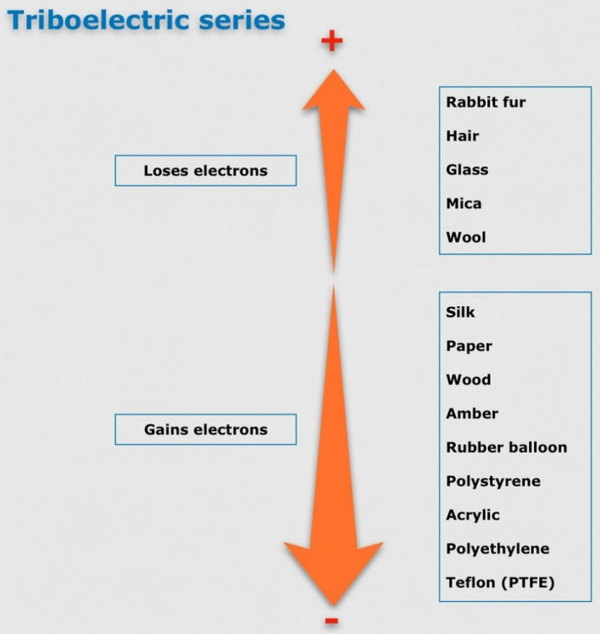
10. Complete this simple diagram of a neutral glass rod and a neutral rubber balloon. Draw some charges in each of them.
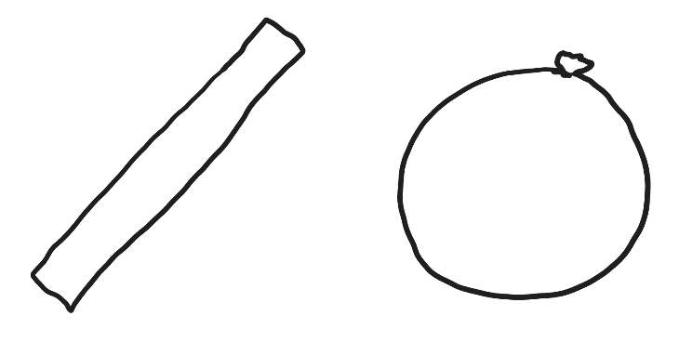

11. Refer to the diagram on the right, and then draw what the charges in the balloon and glass rod might look like after you rub them together.

12. What does the “Law of Conservation of Charge" tell us will happen when the balloon and the glass rod are rubbed together?

13. Draw a diagram showing how a balloon with a strong net charge (either positive or negative) can stick to a wall that has zero net charge. Draw the wall, the balloon, and some charges on each.

