Physics 100 Name: ____________________
Unit 2: Electricity
Practice # 2: Conductors & Insulators, and Charging by Induction

Conductors and Insulators

1. Define “conductor” and give one example.

2. Define “insulator” and give one example.

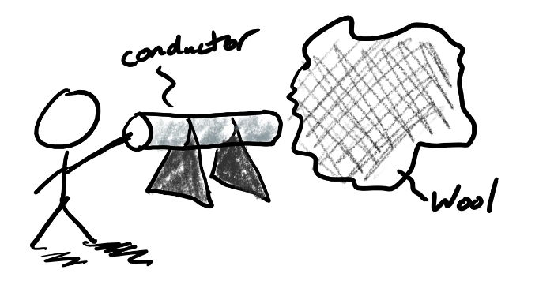
3. First you rub a foam block on some wool fabric. The foam block gains electrons while the wool fabric loses them. Next you hold the foam block next to a small conductor on an insulated stand while you touch the conductor and the Earth. Then you let go of the conductor and move the foam away.

- What is the charge of the small conductor at this point? (+, -, or neutral)

- When you touched the small conductor with your finger, did charges move from the conductor to your finger or from your finger to the conductor?

- What type of charges moved?

- Explain why these charges moved in that direction.

. This time you place the two small conductors so that they’re touching. Then you rub the foam block and the wool together. Next you hold the wool close to the right end of the right conductor, as shown. While you’re holding the wool there, you carefully separate the conductors by touching only their insulator base.

- What are the charges of the two conductors?

- Describe what you could do to ground the conductor on the right?

- If you did ground the conductor on the right, what charges would move, and what would they move from and to?

