Physics 100 Name: ____________________
Unit 2: Electricity
Notes, part 3: Electric Field, Etc.

7. What is an electric field?

8. What creates an electric field?

9. Electric Field Hockey (pHet Simulation)
1. Find and run the simulation.
2. Click the “Field” and “Trace” buttons.
3. Try to win levels 1 and 2.
4. What happens when you turn off “puck is positive,” so that the puck becomes negative?

10. Interesting (and important) facts:
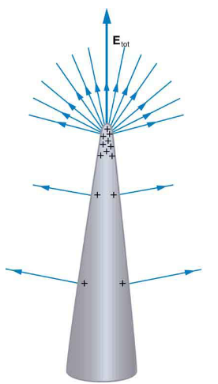
Fact #1: Charges “leak away” from surfaces of charged conductors that are

______________.

This explains why lightning rods are added to buildings:

This also explains why the surface of a Van de Graaff generator is ______________

_____________________

Fact #2: The electric field inside a conductor is _________________. This is why

one of the safest places to be during a lightning storm is

______________________________________________________

