Physics 100 Name: ____________________
Unit 2: Electricity
Notes, part 2: Conductors & Insulators, and Charging by Induction

Conductors and Insulators

1. _______________ allow electrons to easily move through them. List some examples.

2. _______________ do not allow electrons to move through them. List some examples.

3. Protons ________________ (can/cannot) flow through solid conductors. Why not?

4. Ground: a large, neutral source of charge (like the Earth). The ground can serve two purposes…

“The ground” can…

“The ground” can…

5. What happens to an object when the object is “grounded?”

6. What other objects, other than the Earth, could be used to ground something?

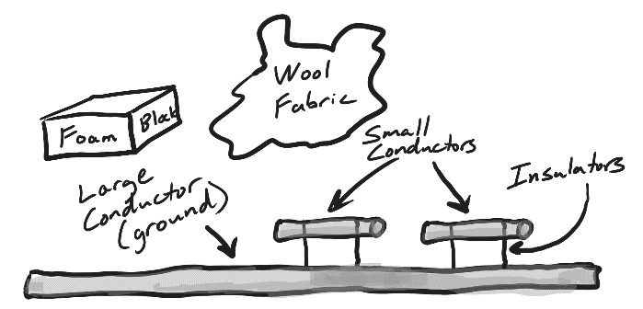
Charging By Induction:
Show two unique methods of charging the small conductors using the materials in the diagram, but without touching the styrofoam or wool to the conductors. This is called “charging by induction” to distinguish it from the other method of charging we have seen – charging by rubbing things together. Explain what is happening during your steps. Assume that everything has a neutral net charge in the beginning.

Method 1: Giving the small conductors opposite charges, without grounding.

Method 2: Charging one conductor at a time, using grounding.

