Physics 100 Name: ____________________
Electricity Part 1: Electrical Charges and “static electricity”

1. What are the two types of charges?

2. Like charges __________________ and unlike charges _________________.

3. In atoms, ______________ carry negative charge and _______________ carry positive charge.

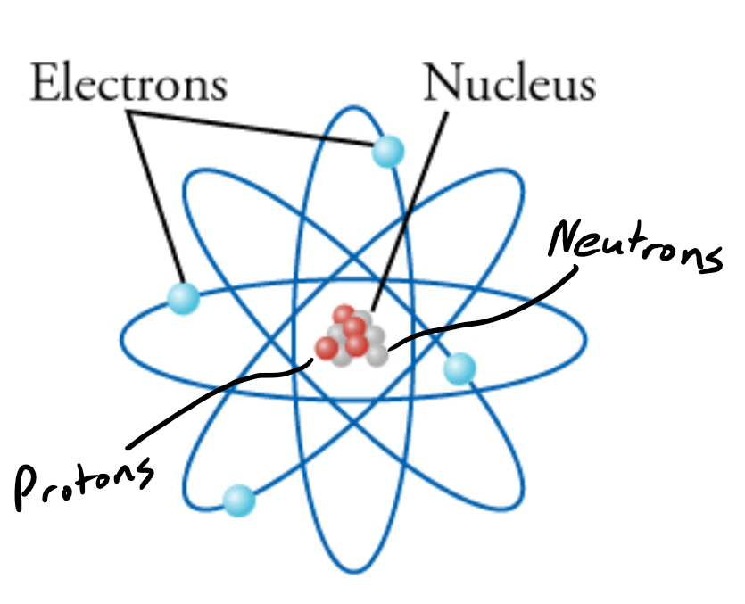

4. The strengths of a proton’s charge and an electron’s charge are

___________________ (though they are opposite)

5. “Net charge” is what you get when you add up all of the positive and negative charges inside something. What is the “net charge” of an object with….

a. 3 protons b. 4 electrons

c. 2 protons and 1 electron d. 5 electrons and 3 protons

d. 7 protons and 7 electrons

6. When materials are rubbed together, charges can be separated, particularly if one material has a greater ________________________________________ than another.

7. Rabbit fur has a _______________ affinity for electrons, while PVC has a _____________ affinity for electrons.

8. Suppose we have a rabbit fur that has zero net charge, and we also have a PVC pipe that has zero net charge. What can we say about the number of protons and electrons in each object?

9. If we rub a PVC pipe with rabbit fur, what effects might we observe? Why?

10. During this experiment, what has happened to the total number of positive and negative charges (if we add up all the positive and negative charges on the two objects)? Has the total increased, decreased, or stayed the same. Explain.

11. Law of Conservation of Charge:

12. In the winter, people often talk about static electricity. What does the “static” part of “static electricity” mean? Why is it called “static electricity?”

