Physics 100 Name: ____________________
Unit 2: Electricity
Notes, part 2: Textbook Chapter 18.1, 18.3 Conductors & Insulators, Electric Field, Etc.

Conductors and Insulators

1. _______________ allow electrons to easily move through them. List some examples.

2. _______________ do not allow electrons to move through them. List some examples.

3. Protons ________________ (can/cannot) flow through solid conductors.

4. Ground: a large, neutral source of charge (like the Earth). The ground can serve two purposes…

“The ground” can…

“The ground” can…

5. What happens to an object when the object is “grounded?”

6. What other objects, other than the Earth, could be used to ground something?

7. What is an electric field?

8. What creates an electric field?

9. Electric Field Hockey (pHet Simulation)
1. Find and run the simulation.
2. Click the “Field” and “Trace” buttons.
3. Try to win levels 1 and 2.
4. What happens when you turn off “puck is positive,” so that the puck becomes negative?

10. Interesting (and important) facts:
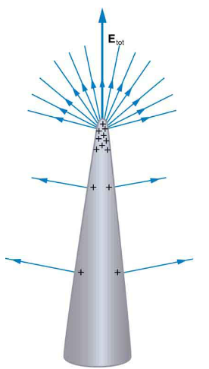
Fact #1: Charges “leak away” from surfaces of charged conductors that are

______________.

This explains why lightning rods are added to buildings:

This also explains why the surface of a Van de Graaff generator is ______________

_____________________

Fact #2: The electric field inside a conductor is _________________. This is why

one of the safest places to be during a lightning storm is

______________________________________________________

