Physics 100 (Stapleton) Name: ____________________________
Circuit Lab

Using Power Supplies and Measuring Voltage Drop
Voltage Reading
Current Reading
Voltage Control (set = 0 before turning on)
Current Control (set = ½ max before turning on)
Using the Power Supply
Step 1: Set Voltage to Zero
Step 2: Set current to ½ of maximum.
Step 3: Turn on power supply.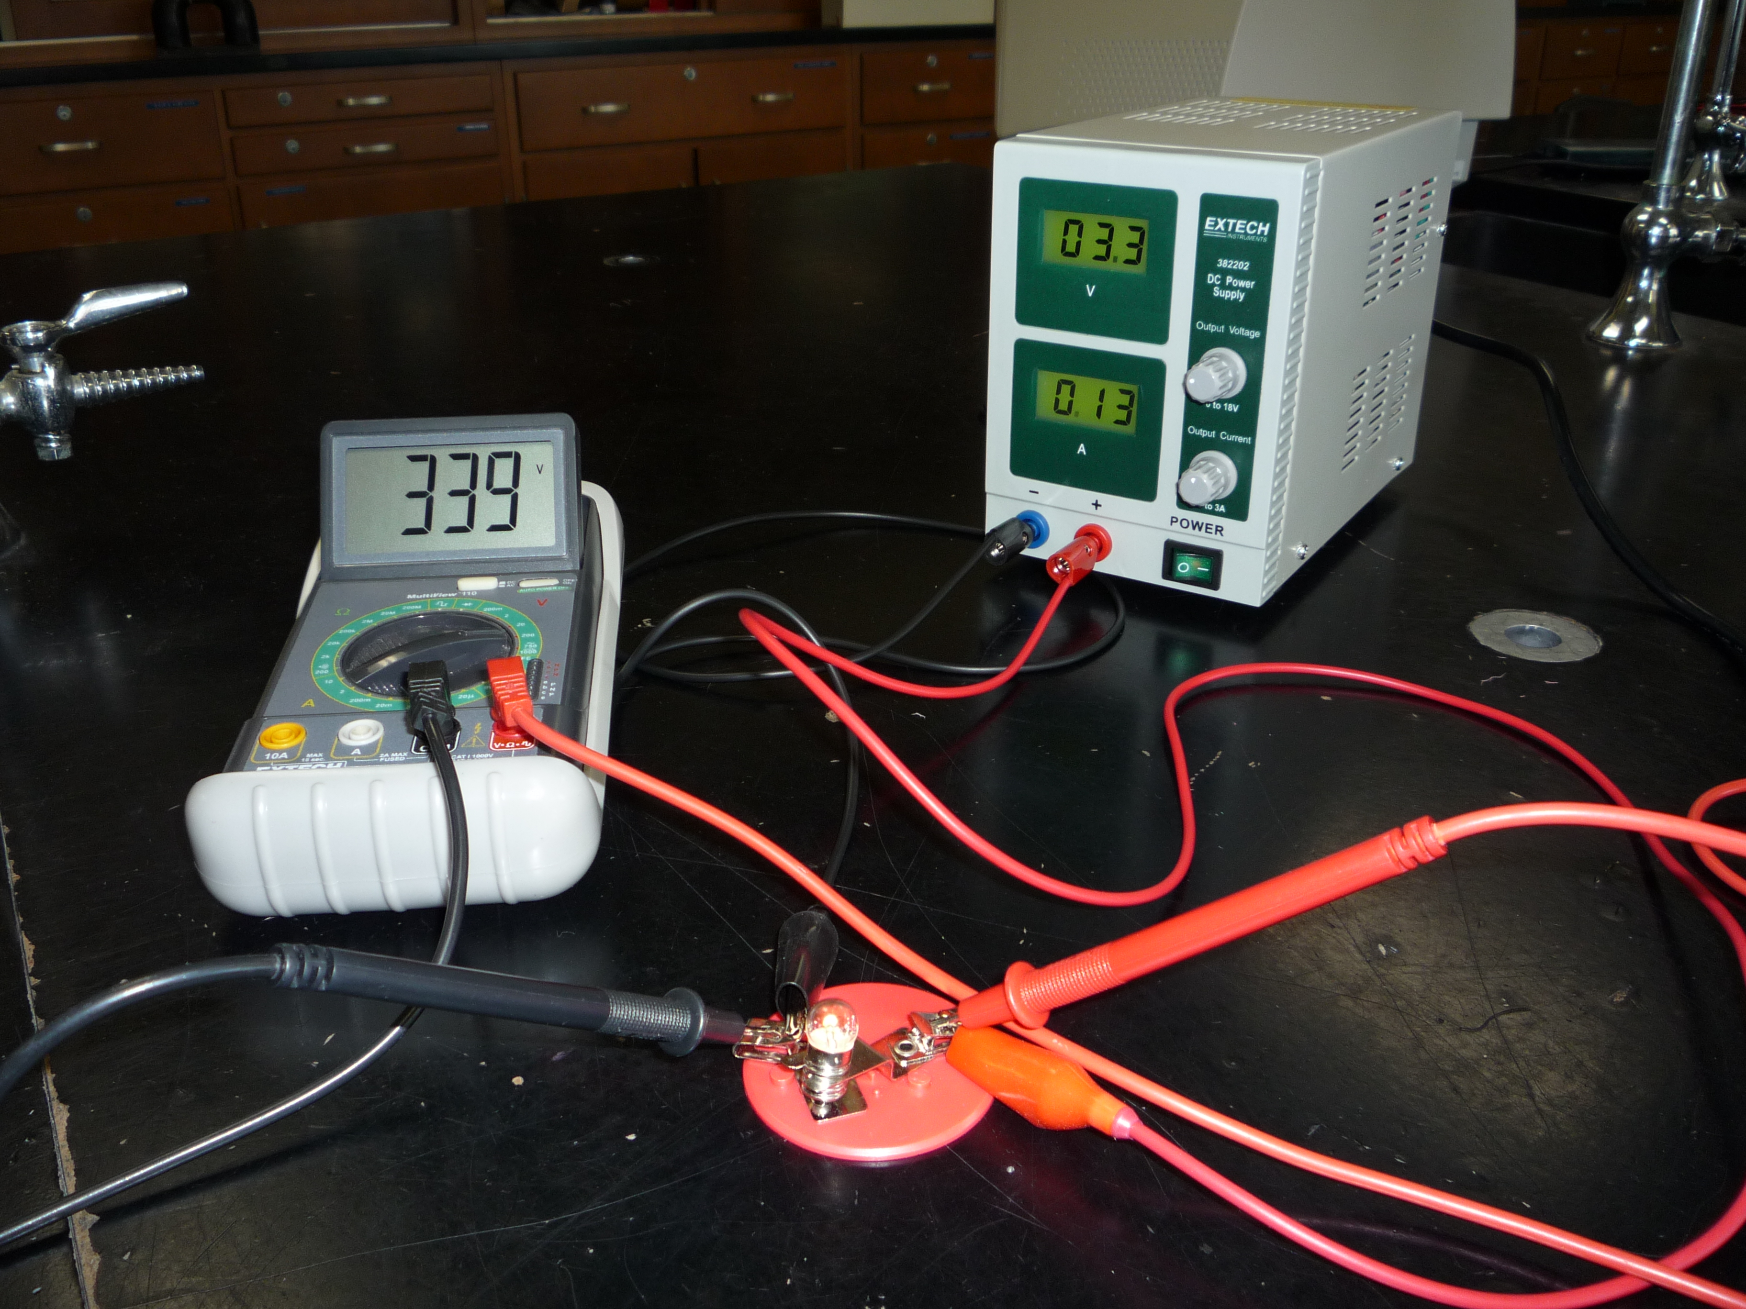 Keep voltage at or below 6V.
Measure Voltage Drop by touching the two probes of the voltmeter to each terminal of the bulb holder.

Measuring Source Voltage and Current: See Power Supply Readout
Measuring Individual Voltage Drops across resistors (bulbs):
Set the Digital Multimeter (DMM) to measure the lower of either 20V or 200V DC (solid line over dotted line) This is done by turning the dial. The DMM should read 0 when you turn it on. Let your teacher know if it does not.
Simply touch the two probes to each terminal on the bulb holder. This measures the potential difference between the two sides of the bulb.
Measuring Current Through Individual Resistors (bulbs): Don’t try it. You will have to infer these values using other methods.
Definition of Power:

Units for Power:
Formula for calculating electrical power:

Example: If 3A of current flows through a bulb with a voltage drop of 9V, the bulb uses __________W of power.

Circuit directions:
- Build each of the follwing circuits with real bulbs and a power source. Remember to limit the voltage to 6V.
- Use all identical bulbs, and assume that they have the same resistance.
- Once you have built each circuit, measure the “voltage drops” across the battery (overall circuit) and the bulbs.
- Then find each of the currents, resistances, and powers in the diagram.
- Use the PhET simulation to check your answers or to find answers that you are missing.

