Physics 100 Name: ________________________
Optics Notes: Some More Light Phenomena
Blue and Red Skies, Human Vision, and Rainbows
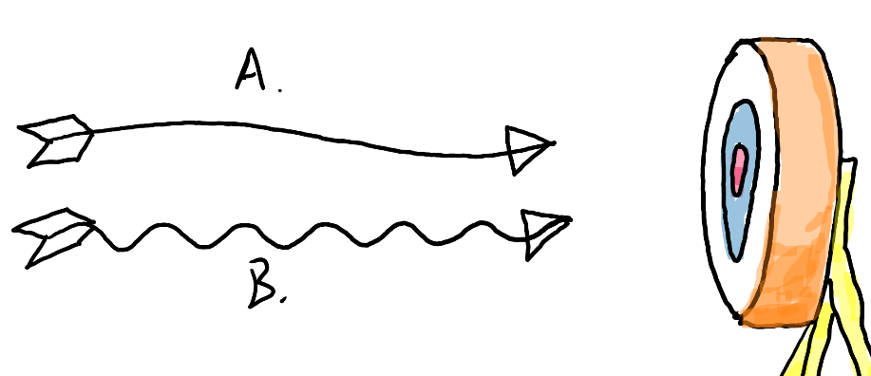
1. Which arrow is most likely to penetrate the target on the right?

2. One arrow represents blue light, and the other represents red. Which is which?

3. We often talk about the “red end” and the “blue end” of the color spectrum. One end passes easily through the atmosphere, and the other end gets scattered all around the sky. Which end of the spectrum gets scattered?

4. Why is the sky blue?

5. Use the diagram below to show why sunsets are red.

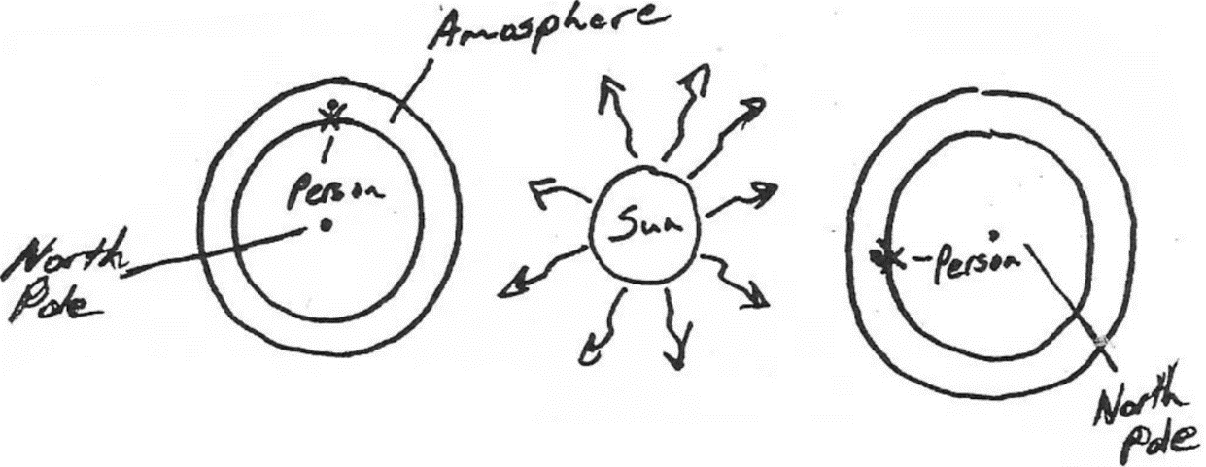

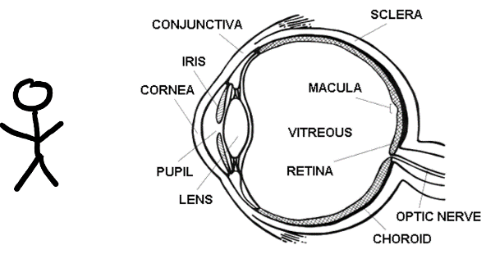
6. Use the diagram on the right to make a simple sketch showing how our eyes see.

7. Use the two dots below to “see” your blind spots. Find your right eye’s blind spot by covering your left eye and focusing on the left dot. Move the paper closer and farther from your face until the right dot disappears. When it disappears it is being projected onto your blind spot.

9-12. The diagrams on the right show how images are projected after being focused by an eye’s lens.

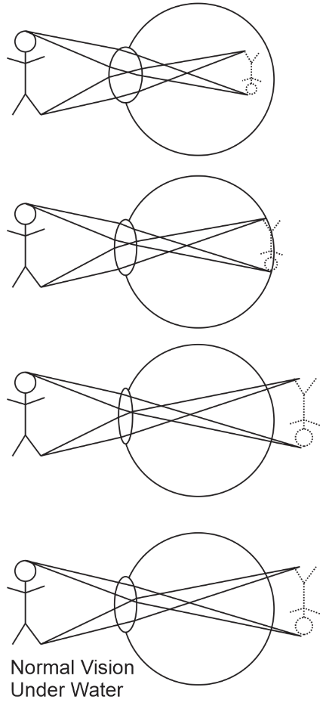
9. One of the eyes is shows an example of myopia (nearsightedness). To a nearsighted person, the image would appear blurry, but if the object were brought closer to the eye, it could be seen clearly. Label the nearsighted eye. [Nearsighted eyes can see things that are near.]

10. One of the eyes is shows an example of hyperopia (farsightedness). To a farsighted person, the image would appear blurry, but if the object were moved farther from the eye, it could be seen clearly. Label the farsighted eye. [Farsighted eyes can see things that are far.]

11. Explain why underwater vision is blurry.

12. Which people can, in some cases, actually see better under water, nearsighted people or farsighted people? [seals have evolved to be like this]
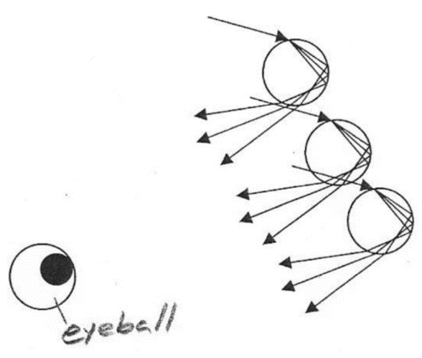

13. The diagram on the right shows how primary rainbows form. In the diagram, sunlight enters each raindrop and exits the raindrops as green, red, and blue light (to keep it simple, we’re not showing a full rainbow).

What color does the eyeball see when it looks at each raindrop?

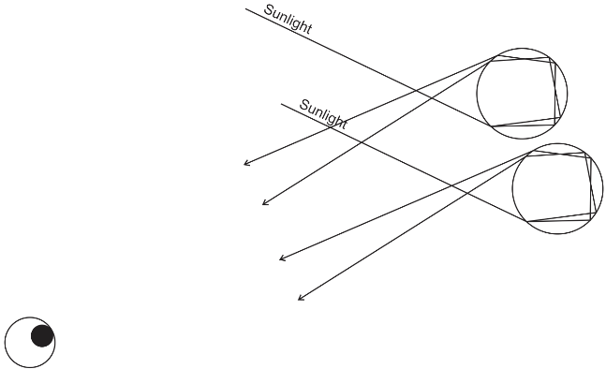
14. The diagram on the right shows how secondary rainbows form. To keep this diagram even simpler, the only colors shown are red and blue.

What color does the eyeball see when it looks at each raindrop?

15. Why does a secondary rainbow look dimmer than a primary rainbow?

