Physics 100 Name: ________________________
Optics Test Review

1. Multiple choice: Light is a special type of _________.
a. Sound wave
b. Electromagnetic wave
c. Longitudinal wave
d. Mechanical wave

2. Describe two properties that light shares with all waves.

3. Describe two properties that light shares with particles.

4. Draw a diagram showing a ray of light passing through a prism and separating into the colors of the rainbow. Label the colors. You can just use the first letters if you want.

5. What wavelengths of light are combined to make black light?

6. What wavelengths of light are combined to make white light?

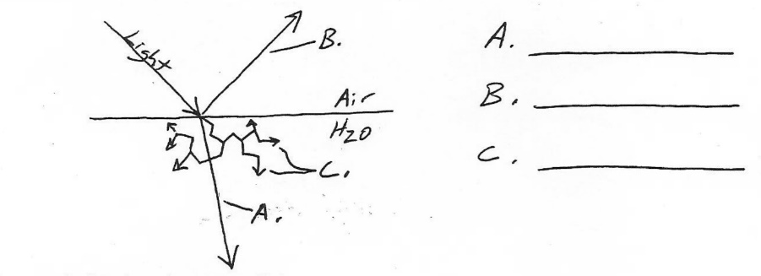
7. Identify the three wave behaviors that are shown on the right.

8. Draw a diagram illustrating a ray of light that is both refracting and reflecting. Draw the normal. Then clearly label the angles of incidence, reflection, and refraction.

9. Explain the “law of reflection.” You can use a diagram if you want, but you will also need some words.

10. Explain why light travels faster through some materials than others.

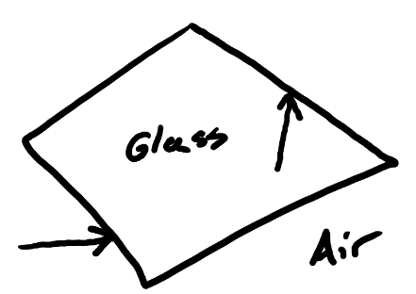
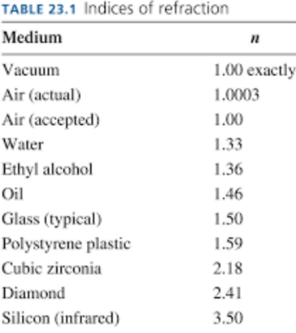
11. The diagram on the right shows two rays of light. One is about to pass from air into glass, and the other is going to pass from glass into air. Draw arrows to show how the rays will refract in each case.

12. If we have a substance that has a higher refractive index(n) than other substances, what does that tell us about our substance?

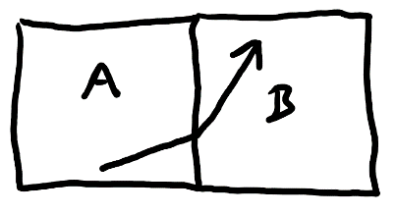

13. Given the manner of light’s refraction as it passes from block A to block B, which block has a higher index of refraction (a higher n)?

14. One of the blocks on the right is polystyrene plastic. The other is glass. A ray of light is passing from one block to the other. Identify the blocks.

15-16. For the next two problems, use the equation $v=\frac{C}{n}$ , where C is the speed of light (3x10⁸m/s).

15. Find the speed of of light in a substance with n = 1.8.

16. a. Find the value of n for a substance in which the speed of light is 2.21x10⁸m/s.

b. Identify this substance using the table on the previous page.

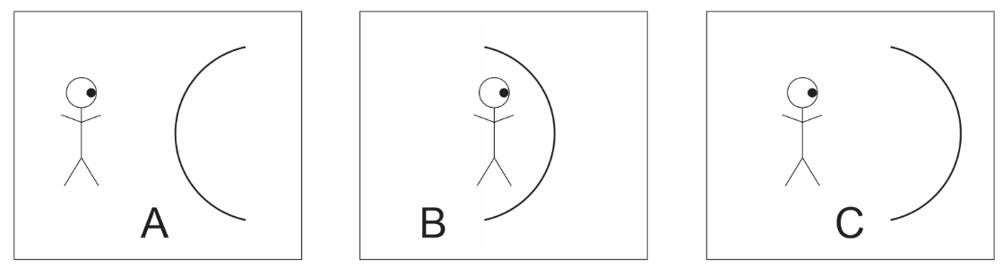
17-21. For the following questions, consider the creatures looking in to the mirrors of the diagrams.

17. In which diagram(s) is the creature using a convex mirror?

18. In which diagram(s) is the creature using a concave mirror?

19. In which diagram(s) will the creature see itself upside-down.

20. In which diagram(s) will the creature definitely see a magnified (larger) version of itself.

21. In which diagram(s) will the creature definitely see a smaller version of itself.

22. Why is the sky blue?

23. Show and explain why sunsets are red.

24. Each of these drawings shows sunlight entering a raindrop, but only red light is shown refracting and leaving the raindrop. 1) Add some refracted blue light to the diagram. 2) Then show where you would have to put your eye if you wanted to look at the raindrops and see blue. 3) Finally, identify which raindrop would be part of a primary rainbow, and which raindrop would be part of a secondary rainbow.

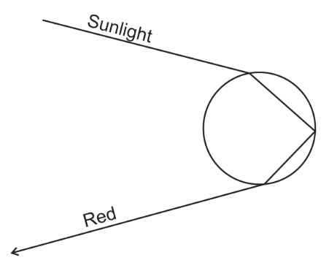
25-27. The diagrams below feature glass lenses. Complete each diagram in a way that shows how the lens refracts light and alters what is seen by the observer’s eyeball. For each diagram…
- Use solid lines to show the path of a light ray from the top of an observed object to the observer’s eyeball.
- Use solid lines to show the path of a light ray from the bottom an observed object to the observer’s eyeball.
- Use dotted lines to show the apparent paths of light to the apparent image seen by the observer.
- Use dotted lines to draw the apparent image of the observed object.

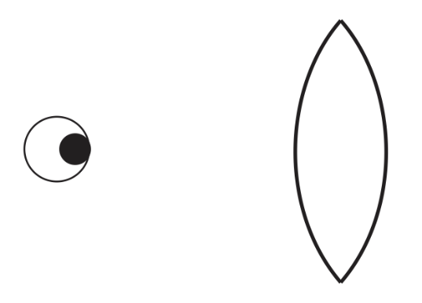
25. Show how an observed object can appear upside-down.

26. Show how an observed object can look larger and right-side-up.

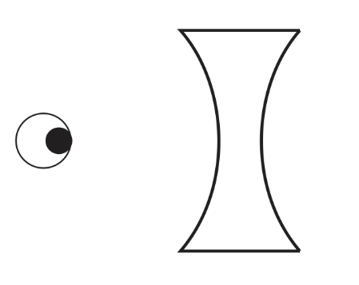
27. Show what any object looks like when viewed through this lens.

28. If a castaway is standing on a rock by the ocean, trying to spear a fish, should they aim above where they see the fish or below where they see the fish? Create a diagram showing why.

