Physics 100 Name: ________________________
Spool Car Analysis Practice Problem

Formulas: $a=\frac{∆v}{∆t}$ $F_{Net}=ma$ $w=mg$

Part 1: Data Collection

1. Measure the mass of your spool car using one of the balances in the classroom.

Spool Car Mass = 186g

2. Use a slow-motion video and the provided spreadsheet to create a graph of your spool car’s velocity, as it changes over time.
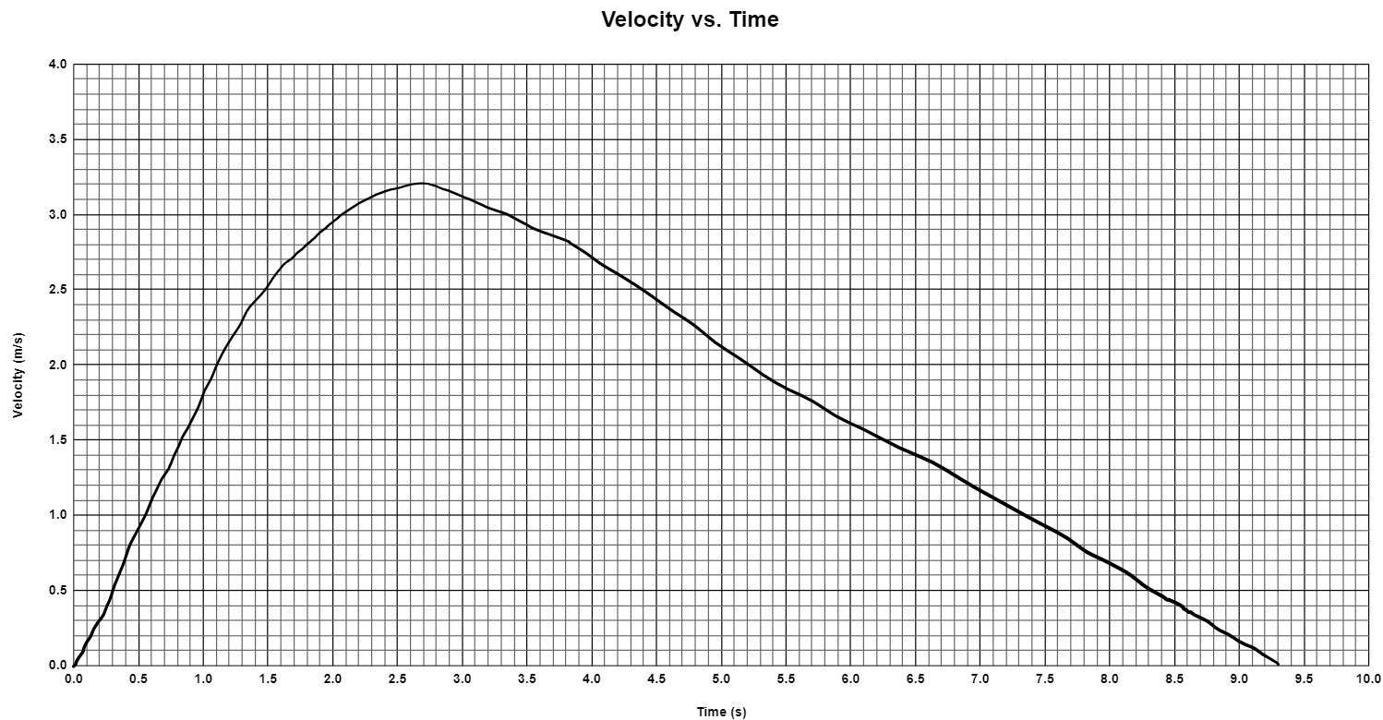

Part 2: Calculations and Finding Forces

3. Convert the mass of your spool car to kg. 1kg = 1,000g.

Spool Tractor Mass = __________

4. Calculate the weight of your spool car, in Newtons.

Spool Tractor Weight = _________

5. On your velocity vs time graph, circle and label the “speeding up” phase and the “slowing down” phase. Also label the maximum velocity, the time at which the car reaches its maximum velocity, and the final time.

6. Calculate your spool car’s average acceleration during the “speeding up” phase.

Acceleration during Speeding Up Phase = __________

7. Calculate the average net force acting on your car while it is speeding up.

F_{Net} = __________

8. Calculate your spool car’s acceleration during the “slowing down” phase.

Acceleration during Slowing Down Phase = __________

9. Calculate the average net force acting on your car while it is slowing down. Show your work.

F_{Net} = __________

10. Create a diagram showing all of the forces acting on your car while it is slowing down.
- Draw your car traveling rightward.
- Label your car with its mass in kilograms.
- Use arrows to show every individual force that is acting on the car.
- Label each individual force with correct units and its correct name.
- Off to the side somewhere, write the Net force and acceleration. Don’t use arrows for these. Just include correct signs and units.

11. Create the same type of diagram showing all of the forces acting on your car while it is speeding up. Assume here that the force of friction is the same when the car is speeding up and slowing down.

