Unit 2 Handout – Forces Name: ________________________________
Physics 100 (Stapleton)

Notes: Introduction to Newton’s Laws

Newton’s 3 Laws of Motion:
- 1st Law: Law of Inertia. Objects in motion…
- 2nd Law: F=ma
- 3rd Law: Action/reaction

Net force (F_{net}):
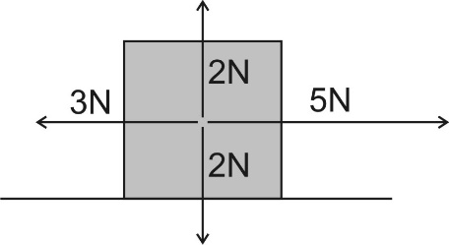

What is the net force that is acting on the box to the right?

Newton’s 1st Law:

- The usual version: Objects in motion remain in motion in a straight line and at a constant speed, and objects at rest stay at rest, unless they are acted upon by an outside (or unbalanced) force.

- Another version: If an object is experiencing a net force, _________________________________________.

If it’s not, _________________________________________________.

Newton's 1st Law is called the "Law of Inertia." Inertia is:

What kinds of objects have the most inertia?

Newton's 2nd Law: F_{net} = ma

Mass:

The unit we will use for mass is the ________________________, which is abbreviated _________
Force:

The unit we will use for force is the ________________________, which is abbreviated _________

Consider a child pushing a toy car. The net force applied to the car equals the mass of the car multiplied by the car’s acceleration. Starting with an ordinary F = ma, show what would happen to the sizes of F, m, and a if…

- The car’s mass is increased, but the applied force is kept the same.

- The car’s mass is decreased, but the applied force is kept the same.

- The car has the same mass, but it accelerates faster.

- The car has the same mass, but less force is applied to the car.

Newton’s 3rd Law:

State Newton’s 3rd Law of Motion:

Describe some examples of action/reaction pairs demonstrating Newton’s 3rd Law.

- Walking Rightward:

- Car driving leftward:

- Helicopter flying upward:

- Gun shooting bullet rightward:

In the case of a gun and a bullet, what is equal and opposite, and what is not? Explain.

Newton Sled Activity

Directions: Make a loop of string and test its length to see if it stretches your rubber bands the correct distance. If it does, make 6 more identical loops of string. Save your original to use as a template if you need to make more.
Launch all of the items below by burning the string to release the stretched rubber bands. Use the same number of rubber bands every time, and make sure that every launch happens in the same way. The only variable here should be the object that is launched. Fill out the data table as you go. Then answer the questions.

Object Launched | Sled travel distance (m) | Launched Object travel distance (or description of its speed)
200g mass
500g mass
Ping pong ball
Entire Earth

- When the ping pong ball is launched, what gets pushed with the most force, the sled or the ping-pong ball? Explain your reasoning.

- When the entire Earth is launched, what gets pushed with the most force, the sled or the Earth? Explain how you can tell.

- Out of all of the items that you launched, which one experienced the most force? ___________________

Which one experienced the least force? __________________

How can you tell?

- Explain how this activity demonstrates F=ma. Cite specific examples.

- Newton’s 1st Law uses the term “unbalanced.” It says that “objects in motion remain in motion, in a straight line and at a constant speed, and objects at rest stay at rest, unless acted upon by an unbalanced (net) force.”

- Before, during or after an object’s launch, when are the forces on the object balanced, and when are they unbalanced?
- For each of these times, explain how you can tell.

- Which of Newton’s Laws do you think is most important for understanding what is going on in this activity?

1st Law: Objects in motion…
2nd Law: F=ma
3rd Law: For every action, there is…

Explain why.

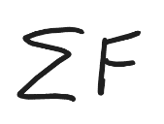
Notes and Practice: Newton’s 2nd Law and Terminal Velocity

1. Newton’s 2nd Law: F_{net} = ma I often write F_{net} like this…

2. If you want, you can use an algebra triangle for F=ma…
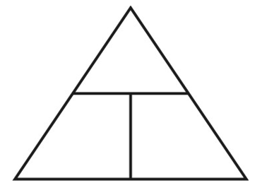

3. Use Newton’s 2nd Law to fill in the missing values in these diagrams

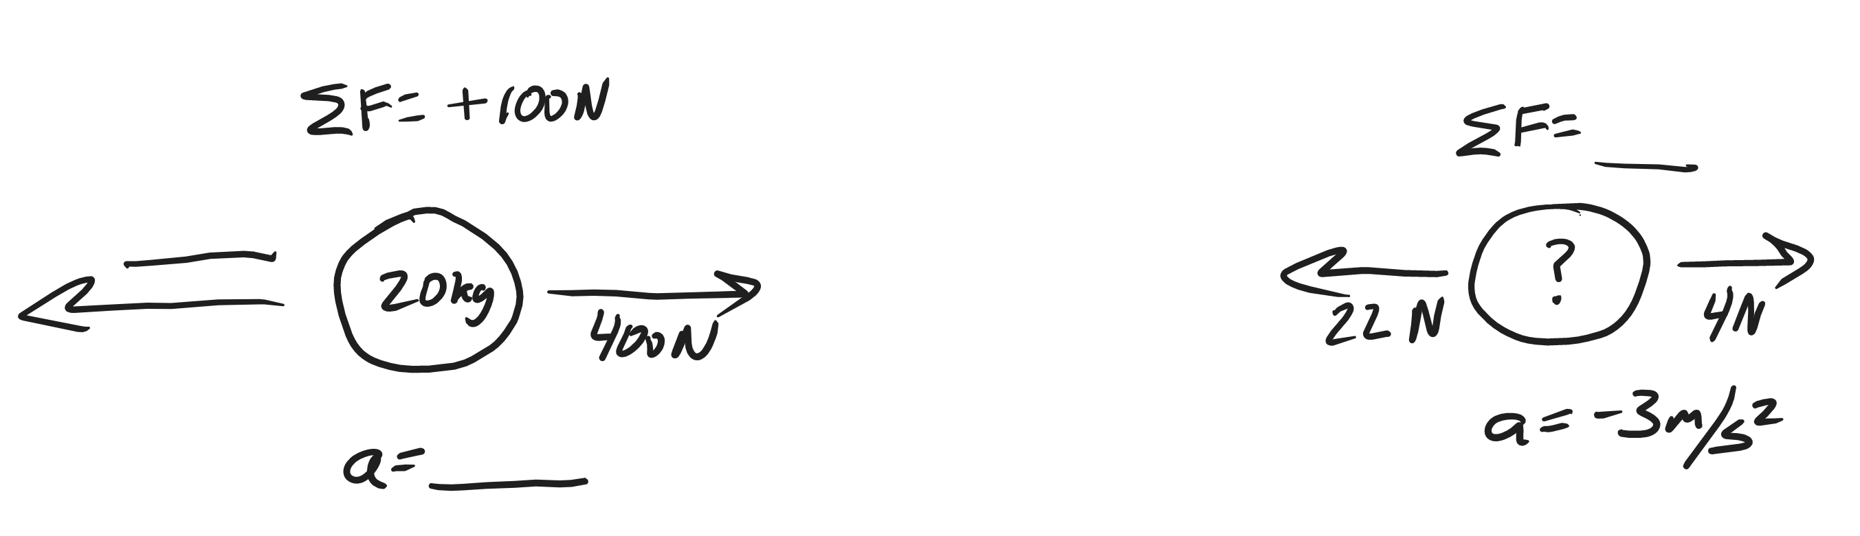

4. Newton’s 2nd Law can also be used to calculate weight. Since weight is the force of gravity, we can use F=ma, with 10m/s² substituted in for acceleration. We usually write the weight formula like this…

5. What is the weight of a 10kg block of ice, on Earth?

6. Use Newton’s 2nd Law, and the formula for weight, to fill in the missing values in these diagrams

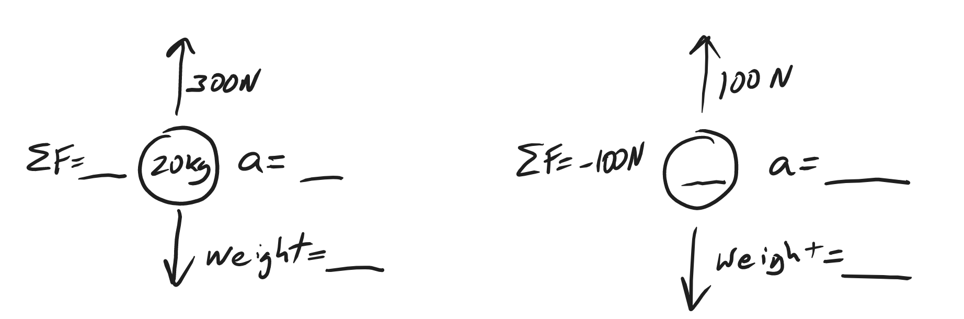

Practice Problems:

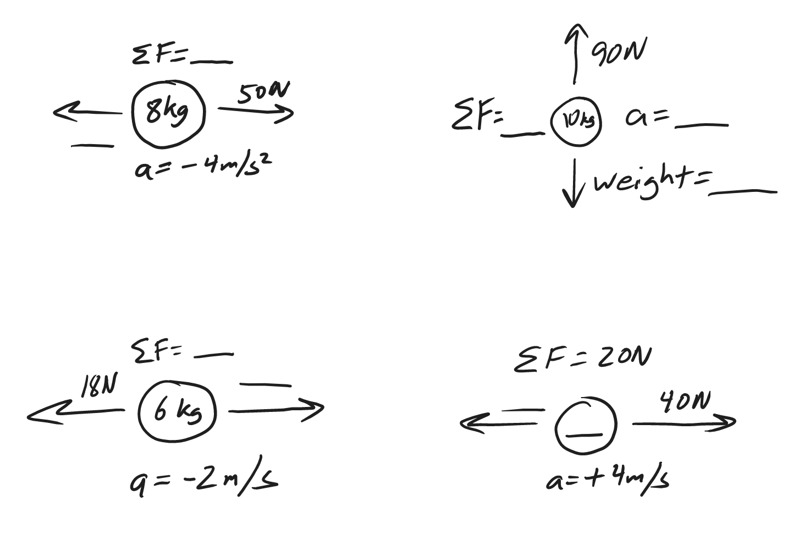
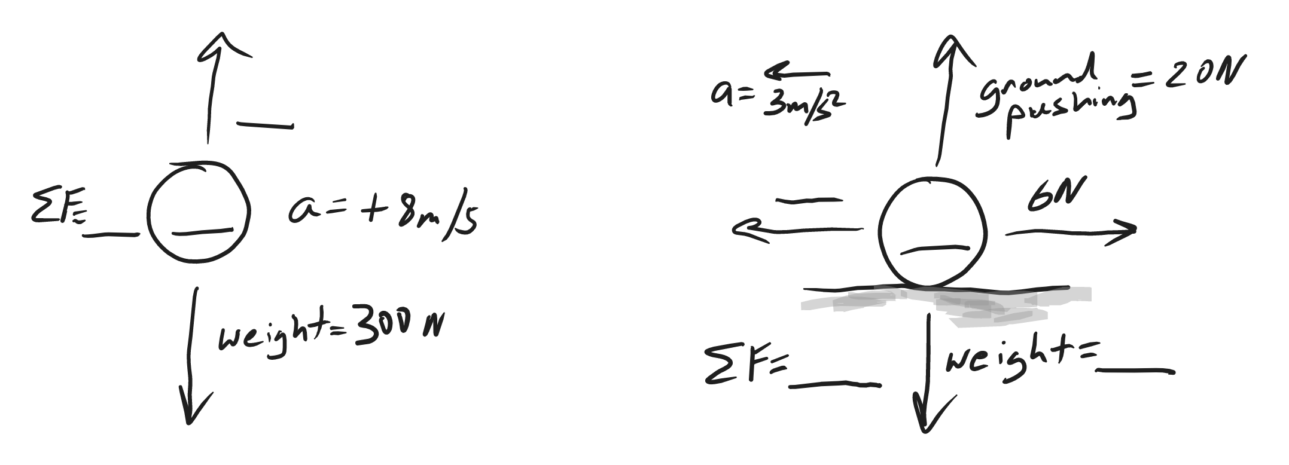

Drag and Terminal Velocity:

7. What is drag?

8. Draw diagrams showing all of the forces acting on a skydiver in 3 different situations: negative acceleration, zero acceleration, and positive acceleration. Which one of these situations is called “terminal velocity?” Why?

The first table below provides information relating to a parachute jump. A parachuter steps out of an air plane, begins to fall, and subsequently reaches terminal velocity. After reaching terminal velocity, the parachute deploys her chute. The chute takes a few moments to open, and soon after that the parachute reaches a new terminal velocity. Minutes later, the parachute lands on the ground.

9. What happens to a falling object’s velocity as it reaches terminal velocity?

10. Why does a falling object reach a terminal velocity?

11. How and why does the act of a parachute opening her parachute affect her terminal velocity?

12. Use the provided data to fill in the table below. Include proper units!

Time | Event
0s | Parachuter steps out of plane
15s | Parachuter reaches a first terminal velocity of 60m/s
50s | Parachuter pulls chute cord. Chute deploys.
60s | Parachuter reaches a second terminal velocity of 7m/s
600s | Parachuter lands

Time | Parachuter Mass | Parachuter Weight | Air Resistance (plus direction) | F_{net}  (plus direction) | Acceleration  (direction) | Speed
0s | 100kg
10s |  |  | 800N Upward |  |  | 45m/s
45s
55s |  |  | 1600N Upward |  |  | 40m/s
150s

Terminal Velocity Practice:

The first table, below, is a timeline detailing a parachuter’s descent from an airplane. The second table is an incomplete analysis of mass, forces, and acceleration relating to the parachuter’s fall. Use the timeline and your knowledge of physics to complete the second table. Pay close attention to the times in the second table. Most of them do not coincide with the times in the first table, but you can still use the first table to complete the analysis for those times. Before you go too far, it would be prudent to first identify the times in the second table at which the parachuter has reached terminal velocity.

Time | Event
0s | Parachuter steps out of plane
20s | Parachuter reaches a first terminal velocity of 45m/s
75s | Parachuter pulls chute cord. Chute deploys.
80s | Parachuter reaches a second terminal velocity of 4m/s
700s | Parachuter lands

Don’t forget proper units!

Time | Parachuter Mass | Parachuter Weight | Air Resistance (plus direction) | F_{net}  (plus direction) | Acceleration  (direction) | Speed
0s | 50kg
3s |  |  | 100N Upward |  |  | 20m/s
72s
76s |  |  | 1500N Upward |  |  | 40m/s
500s

Notes and Practice: Friction and The Normal Force

Define Normal Force:

Define Friction:

What determines the strength of friction between two surfaces?

1)

2)

3)

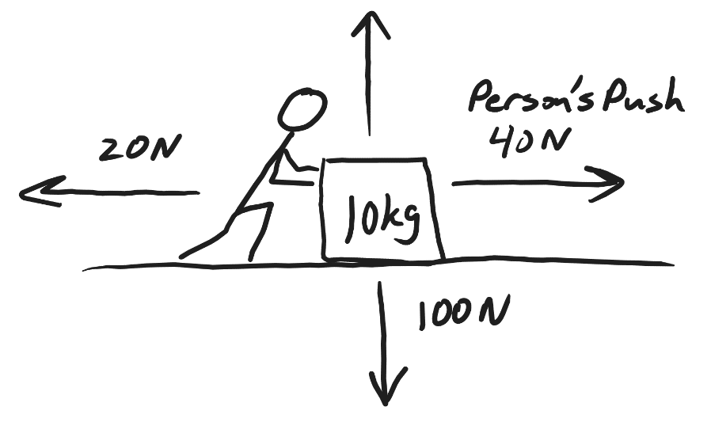
In the diagram on the right, a person is pushing a box. The box is sliding rightward along a level surface. The force of the person’s push is labeled.

A. Label the other forces that are acting on the box: Normal Force, Friction, Weight.

B. Fill in the magnitude of the force that is missing its magnitude.

C. Calculate the net force acting on the box

F_{net} =

D. Use Newton’s 2nd Law to find the box’s acceleration

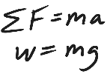
Friction Problems: Draw a diagram showing all of the individual forces and the net force. Then solve the problem.

1. A 3kg box is sliding with a velocity of -2m/s. The force of friction acting on the block. The block’s acceleration is +1m/s². If a person is pushing the block with a force of -4N, what is the force of friction that is acting on the box?

2. A child and her sled have a combined mass of 20kg. Her brother is pushing her along a flat, snowy surface with a force of 40N. If the snow is applying a -10N force of friction, what is the child’s overall acceleration?

3. A hunter is beginning to drag an antelope. The hunter applies a +150N sideways force to the antelope, which has a mass of 60kg. If the antelope is currently accelerating at a rate of 2m/s², what force of friction is acting on the antelope?

4. A car weighing 10,000N is being pushed to the left by three stranded students. If the car has a constant velocity of -1m/s, and the students are applying a total force of -800N, what is the force of friction acting on the car?

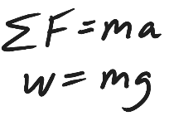
Elevator Problems:
When you’re standing on a scale, what does the scale reading tell you?

5. A student has a mass of 50kg. He is standing on a bathroom scale in an elevator, and the scale reads 300N. What is the student’s acceleration?

6. Another student has a mass of 50kg, and she is standing on a bathroom scale in an elevator. This elevator is accelerating upward at a rate of 2m/s². What is the scale reading?

7*. A third student is also standing on a scale in an elevator, and the scale reads 300N. If the student weighs 600N, what is the acceleration of the student and elevator?

8. A fourth student, whose mass is 60kg, is standing in an elevator on a bathroom scale. The student feels very heavy. In fact, when she looks at the scale, the scale reads twice her normal weight. What is the elevator’s acceleration?

Real-life Problem – Analyzing a Sliding Object

Fill in all of the information below and create a diagram showing all of the forces acting on a sliding object. First slide the object down the hallway and time its slide. Slide it far enough so that you can measure it’s slide time precisely. Then count floor tiles to determine its sliding distance. 1 foot = 0.305m, so you can convert the number of floor tiles (which are each one foot) to meters. Use this formula $\left[a= \frac{2∆x}{t^{2}}\right]$to find the acceleration of the object while it is sliding. Draw a diagram showing all of the individual forces acting on the object as it is slowing to a stop. Add the net force to your diagram, too. Label each force with the correct units, and indicate the correct direction. You’ll need mass in kilograms, so you need to know that 1kg = 1,000g.

Diagram Goes Here…

Slide time (s) _________ Slide distance (floor tiles) __________ Slide distance (meters) __________

Acceleration while sliding (m/s²) = ________ Object mass (g) = _________ Object mass (kg) = _________

F_{net} during slide (N) = ________ Object Weight (N) = __________ F_{Normal} (N) = __________

F_{friction} (N) = ________

Show your math work here...

Spool Car Analysis Homework Problem

Formulas: $a=\frac{∆v}{∆t}$ $F_{Net}=ma$ $w=mg$

Part 1: Data Collection (Pretend that you did this)

1. Measure the mass of your spool car using one of the balances in the classroom.

Spool Car Mass = 130g

2. Video your car speeding up, slowing down, and coming to a stop. Then use video analysis to find your car’s top speed, time to reach top speed, and total travel time.

Top speed = 4.2m/s Time to reach Top Speed = 1.9s Total Travel Time = 5.2s

Part 2: Calculations and Finding Forces

3. Convert the mass of your spool car to kg. 1kg = 1,000g.

Spool Car Mass = __________

4. Calculate the weight of your spool car, in Newtons.

Spool Tractor Weight = _________

5. Calculate your spool car’s average acceleration during the “speeding up” phase.

Acceleration during Speeding Up Phase = __________

6. Calculate the average net force acting on your car while it is speeding up.

F_{Net} = __________

7. Calculate your spool car’s acceleration during the “slowing down” phase.

Acceleration during Slowing Down Phase = __________

8. Calculate the average net force acting on your car while it is slowing down. Show your work.

F_{Net} = __________

9. Create a diagram showing all of the forces acting on your car while it is slowing down.
- Draw your car traveling rightward.
- Label your car with its mass in kilograms.
- Use arrows to show every individual force that is acting on the car.
- Label each individual force with correct units and its correct name.
- Off to the side somewhere, write the Net force and acceleration. Don’t use arrows for these. Just include correct signs and units.

10. Create the same type of diagram showing all of the forces acting on your car while it is speeding up. Assume here that the force of friction is the same when the car is speeding up and slowing down.

Test Review: Newton’s Laws

Formulas and Information: $a=\frac{Δv}{Δt}$ $ΣF=ma$ $w=mg$ 1kg = 1,000g

1. List and describe Newton’s 3 Laws of Motion:

1st Law:

2nd Law:

3rd Law:

2. Draw a diagram of an object that is experiencing four forces in different directions while experiencing a net force of 3N to the left. Use labeled arrows to show all of the forces.

3. Consider a child pushing a toy car. The child is applying a sideways force. The car has a mass, and the car is accelerating.

a. What will happen if the car’s mass is decreased, but the applied force is kept the same.

b. If the car’s mass has been kept the same, but it is accelerating faster, what change must have occurred?

4. Describe the action/reaction pairs of forces that are involved in the situations below. Make sure that you name the objects that are experiencing the forces and give the directions of the forces.

a. Someone walks to the left.

b. A squirrel climbs up a tree.

c. A ball falls from the sky.

5-6. Fill in the missing masses and forces in the diagrams below. Include proper units.

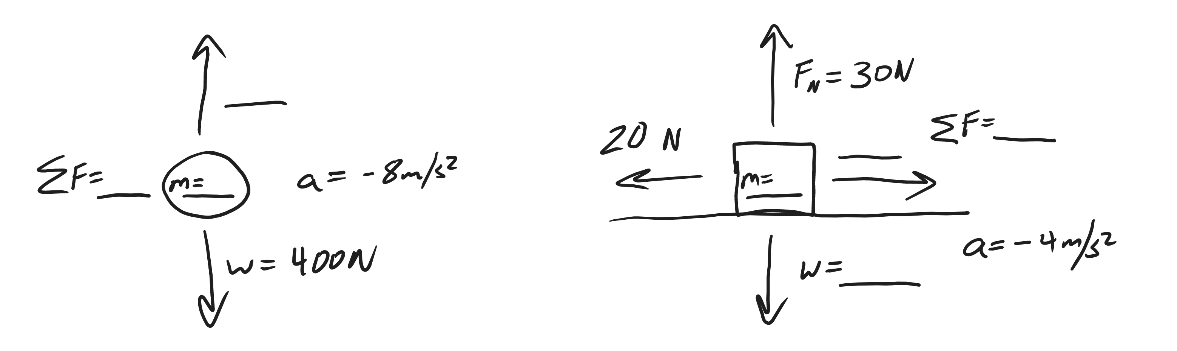

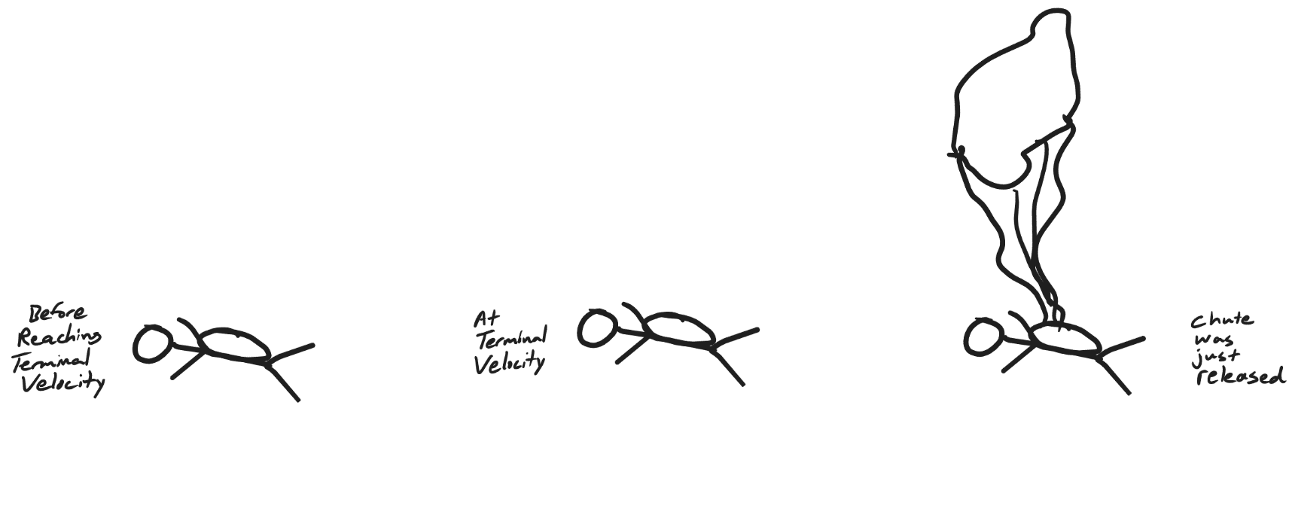
7. In the diagrams below, use arrows to show all of the forces acting on the skydivers. Make sure that the lengths represent the strengths of the forces. For example, the strongest force should have a longer arrow.
8. The first table, below, is a timeline detailing a parachuter’s descent from an airplane. Use the timeline and your knowledge of physics to complete the second table.

Time | Event
0s | Parachuter steps out of plane
20s | Parachuter reaches a first terminal velocity of 47m/s
75s | Parachuter pulls chute cord. Chute deploys.
80s | Parachuter reaches a second terminal velocity of 2m/s
700s | Parachuter lands

Don’t forget proper units!

Time | Parachuter Mass | Parachuter Weight | Air Resistance (plus direction) | F_{net}  (plus direction) | Acceleration  (direction) | Speed
0s | 100 kg
3s |  |  | 200 N Upward |  |  | 30m/s
72s
76s |  |  | 1,800N Upward |  |  | 41m/s
500s

Force Problems and Diagrams: Solve these problems by drawing diagrams showing all of the individual forces.

9. A 3kg box is sliding with a velocity of -3m/s. The force of friction acting on the block. The block’s acceleration is -2m/s². If a person is pushing the block with a force of -8N, what is the force of friction that is acting on the box?

10. A student has a mass of 50kg. He is standing on a bathroom scale in an elevator, and the scale reads 900N. What is the student’s acceleration?

11. Which can you throw with the most force:
a. A ping pong ball b. A 40 pound bag of dogfood
c. Neither, the force depends on how hard you try

12. Explain how you know the answer to number 11.

13. A 400g shuffleboard disk is sitting motionless on smooth, hard, level ground. Someone pushes the disk to the left with a constant force for 0.8 seconds. During this time, the disk reaches a final velocity of -7m/s. After the push is over, the disk continues sliding for 3.5 seconds before coming to a stop. Assuming that the force of friction acting on the disk is the same during the entire event…

a. What was the mass of the disk, in kilograms? _________

b. What is the disk’s acceleration while it is being pushed? ________

c. What is the disk’s acceleration after the push ends (while it is sliding to a stop)? _______

d. What is the net force acting on the disk while it is being pushed? _______

e. What is the net force acting on the disk after the push ends (while it is sliding to a stop)? _______

f. What is the force of friction that is acting on the disk the whole time? _______

g. What is the force of the push? _______

