Physics 100 Name: ______________________________________
Practice Quiz #3:

1. A plastic ball is launched directly upward by a slingshot. The boxes below describe moments in the ball’s flight. In each box, draw arrows (with names) for all of the individual forces. Also use arrows to show the direction of net force and acceleration. Do include the force of drag whenever it would be present.
Stages A-E.  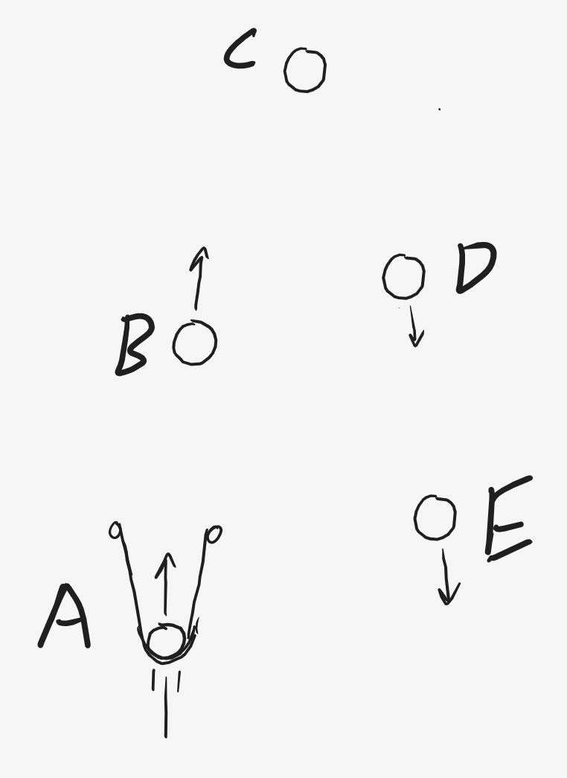 | A. The ball is in the slingshot, being accelerated upward. The slingshot is pushing it upward.
B. The ball is flying upward, free from the slingshot. | C. The ball has reached its high point
D. The ball is falling before reaching terminal velocity. | E. The ball is falling at terminal velocity.

Formulas: $a=\frac{2∆x}{t^{2}}$ $F_{Net}=ma$ $F_{Net}=vector sum of forces$ $w=mg$

2. A 400g shuffleboard disk is sitting motionless on smooth, hard, level ground. Then, someone pushes the disk. They push it for a time of 0.8 seconds. While they are pushing the disk, it slides a distance of 0.7m. After the push is over, the disk continues sliding for 3.5 seconds, traveling another 12m before coming to a stop. You can assume that the force of friction is the same during the push and after the push.

a. What is the mass of the disk, in kilograms? _________

b. What is the disk’s acceleration while it is being pushed? ________

c. What is the disk’s acceleration after the push ends (while it is sliding to a stop)? _______

d. What is the net force acting on the disk while it is being pushed? _______

e. What is the net force acting on the disk after the push ends (while it is sliding to a stop)? _______

f. What is the force of friction that is acting on the disk the whole time? _______

g. What is the force of the push? _______

