Physics 100 Name: _________________________________
Newton’s Laws Quiz #1
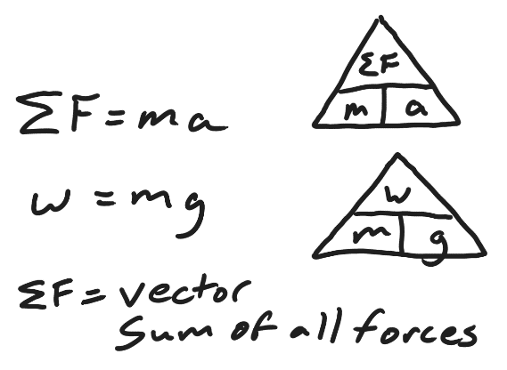
Formulas:

1. (2 pts) Draw a diagram of an object that is experiencing four forces in different directions while experiencing a net force of 4N rightward. Use labeled arrows to show all of the forces.

2. (2 pts) Consider a child pushing a toy car, causing a sideways net force that is accelerating the car.

a. What will happen if the net force is kept the same, but the car’s mass is decreased?

b. What will happen if the net force is decreased, but the car’s mass is kept the same?

3. (2 pts) Describe the action/reaction pairs of forces that are involved in the situations below. Make sure that you name the objects that are experiencing the forces and give the directions of the forces.

a. A student climbs up a ladder.

b. A car drives to our left.

4. (3pts) Fill in the missing forces and acceleration (three blanks) in the diagram below. Make sure that you indicate the correct direction for acceleration.

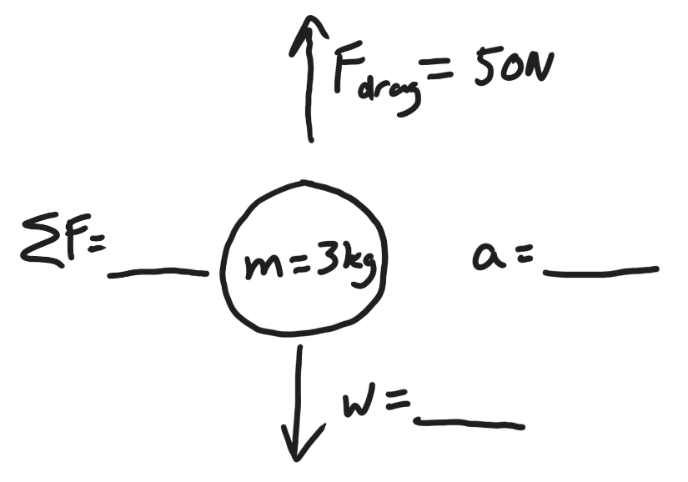

5. (4pts) Fill in the missing forces and acceleration (in the four blanks) below. The box in the picture is sliding sideways across a table top. It is not moving up or down. Make sure that you indicate the correct direction for acceleration.

