Physics 100 Name: _________________________________
Test Review: Newton’s Laws

Formulas and Information: $a=\frac{Δv}{Δt}$ $ΣF=ma$ $w=mg$ 1kg = 1,000g

1. List and describe Newton’s 3 Laws of Motion:

1st Law:

2nd Law:

3rd Law:

2. Draw a diagram of an object that is experiencing four forces in different directions while experiencing a net force of 3N to the left. Use labeled arrows to show all of the forces.

3. Consider a child pushing a toy car. The child is applying a sideways force. The car has a mass, and the car is accelerating.

a. What will happen if the car’s mass is decreased, but the applied force is kept the same.

b. If the car’s mass has been kept the same, but it is accelerating faster, what change must have occurred?

4. Describe the action/reaction pairs of forces that are involved in the situations below. Make sure that you name the objects that are experiencing the forces and give the directions of the forces.

a. Someone walks to the left.

b. A squirrel climbs up a tree.

c. A ball falls from the sky.

5-6. Fill in the missing masses and forces in the diagrams below. Include proper units.

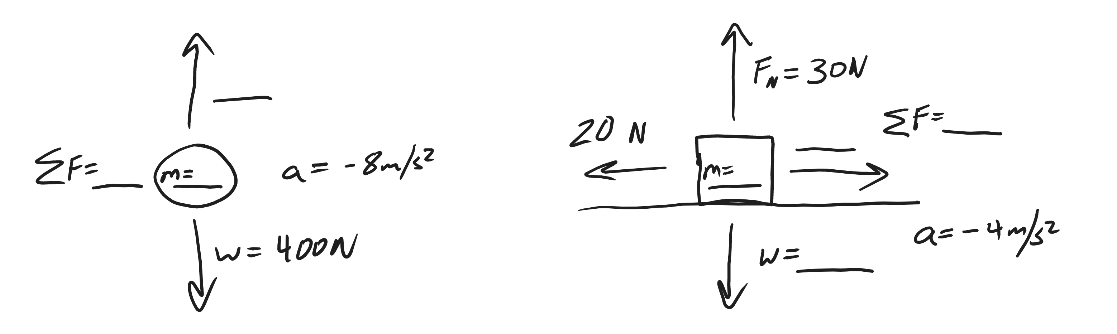

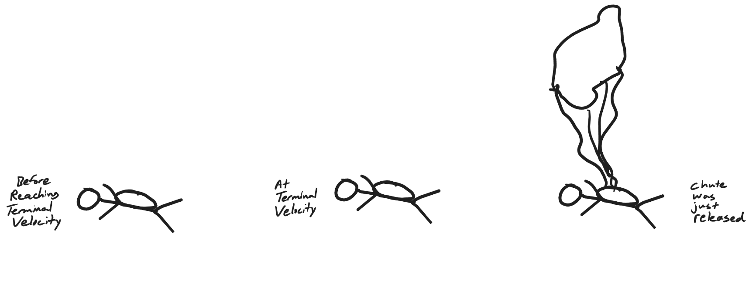
7. In the diagrams below, use arrows to show all of the forces acting on the skydivers. Make sure that the lengths represent the strengths of the forces. For example, the strongest force should have a longer arrow.
8. The first table, below, is a timeline detailing a parachuter’s descent from an airplane. Use the timeline and your knowledge of physics to complete the second table.

Time | Event
0s | Parachuter steps out of plane
20s | Parachuter reaches a first terminal velocity of 47m/s
75s | Parachuter pulls chute cord. Chute deploys.
80s | Parachuter reaches a second terminal velocity of 2m/s
700s | Parachuter lands

Don’t forget proper units!

Time | Parachuter Mass | Parachuter Weight | Air Resistance (plus direction) | F_{net}  (plus direction) | Acceleration  (direction) | Speed
0s | 100 kg
3s |  |  | 200 N Upward |  |  | 30m/s
72s
76s |  |  | 1,800N Upward |  |  | 41m/s
500s

Force Problems and Diagrams: Solve these problems by drawing diagrams showing all of the individual forces.

9. A 3kg box is sliding with a velocity of -3m/s. The force of friction acting on the block. The block’s acceleration is -2m/s². If a person is pushing the block with a force of -8N, what is the force of friction that is acting on the box?

10. A student has a mass of 50kg. He is standing on a bathroom scale in an elevator, and the scale reads 900N. What is the student’s acceleration?

11. Which can you throw with the most force:
a. A ping pong ball b. A 40 pound bag of dogfood
c. Neither, the force depends on how hard you try

12. Explain how you know the answer to number 11.

13. A 400g shuffleboard disk is sitting motionless on smooth, hard, level ground. Someone pushes the disk to the left with a constant force for 0.8 seconds. During this time, the disk reaches a final velocity of -7m/s. After the push is over, the disk continues sliding for 3.5 seconds before coming to a stop. Assuming that the force of friction acting on the disk is the same during the entire event…

a. What was the mass of the disk, in kilograms? _________

b. What is the disk’s acceleration while it is being pushed? ________

c. What is the disk’s acceleration after the push ends (while it is sliding to a stop)? _______

d. What is the net force acting on the disk while it is being pushed? _______

e. What is the net force acting on the disk after the push ends (while it is sliding to a stop)? _______

f. What is the force of friction that is acting on the disk the whole time? _______

g. What is the force of the push? _______

