Physics 100 Name: ______________________________
UNIT 3 HANDOUT – Momentum and Impulse

Definition of Momentum:

Symbol: Why?

Formula:

Three ways to arrange the momentum formula:

Momentum Units:

Practice Using the Momentum Formula:

1. A 3kg goliath frog has a velocity of 2m/s. What’s its momentum?

2. A 50kg pig has a momentum of 150kgm/s. What’s the pig’s velocity?

3. A farmer is chasing the pig. The farmer’s velocity is 4m/s, and her momentum is 200kgm/s. What is the farmer’s mass?

Is momentum a vector quantity or a scalar quantity? Why?

Net Momentum:

Law of Conservation of Momentum:

Practice Using the Law of Conservation of Momentum:

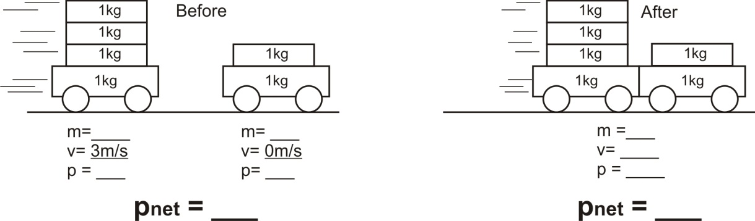
4.

5.
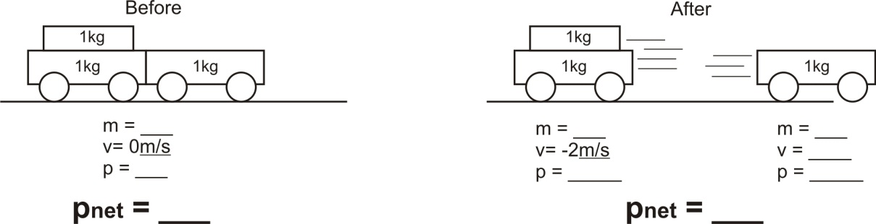

What is “impulse?”

Formula relating impulse to momentum:

Units for impulse:

Three ways to rearrange the impulse/momentum formula:

6. A 2kg block of wood moving at a velocity of 5m/s slows to a stop over a time of 3 seconds. What net force brought the wood to a stop?

7. A 1,000kg car is rolling toward you at a velocity of 2m/s. In order to slow the car to a velocity of 1m/s by pushing against the car for 10 seconds, how hard will you have to push?

Conservation of Momentum Practice Problems (attach extra paper if necessary)

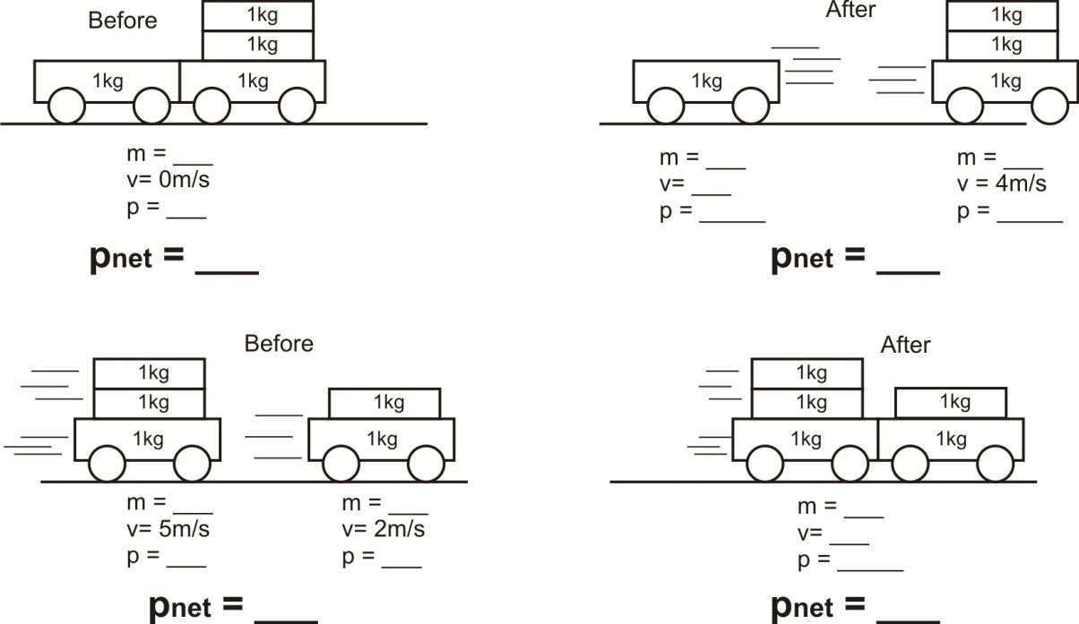
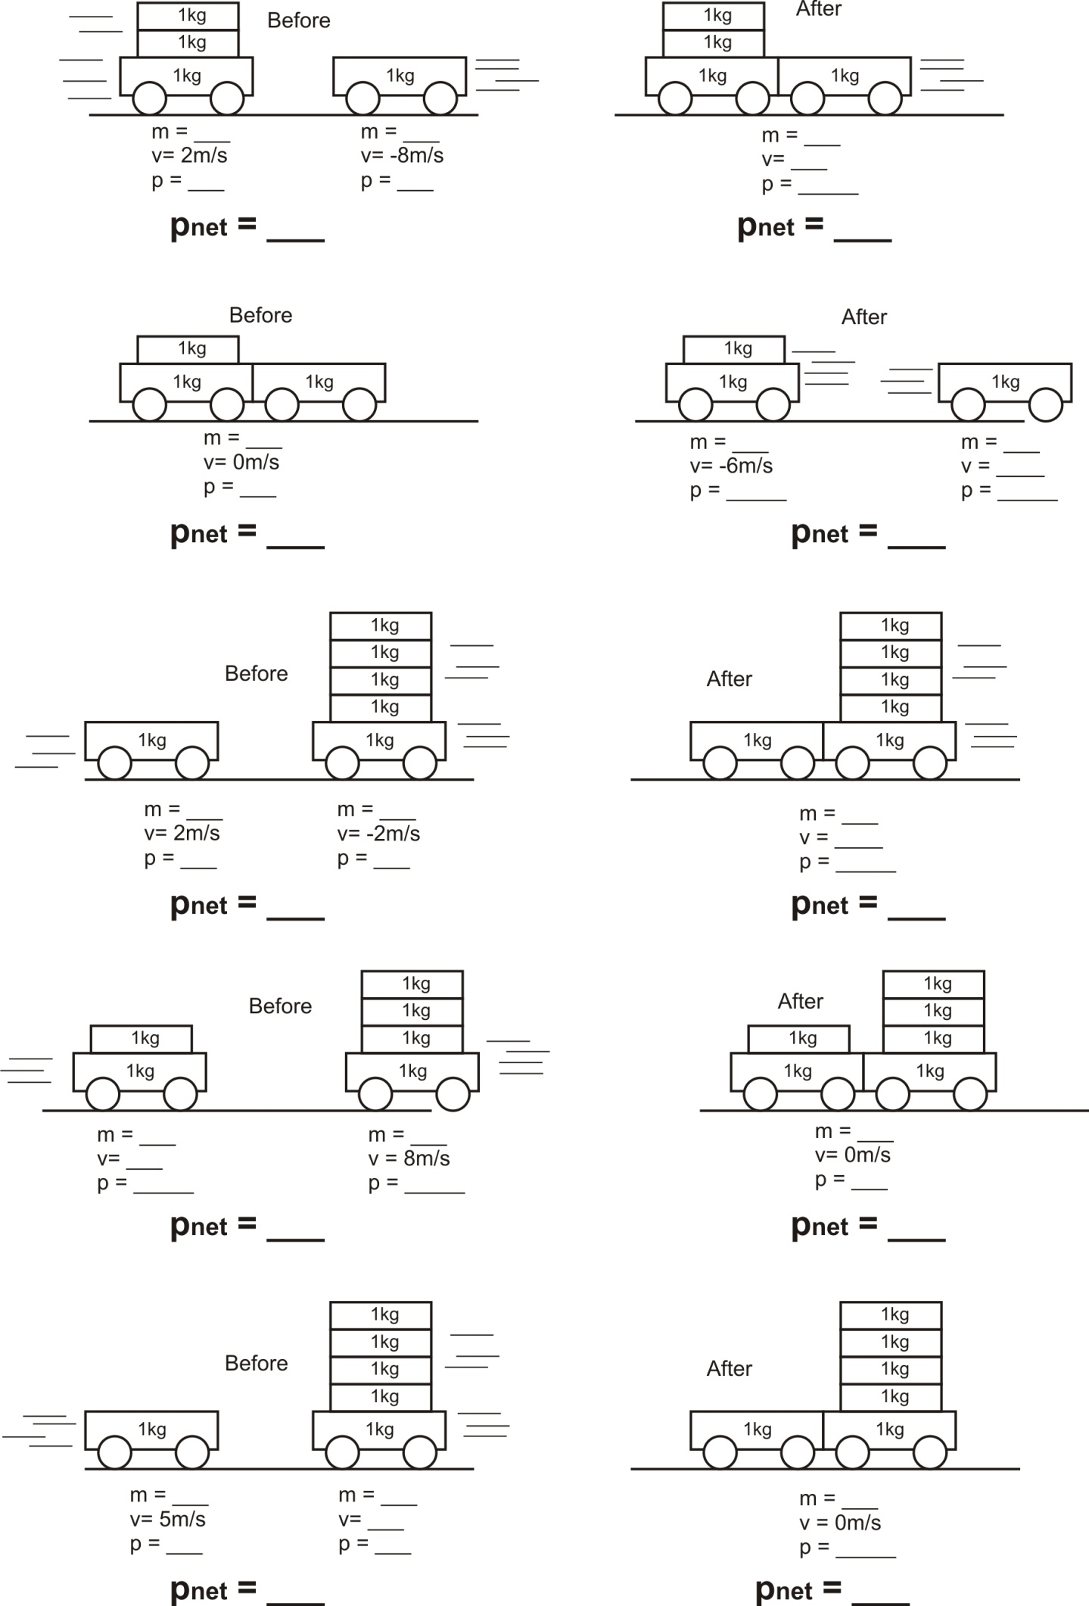
Momentum and Impulse Practice

Formulas: $p=mv$ $Ft= ∆p$ $Ft=m∆v$

Short Answer:

1. Define momentum

2. State the law of conservation of momentum.

3. What are the units for momentum?

4. What is the symbol for momentum?

5. Define impulse.

5. What are the units for impulse?

Problems:

6. A 7kg object has a velocity of -4m/s. What is its momentum?

7. 0.65kg basketball is moving with a velocity of 3m/s. It collides with a stationary 0.05kg tennis ball, transferring half of its momentum to the tennis ball.

- What is the basketball’s velocity after the collision?

- What is the tennis ball’s velocity after the collision?

8. An impulse of 6kgm/s is applied to a mouse. What is the mouse’s change in momentum?

9. A 1,000kg car accelerates from 20m/s to 50m/s.

- What is the car’s Δp?

- If this acceleration takes place over a 30 second time period, what force is being applied?

10. Starting from rest, a 200kg motorcycle accelerates over a distance of 90m in a time of 4 seconds, reaching a velocity of 40m/s. Immediately after that, the motorcycle crashes into a series of cardboard boxes and comes to rest in a time of 3 seconds.

a. What is the motorcycle’s Δp during its acceleration period?

b. What is the motorcycle’s Δp during its deceleration period?

c. What average net force caused the motorcycle’s acceleration?

i. What average net force caused the motorcycle’s deceleration?

11. Car A has a velocity of -10m/s and a mass of 500kg. Car B has a mass of 800kg and a velocity of 6m/s. If the two cars collide and stick together, what is their shared velocity after the collision?

12. Suppose a 3kg steel sphere is moving with a velocity of 4m/s. The steel sphere strikes a second stationary sphere with a mass of 2kg and a velocity of 2m/s. After the collision, the 3kg sphere has a velocity of 3m/s.

- What is the net momentum of this system before the collision?

- What is the net momentum of this system after the collision?

- What is the velocity of the 2kg steel sphere, after the collision?

Momentum and Impulse Practice Quiz

Formulas: $p=mv$ $Ft= ∆p$ $Ft=m∆v$

1. Impulse is equal to the change of
A. Velocity
B. Mass
C. Force
D. Momentum
E. Force x Velocity

2. An object’s momentum is always equal to
A. its average acceleration B. the force applied to the object
C. its velocity multiplied by the applied force D. the impulse imparted to the object
E. Work done on the object E. its mass multiplied by its velocity

3. The change in an object’s momentum is equal to
A. its average acceleration B. the force applied to the object
C. its velocity multiplied by the applied force D. the impulse imparted to the object
E. Work done on the object E. its mass multiplied by its velocity

4. The correct units for momentum are:
a. kgm/s b. Nm/s c. kgm/s² d. Nm/s²

5-7. Three eggs of equal mass are thrown with the same horizontal velocity at three different walls. The walls are identical in every aspect except for their hardness. The first egg splatters against a hard wall and comes to a stop. The second egg hits a soft wall and comes to a stop without splattering. The third egg bounces backward off of a springy wall.

5. Compared to the first egg (hard wall), the second egg (soft wall) experiences…
a. Greater force and the same impulse b. Less force and the same impulse
c. Greater force and greater impulse d. Less force and greater impulse
e. Same force and impulse

6. Which egg experiences the greatest change in momentum?
A. First egg B. Second egg C. Third egg D. None of them

7. Now consider the walls in number 4. Which wall is most likely to be knocked over by the egg impact?
a. Hard wall b. Soft wall c. Springy wall d. None of them

8. A 1kg ball is dropped to the ground. It hits the ground with a velocity of -6m/s and bounces back up with a velocity of +4m/s. What impulse did the ball experience?
A. -2kgm/s B. 4 kgm/s C. -6kgm/s D. 10kgm/s E. 24kgm/s

9. A 1,200-kilogram car traveling at 30 meters per second hits a huge pile of cardboard boxes and is brought to rest in 6 seconds. What is the magnitude of the average force acting on the car to bring it to rest?
A. 6 × 10² N B. 6 × 10³ N C. 6 × 10⁴ N D. 6 × 10⁵ N E. 6 × 10⁶ N

10. A 20kg child is riding a long board. The mass of the long board is 5kg. Both the child and the long board are traveling leftward. Their velocities are both -5m/s. As the child jumps off the long board, the long board speeds up to a velocity of -9m/s. What is the child’s new velocity when she jumps off (before she hits the ground). You can ignore air resistance.

11. A bocce ball was rolling with a velocity of 4m/s. The ball collided with a traffic cone, which applied a force of -5N to the bocce ball. The force lasted for 0.1 seconds, and the mass of the bocce ball was 0.8kg.

- What impulse was applied to the ball before the collision?

- What was the ball’s momentum before the collision?

- What was the ball’s momentum after the collision?

- What was the ball’s velocity after the collision?

12. Use the concepts of momentum, impulse, force, and time to explain how airbags decrease injuries during a collision.

