Physics 100 Name: ______________________________
Midterm Practice

#1-3. Match the description to the type of measurement:

1. The amount of “stuff” in an object: a. Volume b. Weight c. Mass

2. The size of an object: a. Volume b. Weight c. Mass

3. A measure of how strongly the Earth’s gravity pull on an object:
a. Volume b. Weight c. Mass

#4-7. For each of the following units, describe what it measures (e.g. mass, volume, or weight).

4. A gram is a measure of…
a. Length b. Volume c. Mass d. Weight

5. A milliliter is a measure of…
a. Length b. Volume c. Mass d. Weight

6. A kilometer in it is a measure of…
a. Length b. Volume c. Mass d. Weight

7. A Newton is a measure of…
a. Length b. Volume c. Mass d. Weight

#8-13. Match the metric measurements to an object that has that measurement.

Answer Choices:

a. 1 Newton (N) b. 1 liter (L) c. 1 gram (g) d. 1 kilogram (kg)
e. 1 millimeter (mm) f. 1 milliliter (mL) g. centimeter (cm)

8. The mass of a paperclip: A B C D E F G

9. The volume of one chocolate chip: A B C D E F G

10. The thickness of a dime: A B C D E F G

11. The mass of a Nalgene water bottle full of water: A B C D E F G

12. The weight of a raw hamburger patty: A B C D E F G

13. The width of a pinky fingernail: A B C D E F G

13.5. Volume of a Nalgene water bottle: A B C D E F G

#14-20. Multiple choice:

14. ___________ charges attract one another, and ____________ charges repel one another.
a. Opposite, Like b. Like, Opposite c. Opposite, Opposite d. Like, Like
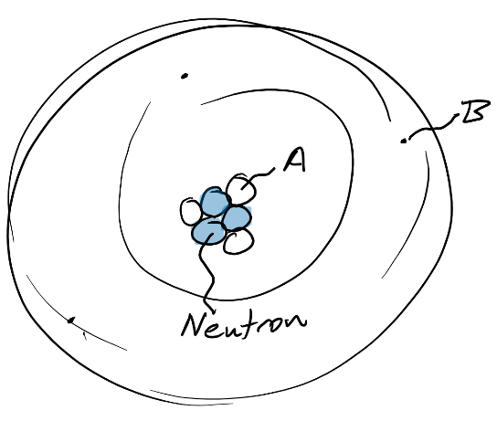
15. Which of the particles in the atom on the right is an electron? A B

16. What is the charge of particle B, in the diagram?
Positive Negative Neutral

17. What is the charge of particle A, in the diagram?
Positive Negative Neutral

18. Which has a stronger charge?
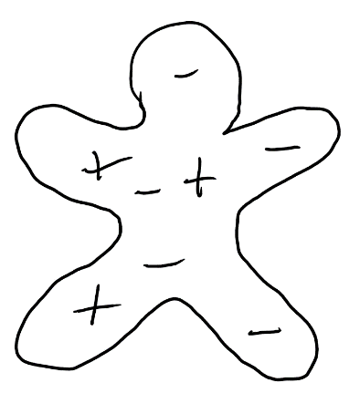
a. a proton b. an electron c. neither, they’re equally strong

19. What is the net charge of the object on the right?
a. -3 b. -2 c. -1 d. 0
e. +1 f. +2 g. +3

20. Which of the following is the main reason why the inside of a car is a safe place to be during a lightning storm?
a. Car tires are made of rubber.
b. Lightning will not strike metal.
c. A car can outrun the lightning.
d. The electric field inside a conductor is always zero.

#21-24. Matching:

Answer Choices: a. Proton b. Electron c. Conductor
d. Insulator e. Electric Field

21. When electric charge is able to move easily through a material, that material is called a(n) _______.
22. _______ When objects are “charged up” by rubbing them together, this is the type of particle that gets transferred from one object to another.
23. When electric charge is not able to move easily through a material, that material is
called a(n) _______.
24. The is a name for a place where any charged particle will experience a push or a pull due to its electric charge ________.

#25-32 Matching:

Answer choices: A. current B. Voltage C. Resistance D. Circuit E. Power
F. DC G. AC

25. A closed loop that electrons can travel in. A B C D E F G
26. The rate at which electrical energy is used. A B C D E F G
27. Something that slows down the flow of electricity through a circuit A B C D E F G
28. The “pressure” that pushes charge through a circuit A B C D E F G
29. The formula for calculating this is IV. A B C D E F G
30. A type of circuit in which electrons flow in one direction. A B C D E F G
31. The amount of flow of electricity through a circuit A B C D E F G
32. A type of circuit in which electron flow switches directions A B C D E F G

Multiple Choice:

#33-34. According to Ohm’s Law…

33. I = _______ a. VR b. V/R c. R/V

34. R = _______ a. IV b. I/V c. V/I

#35-37. For the following questions, use Ohm’s law to decide what happens.

35. If voltage has been kept the same, but current has increased, what has happened to resistance?
a. It has increased b. It has decreased c. It has not changed d. impossible to tell

36. Current has been kept the same, but resistance has increased, what has happened to voltage?
a. It has increased b. It has decreased c. It has not changed d. impossible to tell

37. Resistance has been kept the same, but voltage has decreased, what has happened to current?
a. It has increased b. It has decreased c. It has not changed d. impossible to tell

#38-44 -- Matching:

Answer Bank: a. Generator b. Motor c. magnetism d. north pole
e. south pole f. Iron g. Rubber h. plastic

38. A phenomenon causing attractive and repulsive forces between objects and relating to motions of electric charge

A B C D E F G H I

39. This is an example of a material that has unpaired moving electrons, so it can become magnetized when a permanent magnet is nearby.

A B C D E F G H I

41. Magnetic field lines flow into this part of a magnet.

A B C D E F G H I

42. In this type of device a magnet is moved near a coil of wire, causing electric current to flow through the wire.

A B C D E F G H I

43. Magnetic field lines flow out of this part of a magnet.

A B C D E F G H I

44. In this type of device electricity flows through a coil of wire, turning the coil into an electromagnet which pushes against another permanent magnet to make things move.

A B C D E F G H I

Multiple choice:

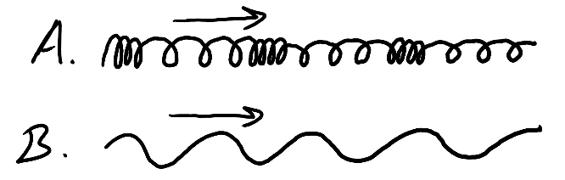
45. The arrows on the right show the direction of wave movement. Which wave is a longitudinal wave?
A. B.
46. Which type of wave always has oscillations that are perpendicular to the direction of travel?
A. a transverse wave
B. a mechanical wave
C. a longitudinal wave
D. a sound wave

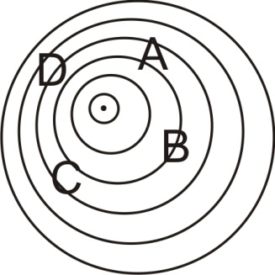
#47-48. In the diagram on the right, the dot represents a moving object, and the circles represent sound wave compressions that are being produced by the object.
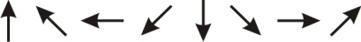
47. Circle the arrow that shows the direction in which the object is moving.
48. At which location will an observer hear the highest frequency?
A B C D
Short answer Questions:

1. Measure the length of the line below, and write the length in appropriate metric units.
Length = _______________________

Rocket Questions:

2. List two factors that affect the drag (air resistance) on a flying object.

1)

2)

3. Explain why adding some weight to a rocket can make it go higher.

4. Newton’s 3rd Law (action/reaction) can be used to explain how water rockets fly.

a) What is the “action?”

b) What is the “reaction?”

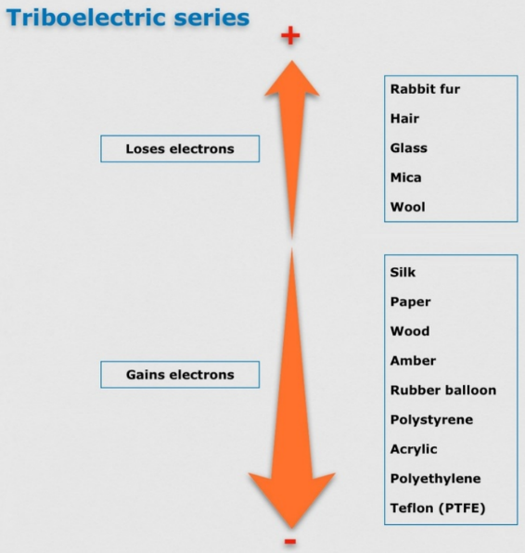
5. Sketch a simple picture of a neutral rubber balloon and a neutral glass stick. Draw some charges in each of them.

6. Refer to the diagram on the right, and then draw what the charges in the rubber balloon and the glass stick might look like after you rub them together.

7. When you feel an electric shock, there are two possible causes for the shock. What are they? [what type of particles are moving, and in which direction(s)?]

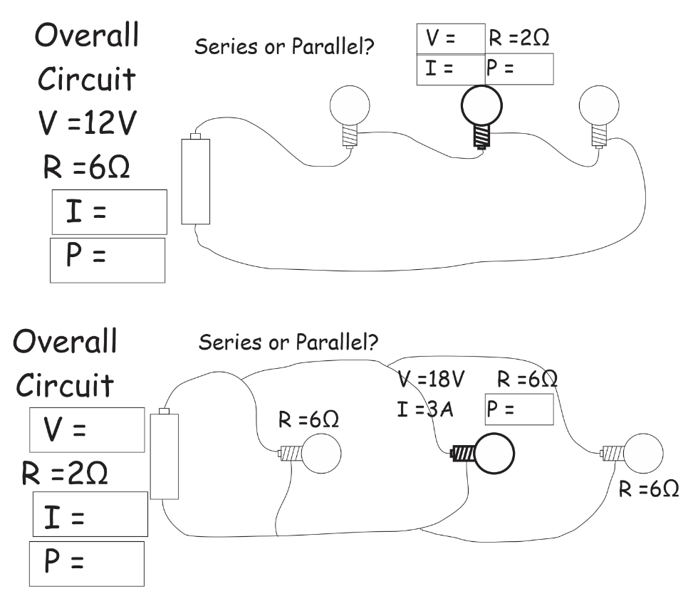
8. Identify each circuit as either series or parallel (circle the correct label). Then fill in the information that is missing in the boxes. There are 9 boxes in all. Don’t skip any! The boxes refer to the overall circuits and also to the middle bulbs.

9. The two diagrams below show a solenoid buzzer. In one diagram, the solenoid is turned off, and in the other it is turned on.
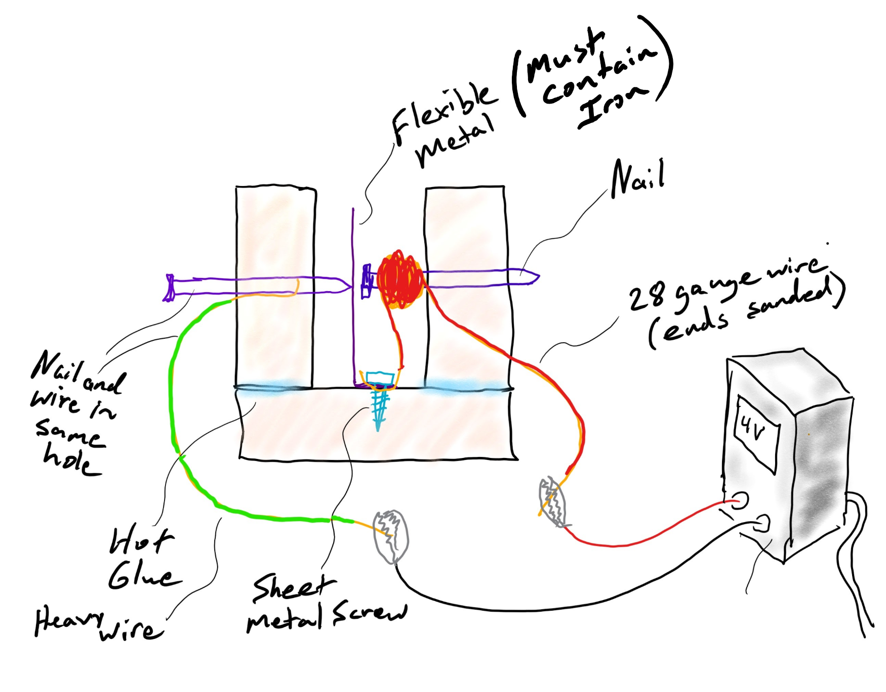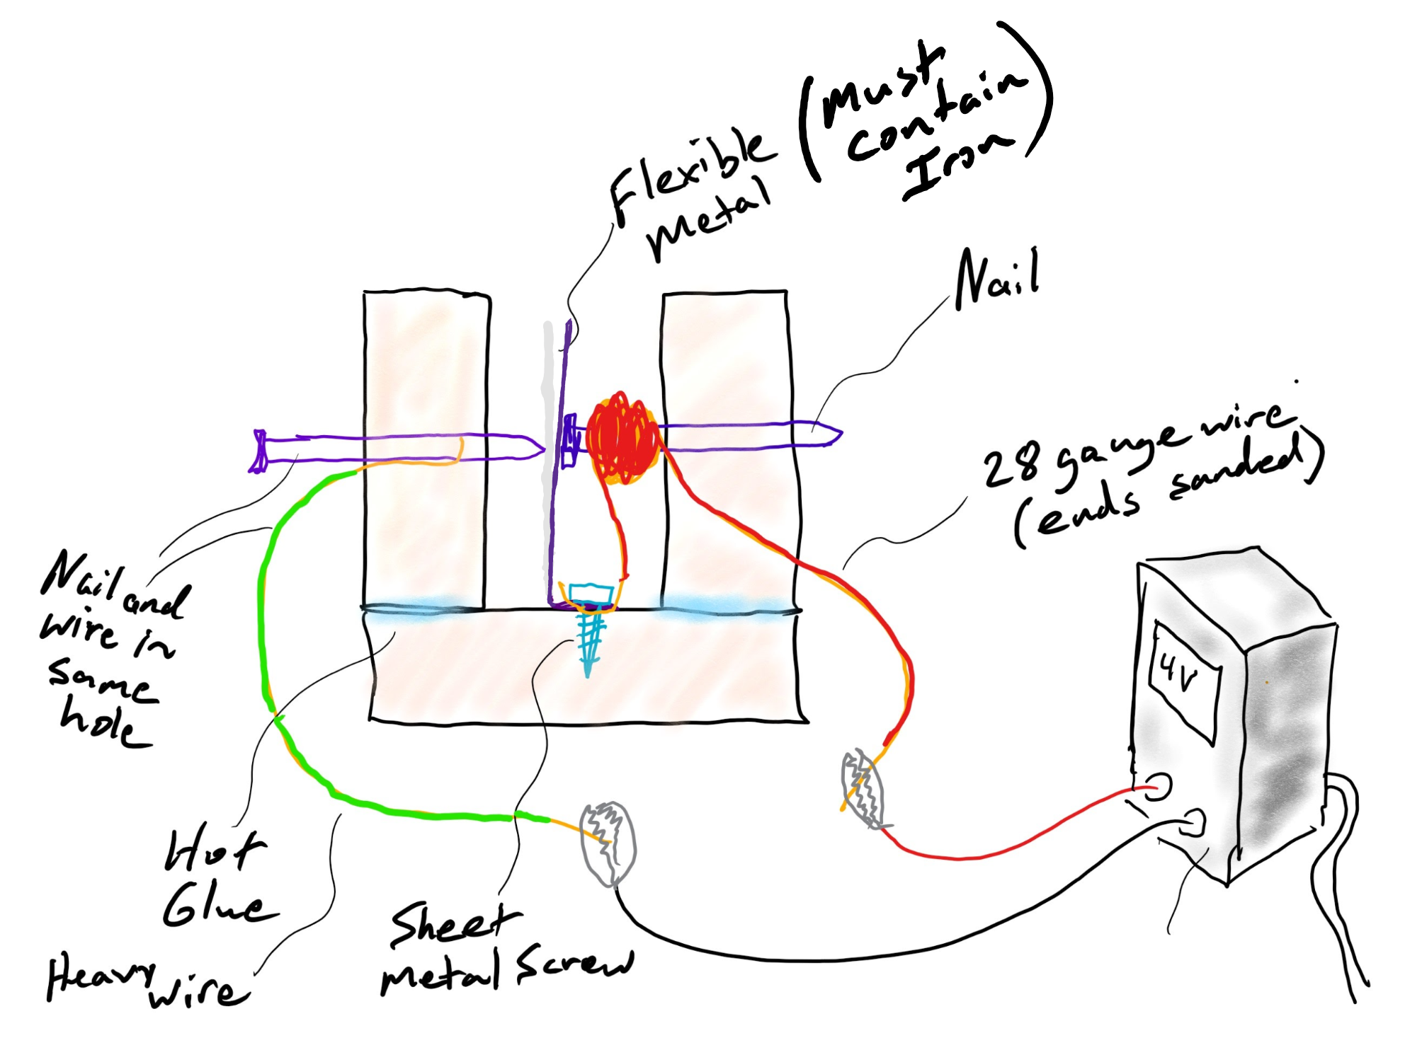

a. Label the correct diagram “solenoid on,” and label the other one “solenoid off.”

b. Explain what causes the buzzer to go from the “on” configuration to the “off” configuration?

c. Explain what causes the buzzer to go from the “off” configuration to the “on” configuration?

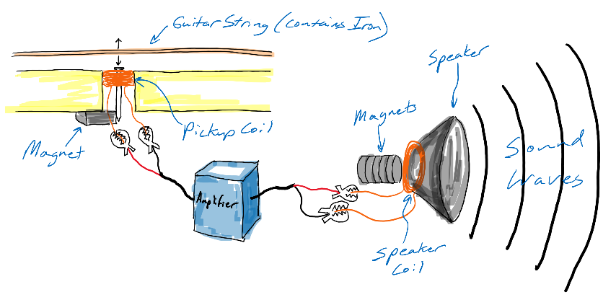
Consider this system showing an electric guitar with its pickup, amplifier, and speaker.

10. Which part of this system functions as a motor?
A. the pickup/magnet/string B. The amplifier C. The speaker

11. Explain how it (the object you identified in #1) functions as a motor.

12. Which part of this system functions as a generator?
A. the pickup/magnet/string B. The amplifier C. The speaker

13. Explain how it (the object you identified in #1) functions as a generator.

14. Why is it necessary to amplify the string sound? Why isn’t the string already as loud as the speaker?

Formulas: V=IR V=λf f=1/T

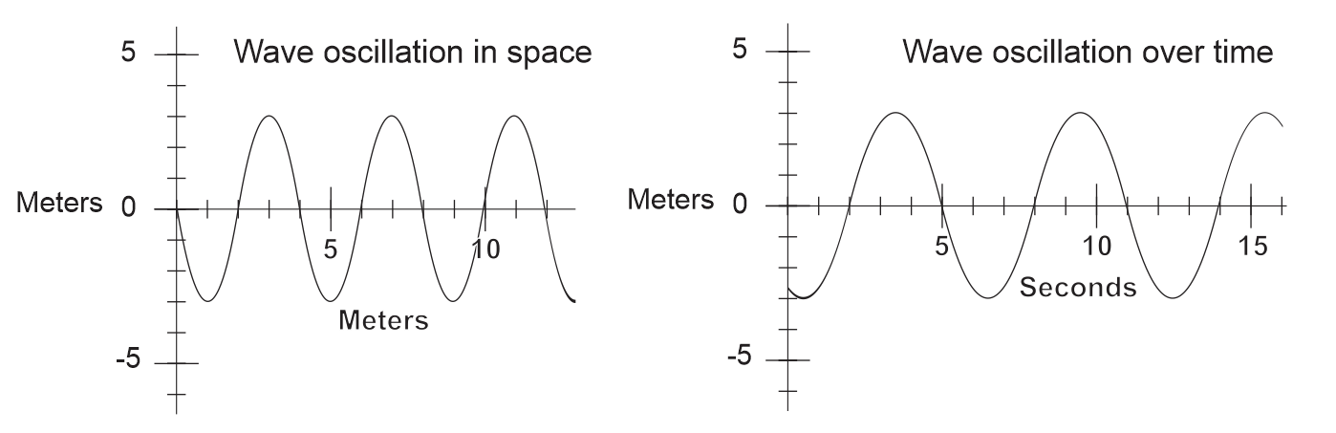
The two graphs below represent the SAME wave. The first diagram shows the wave’s oscillations in space. The second diagram shows the wave’s oscillations over time.

15. What is the wavelength of the oscillation, in meters?

16. What is the period of the oscillation, in seconds?

17. What is the amplitude of the wave?

18. What is the wave’s frequency?

19. What is the wave’s speed?

The two waves on the right produce beats when they are heard together.
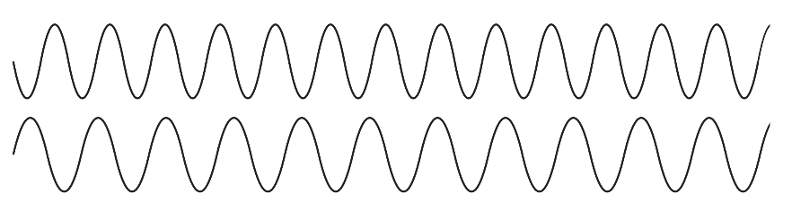
20. Circle all of the places where there is constructive interference between the waves. Label them “constructive.”
21. Circle all of the places where there is destructive interference between the waves. Label them “destructive.”

22. What is the relationship between the frequency of a note played at one fret on a guitar, and the frequency of a note played at the next higher fret?

