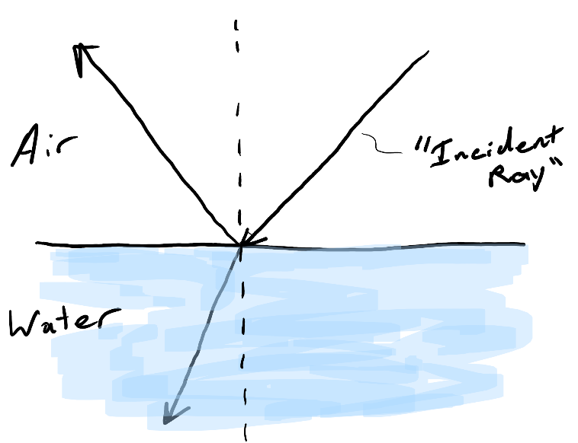
Physics 100 (Stapleton)
Warm-up Quiz, #1

Name: ________________________________

Label the following on the diagram to the right.

1. The normal
2. The angle of incidence
3. The angle of reflection
4. The angle of refraction

Physics 100 (Stapleton)
Warm-up Quiz, #1

Name: ________________________________

Label the following on the diagram to the right.

1. The normal
2. The angle of incidence
3. The angle of reflection
4. The angle of refraction

Physics 100 (Stapleton)
Warm-up Quiz, #1

Name: ________________________________

Label the following on the diagram to the right.

1. The normal
2. The angle of incidence
3. The angle of reflection
4. The angle of refraction

