Unit 1 Handouts (Physics 100) Name: __________________________

Motion Matching Activity Questions: (see directions on website)

On a motion sensor graph of position vs. time…

1. What does a positive (upward) slope tell you about the object’s motion?

2. What does a negative (downward) slope indicate?

3. What does the steepness of a slope tell you about the object’s motion?

4. What does a constant (straight line) slope indicate?

5. What might a smoothly curving line indicate?

6. Sketch a negative slope that is becoming less steep. What does this curve indicate about the motion of an object?

7. Sketch a negative slope that is getting steeper. What does this curve indicate about the motion of an object?

8. Sketch a positive slope that is becoming less steep. What does this curve indicate about the motion of an object?

9. Sketch a positive slope that is getting steeper. What does this curve indicate about the motion of an object?

Notes: Kinematics Intro, Basic Terms, Average Velocity

Kinematics: The study of motion without considering its causes.

Scalar: A quantity with magnitude but no direction. Give an example:

Vector: A quantity with magnitude and direction. Give an example:

Δ = Delta = “change in”

Formula for Δ = Final – initial.

Example Problem: Calculate the “change in position” for an object that moves from the 4m mark to the 1m mark.

 | Symbol | Meaning (what it’s supposed to mean) | Vector or Scalar? | Common Units
Position |  | Where something is on a number line.
Displacement |  | “Change in position”
Distance |  | Like displacement, but doesn’t include direction. What a car’s odometer keeps track of.
Total Distance |  | Sum of all of the distances traveled on a trip.
Change in Time |  | How long some event lasts.
Speed |  | How fast something is moving. A ratio of distance traveled to travel time elapsed.
Velocity |  | Speed and direction.
If I have a velocity of 3 m/s, what does that mean?

One Definition of Velocity:

Average Velocity (symbol = ): when we measure velocity, average velocity is what we will actually measure. This is the average speed of an object as it travels through a given distance. The object may speed up or slow down over that distance, but the average velocity that we calculate will not show this.

Average Velocity Formula (Hint: the units provide the formula)

“Initial velocity” symbol =

Final velocity symbol =

Terminology Practice: A student starts a timer. When the timer gets to 11 seconds, an object is at the 6m mark on the number line to the right. When the timer gets to 13 seconds, the object’s new position is -2. Show these positions and times on the number line to the right. Then calculate each of the following.

Displacement?

Distance traveled?

Average velocity?

Average speed?

Velocity Practice: The graph on the right shows the movement of an object in front of a motion sensor. Determine the velocity of the moving object for lettered each segment, and use your calculations to fill out a velocity vs. time graph for the object (bottom of page).

1. Fill in the correct information for segment A, in the graph on the right.
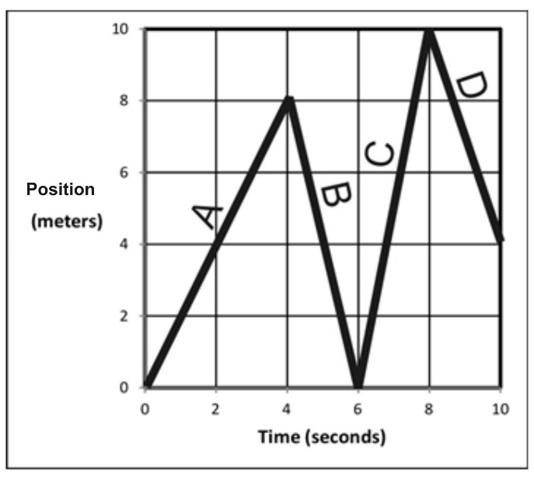
Displacement = _________

Δt = _________

v_{average} = _________

Distance traveled = ___________

Position at end of segment = ____________

2. Fill in the correct information for segment B.

Displacement = _________

Δt = _________

v_{average} = _________

Distance traveled = ___________

Position at end of segment = ____________

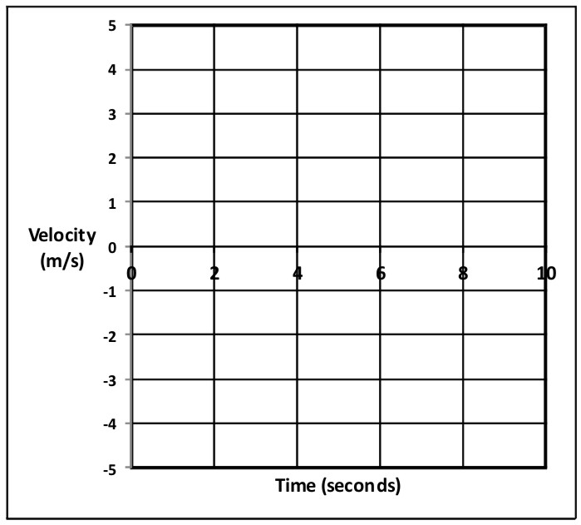
3. Fill in the correct information for the entire trip (segments A-D).

Displacement = _________

Δt = _________

v_{average} = _________

Distance traveled = ___________

Position at end of segment = ____________

4. Use the distance vs. time graph above to fill in the velocity vs. time graph on the right.

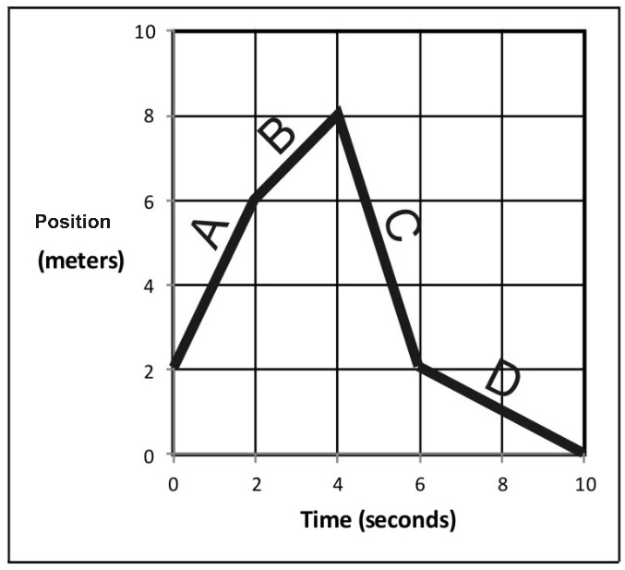
5. Fill in the correct information for segment A, in the graph on the right.

Displacement = _________

Δt = _________

v_{average} = _________

Distance traveled = ___________

Position at end of segment = ____________

6. Fill in the correct information for segment B.

Displacement = _________

Δt = _________

v_{average} = _________

Distance traveled = ___________

Position at end of segment = ____________

7. Fill in the correct information for the entire trip (segments A-D).

Displacement = _________

Δt = _________

v_{average} = _________

Distance traveled = ___________

Position at end of segment = ____________

8. Use previous answers and the distance vs. time graph above to fill in the velocity vs. time graph on the right.

Notes: Acceleration and Motion Graphing

Acceleration Notes:

______________________ tells you how something’s position changes during one second.

______________________ tells you how something’s velocity changes during one second.

Is acceleration a vector or scalar quantity?

Acceleration can happen in two fundamentally different ways:

1)

2)

Negative acceleration is also called _____________________________

Common metric units for acceleration are:

The Analogous Relationship between Velocity and Acceleration:

If Pam has a velocity of +6m/s, that means she travels 6m for every second that ticks by. Another way to say this is that, for each passing second, Pam adds 6m to her position.

Analogously, if Pam’s acceleration is +6m/s/s, this means…

Velocity adds ____________________ each second.

Acceleration adds ________________________ each second.

Velocity is the slope of a _________________ vs _________________ graph.

Acceleration is the slope of a ________________ vs _________________ graph.

The acceleration formula:

Velocity describes a change in position over a time interval. Acceleration describes a change in velocity over a time interval.

a_{average} =

Acceleration Formula Practice Problems:

1. Suppose your velocity is 2m/s. One second later, your velocity is 6m/s. What is your average acceleration over this time period?

2. When your watch reads 8:01:32 AM, your velocity is 6m/s. At 8:01:40 AM (on the same day), your velocity is 2m/s. What is your average acceleration over this time period?

Motion Graphs:

Each row of graphs below comprises a position vs. time graph, a velocity vs. time graph, and an acceleration vs. time graph. Every graph in a row conveys the same motion. For each row, use the one completed graph to fill in the incomplete graphs with reasonable curves. Some rows will have a wider variety of possible answers. Assume that all acceleration is constant.

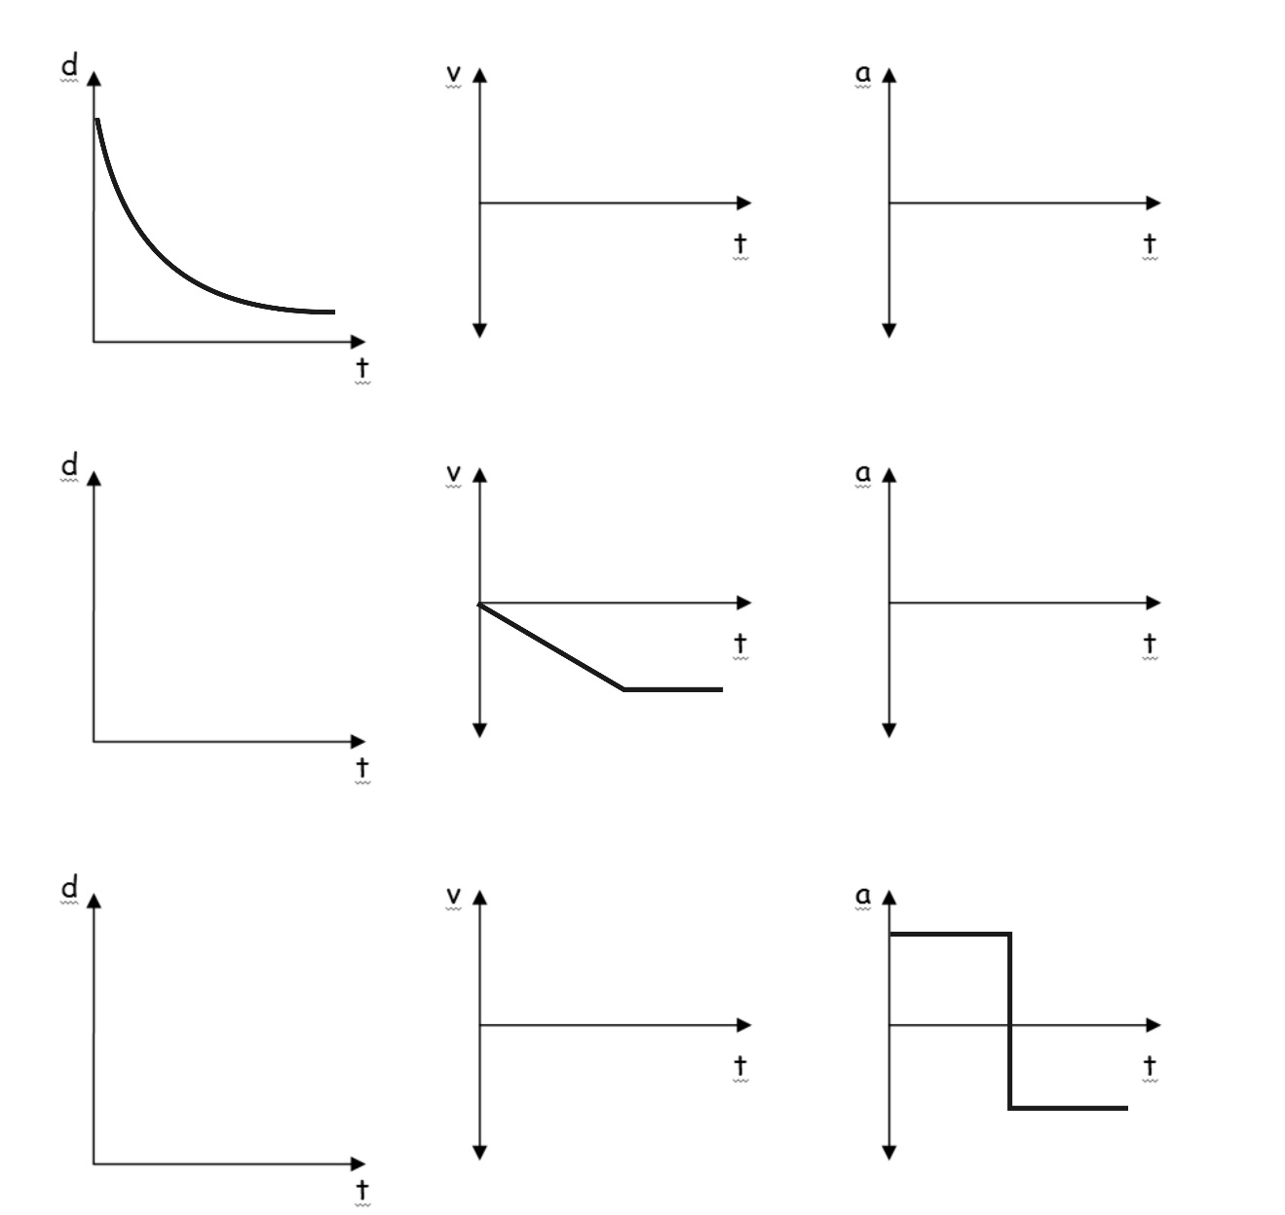
Graph Comparisons: use the information provided in one graph to complete the other two graphs. Be aware that some graphs may be unrealistic, and some may have multiple correct solutions.

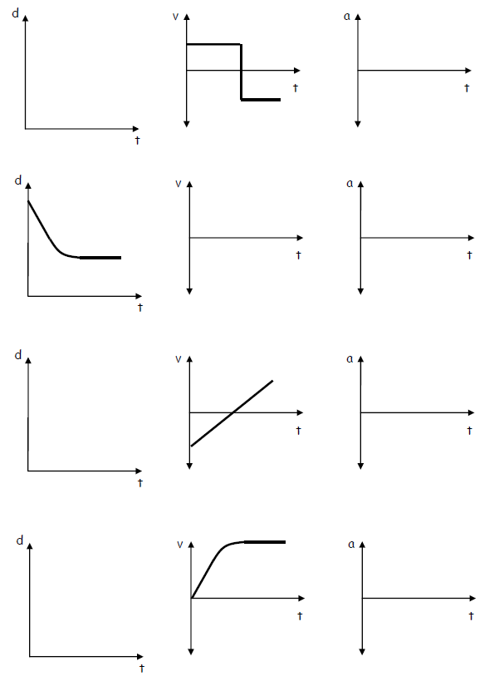
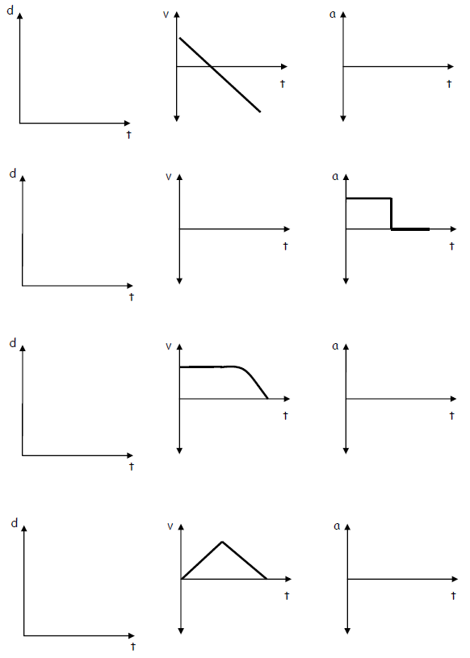

Motion Graph Calculations Practice
Show calculations for velocity for two intervals. Then use those velocities to find acceleration.
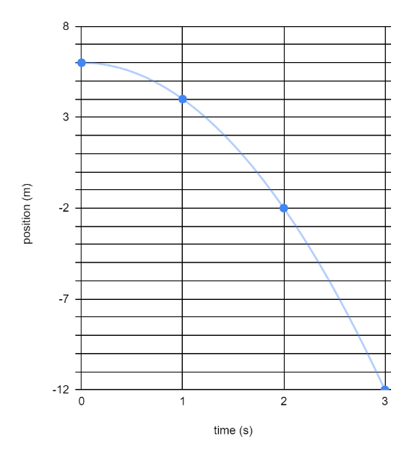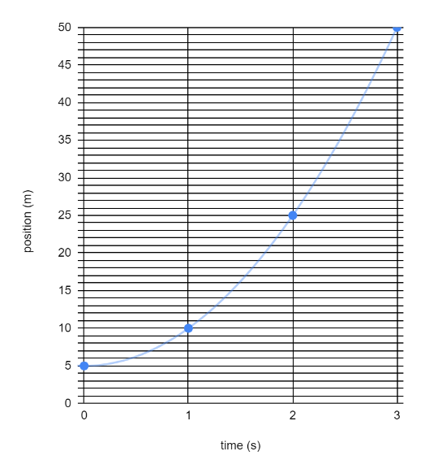

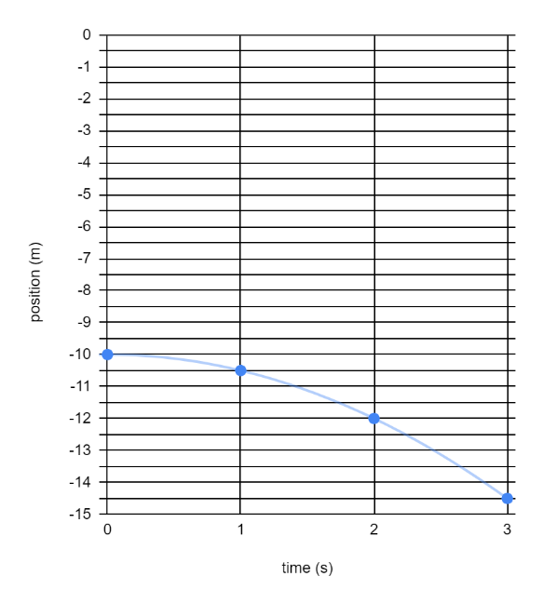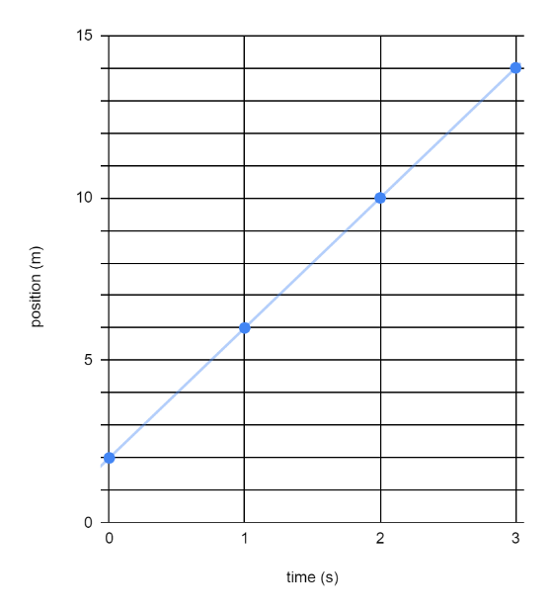

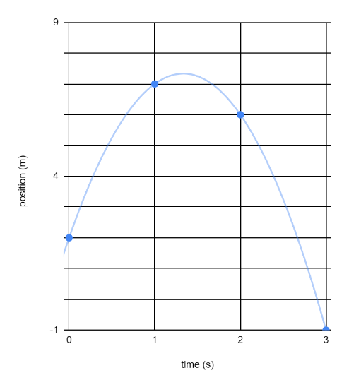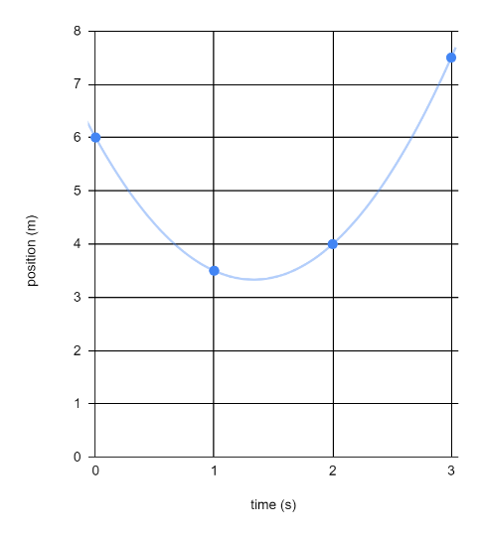
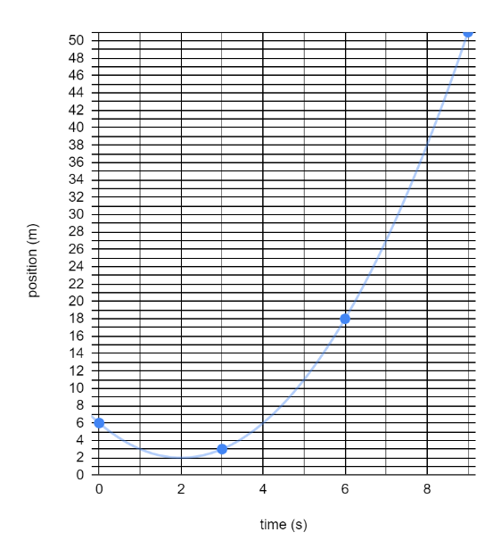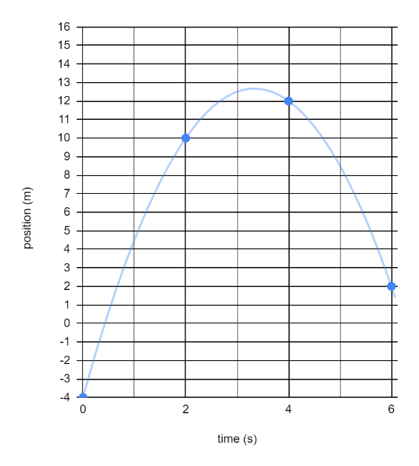
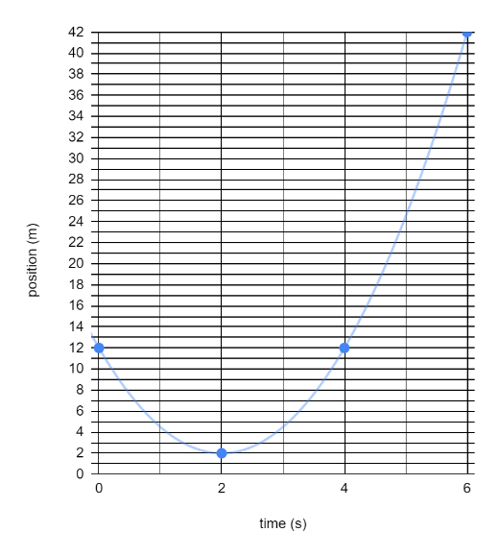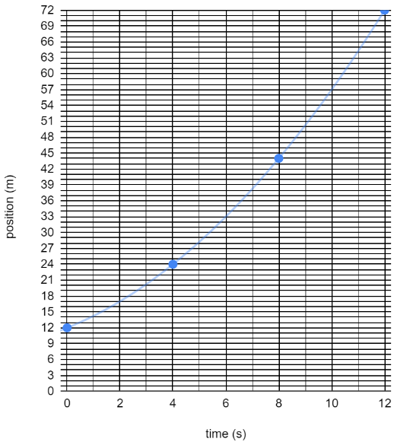

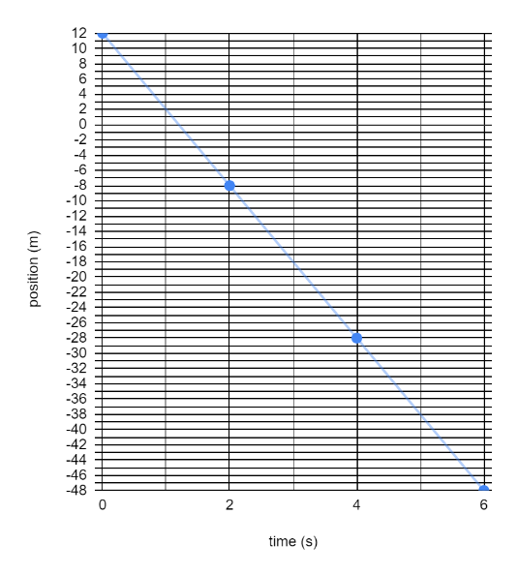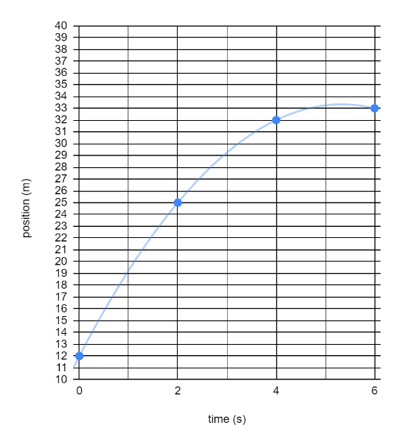

Notes: Free-Fall, More Kinematics Formulas, and Kinematics Problems

Free-fall: The state of being acted upon by only the force of gravity. Objects can be in free-fall if they are moving upward or downward – as long as there is no air resistance or any other force (other than gravity).
Free-fall acceleration: -9.8m/s² or -g. But we will probably use -10m/s² most of the time.
The diagram below is intended to represent an object that is launched vertically upward in the absence of air resistance (i.e. in free-fall). The diagram appears to show the ball moving sideways, but it isn’t moving sideways. The apparent sideways motion is unavoidable if we’re going to separate upward-moving objects from the downward-moving objects (as we need to do for clarity).

1. Fill in one of the blanks in the diagram with a made-up value. Based on that value, fill in the rest. Estimate by using g=10m/s²

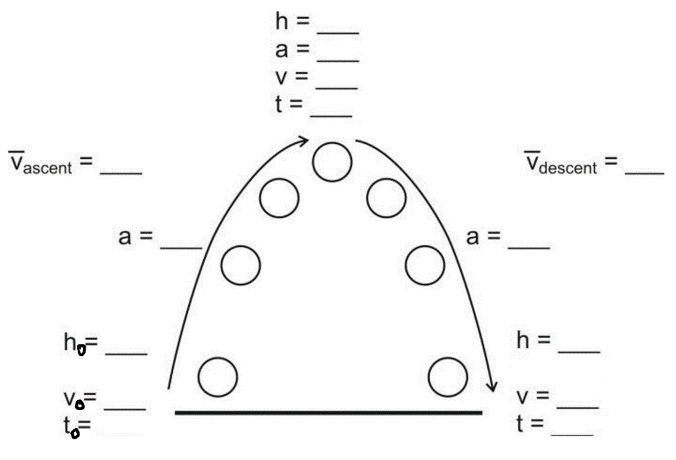

2. Write the formula for acceleration (starting from rest), based on time and displacement:

Example Problem: Starting from rest, a student travels a distance of 6m in a time of 2s, accelerating the entire time. What is the student’s acceleration over this 2s time period?

3. Write the formula for displacement, based on acceleration (starting from rest) and time:

Example Problem: If a ball is dropped in the absence of air resistance, how far does it fall during the first 3 seconds of its fall?

Review and practice Problems:

4. Write the basic formulas for average velocity and acceleration.

5. Starting from rest, a rubber band car travels 5m in 2.82 seconds.

a. What is its average velocity?

b. What is its acceleration?

6. The rubber band car travels over the last floor tile in a time of 0.076 seconds. If the distance across the floor tile is 0.305m, what is the rubber band car’s average velocity during that time?

7. A runner stands motionless. Then she accelerates at a rate of 3m/s² for 3 seconds. How far has she traveled?

8. A car speeds up from 3m/s to 8m/s over a time of 2 seconds. What is its acceleration?

9. A ferrari SF90 can accelerate from 0-60mph in 2.0 seconds. If 60mph is 26.8 m/s…

a. What is the Ferrari’s acceleration?

b. How far does the car travel in those 2 seconds?

Notes and Practice: Converting Between Units

Example Problem: A car is traveling with a speed of 55mph. What is its speed in m/s?

Why does this method work?

Some basic conversions:
1m/s = 2.24mph 1 foot = 0.305m 1km = 0.62miles 1m = 100cm
1 inch = 2.54cm 1km = 1,000m 1gallon = 128 fluid ounces 1 gallon = 4 quarts
1 mile = 5280 feet

1. 8 feet = ________ m

2. 15m = ________ feet

3. A 5km race is __________ miles long.

4. A 23.6 mile marathon is _________ km long

5. 16m/s = ________ mph

6. 16m/s = _______mph

7. 1 foot = ________ cm = _________ m

8. 7 quarts = _______ gallons = ________ fluid ounces

9. 5 hours = _______ days = ________ weeks

10. 300 feet = ________ mile = ________km = ________ m

11. 5m = _________ cm = _________ inches = _________ feet
.

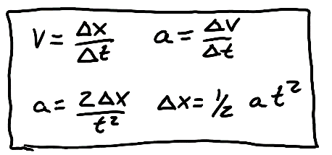
Kinematics Test Review: Part 1

1. What does each of these symbols stand for?

a. $∆x$ b. $∆v$

c. $x$ d. $∆t$

e. t f. v

g. a

2. Label each of the following with either a “V” or an “S,” depending on whether it is a vector (V) or a scalar (S) quantity.

Distance Velocity Acceleration Speed Displacement

3. What makes a vector different from a scalar quantity?

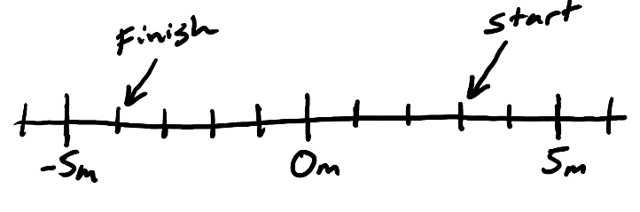
4. The number line on the right shows the starting point and the ending point of a student. The student leaves the starting point when her watch reads 8:07:35. When she reaches the finish line, her watch reads 8:07:49.

a. What is the student’s $∆t$ for this event?

b. What is her displacement?

c. What distance did she travel?

d. What was her average speed?

e. What was her average velocity?

5. A runner runs 400m around a track in a time of 50s, ending at the same point that they started.

a. What distance has the runner traveled?

b. What is the runner’s displacement?

c. What is the runner’s average speed?

b. What is the runner’s average velocity?

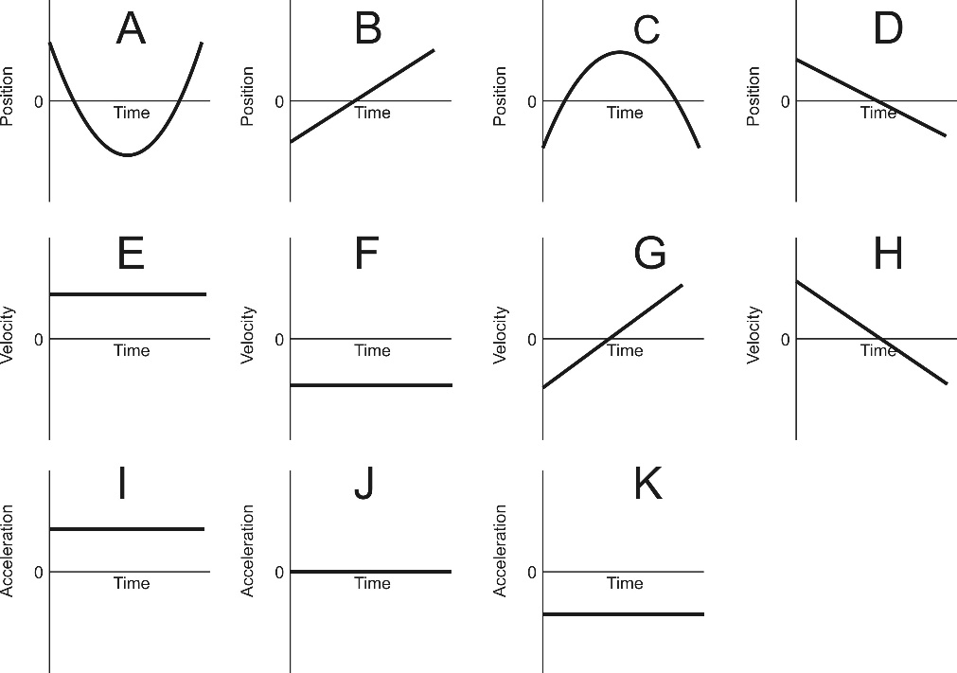
6. Match each of the position graphs with one velocity graph and one acceleration graph that represent the same motion.

Position Graph | Velocity Graph | Acceleration Graph
A
B
C
D

7. A car traveling with a velocity of 21m/s slows down to 15m/s. If it takes 3 seconds for the car to slow down, what is the car’s acceleration during this time period?

8. A ball is dropped from a high place. The ball free-falls for 5 seconds.

a. What is the acceleration of a free-falling object?

b. How fast is the ball traveling after falling for 5 seconds?

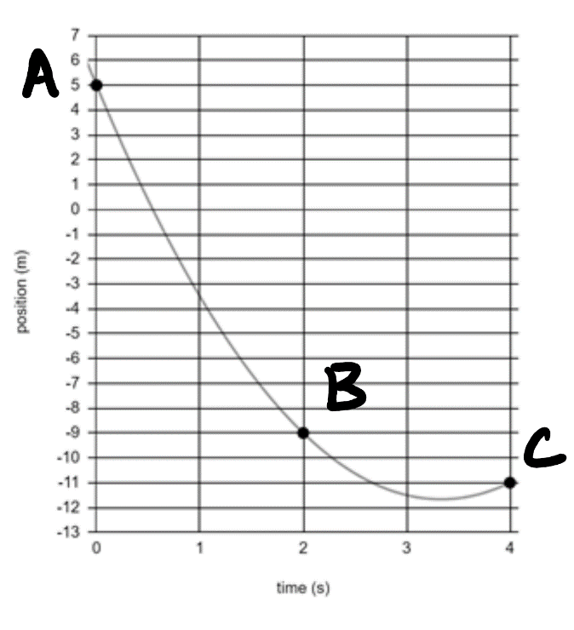

9. The graph on the right shows the positions of a moving object at three different moments in time.

a. What was the average velocity of the object between points A and B?

b. What was the average velocity of the object between points B and C?

c. What was the object’s acceleration?

Kinematics Test Review: Part 2

Formulas that always work: Formulas that only work when starting from rest
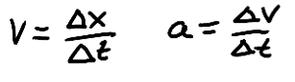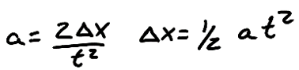

10. Write the basic units for each of the following:

- Position b. Speed

- Acceleration c. Displacement

- Velocity e. Time

11. Suppose an object is launched directly upward in the absence of air resistance (i.e. it is in free-fall). Between the time it is launched and the time it lands, a time of 6 seconds elapses. The object begins and ends at a height of zero meters.

Fill in all of the missing data below, given that the entire trip takes 6 seconds. [Hint: Start by writing “6s” next to the final time (t).]

Some basic conversions:
1m/s = 2.24mph 1 foot = 0.305m 1km = 0.62miles 1m = 100cm
1 inch = 2.54cm 1km = 1,000m 1gallon = 128 fluid ounces 1 gallon = 4 quarts
1 mile = 5280 feet

12. If a spool tractor travels 5m, how many feet is this?

13. A car is travelling at a speed of 60mph. What is its speed in m/s?
14. Identify each of the following as either positive velocity or negative velocity.
Speed to the left Speed to the right
Speed upward Speed downward

Match the descriptions in the left column to the descriptions in the right column

15. ____ Negative velocity and positive acceleration
16. ____ Negative velocity and negative acceleration
17. ____ Positive velocity and positive acceleration
18. ____ Positive velocity and negative acceleration
19. ____ Zero velocity and zero acceleration
20. ____ Zero velocity and negative acceleration
21. ____ Zero velocity and positive acceleration

a. No speed, but beginning to move rightward.
b. No speed, but beginning to move to the left.
c. No movement.
d. Moving leftward, speeding up.
e. Moving rightward, speeding up.
f. Moving leftward, slowing down.
g. Moving rightward, slowing down

22. Use the information from the position vs. time graph, below, to complete the velocity vs. time graph.
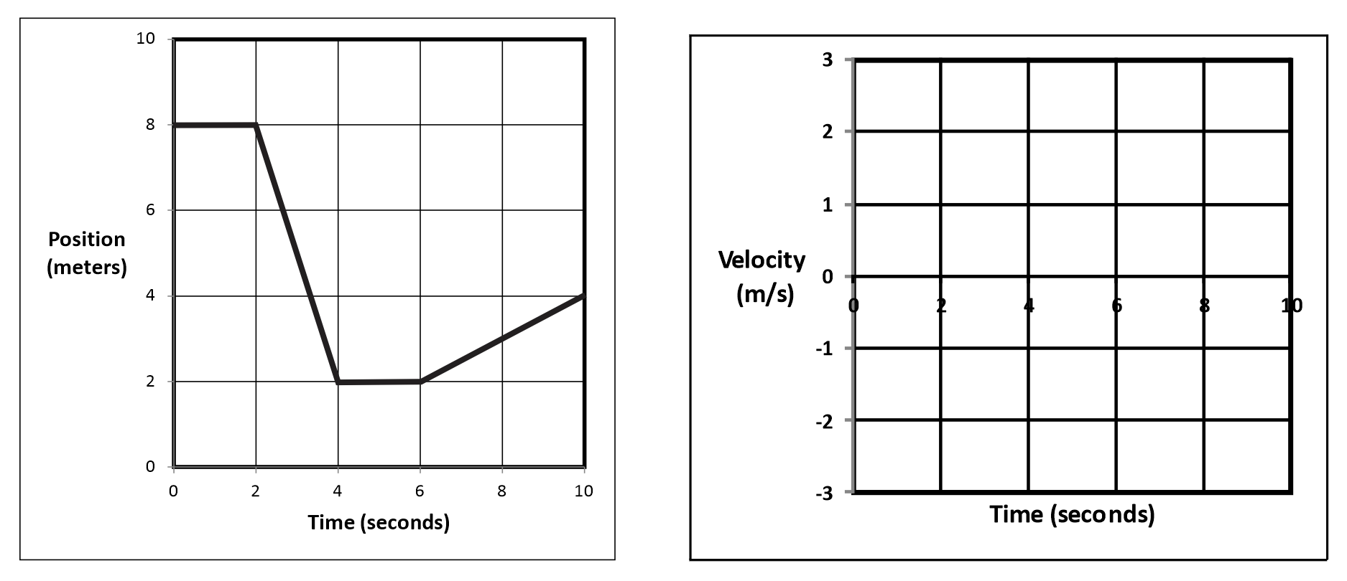

23. A helicopter is sitting still on the ground. Suddenly the helicopter takes off and begins to accelerate upward. If the helicopter travels a distance of 4m in 1.5s, what is its acceleration?

24. A bus can accelerate at a rate of 3m/s². The bus leaves a stoplight (where it was sitting motionless) and accelerates at this rate for 3 seconds. At the end of 3 seconds…

a. What is the speed of the bus?

b. How far has the bus traveled?

c. What is the bus’ average speed over these three seconds

