Physics 100 Name: __________________________
Kinematics Test

Formulas that always work: Formulas that only work when starting from rest
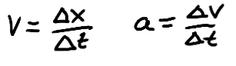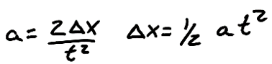
$$Speed= \frac{distance}{time}$$

1-4. Match these symbols to their description:

- _____ $∆v$ 2. _____ a 3. _____ $∆x$ 4. _____ $x$

Choices: a. position b. change in velocity c. change in time d. time
e. acceleration f. displacement g. velocity

5. Which of the following are scalar quantities? Circle all of the scalars.

Displacement Speed Acceleration Velocity Distance

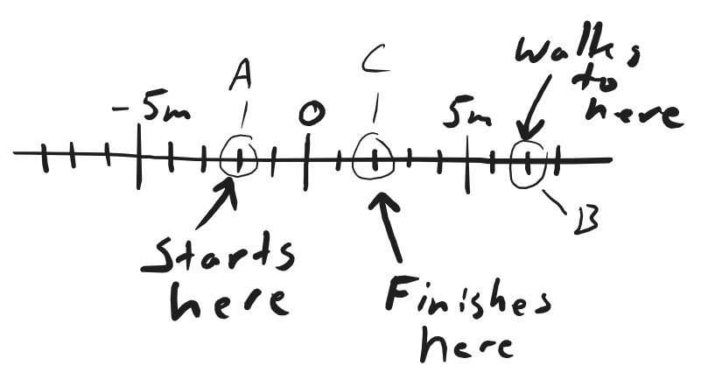
6. A student walks from point A to point B on the number line to the right. He then turns around and walks from point B to point C. The student leaves the starting point (A) when his watch reads 8:15:02. When he reaches the point C, his watch reads 8:15:18.

a. What is the student’s $∆t$ for this entire event?

b. What is his overall displacement?

c. What overall distance did he travel?

d. What was his average speed?

e. What was his average velocity?

For #7 and #8, refer to the velocity and acceleration graphs on the right.

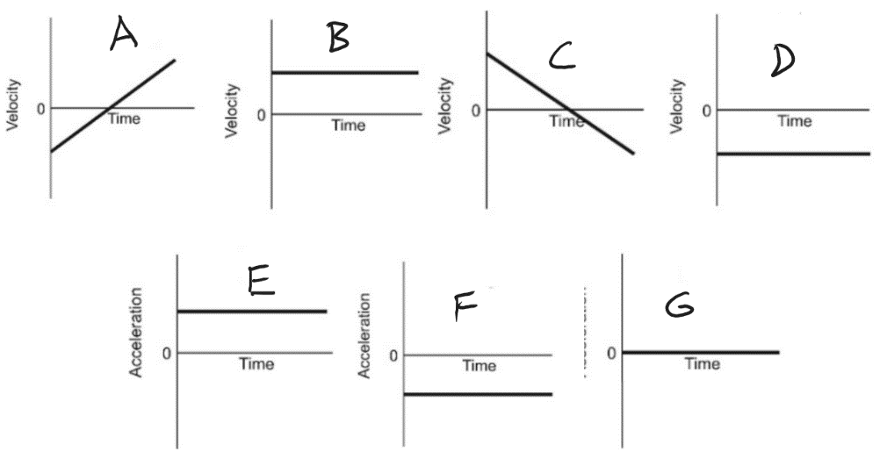
7. Consider this position vs. time graph.
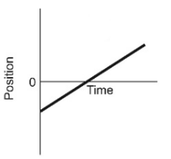

a. ____Which velocity graph matches this motion?

b. ____Which acceleration graph matches this motion?

8. Consider this position vs. time graph.
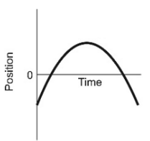

a. ____Which velocity graph matches this motion?

b. ____Which acceleration graph matches this motion?

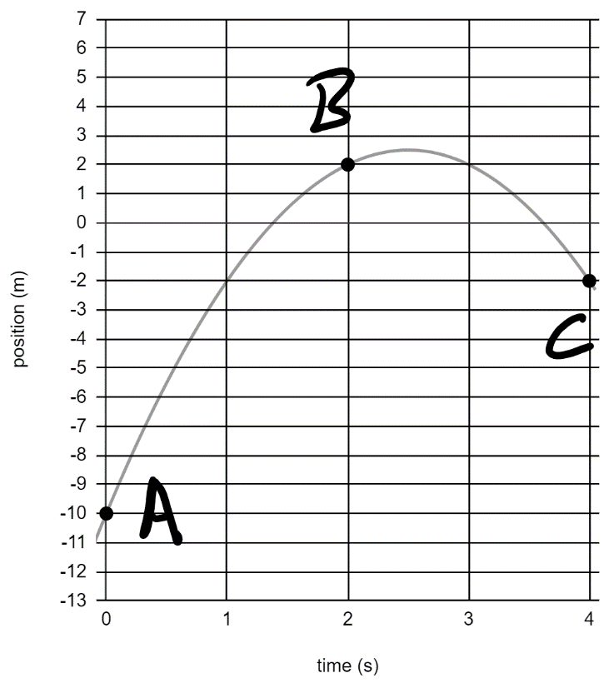
9. The graph on the right shows the positions of a moving object at three different moments in time.

a. What was the average velocity of the object between points A and B?

b. What was the average velocity of the object between points B and C?

c. What was the object’s acceleration?

Circle the correct units for each of the following:

10. Time: m/s m s m/s²

11. Speed: m/s m s m/s²

12. Acceleration: m/s m s m/s²

13. Velocity: m/s m s m/s²

14. Displacement: m/s m s m/s²

15. Suppose an object is launched directly upward in the absence of air resistance (i.e. it is in free-fall). Between the time it is launched and the time it lands, a time of 8 seconds elapses. Some of the items below have been filled in. Fill in the remaining blanks. The bonus items are optional.

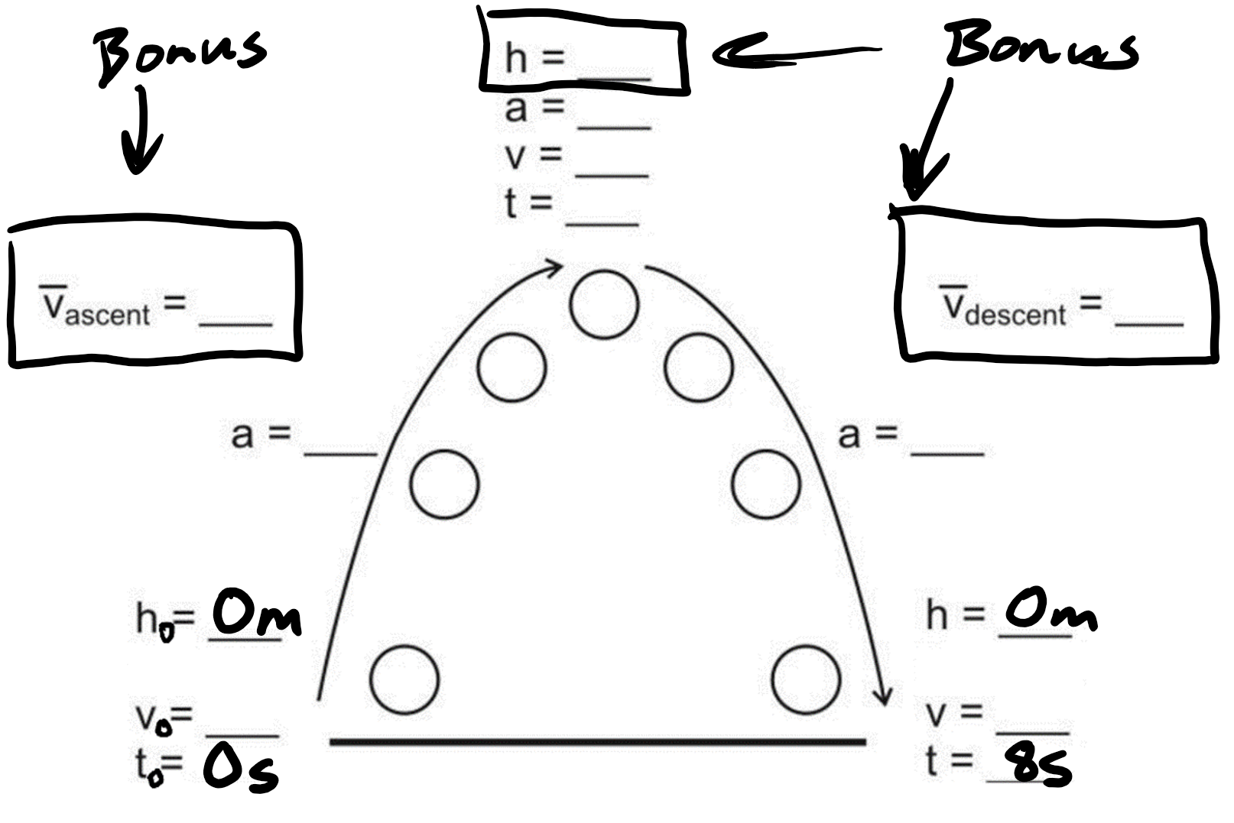

Some basic conversions:
1m/s = 2.24mph 1 foot = 0.305m 1km = 0.62miles 1m = 100cm
1 inch = 2.54cm 1km = 1,000m 1gallon = 128 fluid ounces 1 gallon = 4 quarts
1 mile = 5280 feet

16. 5 inches = ____________ cm

17. 6 m = ____________ feet

18. In physics problems, which directions are considered negative? Circle all that apply.

Upward Downward Leftward Rightward

Match the descriptions in the left column to the descriptions in the right column

19. _____ Negative velocity and positive acceleration

20. _____ Positive velocity and negative acceleration

21. _____ Zero velocity and negative acceleration

a. No speed, but beginning to move rightward.
b. No speed, but beginning to move to the left.
c. Moving leftward, speeding up.
d. Moving leftward, slowing down.
e. Moving rightward, speeding up.
f. Moving rightward, slowing down.

22. Use the information from the position vs. time graph, below, to complete the velocity vs. time graph.

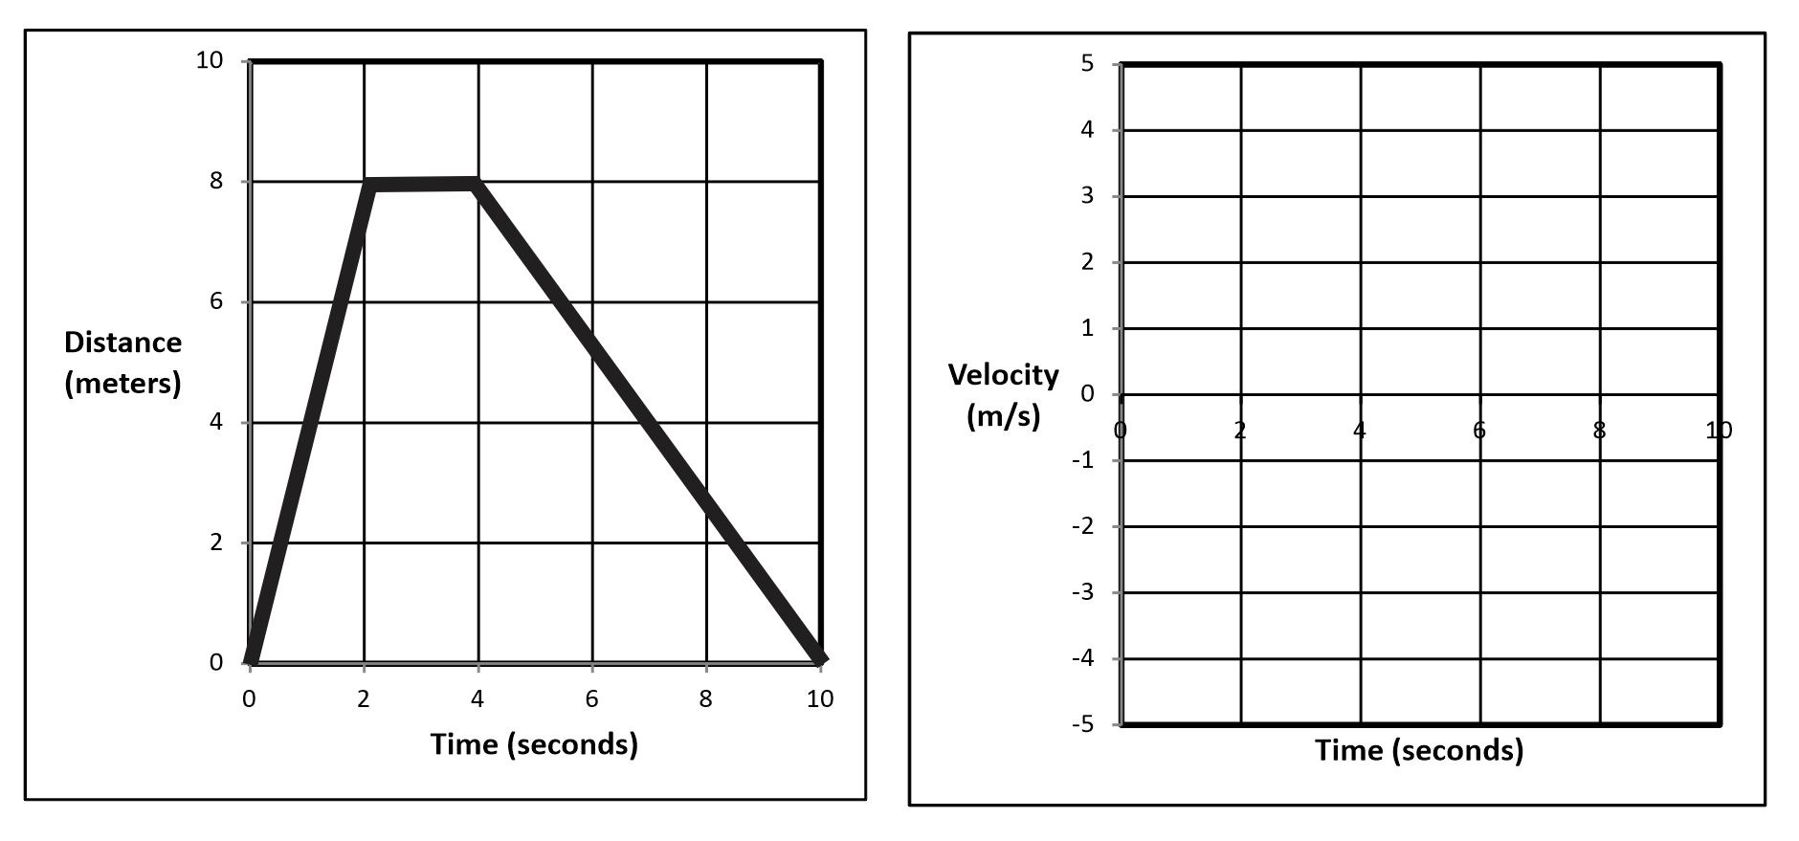

Problems: 3 points each. Partial credit will be awarded as follows: 1.5 points for the correct formula. ½ for substituting correctly into the formula. ½ for correct units.

Formulas that always work: Formulas that only work when starting from rest

23. A ball is dropped from a high place. The ball free-falls for 9 seconds.

a. What is the acceleration of a free-falling object?

b. How fast is the ball traveling after falling for 9 seconds?

24. A car traveling with a velocity of 14m/s speeds up to 20m/s. If it takes 2 seconds for the car to speed up, what is the car’s acceleration during this time period?

25. A helicopter is sitting still on the ground. Suddenly the helicopter takes off and begins to accelerate upward. If the helicopter travels a distance of 8m in 2s, what is its acceleration?

26. A bus can accelerate at a rate of 2m/s². The bus leaves a stoplight (where it was sitting motionless) and accelerates at this rate for 8 seconds. At the end of 8 seconds…

a. What is the speed of the bus?

b. How far has the bus traveled?

c. What is the bus’ average speed over these 8 seconds?

Bonus: A car has a velocity of 30m/s. If the car accelerates at a rate of -5m/s² for 8 seconds, what is the car’s displacement during this acceleration period?

