Physics 100 (Stapleton) Name: __________________________
Notes: Acceleration and Motion Graphing

Acceleration Notes:

______________________ tells you how something’s position changes during one second.

______________________ tells you how something’s velocity changes during one second.

Is acceleration a vector or scalar quantity?

Acceleration can happen in two fundamentally different ways:

1)

2)

Negative acceleration is also called _____________________________

Common metric units for acceleration are:

The Analogous Relationship between Velocity and Acceleration:

If Pam has a velocity of +6m/s, that means she travels 6m for every second that ticks by. Another way to say this is that, for each passing second, Pam adds 6m to her position.

Analogously, if Pam’s acceleration is +6m/s/s, this means…

Velocity adds ____________________ each second.

Acceleration adds ________________________ each second.

Velocity is the slope of a _________________ vs _________________ graph.

Acceleration is the slope of a ________________ vs _________________ graph.

The acceleration formula:

Velocity describes a change in position over a time interval. Acceleration describes a change in velocity over a time interval.

a_{average} =

Acceleration Formula Practice Problems:

1. Suppose your velocity is 2m/s. One second later, your velocity is 6m/s. What is your average acceleration over this time period?

2. When your watch reads 8:01:32 AM, your velocity is 6m/s. At 8:01:40 AM (on the same day), your velocity is 2m/s. What is your average acceleration over this time period?

Motion Graphs:

Each row of graphs below comprises a position vs. time graph, a velocity vs. time graph, and an acceleration vs. time graph. Every graph in a row conveys the same motion. For each row, use the one completed graph to fill in the incomplete graphs with reasonable curves. Some rows will have a wider variety of possible answers. Assume that all acceleration is constant.

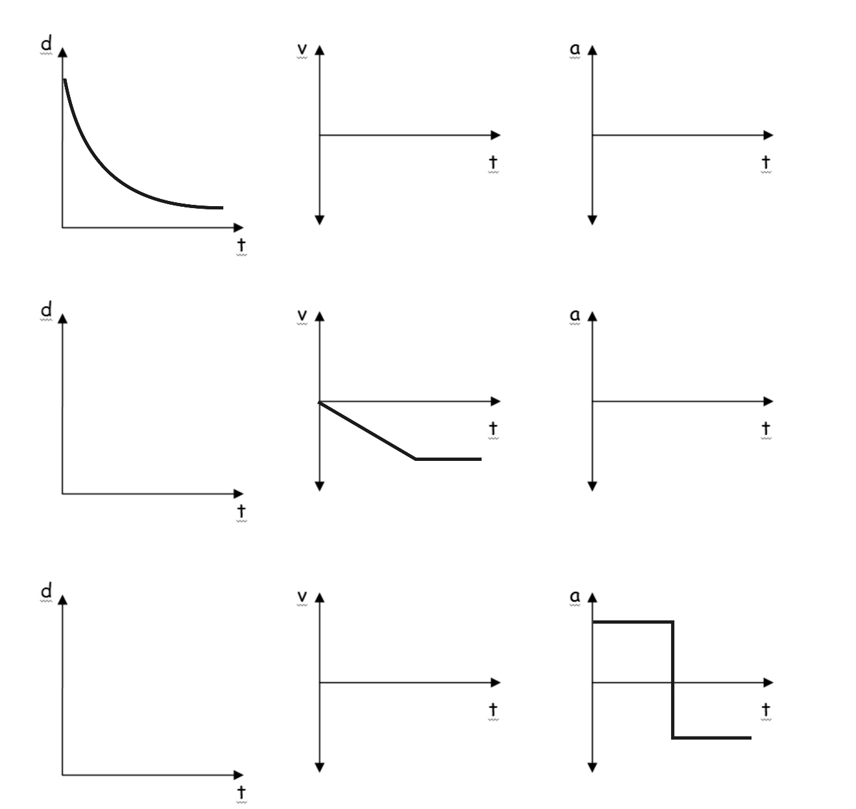
Graph Comparisons: use the information provided in one graph to complete the other two graphs. Be aware that some graphs may be unrealistic, and some may have multiple correct solutions.

