Physics 100 (Stapleton) Name: __________________________
Notes: Kinematics Intro, Basic Terms, Average Velocity

Kinematics: The study of motion without considering its causes.

Scalar: A quantity with magnitude but no direction. Give an example:

Vector: A quantity with magnitude and direction. Give an example:

Δ = Delta = “change in”

Formula for Δ = Final – initial.

Example Problem: Calculate the “change in position” for an object that moves from the 4m mark to the 1m mark.

Position:
Displacement:
Distance:
Speed

 | Symbol | Meaning (what it’s supposed to mean) | Vector or Scalar? | Common Units
Position |  | Where something is on a number line.
Displacement |  | “Change in position”
Distance |  | Like displacement, but doesn’t include direction. What a car’s odometer keeps track of.
Total Distance |  | Sum of all of the distances traveled on a trip.
Change in Time |  | How long some event lasts.
Speed |  | How fast something is moving. A ratio of distance traveled to travel time elapsed.
Velocity |  | Speed and direction.
If I have a velocity of 3 m/s, what does that mean?

One Definition of Velocity:

Average Velocity (symbol = ): when we measure velocity, average velocity is what we will actually measure. This is the average speed of an object as it travels through a given distance. The object may speed up or slow down over that distance, but the average velocity that we calculate will not show this.

Average Velocity Formula (Hint: the units provide the formula)

“Initial velocity” symbol =

Final velocity symbol =

Terminology Practice: A student starts a timer. When the timer gets to 11 seconds, an object is at the 6m mark on the number line to the right. When the timer gets to 13 seconds, the object’s new position is -2. Show these positions and times on the number line to the right. Then calculate each of the following.

Displacement?

Distance traveled?

Average velocity?

Average speed?

Velocity Practice: The graph on the right shows the movement of an object in front of a motion sensor. Determine the velocity of the moving object for lettered each segment, and use your calculations to fill out a velocity vs. time graph for the object (bottom of page).

1. Fill in the correct information for segment A, in the graph on the right.
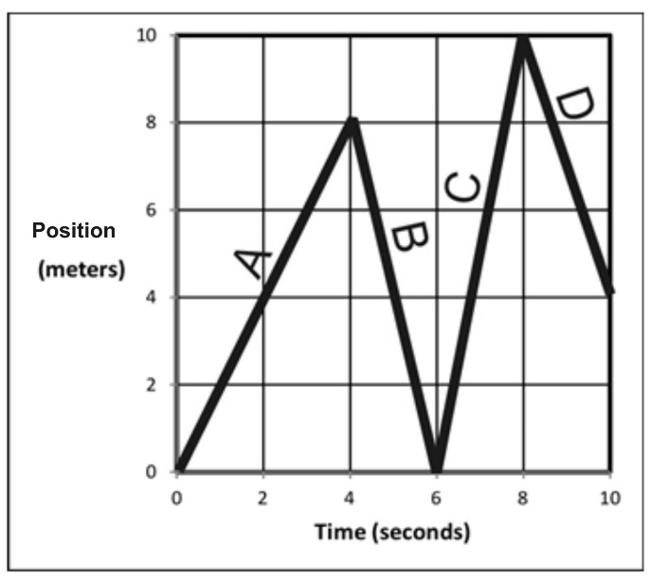
Displacement = _________

Δt = _________

v_{average} = _________

Distance traveled = ___________

Position at end of segment = ____________

2. Fill in the correct information for segment B.

Displacement = _________

Δt = _________

v_{average} = _________

Distance traveled = ___________

Position at end of segment = ____________

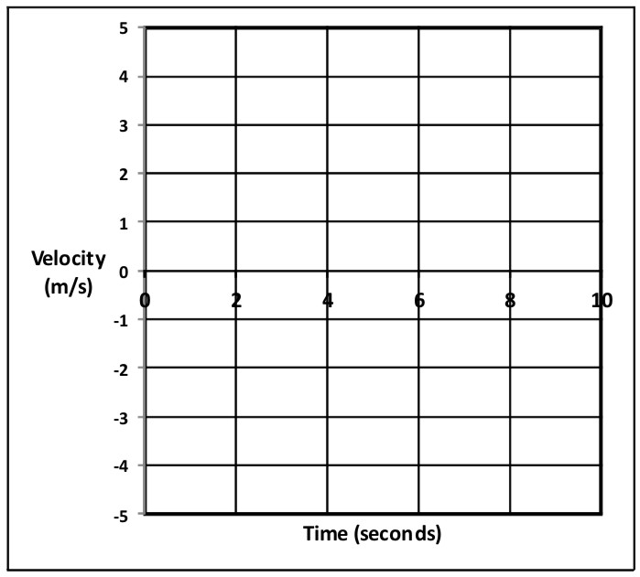
3. Fill in the correct information for the entire trip (segments A-D).

Displacement = _________

Δt = _________

v_{average} = _________

Distance traveled = ___________

Position at end of segment = ____________

4. Use the distance vs. time graph above to fill in the velocity vs. time graph on the right.

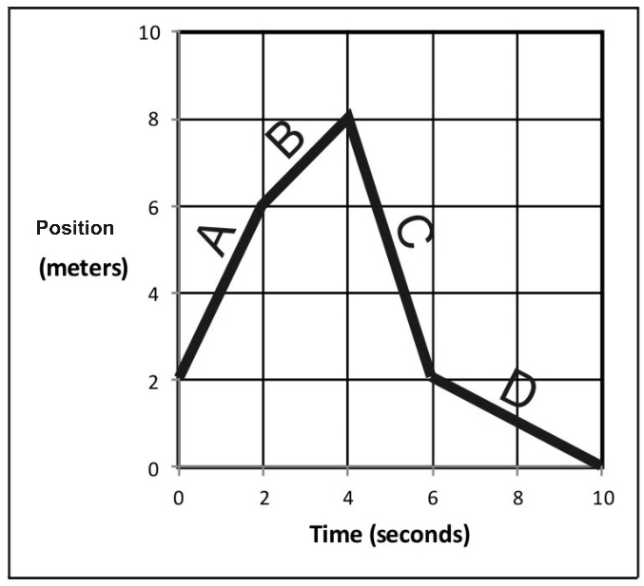
5. Fill in the correct information for segment A, in the graph on the right.

Displacement = _________

Δt = _________

v_{average} = _________

Distance traveled = ___________

Position at end of segment = ____________

6. Fill in the correct information for segment B.

Displacement = _________

Δt = _________

v_{average} = _________

Distance traveled = ___________

Position at end of segment = ____________

7. Fill in the correct information for the entire trip (segments A-D).

Displacement = _________

Δt = _________

v_{average} = _________

Distance traveled = ___________

Position at end of segment = ____________

8. Use previous answers and the distance vs. time graph above to fill in the velocity vs. time graph on the right.

