Physics 100 Name: ________________________
Final Exam Review
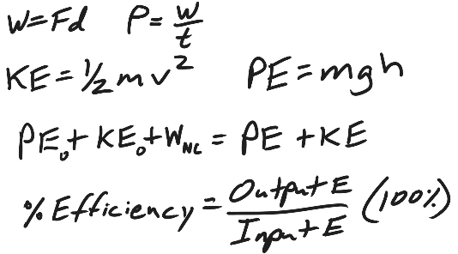
Part 1: Energy

1. What is the physics definition of “energy?”

2. What is the physics definition of “work?”

3. How much work is done when a person pushes a car a distance of 6m while applying a constant force of 70N? Include proper units!

4. How much power is generated by the person (from question #3), if the person accomplishes that task in a time of 5 seconds? Include proper units!

5. Explain how kinetic energy and potential energy are different.

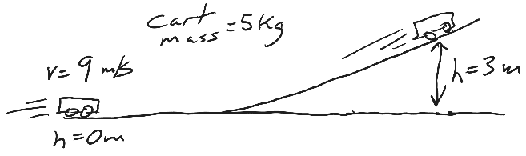
6. A 5kg cart is moving at a speed of 9m/s on a flat surface at a height of 0m. Without experiencing any outside forces, the car rolls up a ramp to a height of 3m above the flat surface. This means the car is “coasting” with no friction.

- Calculate the car’s KE on the flat surface.

- Calculate the car’s PE on the flat surface.

- Calculate the car’s PE at the height of 3m.

- What is the car’s KE at the height of 8m?

- Explain the reasoning behind your answer to part d.

#7-10.
Someone has invented a “machine” to make a cart go fast. The whole point of the machine is to give the cart a high speed when it reaches point E. First the cart sits motionless in a sled at point A. Then a motor pushes it uphill from point A to point B, a distance of 80m. When the cart reaches the top of the hill (point B), it is motionless. Then it begins to roll frictionlessly down to point C. Between points C and D (a distance of 40m), brakes are applied (so the cart won’t fly off the track around the corner), slowing the cart to 5m/s at point D. The cart mass = 50kg.

**The areas that are not shaded are frictionless! Shaded areas either have friction or some kind of non-conservative work being done on the cart!**
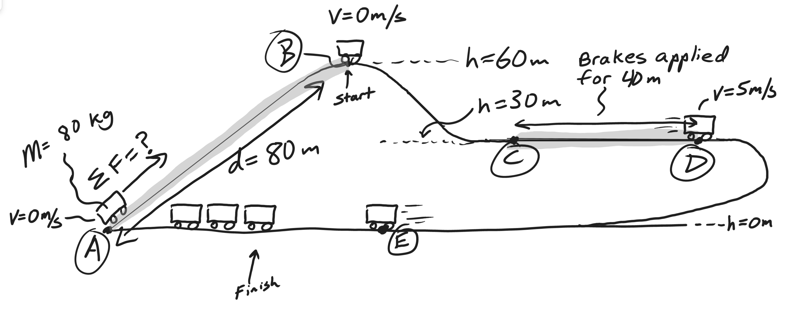
7. Fill out the entire chart, but for this question you will only be graded on the gray cells. For questions that come later, you will need the answers to other cells.
Location | Height (m) | Velocity (m/s) | Potential Energy (J) | Kinetic Energy (J) | Total Energy (J)
A | 0 | 0
B | 60 | 0
C | 30
D | 30 | 5
E | 0

8. State the law of conservation of energy.

9. a. Identify an interval (between two lettered points in the cart’s journey) when the cart’s mechanical energy was conserved.
b. Explain why (or how you know) energy was conserved during this interval.

Starting letter: _______ Ending Letter: ________

Explanation:

10. a. Identify two times when the cart’s mechanical energy was NOT conserved.
b. For each example, explain why (or how you know) energy was not conserved.

Starting letter: _______ Ending Letter: ________

Explanation:

Starting letter: _______ Ending Letter: ________

Explanation:

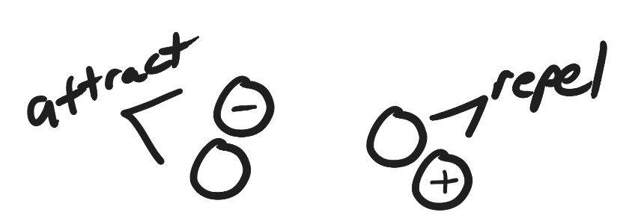
Part 2: Static Electricity

1. For each of the pairs of charges on the right, add positive or negative signs to make the pairs attract and repel.
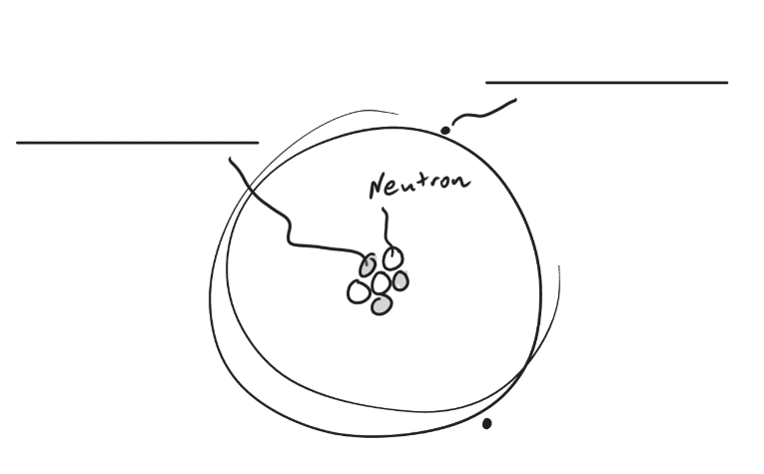
2. On the diagram to the right, write “proton” on the line that is connected to a proton.

3. Write “electron” on the line that points to an electron.

4. Label the proton and the electron with appropriate charges (+ or -)

5. When two objects are rubbed together, and static electricity is created, which type of particle gets transferred?

6. Which has a stronger charge?
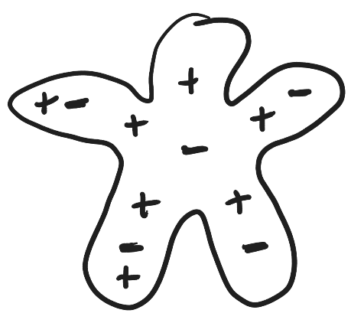
a. a proton b. an electron
c. neither, they’re equally strong

7. What is the net charge of the object on the right?

8. What does the “static” part of the words “static electricity” mean?

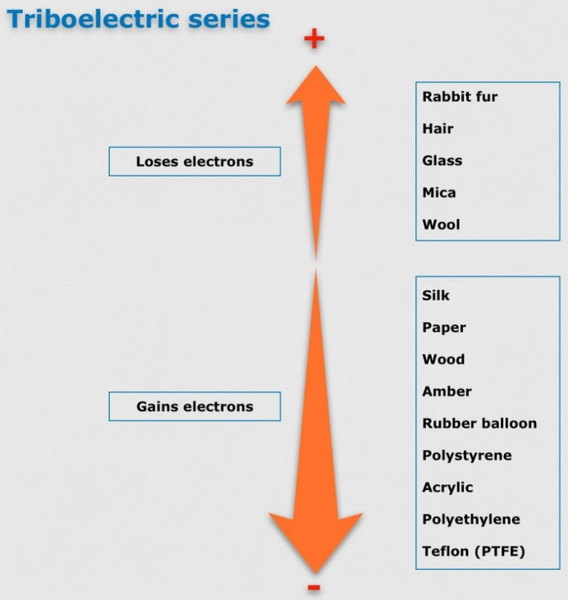
9. Sketch a simple picture of a neutral square of mica and a neutral rubber balloon. Draw some charges in each of them.

10. Refer to the diagram on the right, and then draw what the charges in the mica and the balloon might look like after you rub them together.

11. What does the “Law of Conservation of Charge" tell us will happen when the mica and balloon are rubbed together?

Part 3: Current and Circuits

Matching Section Answer Bank: Current, Voltage, Resistance, Circuit, power, DC, AC

1. ______________ The amount of flow of electricity through a circuit
2. ______________ A closed loop that electrons can travel in.
3. ______________ A type of circuit in which electrons only flow in one direction.
4. ______________ A measure of how fast electrical energy is used.
5. ______________ Something that slows down the flow of electricity through a circuit
6. ______________ The “pressure” that pushes charge through a circuit
7. ______________ A type of circuit in which electron flow switches directions

Ohm’s Law: Complete the formula for Ohm’s Law in three different forms…

8. I = _______ 9. V = _______ 10. R = _______

11. When the voltage (V) in a circuit is kept the same, but resistance (R) is increased, what happens to current (I)?
a. I Increases b. I decreases c. I stays the same

12. When voltage (V) in a circuit is kept the same, but the current (I) decreases, what must have happened to the resistance (R) in the circuit?
a. R increased b. R decreased c. R did not change

13. When the current (I) in a circuit has not changed, but resistance (R) has decreased, what must have happened to voltage (V)?
a. V increased b. V decreased c. V did not change

Circuit Rules

14. In a parallel circuit…
a. Each of the individual currents is the same as the total circuit current.
b. The total circuit current equals the sum of all of the individual currents.

15. In a parallel circuit…
a. Each of the individual voltage drops is the same as the total circuit voltage.
b. The total circuit voltage equals the sum of all of the individual voltage drops.

16. In a series circuit…
a. Each of the individual currents is the same as the total circuit current.
b. The total circuit current equals the sum of all of the individual currents.

17. In a series circuit…
a. Each of the individual voltage drops is the same as the total circuit voltage.
b. The total circuit voltage equals the sum of all of the individual voltage drops.

11. In both series and parallel circuits…
a. The total power used by the circuit equals the sum of all of the powers used by the individual resistors.
b. Each resistor uses an amount of power equal to the total power used by the circuit.

Circuit Puzzles:

12. Fill in the missing information for the overall circuit and for each of the bulbs (resistors).

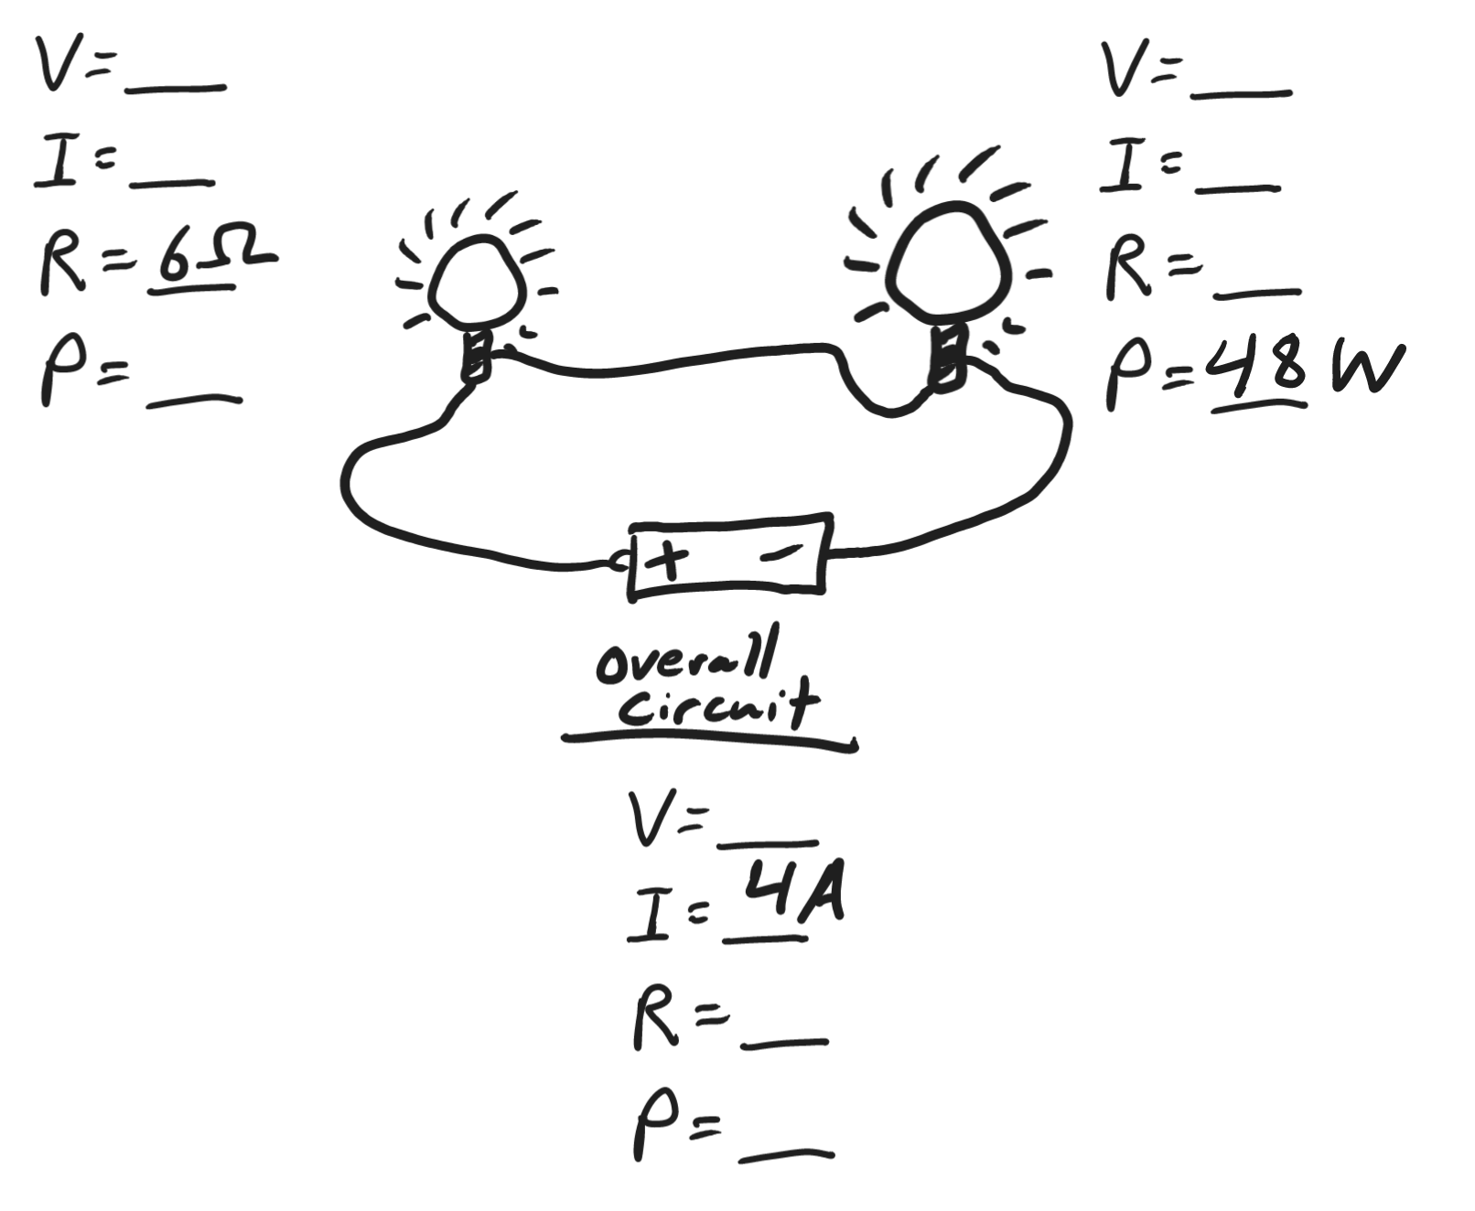
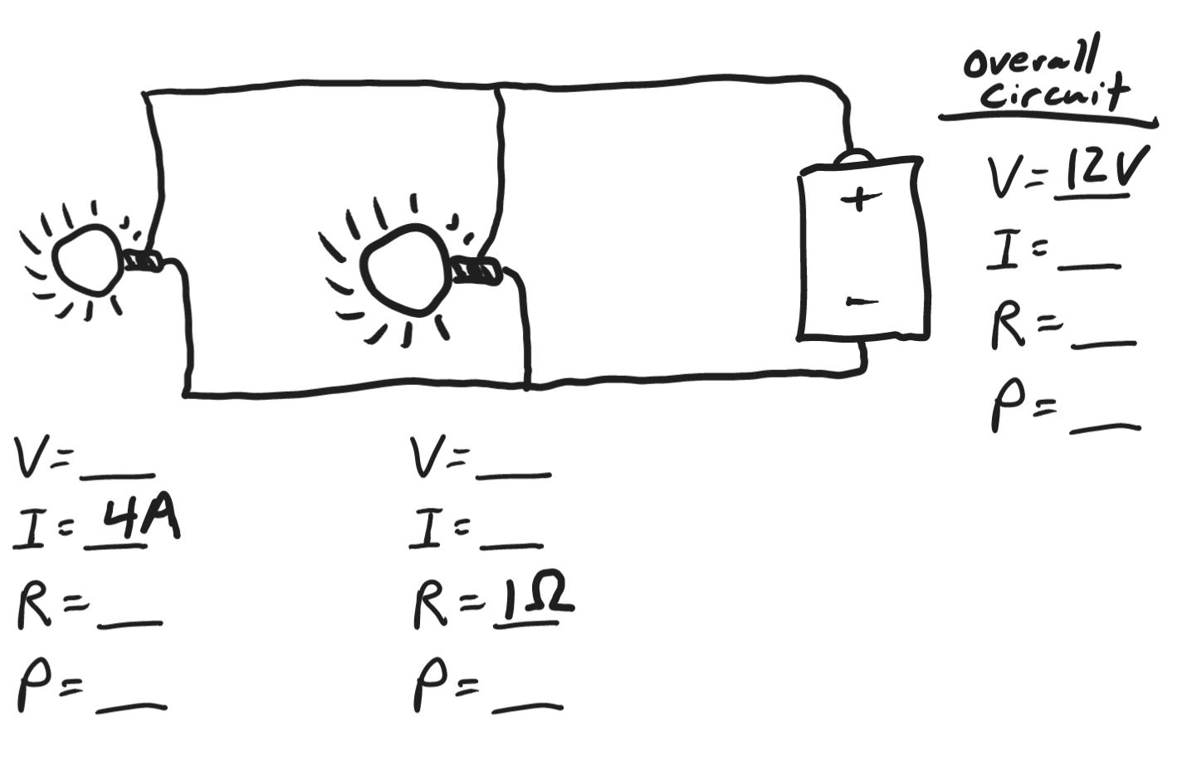

Part 4: Waves and Sound

Match the terms on the right to the blanks below.

1. _____ This is a type of wave that has oscillating magnetic and electric fields.

2. _____ This describes any wave that has an oscillation (disturbance) that is perpendicular to its direction of travel.

3. _____ This describes any wave that has an oscillation (disturbance) that is parallel to its direction of travel.

4. _____ This is the general name for an oscillation (disturbance) that travels through space, transferring energy.
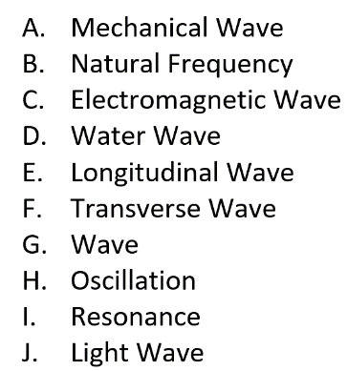
5. _____ This is a back and forth motion; a vibration.

6. _____ This is a specific example of a mechanical wave.

7. _____ This is a specific example of an electromagnetic wave.

8. When an object is struck, hit, or somehow disturbed, it tends to vibrate at its _____.

9. _____ This is a type of wave that travels through matter.

10. _____ This occurs when the one object’s vibrations match the natural frequency of another object, causing the second object to vibrate with increasing amplitude.

11. A. Draw a longitudinal wave and a transverse wave.
B. Label each wave with its name (longitudinal or transverse)
C. On each wave, label all of these parts that apply:
Compression, Rarefaction, Wavelength, Crest, Trough, Amplitude

12. Fred is at the beach. He is standing in the water, 36 m from the shoreline, and a wave splashes him every 6 seconds. Fred has his stopwatch, and he records the time that it takes for a wave to travel from him to the shore. That time is 12 seconds.

- What is the frequency of the waves?

- What is the period of the waves?

- What is the velocity of the waves?

- What is the wavelength of the waves?

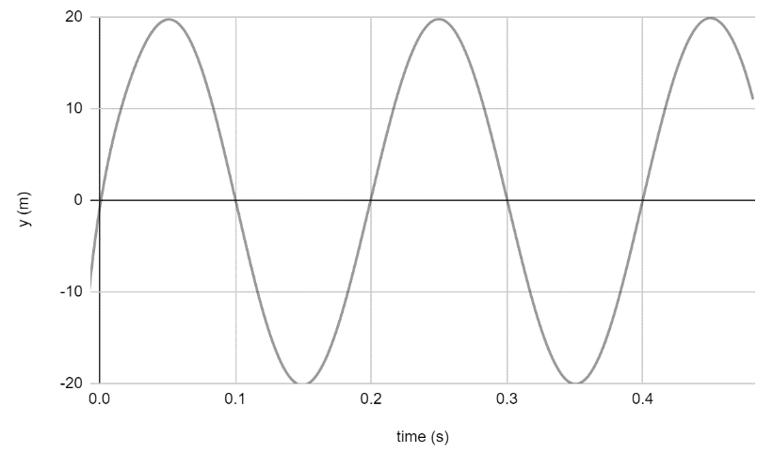
13. Find the period, frequency, and amplitude of the wave on the right.

Period = ___________

Frequency = _________

Amplitude = _________

The diagram below shows sound waves that are given off by a noisy, moving object. On the diagram…

14. Draw an arrow showing the direction of the object’s movement.
15. Draw an X showing where an observer should stand in order to hear the object’s sound at the lowest possible pitch.

16. Suppose something is vibrating at one of its natural frequencies. Draw the wave pattern that you would see if the object has…

- 3 antinodes and 2 nodes

- 4 nodes and 3 antinodes

18. There are standing waves in a 4m long string. This wave pattern has 3 nodes and 2 antinodes. What is the wavelength of these waves?

19. Draw the fundamental frequency and the 1st overtone frequencies for a 2m long pipe that is open on one end and closed on the other For each drawing, provide the wavelength of the sound wave that is produced.

Fundamental (wavelength = _________meters)

1st Overtone (wavelength = _________meters)

